Окно LoginWindow

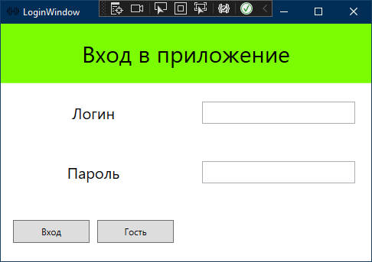

Код LoginWindow.xaml

<Grid>

<Grid.RowDefinitions>

<RowDefinition/>

<RowDefinition/>

<RowDefinition/>

<RowDefinition/>

</Grid.RowDefinitions>

<Grid.ColumnDefinitions>

<ColumnDefinition/>

<ColumnDefinition/>

</Grid.ColumnDefinitions>

<Grid Grid.Row="0" Grid.ColumnSpan="2" Background="LawnGreen"/>

<TextBlock Text="Вход в приложение" Grid.Row="0" Grid.ColumnSpan="2" VerticalAlignment="Center" HorizontalAlignment="Center" FontSize="30"/>

<TextBlock Text="Логин" Grid.Row="1" Grid.Column="0" VerticalAlignment="Center" HorizontalAlignment="Center" FontSize="20" />

<TextBlock Text="Пароль" Grid.Row="2" Grid.Column="0" VerticalAlignment="Center" HorizontalAlignment="Center" FontSize="20" />

<StackPanel Grid.Row="3" Orientation="Horizontal" VerticalAlignment="Center" HorizontalAlignment="Center">

<Button x:Name="EnterBtn" Content="Вход" VerticalAlignment="Center" HorizontalAlignment="Center" Grid.ColumnSpan="2" Grid.Row="3" Width="100" Height="30" Click="EnterBtn_Click" Margin="5"/>

<Button x:Name="GhostBtn" Content="Гость" VerticalAlignment="Center" HorizontalAlignment="Center" Grid.ColumnSpan="2" Grid.Row="3" Width="100" Height="30" Click="GhostBtn_Click" Margin="5"/>

</StackPanel>

<TextBox x:Name="LoginTb" Text="{Binding login}" Grid.Row="1" Grid.Column="1" VerticalAlignment="Center" FontSize="20" Width="200"/>

<TextBox Text="{Binding password}" Name="pwdTextBox" Grid.Column="1" Grid.Row="2" FontSize="20" HorizontalAlignment="Center" VerticalAlignment="Center" Width="200" Visibility="Hidden"/>

<PasswordBox Name="pwdPasswordBox" Grid.Column="1" Grid.Row="2" HorizontalAlignment="Center" FontSize="20" VerticalAlignment="Center" Width="200"/> </Grid>

Код LoginWindow.xaml.cs

public partial class LoginWindow : Window

{

public LoginWindow()

{

InitializeComponent();

}

private void EnterBtn_Click(object sender, RoutedEventArgs e)

{

try

{

//Метод проверки капчи

CaptchaWindow captchaWindow = new CaptchaWindow();

bool isCorrect = (bool)captchaWindow.ShowDialog();

if (isCorrect)

{

//функиця проверки и верности логина и пароля пользователя

User user = App.db.User.FirstOrDefault(u => u.UserLogin == LoginTb.Text && u.UserPassword == pwdPasswordBox.Password);

if (user != null)

{

//Метод проверки ролей

Class1.IsAuth = true;

Class1.User = user;

if (user.UserRole == 1)

{

UserWindow userWindow = new UserWindow();

userWindow.Show();

this.Close();

}

else if (user.UserRole == 2)

{

AdminWindow adminWindow = new AdminWindow();

adminWindow.Show();

this.Close();

}

else if (user.UserRole == 3)

{

ManagerWindow managerWindow = new ManagerWindow();

managerWindow.Show();

this.Close();

}

}

}

}

catch (Exception ex) { MessageBox.Show(ex.Message); }

}

private void GhostBtn_Click(object sender, RoutedEventArgs e)

{

//функция закрытия окна

GhostWindow ghostWindow = new GhostWindow();

ghostWindow.Show();

this.Close();

}

}

Окно CaptchaWindow

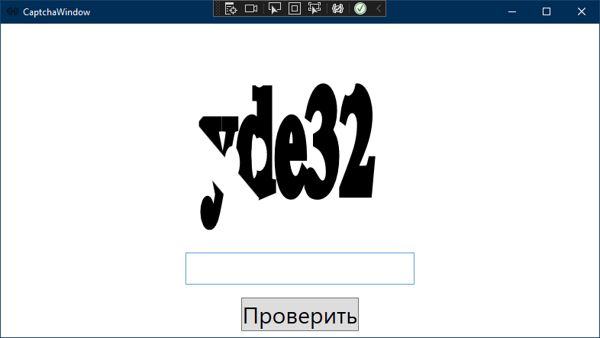

Код CaptchaWindow.xaml

<Grid>

<Grid.RowDefinitions>

<RowDefinition Height="*"/>

<RowDefinition Height="60"/>

<RowDefinition Height="60"/>

</Grid.RowDefinitions>

<Grid x:Name="CaptchaImage" Width="450" Height="250"/>

<TextBox Name="CaptchaTb" Grid.Row="1" VerticalAlignment="Center" FontSize="30" Width="300"/>

<Button Name="CheckCaptcha" Click="CheckCaptcha_Click" Content="Проверить" Grid.Row="2" HorizontalAlignment="Center" VerticalAlignment="Center" FontSize="30" />

</Grid>

Код CaptchaWindow.xaml.cs

public partial class CaptchaWindow : Window

{

//Проверка капчи

string _correctCaptcha { get; set; }

public bool _isCorrect { get; set; } = false;

public CaptchaWindow()

{

InitializeComponent();

string abc = "qwertyuiopasdfghjklzxcvbnm1234567890";//символы которые участвуют в капче

string captcha = "";

Random rnd = new Random();

for (int i = 0; i < 5; i++)

{

captcha = captcha + abc[rnd.Next(0, abc.Length)];

}

_correctCaptcha = captcha;

CaptchaImage.Background = new DrawingBrush(Captha.DrawMyText(captcha));//вывод капчи в виде рисунка

}

private void CheckCaptcha_Click(object sender, RoutedEventArgs e)

{

//проверка капчи

if (_correctCaptcha != CaptchaTb.Text)

{

this.DialogResult = false;

MessageBox.Show("Капча введена неверно");

return;

}

MessageBox.Show("Начинайте работу!");

this.DialogResult = true;

}

}

Код CaptchaWindow.xaml.cs

public partial class CaptchaWindow : Window

{

//Проверка капчи

string _correctCaptcha { get; set; }

public bool _isCorrect { get; set; } = false;

public CaptchaWindow()

{

InitializeComponent();

string abc = "qwertyuiopasdfghjklzxcvbnm1234567890";//символы которые участвуют в капче

string captcha = "";

Random rnd = new Random();

for (int i = 0; i < 5; i++)

{

captcha = captcha + abc[rnd.Next(0, abc.Length)];

}

_correctCaptcha = captcha;

CaptchaImage.Background = new DrawingBrush(Captha.DrawMyText(captcha));//вывод капчи в виде рисунка

}

private void CheckCaptcha_Click(object sender, RoutedEventArgs e)

{

//проверка капчи

if (_correctCaptcha != CaptchaTb.Text)

{

this.DialogResult = false;

MessageBox.Show("Капча введена неверно");

return;

}

MessageBox.Show("Начинайте работу!");

this.DialogResult = true;

}

}

Окно ProductAdminPage

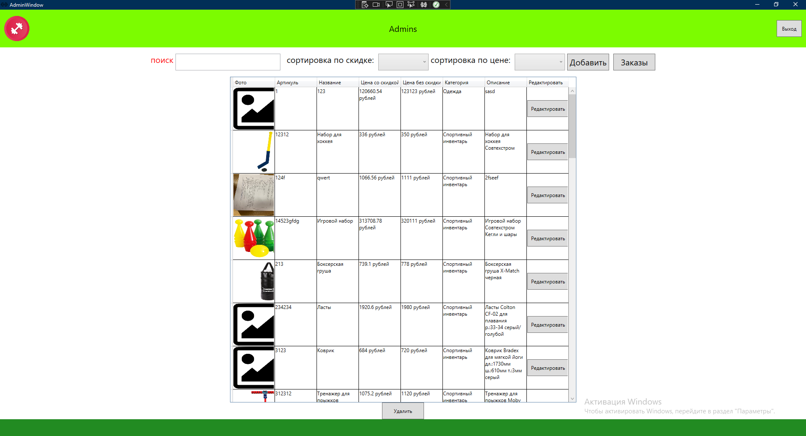

Код ProductAdminPage.xaml

<Grid>

<Grid.RowDefinitions>

<RowDefinition Height="70"></RowDefinition>

<RowDefinition Height="*"></RowDefinition>

<RowDefinition Height="40"></RowDefinition>

</Grid.RowDefinitions>

<WrapPanel Grid.Row="0" VerticalAlignment="Center" HorizontalAlignment="Center">

<StackPanel Orientation="Horizontal" Margin="5 0" Grid.Row="0">

<TextBlock Text="поиск" FontSize="20" Foreground="Red"/>

<TextBox x:Name="TbSearch" Width="250" Margin="5 0" TextChanged="TbSearch_TextChanged"/>

</StackPanel>

<TextBlock Text="сортировка по скидке: " Margin="5 0" FontSize="20" />

<ComboBox Name="CmbSortSkida" Width="120" SelectionChanged="CmbSortSkida_SelectionChanged">

<ComboBoxItem Content="убыванию"/>

<ComboBoxItem Content="возрастанию"/>

</ComboBox>

<TextBlock Text="сортировка по цене: " Margin="5 0" FontSize="20" />

<ComboBox Name="CmbSortCost" Width="120" SelectionChanged="CmbSortCost_SelectionChanged">

<ComboBoxItem Content="убыванию"/>

<ComboBoxItem Content="возрастанию"/>

</ComboBox>

<Button Name="BtnAdd" Content="Добавить" Width="100" Height="40" Click="BtnAdd_Click" FontSize="20" Margin="5 0"/>

<Button Name="BtnOrder" Content="Заказы" Width="100" Height="40" Click="BtnOrder_Click" FontSize="20" Margin="5 0"/>

</WrapPanel>

<DataGrid x:Name="DataTable" ItemsSource="{Binding ProductName}" Background="White" ColumnWidth="100" HorizontalAlignment="Center" AutoGenerateColumns="False" Grid.Row="1">

<DataGrid.Columns>

<DataGridTemplateColumn Header="Фото">

<DataGridTemplateColumn.CellTemplate>

<DataTemplate>

<Image Source="{Binding GetPhoto}" Height="100" Width="150" Stretch="Fill"/><!--фото-->

</DataTemplate>

</DataGridTemplateColumn.CellTemplate>

</DataGridTemplateColumn>

<DataGridTemplateColumn Header="Артикуль">

<DataGridTemplateColumn.CellTemplate>

<DataTemplate>

<TextBlock Text="{Binding ProductArticleNumber}" TextWrapping="Wrap"/><!--артикуль-->

</DataTemplate>

</DataGridTemplateColumn.CellTemplate>

</DataGridTemplateColumn>

<DataGridTemplateColumn Header="Название">

<DataGridTemplateColumn.CellTemplate>

<DataTemplate>

<TextBlock Text="{Binding ProductName}" TextWrapping="Wrap"/><!--название-->

</DataTemplate>

</DataGridTemplateColumn.CellTemplate>

</DataGridTemplateColumn>

<DataGridTemplateColumn Header="Цена со скидкой">

<DataGridTemplateColumn.CellTemplate>

<DataTemplate>

<TextBlock Text="{Binding GetDiscountAmount, StringFormat={}{0} рублей}" TextWrapping="Wrap" /><!--цена со скидкой-->

</DataTemplate>

</DataGridTemplateColumn.CellTemplate>

</DataGridTemplateColumn>

<DataGridTemplateColumn Header="Цена без скидки">

<DataGridTemplateColumn.CellTemplate>

<DataTemplate>

<TextBlock Text="{Binding ProductCost, StringFormat={}{0} рублей}" TextWrapping="Wrap" /><!--цена без скидки-->

</DataTemplate>

</DataGridTemplateColumn.CellTemplate>

</DataGridTemplateColumn>

<DataGridTemplateColumn Header="Категория">

<DataGridTemplateColumn.CellTemplate>

<DataTemplate>

<TextBlock Text="{Binding ProductCategory.Name}" TextWrapping="Wrap"/><!--категория-->

</DataTemplate>

</DataGridTemplateColumn.CellTemplate>

</DataGridTemplateColumn>

<DataGridTemplateColumn Header="Описание">

<DataGridTemplateColumn.CellTemplate>

<DataTemplate>

<TextBlock Text="{Binding ProductDescription}" TextWrapping="Wrap"/><!--описание-->

</DataTemplate>

</DataGridTemplateColumn.CellTemplate>

</DataGridTemplateColumn>

<DataGridTemplateColumn Header="Редактировать"><!--функция редактирования-->

<DataGridTemplateColumn.CellTemplate>

<DataTemplate>

<Button Content="Редактировать" Height="40" Width="100" Click="Button_Click_1"/>

</DataTemplate>

</DataGridTemplateColumn.CellTemplate>

</DataGridTemplateColumn>

</DataGrid.Columns>

</DataGrid>

<Button Content="Удалить" Height="40" Width="100" Click="Button_Click" Grid.Row="2" HorizontalAlignment="Center" VerticalAlignment="Bottom" Margin="10 0"/>

<Border x:Name="BackgroundWin" Visibility="Collapsed" Grid.RowSpan="2" Grid.Row="0" Opacity="0.3" Background="Gray"/><!--скрытое окно-->

<Grid x:Name="TransitWindows" Grid.Row="0" Width="600" Background="White" Grid.RowSpan="2" Visibility="Collapsed">

<Border Padding="10">

<Grid>

<StackPanel>

<StackPanel VerticalAlignment="Center" Margin="20 0 40 0" x:Name="VertikStack" HorizontalAlignment="Left" Width="300" >

<Label Content="Нзвание"/>

<TextBox x:Name="TBName" Grid.Column="1" Grid.Row="0" Height="40" Width="350" Margin="5 0" Text="{Binding ProductName}"/>

<Label Content="Категория"/>

<ComboBox Name="CmbCategory" Width="250" SelectionChanged="CmbCategory_SelectionChanged" Grid.Column="1" Grid.Row="1" Height="40" ItemsSource="{Binding ProductCategory}" DisplayMemberPath="Name"/>

<Label Content="Цена"/>

<TextBox x:Name="TBCost" Grid.Column="1" Grid.Row="0" Height="40" Width="350" Margin="5 0" Text="{Binding ProductCost}"/>

<Label Content="Скидка"/>

<TextBox x:Name="TBSkidka" Grid.Column="1" Grid.Row="0" Height="40" Width="350" Margin="5 0" Text="{Binding ProductCost}"/>

<Label Content="Описание"/>

<TextBox x:Name="TBDecs" Grid.Column="1" Grid.Row="0" Height="40" Width="350" Margin="5 0" Text="{Binding ProductDescription}"/>

<Label/>

</StackPanel>

<StackPanel Orientation="Horizontal" Margin="5 0 5 0" VerticalAlignment="Center">

<Button Content="Сохранить" x:Name="SaveBtn" Click="SaveBtn_Click" Height="20" Width="80" VerticalAlignment="Bottom" Margin="10 0"/>

<Button Margin="10 0" Width="80" Content="Отмена" Click="BtnCancel_Click" Height="20" x:Name="BtnCancel"/>

</StackPanel>

</StackPanel>

</Grid>

</Border>

</Grid>

</Grid>

Код ProductAdminPage.xaml.cs

public partial class ProductAdminPage : Page

{

public ProductAdminPage()

{

InitializeComponent();

DataTable.ItemsSource=App.db.Product.ToList();

CmbCategory.ItemsSource=App.db.ProductCategory.ToList();

}

private void BtnAdd_Click(object sender, RoutedEventArgs e)

{

NavigationService.Navigate(new Pages.AddProductPage(null));

}

private void UpdateData()

{

DataTable.ItemsSource = null;

var currentList = App.db.Product.OrderBy(p => p.ProductName).ToList();

currentList = currentList.ToList().Where(p => p.ProductName.ToLower().Contains(TbSearch.Text.ToLower())).ToList();

if (CmbSortSkida.SelectedIndex >= 0)

{

if (CmbSortSkida.SelectedIndex == 0) currentList = currentList.OrderBy(p => p.ProductDiscountAmount).ToList();

if (CmbSortSkida.SelectedIndex == 1) currentList = currentList.OrderByDescending(p => p.ProductDiscountAmount).ToList();

}

if (CmbSortCost.SelectedIndex >= 0)

{

if (CmbSortCost.SelectedIndex == 0) currentList = currentList.OrderBy(p => p.ProductCost).ToList();

if (CmbSortCost.SelectedIndex == 1) currentList = currentList.OrderByDescending(p => p.ProductCost).ToList();

}

DataTable.ItemsSource = currentList;

}

private void Button_Click(object sender, RoutedEventArgs e)

{

Product product = (sender as Button).DataContext as Product;

App.db.Product.Remove(product);

App.db.SaveChanges();

UpdateData();

}

private void TbSearch_TextChanged(object sender, TextChangedEventArgs e)

{

UpdateData();

}

private void BtnOrder_Click(object sender, RoutedEventArgs e)

{

NavigationService.Navigate(new Pages.OrderPage());

}

private void Button_Click_1(object sender, RoutedEventArgs e)

{

try

{

if (VertikStack != null)

{

//скрытое окно

VertikStack.DataContext = (sender as Button).DataContext as Product;

BackgroundWin.Visibility = Visibility.Visible;

TransitWindows.Visibility = Visibility.Visible;

App.db.SaveChanges();

UpdateData();

}

}

catch (Exception ex)

{

MessageBox.Show(ex.ToString());

}

}

Product productNULL;

private void SaveBtn_Click(object sender, RoutedEventArgs e)

{

//сохранение изменений

productNULL = VertikStack.DataContext as Product;

App.db.SaveChanges();

UpdateData();

BackgroundWin.Visibility = Visibility.Collapsed;

TransitWindows.Visibility = Visibility.Collapsed;

}

private void BtnCancel_Click(object sender, RoutedEventArgs e)

{

//окно скрыто

BackgroundWin.Visibility = Visibility.Collapsed;

TransitWindows.Visibility = Visibility.Collapsed;

}

private void CmbCategory_SelectionChanged(object sender, SelectionChangedEventArgs e)

{

}

private void CmbSortSkida_SelectionChanged(object sender, SelectionChangedEventArgs e)

{

UpdateData();

}

private void CmbSortCost_SelectionChanged(object sender, SelectionChangedEventArgs e)

{

UpdateData();

}

}