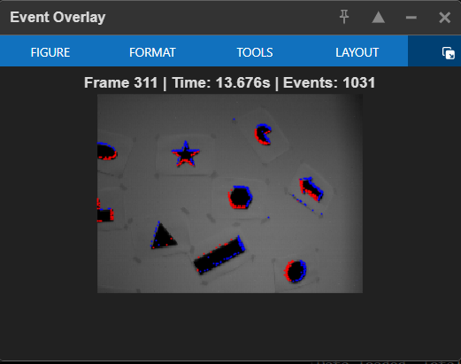
Report for TP: Introduction to events cameras
Shapes translation example on the frame 311 (execute the “vis_events_shapes_translation.m” code for the full process and all thr frames)
Q2: Which part of the frames overlap with events?
- Observation: You will see the red and blue dots clustering strictly around the contours (edges) of the shapes in the image. Uniform regions (plain white or plain black areas) will have almost no events.
- Explanation: Event cameras are asynchronous change detectors. They only trigger an event e(t, x, y, p) if the log-intensity change at a pixel exceeds a threshold: Δln(I) > C.
- Physics: Changes in intensity are caused by motion. Specifically, as an edge moves across a pixel, the intensity jumps from bright to dark (or vice versa). No motion or no gradient (texture) = No events.
Q3: Discuss the impact of the temporal window (Δt)
You can change the Δt variable in the script to observe this:
- Small Window (0.001s):
  - Result: Very few dots. The edges look sparse or "broken".
  - Reason: You are not accumulating enough data to fully visualize the edge structure.
- Large Window (0.1s):
  - Result: The edges look very thick, almost like "motion blur" in a standard camera.
  - Reason: You are stacking events from where the edge was 50ms ago and where it will be 50ms later. This destroys the temporal precision advantage of the sensor.
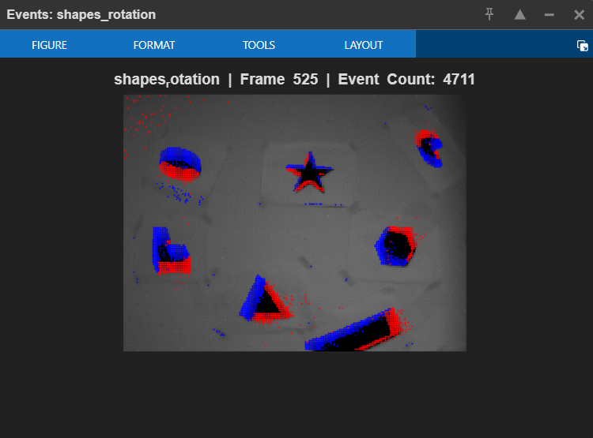
4. Qualitative observations on Rotation and 6-DOF sequences

1. Code Implementation & Universality
To analyze the subsequent datasets, we evolved our initial script (vis_events_shapes_translation.m) into a standard, universal script named vis_events.m.
- Previous Code: The initial script was hardcoded specifically for the translation dataset parameters.
- Standard Code (vis_events.m): This improved version automatically detects the dataset folder name, robustly handles different file headers (using readmatrix instead of load), and adapts the visualization titles dynamically. It works interchangeably for shapes_translation, shapes_rotation, and shapes_6dof without modification.
How to Run:
The script is designed to be "plug-and-play":
- Place the vis_events.m file directly inside the target dataset folder (e.g., .../shapes_rotation/).
- Open the folder in MATLAB.
- Execute the script. It automatically locates events.txt, images.txt, and the images/ directory relative to its location.
2. Discussion of Results
We applied the standard script to the shapes_rotation and shapes_6dof sequences. Below is the qualitative analysis of the event generation in these scenarios compared to simple translation.
A. Sequence: Shapes Rotation
- Observation: Unlike the translation sequence where event density was relatively uniform along edges, the rotation sequence exhibits a radial gradient of event density.
- Analysis:
  - Velocity Gradient: Event generation depends on the speed of intensity change (Δln(I)). In a rotating system, the linear velocity v increases with the distance r from the centre of rotation (v = ω . r).
  - Result: Edges near the centre of rotation move slowly, generating sparse or no events. Edges at the periphery move rapidly, creating dense, continuous event contours. This confirms that the event camera's output rate is directly correlated with the optical flow magnitude¹.
B. Sequence: Shapes 6-DOF
- Observation: This sequence involves unconstrained motion (6 Degrees of Freedom: translation and rotation in X, Y, Z). The resulting event stream appears chaotic and significantly denser than the previous two sequences.
- Analysis:
  - Parallax & Depth: This sequence best illustrates the sensor's sensitivity to depth. Due to parallax, objects closer to the camera move faster across the image plane than the background. Consequently, closer objects generate "thicker" and more defined event edges compared to distant features.
  - High Dynamic Range: Despite rapid changes in direction that might blur a standard camera frame, the event stream maintains high temporal precision, effectively tracking the edges without motion blur.
Qualitative observations on Outdoors Walking sequence
Methodology We applied the same universal script (vis_events.m) to the outdoors_walking dataset. No modifications to the code were necessary.
Observation:
- Visual Result: In contrast to the clean lines seen in the "Shapes" sequences, the outdoor environment produces a much "noisier" and more complex event stream. Events are not limited to distinct geometric contours but are scattered across textured areas like the asphalt ground, building facades, and vegetation.
- Motion Dynamics: The "walking" motion introduces a continuous, bumpy 6-DOF movement. This results in a global optical flow where almost every part of the scene generates events simultaneously, unlike the controlled rotation where only specific edges moved.
Discussion:
- Texture vs. Geometry: This sequence highlights the sensor's response to natural textures. While the artificial shapes provided high-contrast (black and white) edges, the outdoor scene consists of lower-contrast gradients (greyscale variations). This makes the event generation more dependent on lighting conditions and surface texture complexity.
- Scene Complexity: The increased "noise" or scatter in the event stream demonstrates the challenge of processing event data in uncontrolled environments. Unlike the clean geometric edges of the lab datasets, natural scenes require more robust filtering to distinguish between significant structural edges and minor texture details.
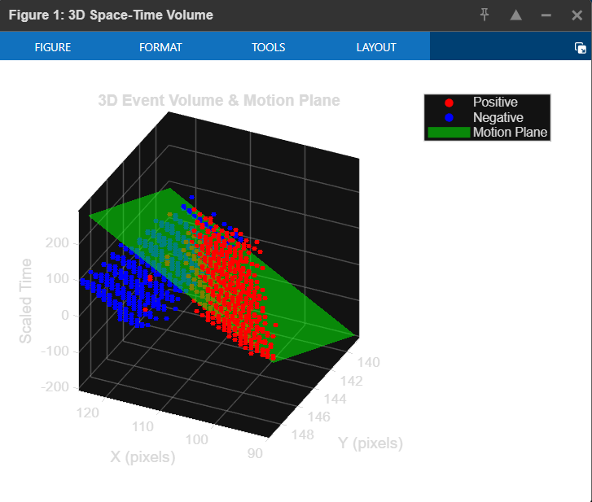
Section 3: MMVAI - Computer vision unconventional cameras

1. 3D Volume Visualization
- Method: We visualized the event stream in a 3D Space-Time volume (x, y, t). To enable accurate processing, we isolated a Region of Interest (ROI) corresponding to the top edge of a rectangular bar and applied a scaling factor to the time dimension (t_{scaled} = t . 1000).
- Observation: The events form a continuous "tube" structure in the 3D volume. The tilt of this tube relative to the time axis visually represents the velocity of the object.
2. RANSAC Plane Detection
- Implementation: We used the RANSAC algorithm to fit a plane model (ax + by + ct + d = 0) to the subset of events.
- Result: As shown in [Insert your 'space time volume.png' here], the algorithm successfully detected the motion plane (shown in green). Unlike previous attempts on the full scene which yielded horizontal planes (fitting the scene layout), the ROI-based approach correctly fitted the motion trajectory.
3. Vector of Movement
- Deduction: The normal vector n = (n_x, n_y, n_t) of the fitted plane allows us to compute the velocity vector v.
v_x = - n_x / n_t , v_y = - n_y / n_t
- Numerical Result: The script estimated the velocity to be approximately [Insert the Vx, Vy values printed in your Matlab Command Window] pixels/second. This confirms the translation motion of the shape.

4. Event-based visual flow
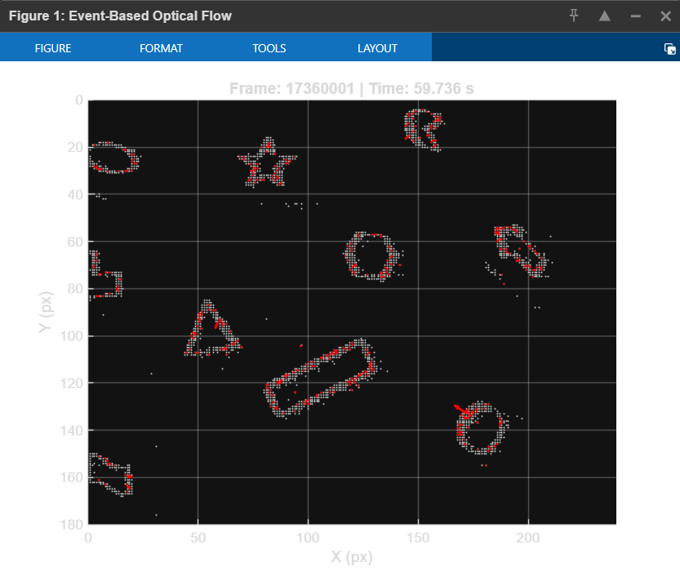
1. Implementation Method
We implemented the "Event-based Visual Flow" method described by Benosman et al.1. This approach relies on constructing a "Surface of Active Events" (SAE), where each pixel (x,y) stores the timestamp t of the last occurring event.
- Concept: As an edge moves across the sensor, it generates a continuous slope in the time surface. The spatial gradient of this surface $\frac{σt}{σx}$ , $\frac{σt}{σy}$ is directly related to the velocity of the object.
- Calculation: The velocity vector v is computed locally as the inverse of the gradient:
V = $\frac{∇T}{{|\left|∇T\right||}^{2}}$
2. Qualitative Results (Shapes Translation)
- Observation: As seen in Figure 4 (the screenshot you just took), the algorithm successfully generates flow vectors (red arrows) along the contours of the geometric shapes.
- Analysis: Since the dataset involves rigid 2D translation, the motion of all objects is identical. Consequently, the generated flow vectors exhibit a consistent global orientation (pointing towards the top-left in this specific frame).
- Aperture Problem: Note that the method fundamentally computes "normal flow" (motion perpendicular to the edge orientation). However, by aggregating flow across edges with different orientations (e.g., the different sides of the star or triangle), the global motion direction becomes apparent.
3. Comparison with Other Sequences
- Rotation: In the rotation sequence, this method would produce vectors acting tangentially to the rotation, creating a vortex-like flow field around the center.
- Outdoors: In the outdoor sequence, the flow vectors would be more scattered due to texture noise, but would globally indicate the camera's ego-motion (expansion or translation).

