Ran_Ji_Project2
Ran Ji
2025-11-16
1.Setting
2.Load data
## # A tibble: 6 × 7
## Date Daily Max 8-hour CO Conc…¹ units_CO Daily Mean PM2.5 Con…² units_PM
## <chr> <dbl> <chr> <dbl> <chr>
## 1 01/01/2018 0.2 ppm 7.5 ug/m3 LC
## 2 01/02/2018 0.7 ppm 7.5 ug/m3 LC
## 3 01/02/2018 0.7 ppm 10.4 ug/m3 LC
## 4 01/03/2018 0.9 ppm 15.2 ug/m3 LC
## 5 01/04/2018 0.2 ppm 9.7 ug/m3 LC
## 6 01/05/2018 0.2 ppm 5.7 ug/m3 LC
## # ℹ abbreviated names: ¹​`Daily Max 8-hour CO Concentration`,
## # ²​`Daily Mean PM2.5 Concentration`
## # ℹ 2 more variables: `Daily Max 8-hour Ozone Concentration` <dbl>,
## # units_O3 <chr>
## spc_tbl_ [479 × 7] (S3: spec_tbl_df/tbl_df/tbl/data.frame)
## $ Date : chr [1:479] "01/01/2018" "01/02/2018" "01/02/2018" "01/03/2018" ...
## $ Daily Max 8-hour CO Concentration : num [1:479] 0.2 0.7 0.7 0.9 0.2 0.2 0.2 0.2 0.3 0.5 ...
## $ units_CO : chr [1:479] "ppm" "ppm" "ppm" "ppm" ...
## $ Daily Mean PM2.5 Concentration : num [1:479] 7.5 7.5 10.4 15.2 9.7 5.7 9.8 7.6 9.4 6.9 ...
## $ units_PM : chr [1:479] "ug/m3 LC" "ug/m3 LC" "ug/m3 LC" "ug/m3 LC" ...
## $ Daily Max 8-hour Ozone Concentration: num [1:479] 0.037 0.034 0.034 0.032 0.035 0.036 0.036 0.036 0.037 0.029 ...
## $ units_O3 : chr [1:479] "ppm" "ppm" "ppm" "ppm" ...
## - attr(*, "spec")=
## .. cols(
## .. Date = col_character(),
## .. `Daily Max 8-hour CO Concentration` = col_double(),
## .. units_CO = col_character(),
## .. `Daily Mean PM2.5 Concentration` = col_double(),
## .. units_PM = col_character(),
## .. `Daily Max 8-hour Ozone Concentration` = col_double(),
## .. units_O3 = col_character()
## .. )
## - attr(*, "problems")=<externalptr>
3.Function
The cleaning function performs several preprocessing steps to prepare the air quality data for analysis. First, it renames the pollutant variables using short and informative names. Next, the function converts the Date column into proper Date format and averages measurements when multiple readings exist on the same day. It also removes duplicate rows and corrects measurement errors by replacing any negative pollutant values with zero. This standardized cleaning ensures that all three datasets (2018–2020) share a consistent structure and are ready for further analysis and visualization.
4.Clean data
## # A tibble: 6 × 4
## date co pm25 o3
## <date> <dbl> <dbl> <dbl>
## 1 2018-01-01 0.2 7.5 0.037
## 2 2018-01-02 0.7 8.95 0.034
## 3 2018-01-03 0.9 15.2 0.032
## 4 2018-01-04 0.2 9.7 0.035
## 5 2018-01-05 0.2 7.75 0.036
## 6 2018-01-06 0.2 7.6 0.036
## date co pm25 o3
## Min. :2018-01-01 Min. :0.1000 Min. : 0.000 Min. :0.01200
## 1st Qu.:2018-04-01 1st Qu.:0.2000 1st Qu.: 6.388 1st Qu.:0.03000
## Median :2018-06-30 Median :0.3000 Median : 8.200 Median :0.03700
## Mean :2018-07-01 Mean :0.3289 Mean : 8.569 Mean :0.03908
## 3rd Qu.:2018-10-02 3rd Qu.:0.4000 3rd Qu.:10.625 3rd Qu.:0.04800
## Max. :2018-12-31 Max. :1.0000 Max. :20.400 Max. :0.06700
## NA's :4 NA's :13 NA's :9
5.Plot 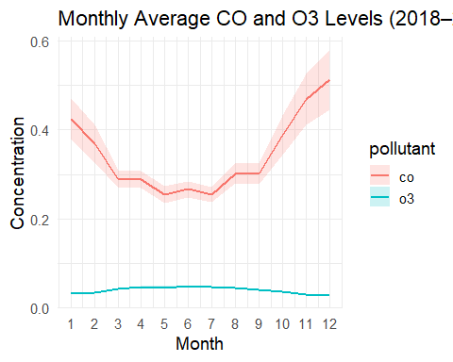
Monthly average CO levels show a clear seasonal pattern, decreasing in the summer and rising sharply in late fall and winter. Ozone concentrations remain low and relatively stable throughout the year. The 95% confidence intervals for CO are wider due to greater variability, while O3 variability is minimal.
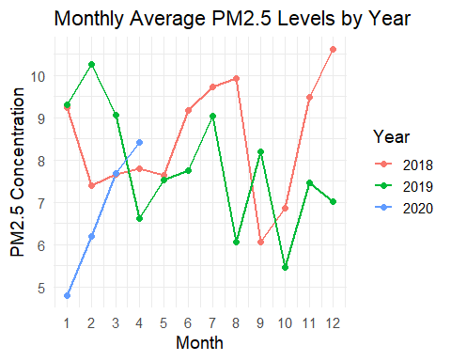
PM2.5 levels show noticeable seasonal variation across all three years, with higher concentrations in winter and early spring. Although the overall patterns are similar across years, 2018 appears to have slightly higher PM2.5 values during winter months.
Github link: https://github.com/Ran0810/Ran_Ji_Project2

