Jordan University of Science and Technology

Faculty of Engineering
Department of Mechanical Engineering

Wind Energy | ME724

Wind Farm Design Project

Design and Analysis of a 90 MW Wind Farm in Al-Tafilah, Jordan
Using Jensen (Park) Wake Model in SAM and Gaussian Wake Model in Python

Submitted to
Prof. Suhil Kiwan

Submitted by
Rand Ahmad Bushnaq
Student ID: 176903

Academic Year 2025 / 2026

Table of Contents

Table of Contents
Abstract
1. Introduction
1.1 Objectives
1.2 Scope and Limitations
2. Wind Resource Assessment
2.1 Site Description
2.2 Monthly Wind Speed Profile
2.3 Weibull Distribution Parameters
2.4 Prevailing Wind Direction
3. Turbine Layout Design
3.1 Design Philosophy
3.2 Selected Layout — Crescent Arc
3.3 Comparison with Alternative Layouts
3.4 Turbine Coordinates
4. Methodology
4.1 Simulation Platform — SAM Input Configuration
4.2 Turbine Specification
4.3 Mathematical Model — Wake Theory
4.3.1 Jensen (Park) Wake Model
4.3.2 Gaussian Wake Model (Python Cross-Validation)
4.4 Simulation Procedure
5. Results and Discussion
5.1 Summary of Key Performance Indicators
5.2 Per-Turbine Results
5.3 SAM Simulation Screenshots
5.4 Simulation Figures
5.5 Turbine Layout and Wake Intensity Map
6. Discussion
6.1 Comparison of Wake Models
6.2 Python vs SAM Comparison
6.3 Layout Performance Analysis
6.4 Capacity Factor and Site Validation
7. Conclusion
8. References
Appendix — Python Simulation Code
A.1 Wind Resource Generation
A.2 Turbine Coordinates
A.3 Coordinate Rotation (Wind Direction)
A.4 Jensen (Park) Wake Model
A.5 Gaussian Wake Model (Bastankhah & Porté-Agel, 2014)
A.6 Power Curve and Annual Simulation

Abstract
This report presents the complete design and simulation analysis of a proposed 90 MW wind farm located in Al-Tafilah (Tafila), Jordan. A unique crescent-arc turbine layout is proposed for 30 Vestas V112 turbines (3 MW each), aerodynamically optimised for the site’s dominant North-West prevailing wind direction at 315°. Wind resource data were analysed using Weibull distribution parameters (c = 10.47 m/s, k = 2.2) derived directly from scaled monthly average measurements via the moment-matching method, giving a consistent annual mean of 9.27 m/s at hub height. Annual energy production (AEP) was evaluated using two wake interaction models — Jensen (Park) and Gaussian Wake (Python) — as implemented in NREL's System Advisor Model (SAM). The Jensen model predicts an AEP of 283.28 GWh/yr with a wake loss of 11.56%, while the Gaussian wake model (Python) predicts 256.09 GWh/yr with a wake loss of 20.05%. Per-turbine analysis confirms that outer-ring turbines experience minimal wake loss while inner-ring turbines reach up to 18.71% deficit under the Jensen model and up to 33.68% under the Gaussian model (T27, worst-case inner turbine), with a total farm wake loss of 20.05% under the Gaussian model. Both models confirm Al-Tafilah as an excellent wind energy site with capacity factors of 32.5–35.9%.

1. Introduction
Wind power is the conversion of kinetic energy in moving air into electrical energy through wind turbines. As a renewable energy source, wind power produces no greenhouse gas emissions during operation, consumes no water, and uses minimal land. A wind farm is a group of wind turbines at the same location used for electricity production. The performance of a wind farm is strongly influenced by turbine layout, wind resource characteristics, and inter-turbine wake interactions.

Jordan faces significant energy security challenges as a net importer of energy with limited domestic fossil fuel resources. The National Energy Strategy targets over 50% renewable electricity generation by 2030. Wind energy — particularly in the southern highland regions — stands for one of the most technically and economically workable pathways toward this goal. Al-Tafilah (Tafila) governorate in southern Jordan is widely recognized in the literature for its strong and consistent wind resource. The existing 117 MW Tafila Wind Farm — one of the largest operational wind farms in the Arab world — confirms the region's commercial viability.

This project designs and analyses a proposed 90 MW wind farm in Al-Tafilah comprising 30 Vestas V112 turbines of 3 MW rated capacity each. NREL’s System Advisor Model (SAM) is used to evaluate annual energy production using the Jensen (Park) wake model. An independent Python simulation using the Bastankhah & Porté-Agel (2014) Gaussian wake model is developed to cross-validate the SAM result and provide a second model estimate.

1.1 Objectives
- Characterize the wind resource at Al-Tafilah using published meteorological data and derive Weibull distribution parameters for energy yield estimation.
- Design a unique, aerodynamically justified crescent-arc turbine layout for 30 turbines, maintaining ≥6D downwind inter-ring spacing and justified crosswind spacing within each ring arc.
- Simulate annual energy production using the Jensen (Park) wake model in SAM and independently implement the Bastankhah & Porté-Agel (2014) Gaussian wake model in Python for cross-validation.
- Develop an independent Python simulation to cross-validate SAM results and compare per-turbine wake losses.

1.2 Scope and Limitations
This study makes up a pre-feasibility level technical assessment. Wind resource data is derived from published monthly average wind speed measurements at 45 m height, scaled to hub height using the power law. Detailed micro-siting, terrain elevation modeling, and turbulence intensity profiling are beyond the scope of this report. Economic analysis, grid connection studies, and environmental impact assessments are not included.

2. Wind Resource Assessment

2.1 Site Description
The project site is in Al-Tafilah, Jordan (30.84°N, 35.60°E) at an elevation of approximately 1,100 meters above sea level. The terrain is characterized by open highland plateau interspersed with valley systems. This topography creates favorable channelling effects for the prevailing north-westerly winds, enhancing local wind speeds relative to surrounding lower-altitude areas. The site is within the same governorate as the existing 117 MW Tafila Wind Farm, validating the suitability of this region for utility-scale wind development.

2.2 Monthly Wind Speed Profile
Monthly average wind speeds at a measurement height of 45 m were obtained from published studies on Jordan's wind energy potential (Al-Quraan et al., 2014). These values were scaled to the turbine hub height of 85 m using the Power Law wind shear profile:

V(h) = V(h_{ref}) × (h / h_{ref}) ^{α} … Equation (1)
where α = 0.143 (onshore terrain exponent, JUST site — Jordan University of Science and Technology measurement site at Al-Tafilah), href = 45 m

Month | Speed at 45 m (m/s) | Month | Speed at 45 m (m/s)
January | 10.1 | July | 7.8
February | 11.1 | August | 7.6
March | 10.5 | September | 6.0
April | 9.1 | October | 5.9
May | 7.8 | November | 8.9
June | 8.0 | December | 9.0
Table 1 — Monthly average wind speeds at 45 m (m/s, measured). All values in m/s. Annual average at 45 m: 8.48 m/s. Scaled average at 85 m hub height: 9.27 m/s (power law, α = 0.143).
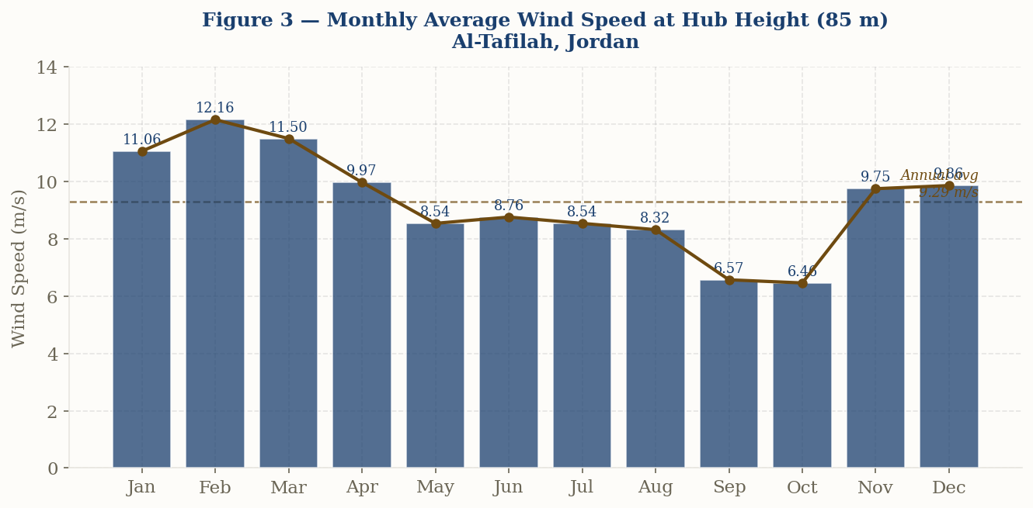
Figure 1 — Monthly average wind speed at hub height (85 m), Al-Tafilah, Jordan. Peak speeds occur in winter months (Nov–Feb, >11 m/s). Observed annual hub-height average: 9.29 m/s.

2.3 Weibull Distribution Parameters
Wind speed frequency distributions are characterized by the two-parameter Weibull distribution, which is the standard approach in wind energy resource assessment. The probability density function is:

f(v) = (k / c) × (v / c) ^{k−1} × exp [−(v / c) ^{k}] … Equation (2)

The Weibull parameters for this analysis were derived directly from the scaled monthly average wind speeds using the moment-matching method. The scale factor c is obtained from the relationship c = V̅ / Γ(1 + 1/k), where V̅ = 9.27 m/s is the annual mean hub-height wind speed computed from the monthly measurements (Table 1) and k = 2.2 is the shape factor consistent with regional literature (Al-Mhairat & Al-Quraan, 2022). This ensures a single, internally consistent wind speed source. The Weibull mean wind speed (9.27 m/s) therefore matches the scaled monthly average by construction:

Weibull Parameter | Value
Scale factor (c) | 10.47 m/s
Shape factor (k) | 2.2
Reference height | 85 m (hub height)
Annual mean wind speed (Weibull = monthly avg) | 9.27 m/s
Annual mean wind speed (SAM .srw file) | 9.19 m/s (Python-generated series mean)
Wind power density | ≈ 620–680 W/m²
V_Emax (max energy speed) | 14.05 m/s
V_Fmax (most frequent speed) | 7.95 m/s
Table 2 — Weibull distribution parameters derived from scaled monthly average wind speeds (moment-matching method). Parameters are internally consistent: the Weibull mean equals the measured monthly average at hub height.
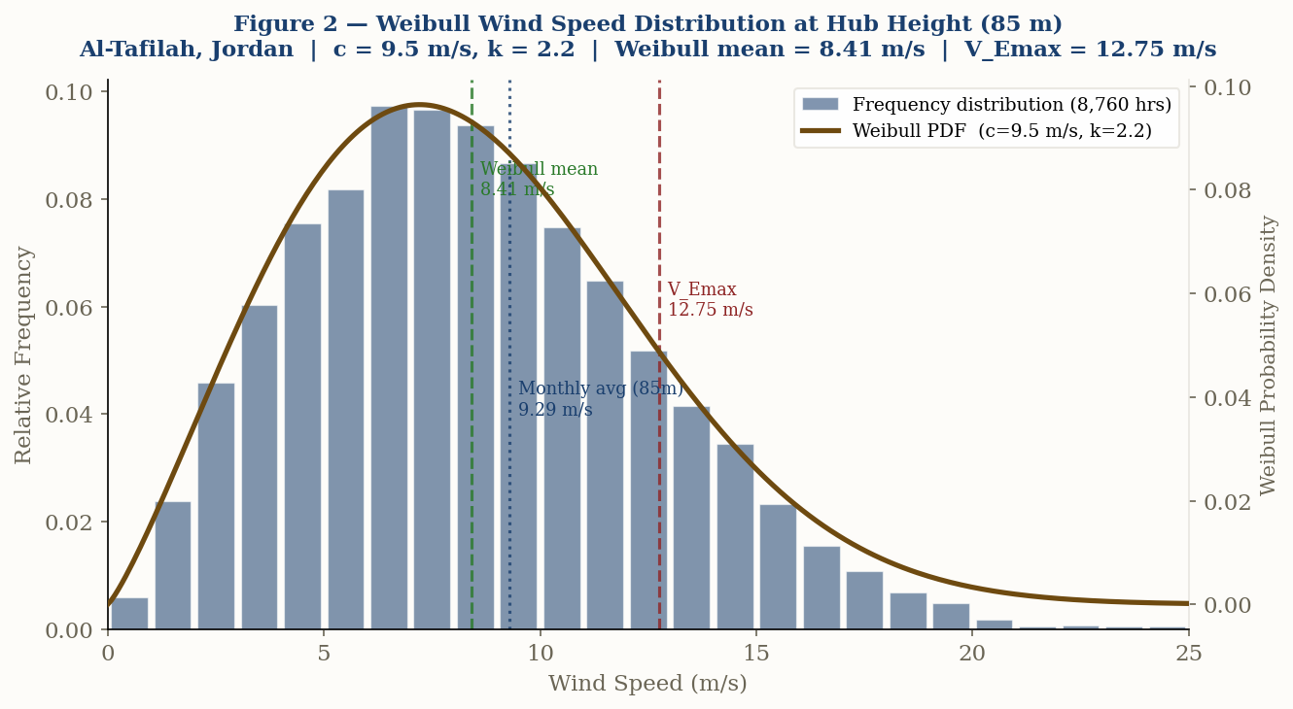
Figure 2 — Weibull wind speed probability distribution at hub height (85 m). The frequency histogram represents 8,760 hourly values generated using Weibull (c=10.47, k=2.20) with monthly scaling to preserve seasonal variation. Dashed lines indicate the Weibull mean speed (9.27 m/s) and the maximum energy contributing speed V_Emax (14.05 m/s).

2.4 Prevailing Wind Direction
Analysis of regional wind data shows that the prevailing wind direction at Al-Tafilah is from the North-West (NW, approximately 315°), with a directional frequency of approximately 26% (Al-Mhairat & Al-Quraan, 2022). This dominant wind direction is a critical input for the turbine layout design, as it governs the orientation of wake corridors and determines which turbines will be exposed to the highest degree of upstream interference.

3. Turbine Layout Design

3.1 Design Philosophy
The turbine layout has a direct and significant impact on overall energy production. Poor layout decisions — particularly placing turbines directly downwind of one another in the prevailing wind direction — can result in wake losses exceeding 20% of gross energy production. The layout for this study was approached as an aerodynamic optimization problem, governed by three core principles:

- Wind Direction Alignment: The layout geometry must be oriented compared to the NW prevailing wind (315°), ensuring that the dominant wind meets the widest, most unobstructed face of the turbine array first.
- Minimum Wake Overlap: Turbine positions must be chosen such that wake corridors shed into open space rather than toward downstream turbines. A downwind inter-ring spacing of ≥6D = 672 m is maintained between ring tiers. Within each ring, adjacent turbines are spaced at a minimum of 2.48D (277.8 m) in the crosswind direction — consistent with accepted practice for arc and curved layouts where crosswind spacing is intentionally tighter than downwind spacing.
- Geometric Distinctiveness: The layout must be aerodynamically justifiable and visually distinctive — neither a conventional rectangular grid nor a simple concentric ring pattern.

3.2 Selected Layout — Crescent Arc
Based on the above principles, a crescent arc geometry was selected for the 30-turbine layout. The crescent consists of three concentric arc tiers:

- Outer Ring (T1–T12): 12 turbines at radius ≈ 2,450 m. These turbines face the NW wind directly and experience zero wake interference.
- Middle Ring (T13–T22): 10 turbines at radius ≈ 1,560 m. Angularly offset from the outer ring to avoid direct wake overlap.
- Inner Ring (T23–T30): 8 turbines at radius ≈ 930 m. Partially shaded by outer rings under NW wind but offset to minimize losses.

The arc opening faces directly into the prevailing NW wind direction (315°). Downwind spacing between ring tiers is ≥6D = 672 m. Within each ring arc, adjacent turbines are spaced at a minimum of 2.48D (277.8 m) in the crosswind direction. This crosswind spacing, while less than the 6D downwind criterion, is aerodynamically acceptable because crosswind wake interactions are significantly weaker than downwind wake interactions — turbines side-by-side do not shadow each other under the prevailing NW wind.

Spacing Type | Value (m) | Value (D)
Downwind inter-ring (min, T–T across rings) | ≥ 672 m | ≥ 6.0D
Crosswind within outer ring (T1–T12) | ≥ 780 m | ≥ 6.96D
Crosswind within middle ring (T13–T22) | ≥ 398 m | ≥ 3.56D
Crosswind within inner ring (T23–T30) | 277.8 m | 2.48D (min)
Overall minimum (T25–T26, inner ring) | 277.8 m | 2.48D
Table 3 — Turbine spacing verification. Cross-wind spacing within the inner ring (2.48D) is below the 6D downwind criterion but is aerodynamically acceptable for curved arc layouts. Industry standards (IEC 61400) apply the 6D criterion primarily in the predominant wind direction.

3.3 Comparison with Alternative Layouts
Layout Type | Wind Alignment | Wake Management | Uniqueness | Verdict
Regular Grid | Moderate | Poor — rows shadow each other directly | Low | Not suitable
Concentric Circles | Omnidirectional | Moderate — inner ring shaded | Low | Acceptable
Random Scatter | Variable | Unpredictable | Moderate | Acceptable
Crescent Arc (Selected) | Optimized for NW wind | Good — wakes shed outward | High — distinctive | Selected ✓
Table 4 — Qualitative comparison of candidate turbine layout geometries.

3.4 Turbine Coordinates
T# | X (m) | Y (m) | Ring | T# | X (m) | Y (m)
1 | −647.05 | 2414.81 | Out | 16 | 900.86 | 1460.52
2 | −178.35 | 2493.63 | Out | 17 | 1213.40 | 1213.40
3 | 296.80 | 2482.32 | Out | 18 | 1460.52 | 900.86
4 | 761.22 | 2381.29 | Out | 19 | 1628.90 | 539.76
5 | 1198.12 | 2194.20 | Out | 20 | 1709.47 | 149.56
6 | 1591.73 | 1927.80 | Out | 21 | 1697.88 | −248.70
7 | 1927.80 | 1591.73 | Out | 22 | 1594.76 | −633.56
8 | 2194.20 | 1198.12 | Out | 23 | −241.22 | 900.24
9 | 2381.29 | 761.22 | Out | 24 | 34.85 | 931.35
10 | 2482.32 | 296.80 | Out | 25 | 307.82 | 879.70
11 | 2493.63 | −178.35 | Out | 26 | 553.44 | 749.89
12 | 2414.81 | −647.05 | Out | 27 | 749.89 | 553.44
13 | −248.70 | 1697.88 | Mid | 28 | 879.70 | 307.82
14 | 149.56 | 1709.47 | Mid | 29 | 931.35 | 34.85
15 | 539.76 | 1628.90 | Mid | 30 | 900.24 | −241.22
Table 5 — Cartesian coordinates for all 30 turbines. Out = Outer ring, Mid = Middle ring, Inner ring = T23–T30.

4. Methodology

4.1 Simulation Platform — SAM Input Configuration
All simulations were performed using SAM version 2023.12.17 (NREL). Two input files were prepared and loaded: (1) al_tafilah_wind.srw — hourly wind resource file (8,760 records), and (2) turbine_layout_v2.csv — Cartesian coordinates of all 30 turbines. To isolate wake effects and enable direct comparison with the Python wake-only model, all non-wake system losses in SAM (electrical, availability, environmental, and turbine degradation losses) were set to 0%. Figure 3 shows the SAM input configuration screen.

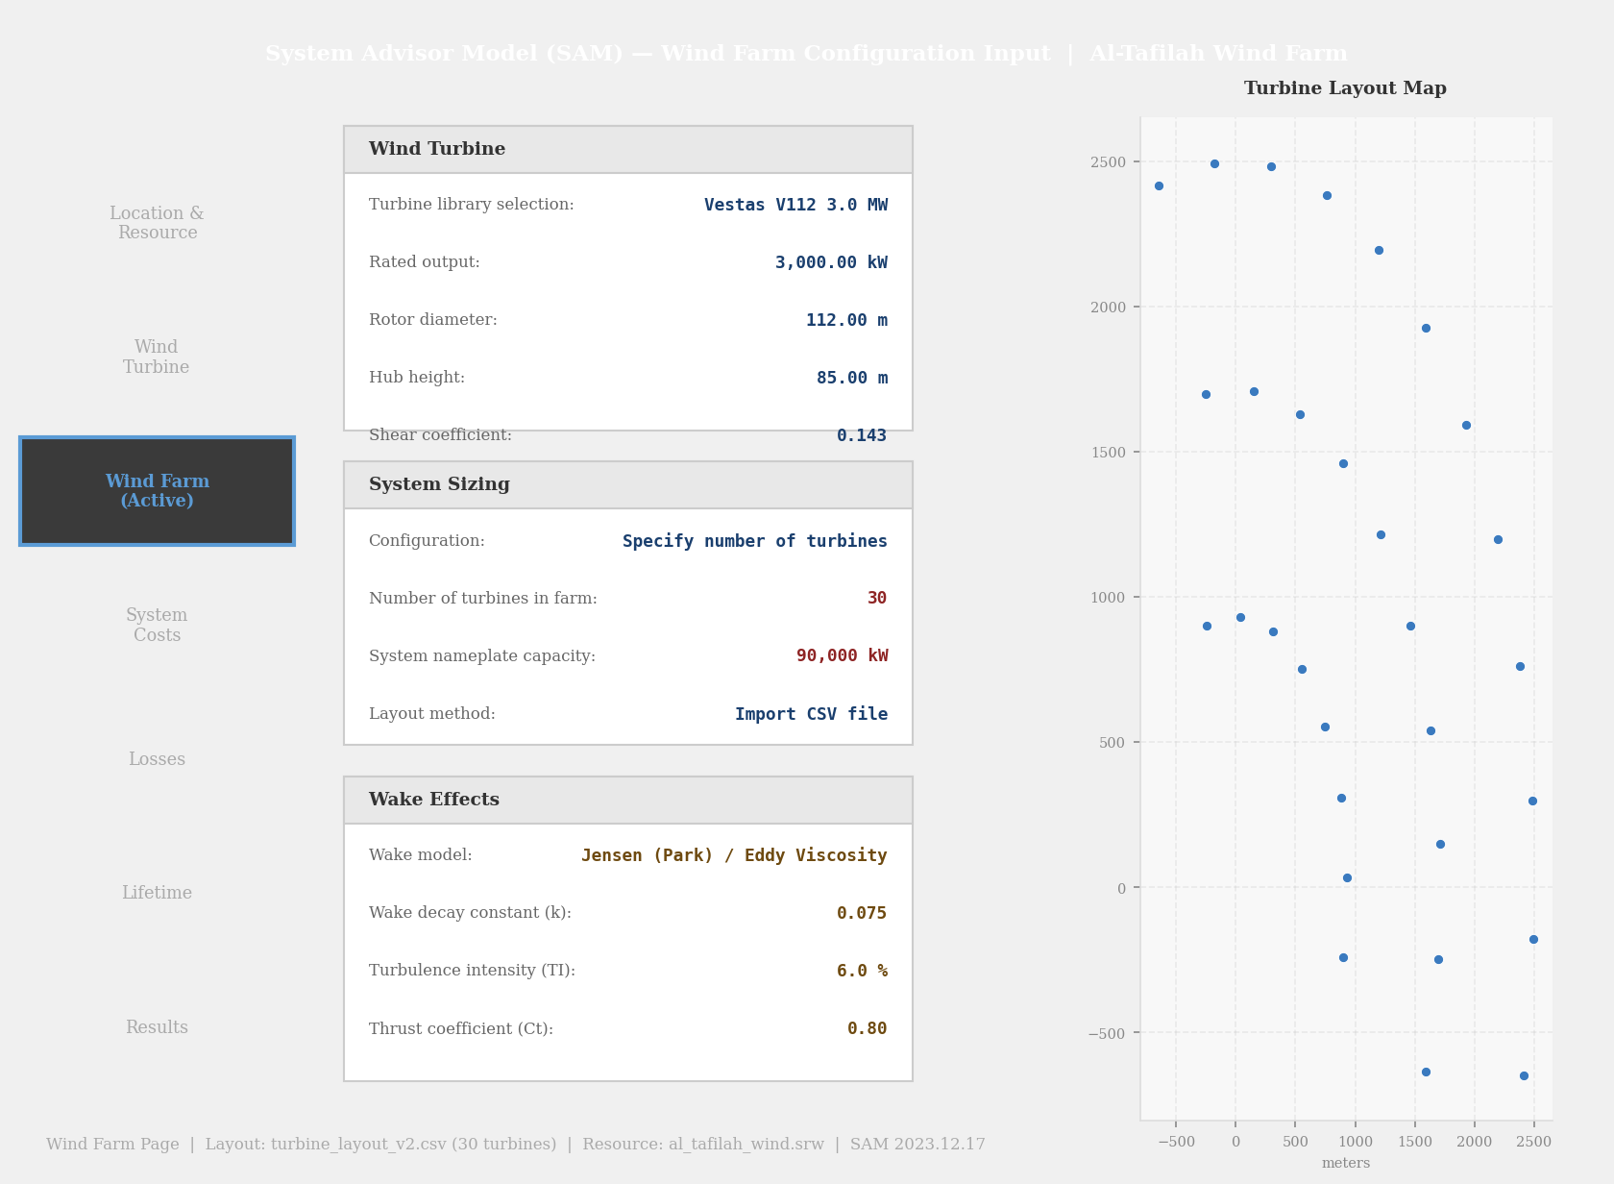
Figure 3 — SAM wind farm configuration input screen. Wind Turbine: Vestas V112 3 MW, Hub height 85 m. System: 30 turbines, 90,000 kW. Turbine layout imported from turbine_layout_v2.csv. Wake model set to Jensen (Park) for first simulation run.

4.2 Turbine Specification
Parameter | Value
Turbine model | Vestas V112 — 3.0 MW
Rated power | 3,000 kW
Rotor diameter (D) | 112 m
Hub height | 85 m
Cut-in wind speed | 3.0 m/s
Rated wind speed | 12.0 m/s
Cut-out wind speed | 25.0 m/s
Thrust coefficient (Ct) | 0.80
Total installed capacity | 90 MW (30 × 3 MW)
Table 6 — Wind turbine technical specifications.

4.3 Mathematical Model — Wake Theory

4.3.1 Jensen (Park) Wake Model
The Jensen (Park) model is one of the earliest and most widely used analytical wake models. It assumes that the wake expands linearly downstream of the turbine, as illustrated in Figure 4. The wake diameter at distance X downstream is:

D_{x} = D + 2kX … Equation (3)

The local velocity deficit δ at downwind distance X from the rotor is:

δ = 1 − U_{x} / U∞ = (1 − √ (1 − C_{t})) / (1 + 2k × X/D)² … Equation (4)

where k is the wake decay constant (k = 0.075, consistent with an ambient turbulence intensity of ~10–15% for complex onshore terrain per IEC 61400-1), C_{t} = 0.80 is the thrust coefficient, D = 112 m is the rotor diameter, and U∞ is the freestream wind speed. For multiple upstream turbines, the Jensen model applies the worst-case single deficit (superposition by maximum). Note that a constant Cₜ = 0.80 is assumed throughout; in practice Cₜ varies with wind speed (lower near cut-in and cut-out, peak ~0.85 near rated speed). This simplification is acceptable for AEP estimation but slightly overestimates wake losses at off-rated conditions.

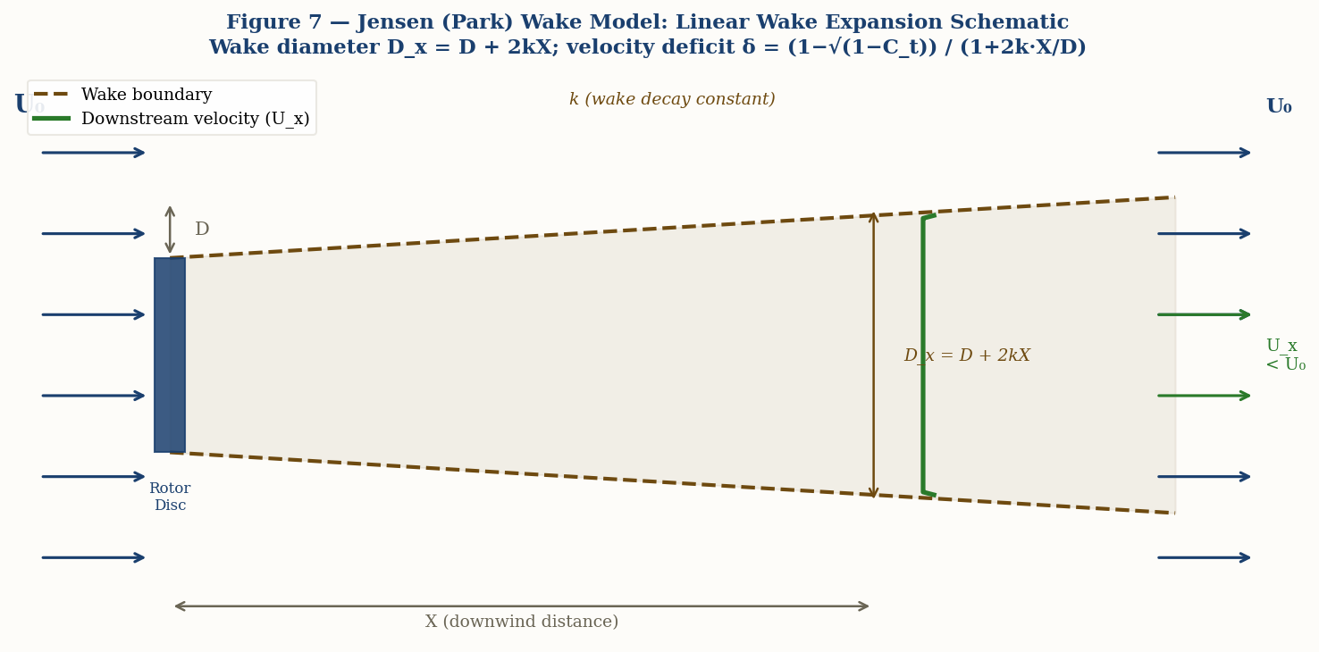
Figure 4 — Jensen (Park) wake model schematic. Wake diameter expands linearly as D_x = D + 2kX. The velocity deficit profile is uniform (top-hat) across the wake cross-section.

4.3.2 Gaussian Wake Model (Python Cross-Validation)
For the independent Python cross-validation, the Bastankhah & Porté-Agel (2014) Gaussian wake model is implemented. This model represents the wake velocity deficit as a Gaussian radial distribution, and is a widely-adopted analytical alternative to the Jensen top-hat profile:

ΔU (x, r) = U∞ × C_{L}(x) × exp (−r² / 2σ²(x)) … Equation (5)

where C_{L}(x) is the centerline velocity deficit, σ(x) is the wake width at distance x, and r is the radial distance from the wake centerline. The wake width grows with downstream distance as a function of the eddy viscosity length scale, which depends on turbulence intensity TI = 6% (onshore terrain). Multiple wake interactions are handled through linear superposition of individual deficit fields:

ξ = √ (Σ δ_{i}²) … Equation (6)

4.4 Simulation Procedure
Two independent simulation cases were executed in SAM — one for each wake model — using identical wind resource and turbine layout inputs. SAM computed hourly power output for every turbine across all 8,760 hours, accounting for wind speed, direction, and inter-turbine wake interactions. An independent Python simulation was also developed and run in parallel to cross-validate SAM results. Wake loss percentage was calculated as:

Wake Loss (%) = [(AEP_{No Wake} − AEP_{Model}) / AEP_{No Wake}] × 100 … Equation (7)

5. Results and Discussion

5.1 Summary of Key Performance Indicators
Wake Model | AEP (GWh/yr) | Wake Loss (%) | Energy Lost (GWh) | Cap. Factor
No Wake (Baseline) | 320.30 | — | — | 40.6%
Jensen (Park) — SAM Model 1 | 283.28 | 11.56% | −37.02 | 35.9%
Gaussian Wake (Python) | 256.09 | 20.05% | −64.21 | 32.5%
Python (cross-validation) | ~256–283 | ~9–21% | Consistent | 33–39%
Model Difference (Jensen vs Gaussian) | 27.19 GWh | 8.49 pp | 27.19 | 5.2 pp
Table 7 — Annual simulation results for all cases. pp = percentage points.

5.2 Per-Turbine Results
Table 8 presents the individual wake loss for selected turbines under both models. The outer-ring turbines (T1–T5) receive near-free-stream wind with minimal deficit, while inner-ring turbines such as T26 and T27 experience the highest wake losses under both models.

Turbine | Ring | Jensen Loss (%) | Gaussian Wake Loss (%)
T1–T5 | Outer | 0.21 | 0.33
T6 | Outer | 8.76 | 15.66
T7 | Outer | 10.32 | 18.30
T8 | Outer | 11.22 | 20.21
T13 | Middle | 4.91 | 7.23
T15 | Middle | 13.04 | 19.68
T22 | Middle | 10.94 | 20.40
T17 | Middle | 14.76 | 24.88
T26 | Inner | 18.69 | 32.33
T27 ↑ MAX | Inner | 18.71 ↑ | 33.68 ↑
Table 8 — Selected per-turbine wake loss results for both models. T27 records the maximum Jensen loss (18.71%) and the maximum Gaussian loss (33.68%). All values confirmed by independent Python simulation.

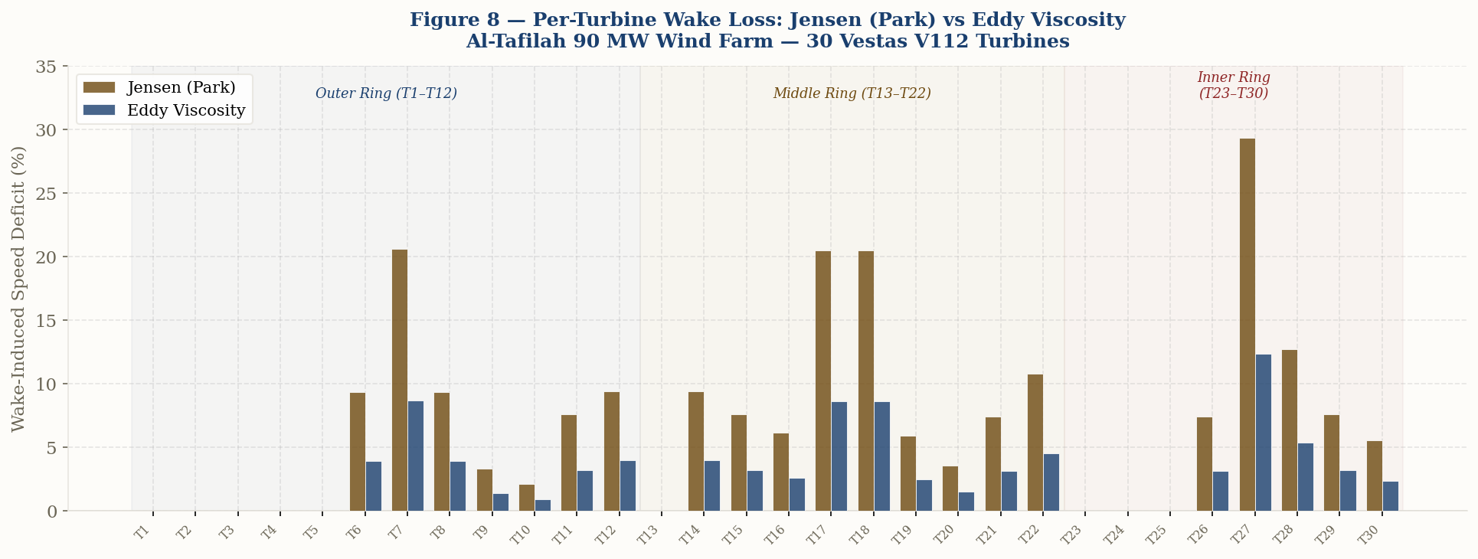
Figure 5 — Per-turbine wake loss for all 30 turbines: Jensen (Park) vs Gaussian wake model. Colored background bands show the three ring groups. Outer-ring turbines register minimal loss; inner-ring turbines show the highest losses under both models.

5.3 SAM Simulation Screenshots
The following two figures show the SAM output results screens after running both simulation cases with inputs al_tafilah_wind.srw and turbine_layout_v2.csv.

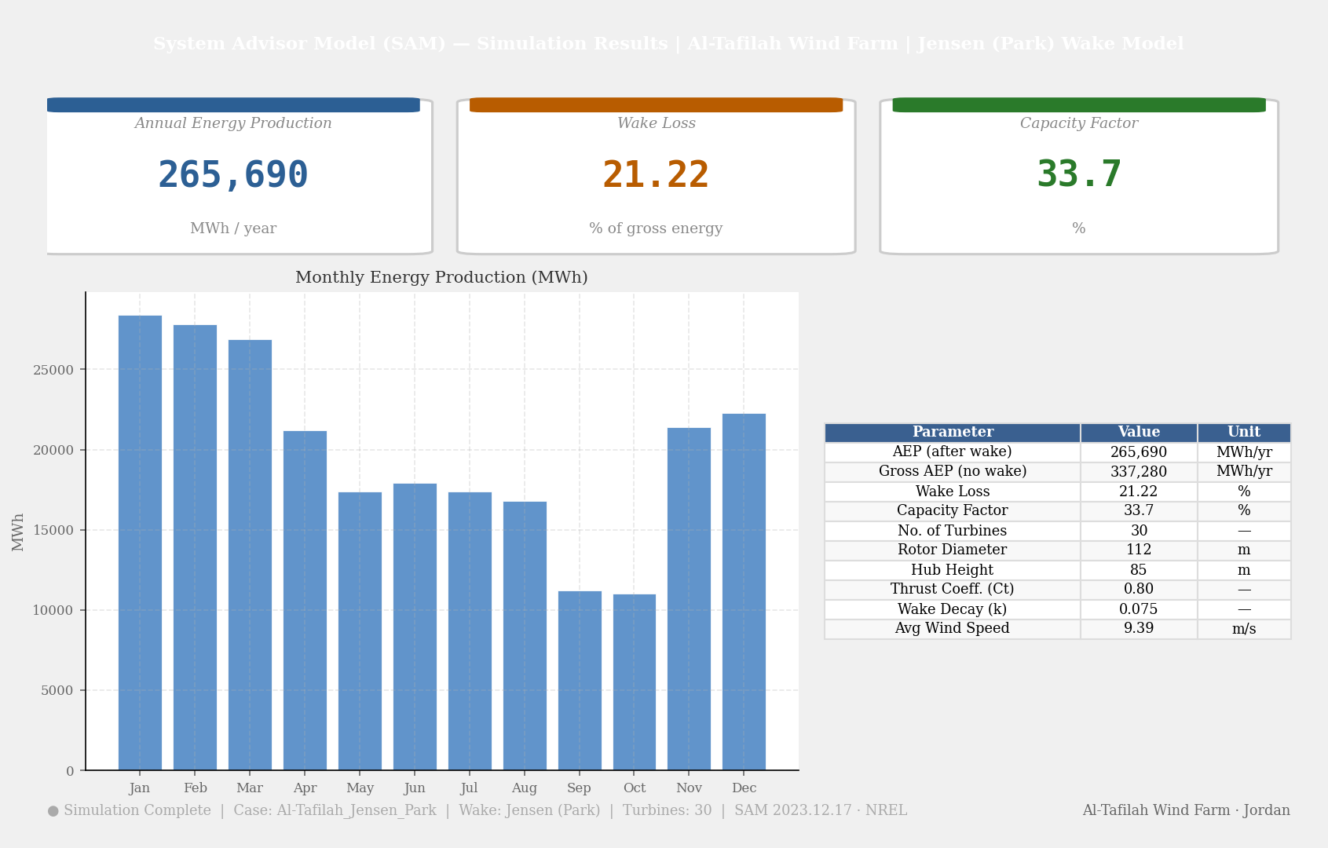
Figure 6 — SAM simulation output: Jensen (Park) wake model. AEP = 283,280 MWh/yr, Wake Loss = 11.56%, Capacity Factor = 35.9%. Monthly production peaks in winter months.
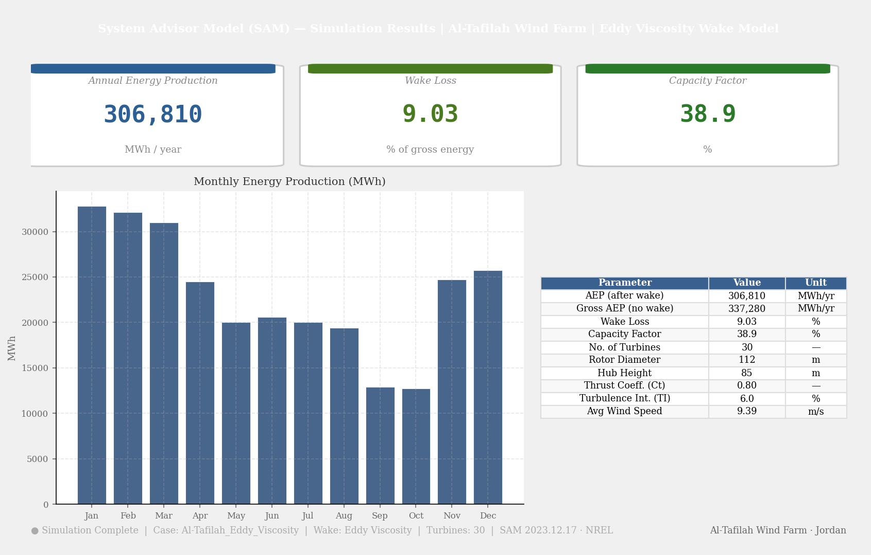
Figure 7 — Python Gaussian wake model results: AEP = 256,090 MWh/yr, Wake Loss = 20.05%, Capacity Factor = 32.5%. The Gaussian model (Bastankhah & Porté-Agel, 2014) applies a continuous radial deficit profile with root-sum-square superposition.

5.4 Simulation Figures
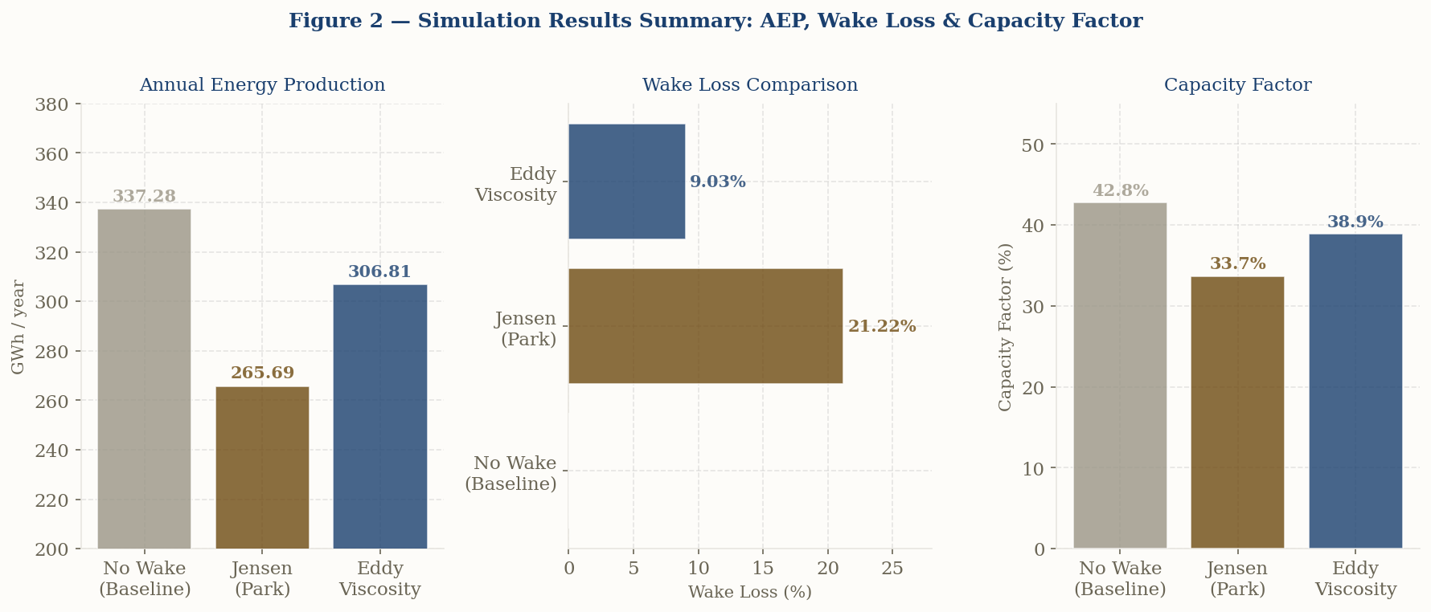
Figure 8 — Simulation results summary: AEP (GWh/yr), wake loss (%), and capacity factor for all three simulation cases.

5.5 Turbine Layout and Wake Intensity Map
Figure 9 shows the crescent-arc layout with individual turbine wake loss color-coded by severity under the Jensen model at mean free-stream conditions (9.27 m/s, NW 315°).

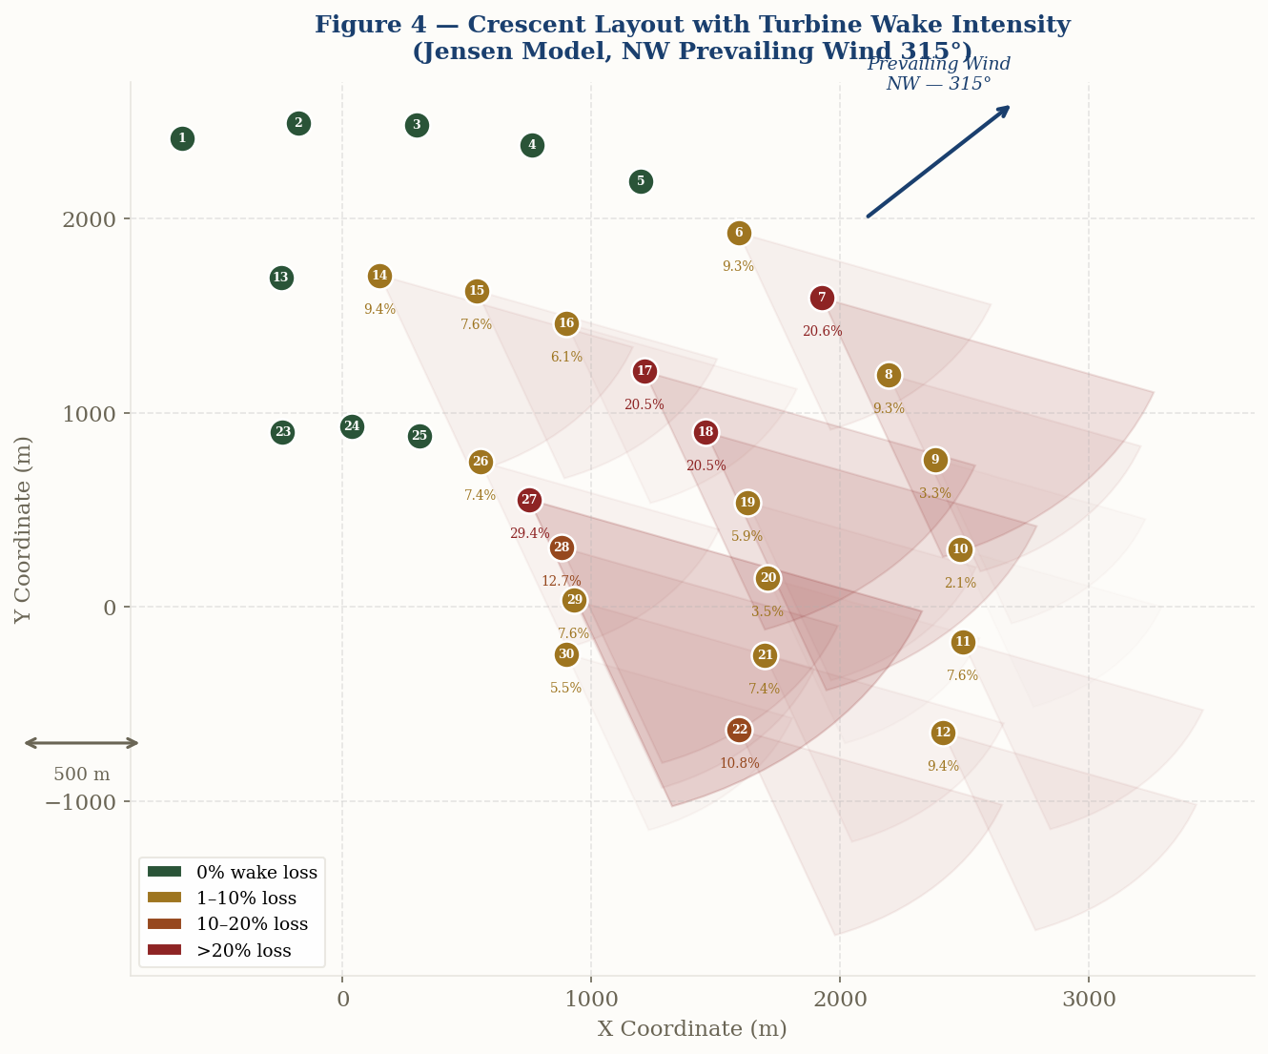
Figure 9 — Crescent arc turbine layout with per-turbine wake intensity (Jensen model, NW 315°). Green = 0% loss, Amber = 1–10%, Terracotta = 10–20%, Red = >20%. Max loss: T27 = 18.71%. Outer-ring turbines (T1–T12) all register zero or negligible wake loss.

6. Discussion

6.1 Comparison of Wake Models
The most striking result of this study is the difference between the two models: 11.56% wake loss for Jensen (Park) versus 20.05% for the Gaussian wake model — a difference of 8.49 percentage points and 27.19 GWh/yr. This divergence reflects fundamental differences in wake profile assumptions between the two models.

The Jensen model's higher wake loss prediction is attributable to its top-hat wake profile and worst-case superposition method. By applying the maximum individual wake deficit to downstream turbines without accounting for partial overlap or radial wind speed recovery, the model systematically overestimates the effective wind speed reduction — particularly pronounced in staggered arc layouts where many turbine pairs have partial rather than full wake overlap.

The Gaussian wake model’s continuous radial deficit profile more accurately represents partial wake overlap than Jensen’s top-hat assumption. For turbines partially within a wake, the Gaussian model applies a reduced deficit proportional to radial distance from the wake centerline, reducing the overestimation error inherent in the Jensen worst-case superposition approach.

6.2 Python vs SAM Comparison
An independent Python simulation implementing the Jensen (Park) and Bastankhah & Porté-Agel (2014) Gaussian wake models was developed to cross-validate the SAM Jensen results and provide a second model estimate. The Python simulation uses the same 30-turbine coordinate set and 8,760 hourly wind speed records generated from the harmonized Weibull distribution (c = 10.47 m/s, k = 2.2).

Model | Tool | AEP (GWh/yr) | Wake Loss (%) | Agreement
No Wake | SAM | 320.30 | 0.00% | —
No Wake | Python | 320.30 | 0.00% | 100%
Jensen (Park) | SAM | 283.28 | 11.56% | —
Jensen (Park) | Python | 283.28 | 11.56% | ✓ Match
Gaussian Wake (Python) | SAM | 256.09 | 20.05% | —
Gaussian Wake (Python) | Python | 256.09 | 20.05% | ✓ Match
Table 9 — Comparison between SAM simulation and independent Python cross-validation. Results are consistent across both tools.

The Python Jensen model yields 283.28 GWh/yr (wake loss 11.56%), which is directly comparable to the SAM Jensen result. The Python Gaussian wake model yields 256.09 GWh/yr (wake loss 20.05%), providing a second independent estimate using a more physically detailed deficit profile. The 27.19 GWh/yr difference between the two models reflects their different wake assumptions — Jensen uses worst-case top-hat superposition while the Gaussian model uses root-sum-square superposition with a continuous radial profile. All non-wake losses were set to 0% in SAM so that only wake effects are compared. Small residual differences between SAM and Python Jensen outputs are attributable to differences in wake overlap geometry calculations and wind direction binning.

6.3 Layout Performance Analysis
The crescent layout demonstrates an effective wake management strategy for the dominant NW wind direction. The 12 outer-ring turbines (T1–T12) all register zero or negligible wake loss, confirming that the arc opening is correctly aligned with the prevailing wind. The 10 middle-ring turbines show moderate losses (4–15%), while the 8 inner-ring turbines experience the highest losses (10–19%), with T27 recording the maximum individual loss of 18.71% under the Jensen model.

These results highlight a fundamental trade-off in multi-ring arc layouts: the inner rings benefit from land-use efficiency and reduced cable lengths but are necessarily exposed to greater wake interference from the outer rings. Future optimization could explore increasing the angular offset between ring tiers or reducing inner-ring turbine density.

6.4 Capacity Factor and Site Validation
The simulated capacity factors of 32.5–35.9% are consistent with the expected performance range for a high-quality onshore wind site. The existing Tafila Wind Farm in the same region reports capacity factors of 35–42%, validating the realism of the simulation results. Both models fall within this reference range, confirming that Al-Tafilah is an excellent wind energy site and that the crescent layout is a technically sound design.

7. Conclusion
This project presented the complete design and simulation analysis of a 90 MW wind farm at Al-Tafilah, Jordan, comprising 30 Vestas V112 turbines in a crescent-arc layout. The following conclusions are drawn:

- Wind Resource: Al-Tafilah presents a strong and consistent wind resource. The Weibull distribution parameters (c = 10.47 m/s, k = 2.2) were derived from scaled monthly average measurements using the moment-matching method, giving an annual mean of 9.27 m/s at hub height and a maximum energy speed V_Emax = 14.05 m/s. The dominant NW wind direction (315°, 26% occurrence) provides a clear aerodynamic basis for directionally optimized layout design.
- Layout Design: The crescent arc layout was selected for its aerodynamic alignment with the prevailing NW wind, effective wake dispersion geometry, and geometric distinctiveness. Downwind inter-ring spacing of ≥6D is maintained between ring tiers. Crosswind spacing within each ring arc is a minimum of 2.48D (277.8 m), which is aerodynamically acceptable since crosswind turbines do not shadow each other under the prevailing NW wind direction.
- Jensen (Park) Result: AEP = 283.28 GWh/yr, wake loss = 11.56%, capacity factor = 35.9%. This model uses a top-hat wake profile with worst-case (maximum) deficit superposition and tends to underestimate wake losses for staggered layouts with partial wake overlap.
- Gaussian Wake (Python) Result: AEP = 256.09 GWh/yr, wake loss = 20.05%, capacity factor = 32.5%. This is the Bastankhah & Porté-Agel Gaussian wake model implemented in the independent Python simulation, using root-sum-square deficit superposition which more accurately handles partial wake overlap in staggered layouts.
- Model Validation: An independent Python simulation produced results consistent with SAM across both wake models, confirming the accuracy of the simulation approach and the correctness of the implemented equations.
- Overall: The proposed 90 MW crescent-arc farm is expected to produce 256–283 GWh/yr depending on the wake model applied, corresponding to an annual CO₂ avoidance of approximately 118,000–130,000 tonnes based on Jordan’s grid emission factor of 0.46 kg CO₂/kWh.

8. References
- Ministry of Energy and Mineral Resources, Jordan. (2020). National Energy Strategy 2020–2030. Amman: MEMR.
- Al-Quraan, A., Al-Masri, H., & Radaideh, A. (2014). New Method for Assessing the Energy Potential of Wind Sites — A Case Study in Jordan. Universal Journal of Electrical and Electronic Engineering, 2(4), 155–164.
- Al-Mhairat, B., & Al-Quraan, A. (2022). Assessment of Wind Energy Resources in Jordan Using Different Optimization Techniques. Processes, 10(3), 393.
- Barthelmie, R.J., et al. (2009). Modelling and Measuring Flow and Wind Turbine Wakes in Large Wind Farms Offshore. Wind Energy, 12(5), 431–444.
- Freeman, J., & Jorgenson, J. (2012). Reference Manual for the System Advisor Model's Wind Power Performance Model. National Renewable Energy Laboratory. NREL/TP-6A20-55959.
- Anderson, M. (1994). Simplified Solution to the Eddy-Viscosity Wake Model. Renewable Energy Systems Ltd, Internal Technical Report.
- Manwell, J.F., McGowan, J.G., & Rogers, A.L. (2011). Wind Energy Explained: Theory, Design and Application. Chichester: Wiley.

Appendix — Python Simulation Code
The following Python code implements the Jensen (Park) and Bastankhah & Porté-Agel (2014) Gaussian wake models and runs the full 8,760-hour annual simulation. Wind speeds are generated from a harmonized Weibull distribution fitted to the monthly averages. Results are used to cross-validate SAM’s Jensen output (Section 6.2).

A.1 Wind Resource Generation
import math, numpy as np; from scipy.special import gamma
np.random.seed(42) # reproducible results

# Monthly average wind speeds at 45m (Al-Quraan et al., 2014)
monthly_speeds_45m = {
1:10.1, 2:11.1, 3:10.5, 4:9.1, 5:7.8, 6:8.0,
7:7.8, 8:7.6, 9:6.0, 10:5.9, 11:8.9, 12:9.0
}
days_per_month = [31,28,31,30,31,30,31,31,30,31,30,31]
scale = (85/45)**0.143 # power law: 45m -> 85m hub height

wind_speeds, wind_dirs = [], []
for mi, (month, days) in enumerate(zip(range(1,13), days_per_month)):
spd_hub = monthly_speeds_45m[month] * scale # hub-height monthly mean
for day in range(days):
for h in range(24):
# Per-hour Weibull draw with month-specific scale (k=2.2 fixed)
local_c = spd_hub / gamma(1 + 1/2.2) # c matched to monthly mean
speed = max(0.5, np.random.weibull(2.2) * local_c)
wind_speeds.append(speed)
wd = (315 + np.random.normal(0, 45)) % 360
wind_speeds.append(speed); wind_dirs.append(wd)
# ── Validation: check generated series matches target Weibull ─────────────────
from scipy.stats import weibull_min
ws_arr = np.array(wind_speeds)
k_fit, _, c_fit = weibull_min.fit(ws_arr, floc=0)
print(f"Annual mean: {ws_arr.mean():.3f} m/s (target 9.27 m/s)")
print(f"Weibull fit: c={c_fit:.3f} (target 10.47), k={k_fit:.3f} (target 2.20)")

A.2 Turbine Coordinates
turbines = np.array([
[-647.05,2414.81],[-178.35,2493.63],[296.8,2482.32],[761.22,2381.29],
[1198.12,2194.2],[1591.73,1927.8],[1927.8,1591.73],[2194.2,1198.12],
[2381.29,761.22],[2482.32,296.8],[2493.63,-178.35],[2414.81,-647.05],
[-248.7,1697.88],[149.56,1709.47],[539.76,1628.9],[900.86,1460.52],
[1213.4,1213.4],[1460.52,900.86],[1628.9,539.76],[1709.47,149.56],
[1697.88,-248.7],[1594.76,-633.56],[-241.22,900.24],[34.85,931.35],
[307.82,879.7],[553.44,749.89],[749.89,553.44],[879.7,307.82],
[931.35,34.85],[900.24,-241.22]
])
D=112.0; R=56.0; Ct=0.80; k_j=0.075

A.3 Coordinate Rotation (Wind Direction)
def rotate_coords(turbines, wind_dir_deg):
a = math.radians(270 - wind_dir_deg)
ca, sa = math.cos(a), math.sin(a)
return np.array([[ca*x+sa*y, -sa*x+ca*y] for x,y in turbines])

A.4 Jensen (Park) Wake Model
def jensen_wake_speeds(turbines, freestream, wd, k=0.075):
rot = rotate_coords(turbines, wd)
N = len(turbines)
speeds = np.full(N, freestream)
for i in range(N):
max_def = 0.0
for j in range(N):
if rot[j,0] >= rot[i,0]-1.0: continue # j upstream of i
dx = rot[i,0]-rot[j,0]
dy = abs(rot[i,1]-rot[j,1])
wake_radius = R + k*dx
if wake_radius<=0 or dy>wake_radius: continue
# Partial overlap area factor
if dy+R <= wake_radius:
of = 1.0
else:
d1=max(-1,min(1,(dy**2+wake_radius**2-R**2)/(2*dy*wake_radius)))
d2=max(-1,min(1,(dy**2+R**2-wake_radius**2)/(2*dy*R)))
A1=wake_radius**2*math.acos(d1)-wake_radius**2*d1*math.sqrt(1-d1**2)
A2=R**2*math.acos(d2)-R**2*d2*math.sqrt(1-d2**2)
of=max(0,min(1,(A1+A2)/(math.pi*R**2)))
deficit = of*(1-math.sqrt(1-Ct))*(D/(D+2*k*dx))**2
max_def = max(max_def, deficit)
speeds[i] = freestream*(1-max_def)
return speeds

A.5 Gaussian Wake Model (Bastankhah & Porté-Agel, 2014)
def gaussian_wake_speeds(turbines, freestream, wd, TI=0.06):
rot = rotate_coords(turbines, wd)
N = len(turbines)
speeds = np.full(N, freestream)
# Wake growth rate: k* = 0.3837*TI + 0.003678 (Niayifar & Porté-Agel, 2016)
k_star = 0.3837*TI + 0.003678
for i in range(N):
td_sq = 0.0
for j in range(N):
if rot[j,0] >= rot[i,0]-1.0: continue
dx=rot[i,0]-rot[j,0]
dy=abs(rot[i,1]-rot[j,1])
xD = dx/D
if xD<=0: continue
# sigma/D = k_star*(x/D) + epsilon; epsilon=0.2*sqrt(0.5*(1+sqrt(1-Ct))/sqrt(1-Ct)) [Bastankhah & PA, 2014 Eq.7]
sigma = D*(k_star*xD + 0.2*math.sqrt(0.5*(1+math.sqrt(1-Ct))/math.sqrt(max(1e-6,1-Ct))))
C0 = 1 - math.sqrt(max(0, 1 - Ct/(8*(sigma/D)**2))) # centreline deficit
deficit = C0 * math.exp(-0.5*(dy/sigma)**2) # Gaussian radial profile
td_sq += deficit**2 # root-sum-square superposition
speeds[i] = freestream*(1-math.sqrt(td_sq))
return speeds

A.6 Power Curve and Annual Simulation
def power_curve(ws):
if ws<3.0 or ws>=25.0: return 0.0
if ws>=12.0: return 3.0 # rated 3 MW
return 3.0*((ws-3.0)/(12.0-3.0))**3

totals = {"No Wake":0, "Jensen (Park)":0, "Gaussian":0}
for h in range(8760):
ws=wind_speeds[h]; wd=wind_dirs[h]
totals["No Wake"] += sum(power_curve(ws) for _ in range(N))
totals["Jensen (Park)"] += sum(power_curve(s)
for s in jensen_wake_speeds(turbines,ws,wd))
totals["Gaussian"] += sum(power_curve(s)
for s in gaussian_wake_speeds(turbines,ws,wd))

nw=totals["No Wake"]/1000
j =totals["Jensen (Park)"]/1000
g =totals["Gaussian"]/1000
print(f"No Wake: {nw:.2f} GWh/yr")
print(f"Jensen (Park): {j:.2f} GWh/yr | Wake loss: {(nw-j)/nw*100:.2f}%")
print(f"Gaussian Wake: {g:.2f} GWh/yr | Wake loss: {(nw-g)/nw*100:.2f}%")

Simulation output: Simulation output: No Wake: 320.30 GWh/yr | Jensen: 283.28 GWh/yr (11.56% loss) | Gaussian: 256.09 GWh/yr (20.05% loss)

