CATHEDRALBEVY · QUEST OVERVIEW · SIX PAGES · 2026-08-27
One Bell Is Not a Name
A six-day errand in Ombreval · features/quest_ring_a_dead_womans_name_at_marenstide
Twenty-two years after the Hammering, the man who holds the drowned gives you his sister's name and no money. Six game days to the Marenstide reading: ninety-six sparks, one living person who will stand up and say she was who you say she was, and one line in a notary's book — and then thirty-four slow strokes, one a year of the life. Or the roll is read without her again, as it has been twenty-two times.

1. What this is
Document scope. One optional six-day questline inside Cathedralbevy. Not the premise, not the main story, not a whole-game design. Movement, speech, items, the law ladder, the Night Office and persistence are dependencies it consumes and does not own. This overview was first written as a whole-game GDD; the reframing is itself the finding.
6 | 96 | 1 | 1 | 5 | 4–6 h
game days | sparks | witness standing | deed entered | outcomes | one playthrough

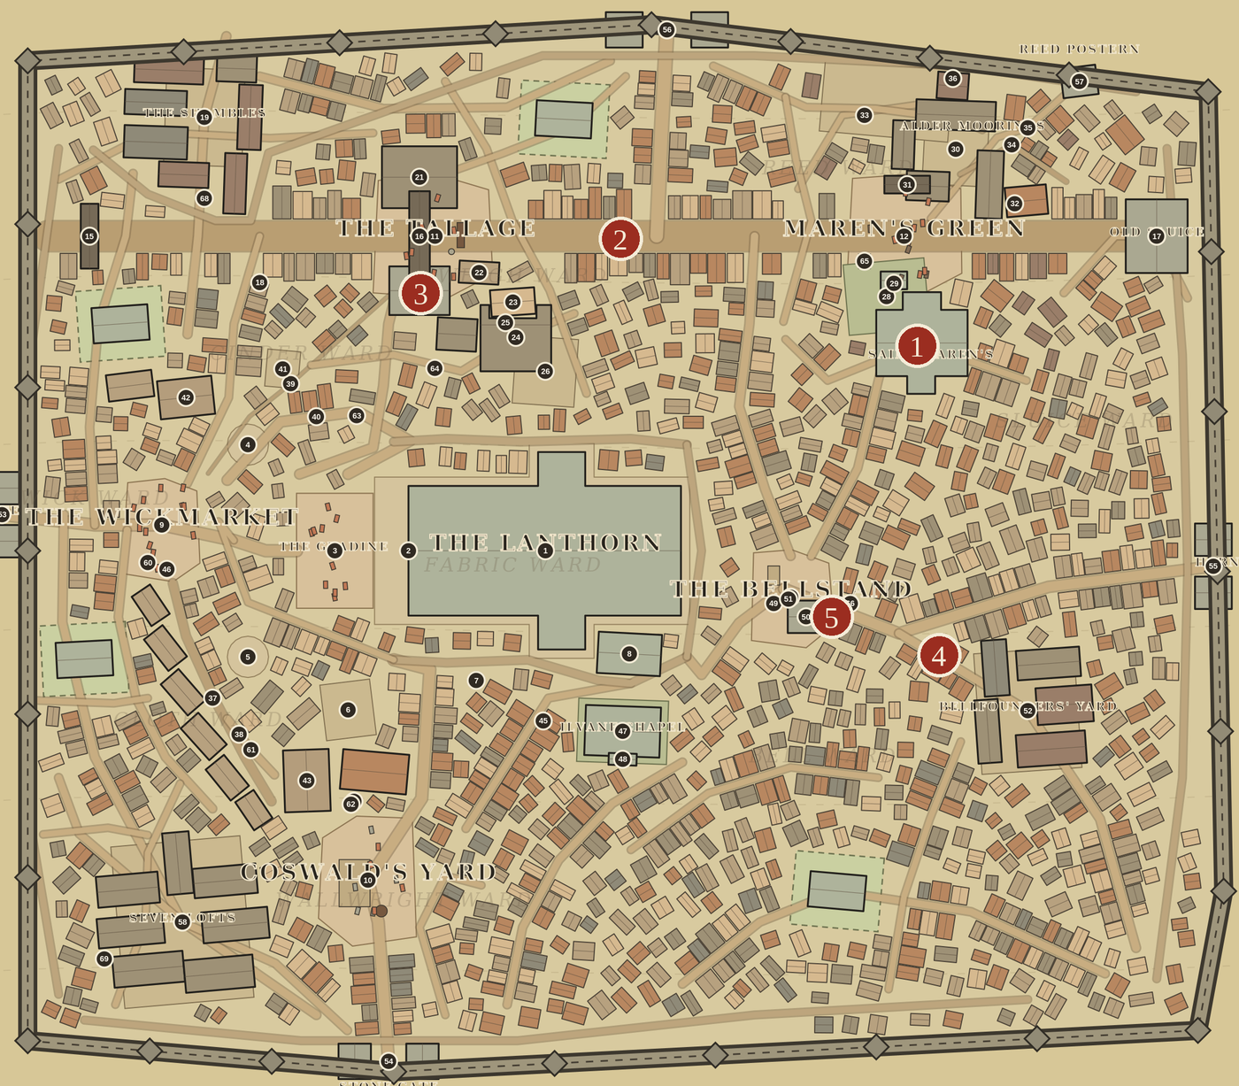 | The premise is canon, played. lore/the_dry_boatmen.md already establishes every load-bearing part of it: Saint Maren keeps the roll of the drowned; at Marenstide her roll is read at the church; since the diversion almost nobody drowns in Ombreval, so after F.415 the parish began adding the ward's Hammering dead to the roll of the drowned — because the Hammering dead were denied their name-knells and this was a bell that could still be rung for them. The traditional families object in the ward's flattest voice, you cannot drown under slate, and the wick-priest Renn Hobbe reads them anyway and takes the argument afterwards in the porch. The quest adds one name to that argument and a price to that bell.
Figure 1 — Where the quest sends you. The walled plan of Ombreval, pins: 1 Saint Maren's: the reading and the bell; 2 the Cut: the room, and the fuller in it; 3 the Tallage toll-house: the notary's book; 4 Bitter Well: buckets, queue, five listeners; 5 the Stone House: if a route goes wrong.
The cast is already carrying it. None of this was written for a quest. Noll Fitch the sexton opens the ground, rings Maren Smallvoice for the name-knell at one slow stroke a year of the life, chalks the newest buried name on the charnel-door lintel, and remembers helping bury the Hammering dead at thirty-five — the common toll was not a name-knell, whatever the Chapter wrote. Renn Hobbe was twelve in the Hammering and watched his father climb toward the bells while stone fell: I will not tell a family that one common toll settled their dead. Cobb Hawser holds every name the Serle has taken in thirty years, in order, and nobody has asked him for it in twenty years. Tilman Rue stands at the back of paupers' burials watching who counts the strokes and who reads the lintel — and who already knew it. And some quiet purse has paid the paupers' ninety-six for years, which neither the sexton nor the priest has ever asked about. The quest is what happens when somebody finally asks.
And the naming law supplies the difficulty. lore/families/family_rud.md makes the Hawsers the worked example of a landed name — a Hawser is nobody's concern, and the street lets the byname take him — while the Ruds are the same law one stage on: a name with no property left, kept alive by nothing but everyone else's paperwork. So the quest is that law with a deadline on it. To get a Hawser into one book you must argue with a Rud who is already in six.
What the player is promised. Not a hero and not a detective: an errand-runner and a beggar of favours who must, before the feast, raise the ninety-six and put it in the sexton's hand, find someone still living who remembers her and get one of them to stand at the reading, get her room into the notary's book over a sitting tenant, and be in earshot when the bell rings.
Three things it is made of. The price is fixed and the routes are not: ninety-six is canon, and the four purses that can pay it mean four different things by the time the bell rings. Code counts, people judge: the sim owns the arithmetic, the kinship rule, the deadline and the receipts, and whether anyone helps a stranger is an LLM's judgement, never a rule. Nothing is a marker: a witness is found by saying a dead name within twenty metres of somebody who was alive in F.415, and caught before their next leg.

2. How it starts
Two scenes on the first day, both where the cast already stands.
Cobb Hawser, at Tanners' Slip. Sixty-three, a pauper, teasing junk cable back to tow from a stool, and — his sheet's own claim — the man who holds the drowned: every name the Serle has taken in thirty years, in order, with the weather and the boat and who was fool enough to send them out. He will tell the lot for a bowl at the Hungry Ox, and nobody has asked him in twenty years. He was born boat-family; the name went with the hull, and the street named him Hawser because rope is what he gathers now. He keeps every drowned name in his head and cannot get his own sister onto the parish's roll, because she died under a roof. He hands the letter over on the ordinary two-sided offer card — refusable — and says the thing the quest hangs on: she was thirty-four, she died under the slate in F.415, and they never rang her.
Alis Hawser, my sister, thirty-four, of the room on the Cut. She died under the slate in F.415 and they never rang her. Ninety-six is what the parish asks for a bell and I have never had ninety-six. Noll Fitch will ring it. Renn Hobbe will read her at Marenstide with the drowned if somebody living will stand up and say she was there. I would, but I am her brother.
Noll Fitch, at the charnel door. The sexton is fifty-seven, which makes him thirty-five in the Hammering year; he buried them. Everyone gets a name and a bell, he says, and that is the whole of his politics. He states the terms, and the terms are the quest: the parish has one price for a bell, and it is the paupers' ninety-six, and I will take it from you as readily as from the purse I have never asked about. Renn Hobbe would read her tomorrow and cannot — the ward wants somebody living to stand up and say she was there, and he is the one who answers for it in the porch every year after. And the notary will not enter a room to a dead woman on one man's word — least of all her brother's. Then he tells you how long the bell takes, in four words: a stroke a year. Thirty-four of them, slow, and Rue will count every one — and the bell that rings them is already in the code, comment and all.
The first twenty minutes. The crier's count starts at six. The casebook is the letter with what you have learned written on the back of it. Bitter Well hands out turns and a bucket carried to a widow court pays one; a carried message pays one; the fuller's yard on the Cut pays two, and the fuller's yard is where the room is. Within an office the player has said a dead woman's name to three people, watched one of them stop walking, and learned that the room has a man in it.
Declining changes nothing and is a real option. Marenstide arrives, Renn Hobbe reads the roll without her, and the letter can be offered again next year — which is precisely what has happened twenty-two times.

3. One quest day
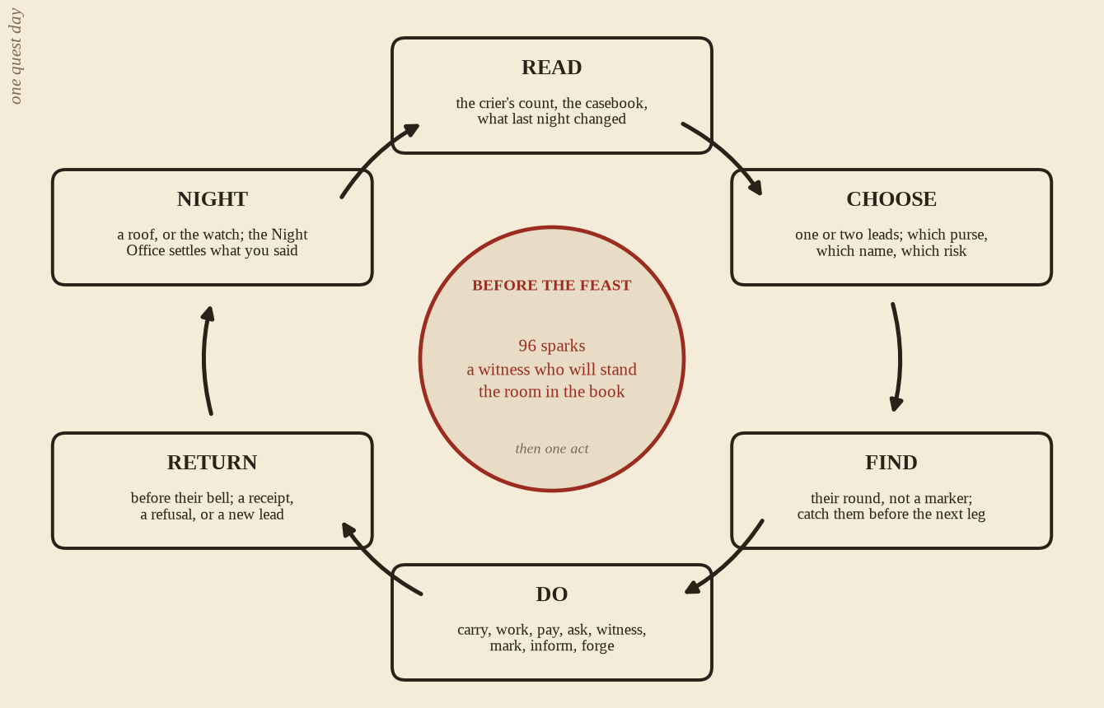
Figure 2 — One quest day. The same six steps every day; the three things in the middle are what the sixth day counts, and nothing on the diagram is a HUD element.

The office ladder is the quest clock. Nothing here is new; the day already runs on seven bells, and the quest only says which of them matter.
the Kindling 05 | Dayspring 07 | High Wick 12 | the Waning 15 | Lamplight 18 | the Snuffing 21
yards and gates stir; the day's paid errands are given out here or not at all | the well queue: the cheapest place to be heard by five people at once | everyone is at a hearth, and the crier cries the count | the notary's last hour at the toll-house; deeds close | the last hour a Major hears you before sleeping on it | the Scold; gates shut, and the watch is the only audience left

The quest-day decision is which of three things the Waning is spent on: earning the last four sparks, walking a householder to the toll-house, or catching the one witness who will be at her wharf until the bell. They are mutually exclusive most days, and that is the whole design.
The microphone is a public act, not a menu. You say a dead name to shake a memory loose; you say what a person told you to say, faithfully or with one word moved, and are paid on whether it was believed; you say something about a Rud within twenty metres of a grey coat and it is a summons. At the reading you say Alis Hawser where people are standing, and the sim does nothing with the sound at all — it only counts who was inside twenty metres to hear it.

4. Six days, three things
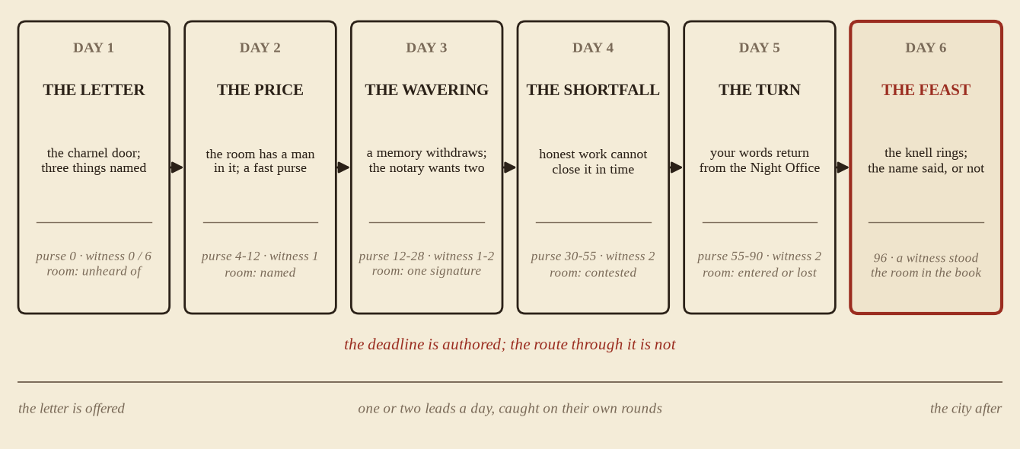
Figure 3 — The six days of the quest: the authored beat of each day, and the purse, witness and room the player is expected to be holding by the end of it.
The purse: ninety-six sparks. Against the shipped catalogue that is eight coats or forty-eight loaves, in a city where ale, a herring and a chalk pen cost one each — deliberately more than honest errands produce in six days. The shortfall is the design, and the four ways to close it are not equivalent.
Purse | How | What it costs
Your own getting | Authored errands paid on receipt: buckets, carried words, a fuller's load, a barrow to the Moorings. 1–4 each; a hard day is 8–12. | Days — and every hour earning is an hour not asking.
A lender's book | Averil Skell, the fish smoker of Maren's Green, lends at a spark on the dozen. It is a sideline on her sheet, not a trade. | A debt with a date. Averil has been known to sell a debt.
The Custody's dry money | Lise Copp's counter, where the grey clerks pay their quiet people. Tilman Rue already counts faces at paupers' burials and would like this one's. | Your name in a book you cannot read, and the funeral's faces in the Custody's.
The quiet purse | Somebody has paid the paupers' ninety-six for years and nobody has ever asked whose it is — and somebody meets in the sexton's crypt after a pauper's burial while he keeps the hinge oiled and himself elsewhere. Ask, and it pays. | On a condition: the name on the lintel becomes a pass, a word said at a door by people who need one. She stops being a woman and becomes a password.

The witness: six memories, one who will stand. Six existing sheets are seeded with a memory of Alis, and every one of them was an adult or nearly so in F.415 — a content rule, not an accident.
Who | Why they remember | Why they might not stand
Nan, washerwoman, 66 | Has washed for half the Cut so long she knows a household by its linen, and remembers every debt, birth and grudge on that street the way a rent-book does. | A pauper and a widow of the Weigh — and her daughter wears a grey coat at the chapter house, so standing up in a Reed argument is a family matter too.
Gude, herb-seller, 66 | Sixty-six years at the stall by the fish-hall steps; she has sold simples to that street her whole life. | One of the Spared — she looked up through the Great Rose and said plainly she saw one sun, and has been pitied and doubted since. She is tired of remembering for other people, and wants to know who is paying.
Cobb Hawser, rope-picker, 63 | Her brother, and the man who holds the drowned. | Kin, and the notary discounts kin. He knows it. It is why he asked you, and it is the tutorial for the rule.
Hamel of the Reach, bencher, 58 | Tallied freight into the dry warehouses on that cartway for thirty years; knows who held which door. | Born boat-family; the name went with the hull, and the ward seated him because there are more Hawsers than Alders and the fallen like to see one of their own on a seat — which is also why standing up for a fallen name in an election year is not free.
Idonea Tarn, bencher, 54 | Keeps the cooperage ledgers in a book that has never once been wrong; thirty-two when it happened. | Counts before she speaks, and wants to get through one more reckoning without being made to say an awkward word in public.
Wyn Alder, boatwoman, 34 | Twelve when the Moorings roof came down in the Hammering and killed her father. She took the fore-pole when her brother froze. | The authored objection, and it is personal. Water keeps its name and its dead, and the sky can mind its own business. Her own father died under a roof and she has never asked the parish to read him. If Alis is read, why not Alder?

Wyn Alder's refusal on day three is the quest's best scene and its designed reversal, and none of it was written for the quest: her father, her line about water keeping its dead, and the name she speaks in the nave but not in the street are all on her sheet. She is not defending a tradition, she is defending her father from being made an exception to. The best way out is therefore not persuasion but asking for Alder too — get her to name her own dead to the priest and the objection inverts, the two names go up together, and the man whose father climbed toward the bells while stone fell is the last in the parish who will refuse that. Failing which: read the name apart from the roll in the porch argument Renn Hobbe takes every year; stand somebody else and let her say her piece publicly; or lean on her, since Averil Skell holds forty-eight sparks of her brother's debt and collects in the street — and the Night Office will have carried what you did to two wards by morning.
The room: a deed twenty-two years late. Alis held a room on the Cut. Tam Rud has it now — twenty-nine, a journeyman fuller, sworn to the Breach, seven years old when she died, and a Rud, which is to say a name that appears in the fulling-master's ell-tally, the ward book and a debt list, while a Hawser appears in nothing. The notary will enter a retrospective deed on two householders of two different wards, in person, before the Waning, neither of them kin, with no live counter-claim standing. He cannot be bought — that is on his sheet — so the routes are persuasion, settling Tam's debt, informing on him, or forging the ward's hand, which buys about two days because the ward overwrites any notice older than two game days with its own cross.

5. A day in the life
Day four. Two days to Marenstide. Forty-one sparks.
The Kindling. The fuller's yard on the Cut. Tam Rud gives you a load for two and asks, for the third morning, why a stranger keeps coming to the one room in the ward nobody wants. You do not tell him that the notary closes at the Waning.
Dayspring. Bitter Well. Sibbe Quern hands out turns, hand before trade, and gives you the Alders' bucket. Wyn Alder — who told you yesterday, flatly and in front of four people, that water keeps its name and its dead and the sky can mind its own business — takes it without looking at you and pays the spark anyway, because the bucket is the bucket. Her father died under a roof too. Neither of you says so.
High Wick. Jos Brant cries two days to Marenstide. Gude is at her stall by the fish-hall steps, sixty-six, and she remembers Alis perfectly well. What she wants to know before she says so in front of a notary is who is paying for the bell. It is a fair question, she has spent thirty years being asked to remember things for other people, and you do not have a clean answer yet.
The Waning. The Tallage. Odo Trask, over the open fee book: two householders of two different wards, in person, neither of them kin, before this bell. You have Nan of the Weigh. Hamel of the Reach is Reed, is not kin, tallied that cartway for thirty years — and is a sitting bencher in an election year, so his word has a price and he names it.
Lamplight. The Bell and Ladle. Renna Tapster banks the fire. Averil Skell will lend twelve at a spark on the dozen, due at the quarter, and mentions in the same breath that Tam Rud owes her eleven — which is a route to the room and a debt in the same sentence, and you cannot take both.
The Snuffing. Seven strokes, then the Scold. Tilman Rue is at the charnel door at somebody else's burial, doing what his sheet says he does — watching who counts the strokes and who reads the chalked name, and who already knew it. He counts you. Forty-one of ninety-six, one witness standing, no deed, two days.
The Watch, unseen. Gude settles being asked into a memory; the ward mood comes back wary of the stranger who is buying something. You will hear that tomorrow, in other people's mouths, before you have said a word.

6. What pushes back, and how it ends
Pressure | What the player feels
The count | Six, five, four, cried daily at High Wick. Nothing else in the game has ever counted down.
The offices | People move, yards close, the notary goes home. A missed bell changes the route, not the objective.
The stranger rule | Your word weighs nothing until you have been named and remembered; most of the city does not think about you until you address it.
Your own words | Hearing has no walls. What you said within twenty metres of the wrong coat is a notice by morning, and the Night Office settles the rest into memories and ward moods.
The law | Word, summons, the Stone House, a posted three-spark fee. Arrest costs offices, never the quest.

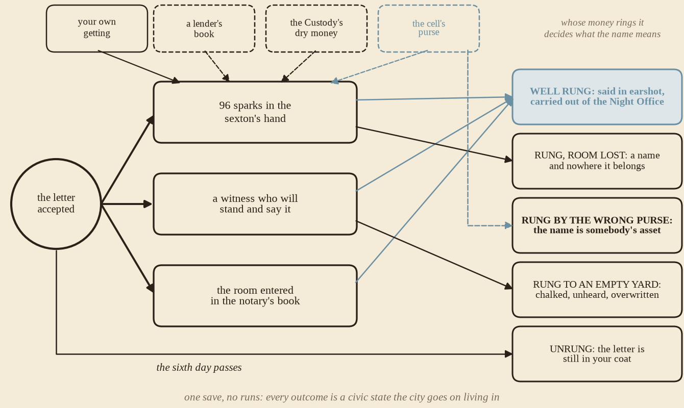
Figure 4 — How the quest ends. Every outcome is a position the city then lives in, and whose money rang the bell is tracked apart from whether it rang.
Nothing here is a reload. Miss a person and you learn tomorrow's round. Lose a witness and the casebook names the reason. Get arrested and the reading proceeds without you — which is one of the authored ways to end up rung, not heard. Come up short on the sixth day and the sexton will not ring on credit, but he will say so to your face, and Cobb will be standing there.
Whose money rang it is tracked apart from whether it rang. The integrity ledger records provenance, promises kept and broken, forged marks later discovered, and whether a man went to the Stone House to clear a room. It changes reactions, law and what people say afterwards. It is never a score, and it never moves the arithmetic after the bell.

7. What it would cost to build
Most of it ships. The quest consumes, unchanged: the clock and its seven offices; the microphone and typed chat as speech heard within twenty metres; two-sided offers and the item catalogue; the unknown-people rule with knows and remember; go_to and places_known; notices, custody and the Stone House; chalk marks with forging and scrubbing; homes and 1,101 nav doors; rounds and hearth meals; the Night Office's thirty Major reflections and eight ward moods; and the soundscape's assembled bell patterns, Saint Maren's small bell among them at 300 m.
What the quest adds is small, and shaped like the code already there.
Quest work | Size | LLM spend
Quest state and the six-day clock. Catalog, phases, the reading window, receipts, the integrity ledger; all of it in the pure sim, off when the catalog is absent. | M | zero
ring_knell and the lintel. BellPattern::NameKnell { years } already ships — one slow stroke per year of the life, 300 m, with a logged stroke count. New: the sexton-only action that fires it, the one-slot LintelName mark, and a percept that carries the name. | S | one turn, bought by your offer
stand_witness / withdraw_witness / enter_deed. Typed actions validated against quest state; the model chooses which authored condition it names and whether it believes you. | S–M | one turn each
Authored paid errands. Four kinds — carry, spoken errand, attend with, statement to — each a receipt, not a job system. | M | reuses turns already bought
The casebook. A quest-only projection on its own revision; explicitly not in the actor snapshot. | S | zero
Seeds. The letter, six memories on existing sheets, the room and its tenant claim, the crier's count. | S | prompt lines only

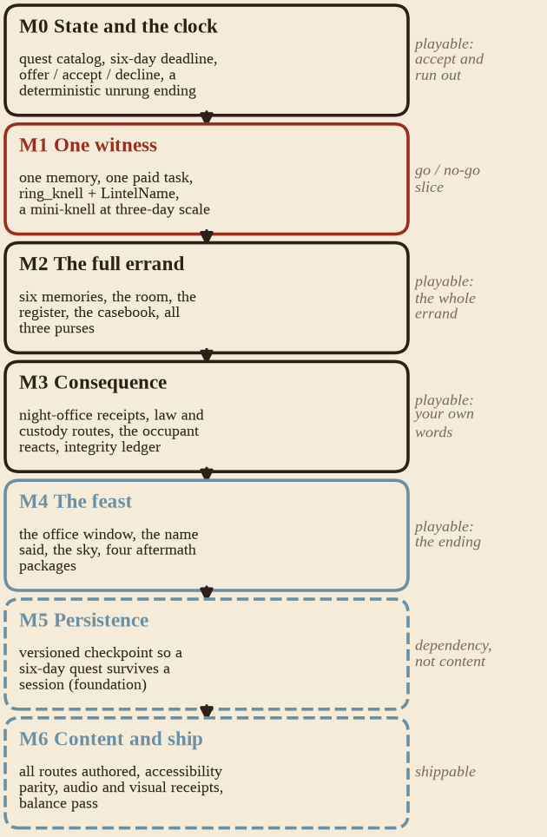 | Each milestone is playable. M0 is the clock and a deterministic unrung; M1 is one witness, one purse and one bell at a reduced scale, and is the go/no-go for the whole feature; M2 is the full errand; M3 is consequence; M4 is the reading and its five outcomes; M5 and M6 are the foundation and the polish.  The slice that decides it is three days, one witness and a reduced sum: find Nan on her round, say a dead name inside twenty metres, hear what would move her, earn it, hand it over, and have her still standing there the next morning after the Night Office has had it. If asking one person to remember a dead woman and stand up for her is not compelling at that scale, the other five should not be authored.
Figure 5 — Build order. Each milestone is playable on its own; M1 is the vertical slice the rest of the quest is judged by.
Three foundation dependencies, named honestly. Persistence: there is no world save today, and a six-day quest cannot be one process lifetime. Earning: there is no wage, workplace or payout path anywhere in the sim — the quest owns four authored errands and a general economy stays a base-game feature. Player curfew: the Snuffing moves NPCs but no watch-witnessed detection exists, so night play is atmosphere until it does. Two named actors, the wick-priest and the notary, are Minor today and decisive here; promote them before shipping rather than treating a Minor as a Major quest subject.
What we do not know yet. Whether the model reliably surfaces a seeded memory when a dead name is said within twenty metres of it, or whether the name needs a code-side percept behind it — this is what M1 is for, and everything else waits on it. Whether ninety-six is reachable without the errands quietly becoming a job system. Whether Wyn Alder's principled refusal reads as a scene or as a broken flag. Whether being overwritten on the lintel by the next pauper is the point or a disappointment. And whether the parish's price should be waivable by the priest's own mercy, which would be the warmest moment in the quest and would also dissolve its only hard number.
How it is proved. cathedral-headless --fake runs the whole six days in seconds and asserts the arithmetic: ninety-six rings, ninety-five does not, a withdrawn witness never counts, kin never satisfies the deed, and the reading fires exactly once even if one pump crosses three offices. A CATHEDRAL_HEADLESS=1 drive script then walks the slice in the real renderer and screenshots the lintel, with no window on anybody's desktop.
Why this one and not another. It is small, it is dated, it ends, and it leaves marks the next quest can find: a name on a lintel, a line in a book, a debt, and eight wards with an opinion about a stranger. That is the shape worth repeating — not because this errand is special, but because a city that can hold one of these can hold a dozen.
Out of scope for this quest: combat, health, skill trees, procedural characters, romance, full interiors, a quest generator, quest markers, a reputation number, and every part of the second sun and the impossible light. The Hammering's cause is canonically unestablished and stays that way; this quest is about a bell, a book and a name.

