CATHEDRALBEVY • SIX-PAGE QUEST OVERVIEW • 27 AUGUST 2026
NINE BEFORE RAIN
An authored five-day civic quest in Ombreval
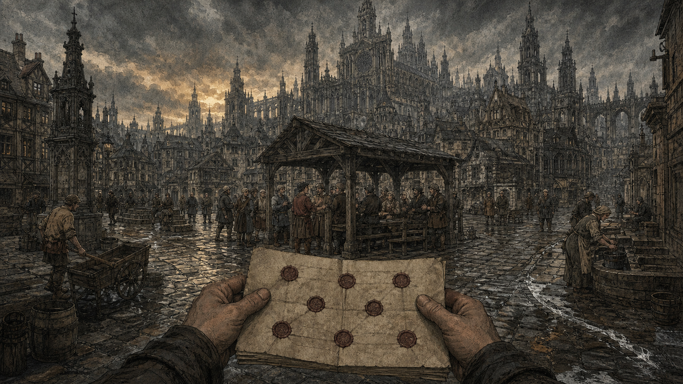
The docket is the quest log; the streets are the dialogue tree; the storm is the deadline.
Five days. Sixteen benchers. Nine must agree. Every legal way to pay for Ombreval’s broken drains makes somebody poorer.
Document scope. Nine Before Rain is one optional five-day quest arc inside Cathedralbevy—not the whole game. Movement, conversation, schedules, law, inventory and persistence are dependencies. Hard rain is coming and the Common Bench has deadlocked. First Seat Gude Dask assigns an unknown visitor; the Common Clerk enters a narrow runner’s writ. Carry terms between eight hostile wards, do work people can witness, and return with nine conditional pledges for the legal hand-count. You cannot save everyone. You can make the cost legible, keep or break your word, and wake after the vote inside the city this quest changed.
5  QUEST DAYS | 16  BENCHERS | 9  MUST AGREE | 3  BAD BASE PLANS | 4–6h  FULL QUEST

01 CODE COUNTS; PEOPLE JUDGE  For this quest, code verifies deeds, conditions and votes; smart actors decide trust, terms and how refusal sounds.  02 A PROMISE HAS A PLACE AND BELL  Every quest favor means finding a real person, at a real office, before they move or sleep. |  | 03 YOUR VOICE HAS WITNESSES  Quest-critical speech uses the existing twenty-metre hearing rule: useful and compromising words travel together.  04 EVERY WIN LEAVES A LOSER  Passing this measure is not a moral score. Its queues, prices, repairs and grudges become the quest’s aftermath.

PAGE 02 / 06 • QUEST DESIGN
How one quest day plays
Each day of Nine Before Rain is a social heist against seven office bells.

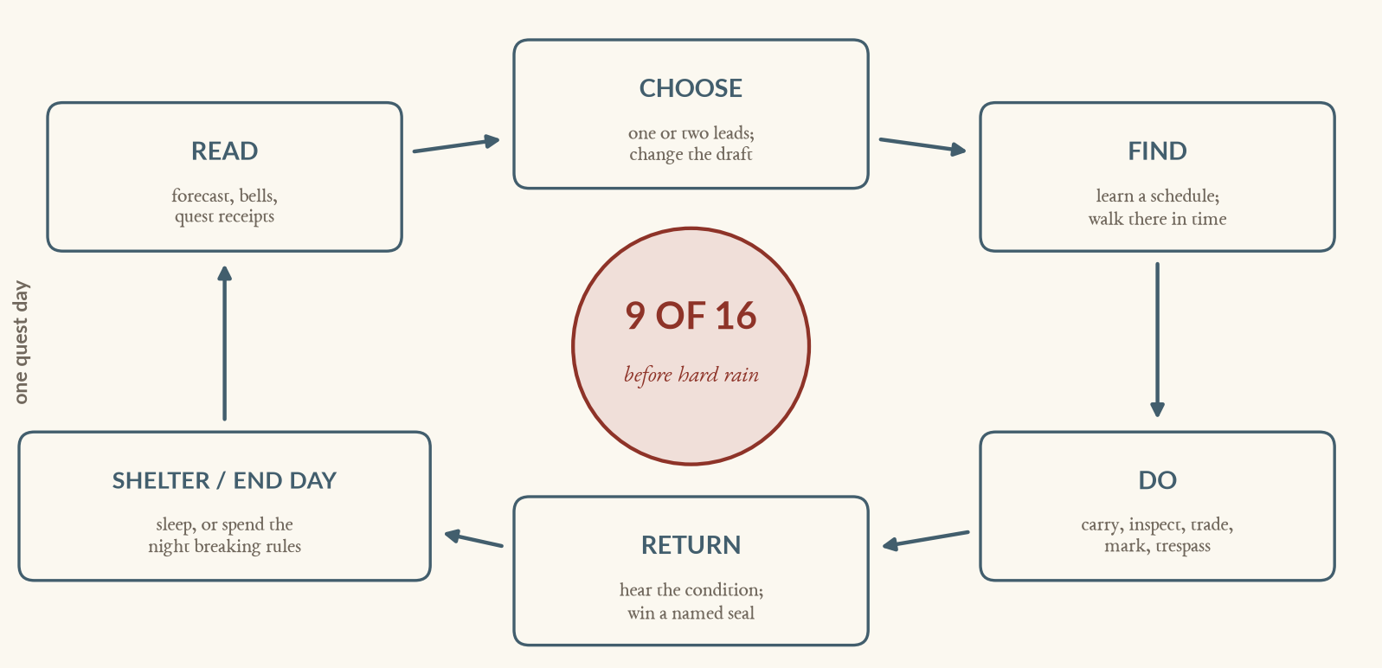
The quest’s repeatable loop. Conversation discovers the opportunity; embodied play earns the receipt.
THE FIRST TWENTY MINUTES  ● 0–3 Gude gives you the runner’s writ and a blank docket. Bring back the Wick bencher’s terms.  ● 3–8 At the Wickmarket, directions and the office clock put Jonet Kett at Slate Cistern.  ● 8–14 Jonet will listen after you operate Slate’s first-wash board and help make a witnessed tank-and-queue count.  ● 14–18 You work the board and tally buckets while the queue watches. Code records place, time and witnesses.  ● 18–20 Jonet pledges only if the measure lowers Wick’s sealed fire line. Her named condition enters the docket. |  | THE CASEBOOK ANSWERS ‘WHAT NEXT?’  ONE DIEGETIC QUEST CARD  RAIN: after Lamplight, Day 5  SEALS: 1 / 9  DRAFT: city assessment + fire reserve  LEAD: Idonea Tarn, Maren’s Green until the Waning  No persuasion percentage. No exhaustive quest arrows. For this quest, the card records only public facts, explicit promises and leads the player has actually heard.  Names, schedules, shortcuts and secrets remain knowledge in the player’s head—or notes they choose to pin.

EXISTING OFFICE LADDER — QUEST CLOCK (WATCH AT 02:00)
KINDLING 05  first jobs; gates stir | DAYSPRING 07  queues and carriers | HIGH WICK 12  public meals; hearings | WANING 15  last paid work | LAMPLIGHT 18  last words; beds | SNUFFING 21  curfew or night play
The quest-day decision: cash one more favor before the Waning, land one dangerous last word before a bencher sleeps, or turn back before Snuffing closes ordinary meetings.

FOUR QUEST TASK SHAPES; MANY HUMAN VERSIONS
ERRAND OF WORDS | PUBLIC WORK | PROOF + WITNESS | MISCHIEF
Repeat a line faithfully, soften it, or change one dangerous word; payment and reaction follow what was actually heard. | Wind, lift, brace, sound or clear a fixture while place, office, item and witnesses make a deterministic receipt. | Bring the right object or person to a public place before a bell: a weight, viewer, debtor, keeper or household count. | Forge or scrub a mark, bribe an officer, stay out after curfew or ring falsely; the shortcut uses the same law spine as the consequence.

PAGE 03 / 06 • QUEST DESIGN
Five quest days, nine pledges
This is one authored coalition quest, not a procedural quest generator.

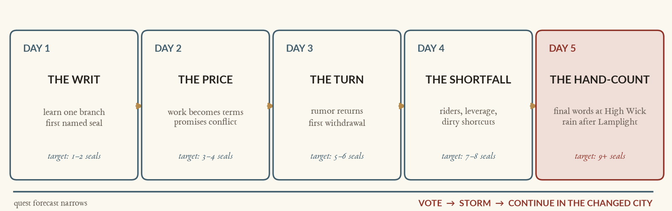
The storm schedule is authored for this quest. The forecast narrows, never ambushes the player with a hidden roll.
BUILD ONE LEGAL MEASURE
BASE | WHAT IT DOES | BUILT-IN ENEMY | EXAMPLE RIDERS
CITY-WIDE ASSESSMENT | Every household pays; low streets get the fastest repair. | Wallwright: ‘water runs downhill; so does money.’ | Poor-house exemption • Chapter composition
CUT CART FEE | Freight funds the culvert; carts and market prices rise. | Cloth: ‘to lift it twice’ becomes law. | Sunset clause • capped freight loads
REED POSTERN TOLL | Barrows fund the work; fish and poor carriers pay first. | Reed blocks; Weigh calls it honest arithmetic. | Handbarrow exemption • public tun audit
THE DRAFTING RULE
Choose one base and at most two riders. Every seal names its condition. Change the draft and invalid seals turn grey immediately; nobody secretly ‘changes their mind’ off-screen. The quest’s five-day deadline permits four or five ward branches, never all eight.

EIGHT AUTHORED WARD BRANCHES FOR THIS QUEST
WARD | THE KNOT | PLAYABLE LEVER
FABRIC | Chapter traffic wears civic streets but consecrated ground pays no tax. | Count feast wear; bargain a voluntary Chapter composition.
WICK | Households queue while Slate Cistern keeps a third sealed for fire. | Inspect the reserve and choose whose buckets stay behind clay.
CLOTH | A Cut fee tolls every bale twice; dye-water takes every drain’s blame. | Trace a marked outfall; audit one suspicious freight manifest.
WALLWRIGHT | The city owns Lodge Well’s shaft; the lodge claims its windlass. | Witness shaft and windlass costs; secure a lawful hearing date.
CINDER | Burned once: it wants fire reserves and Three-Curb repaired first. | Stand a fire watch; settle three tangled keeping shares.
WEIGH | It wants barrow tolls—and fears proving sixty years of measures wrong. | Arrange a neutral proving procedure without settling the tun.
REED | The poor man’s postern carries fish, kin, work—and convenient silence. | Run a timed barrow; witness what gate delay does to a load.
BELL + SLUICE | The poorest ward wants the Step Cistern keeper paid from the Chest. | Clear a drain run; carry the household count nobody funded.
SECURING NINE CONDITIONAL PLEDGES
A seal tracks a conditional pledge, not favor points or the legal vote. If a predicate breaks, the docket names who withdrew and why. Only the public hand-count enacts the measure, so the coalition remains arithmetic the player can reason about—not an invisible persuasion total.

PAGE 04 / 06 • QUEST DESIGN
Speech opens the door; play closes the deal
In this quest, the microphone is a public act, not a menu-selection device.

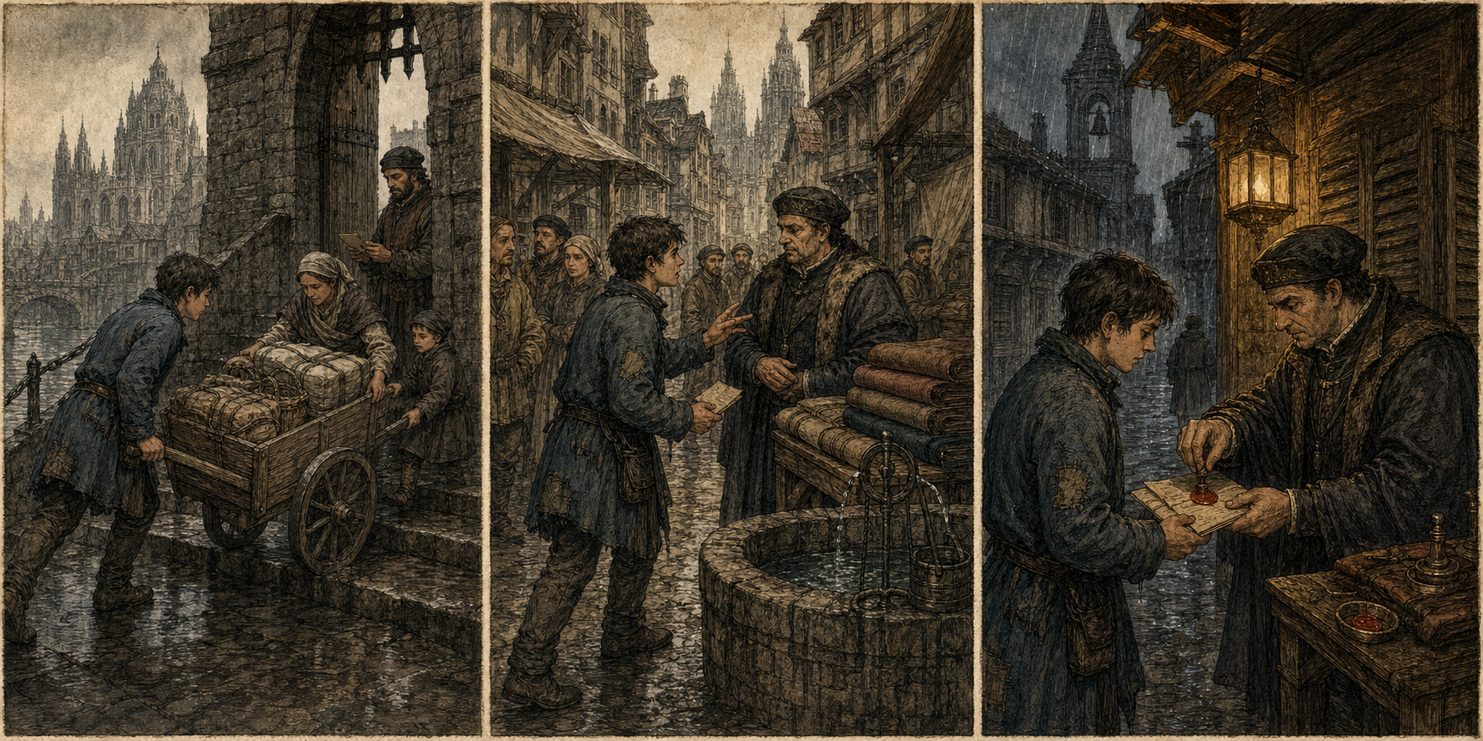
A playable quest day: visible service at the postern → words carried through a crowded lane → a conditional seal before curfew.
QUEST ACTIONS AND SYSTEM DEPENDENCIES
VERB | WHAT IT MEANS IN PLAY | STATUS
SPEAK | Typed or voiced. Everyone within 20 m may hear; where you stand is part of the sentence. | EXISTING SYSTEM
FIND + FOLLOW | Read bells, weather, names and routines; ask directions; catch a person before their next leg. | EXISTING SYSTEM
CARRY + OFFER | Move messages, food, tally sticks, weights and coin through the existing two-sided offer system. | EXISTING SYSTEM + QUEST CONTENT
CHALK + SCRUB | Redirect a well queue, stall or ward destination. Forgery works because the city trusts the mark. | EXISTING SYSTEM
WORK + INSPECT | Wind, lift, brace, sound, tally and clear at authored fixtures. No QTE; place, time, item and witnesses are the skill. | REQUIRED FOR QUEST
BREAK THE RULE | Keep a bencher awake, cross curfew, hide evidence, bribe, forge, or ring a false peal as a late-quest optional route. | OPTIONAL QUEST EXTENSION
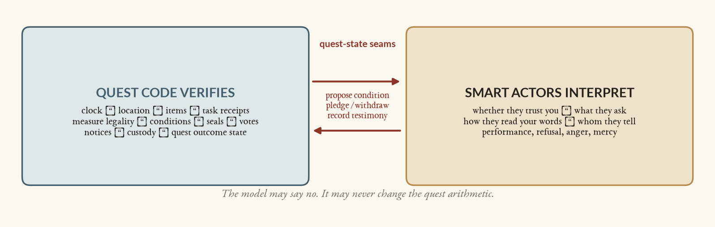
A critical reliability boundary for this quest: authored conditions and deterministic receipts preserve free conversation without letting a model invent or erase its rules.
ONE OFFICE, PLAYED THREE WAYS
Rohese Sedge will pledge only to a publicly accounted barrow toll with a neutral proving procedure. Bring the Line-keeper’s tally by the Waning and she agrees cleanly; borrow a witness and owe them; falsify the count and keep her only until a viewer catches it. The quest condition stays fixed. The route, witnesses, debt and aftermath are yours.

PAGE 05 / 06 • QUEST DESIGN
Pressure makes stories
Nine Before Rain adds no combat, and none of its setbacks require reloading.

FIVE QUEST PRESSURES, ALL LEGIBLE
PRESSURE | WHAT THE PLAYER FEELS
BELLS | People move, stalls close, paid work ends and the vote arrives. A missed office changes the route, not the objective.
RAIN | Forecast → first drops → clogged aprons → authored downpour. Low streets and cellars rehearse what is at stake.
LAW | Word → summons → warrant → custody. Bribes, surety, restitution and breaking free already make consequences playable.
WORD | Bounded rumor facts travel at walking speed; the Night Office settles the day into memories and ward mood.
ROOF | The clerk’s loft is safe but far. Another bed buys position. Staying out buys illegal opportunity and curfew risk.
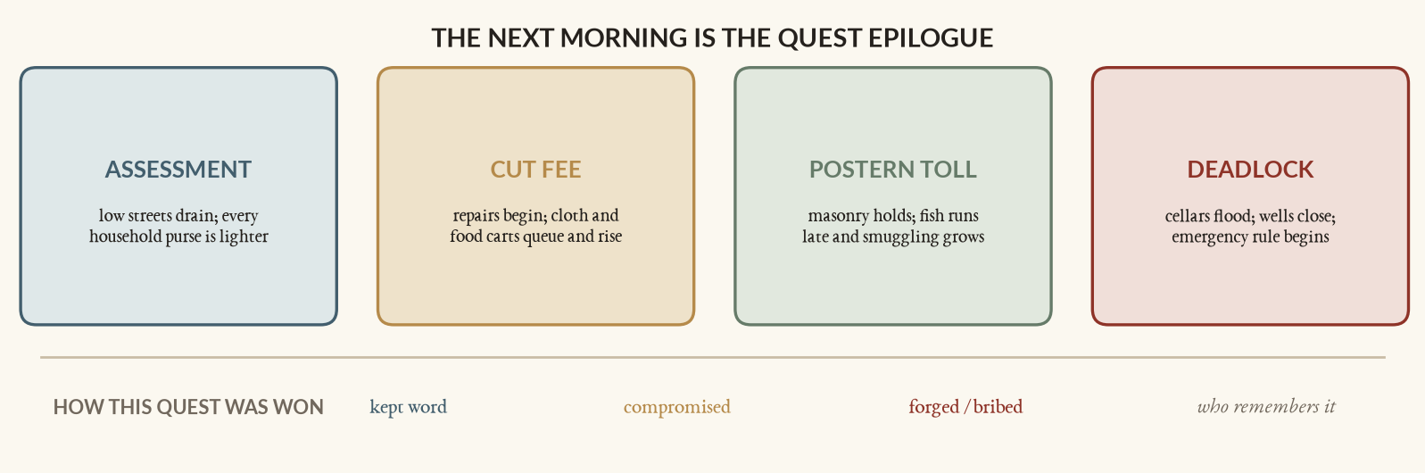
The passed motion selects the quest’s civic consequence; how you passed it selects the social consequence.
QUEST FAIL-FORWARD ROUTES  ● Miss the meeting. The bencher moves or sleeps; learn tomorrow’s route or use a riskier intermediary.  ● Get caught lying. A seal hardens or withdraws; unlawful contacts become more useful.  ● Get arrested. The Stone House becomes a dense scene: prisoners, surety, debt, testimony and escape—at the cost of offices.  ● Lose the hand-count. The storm still arrives. Flood damage, emergency rules and remembered blame become the continuing world. |  | LEVERAGE GAINED DURING THE QUEST  KNOWLEDGE names, schedules, secrets, conditions  ACCESS writs, roofs, keys, introductions, passes  MEANS sparks, food, evidence, favors and debt  STANDING unknown → useful → trusted / marked / wanted  These are quest-state changes, not Cathedralbevy’s global progression model. The quest reward is an enacted civic rule visible in tomorrow’s queues, prices, work routes and grudges.

A DAY-FOUR CASCADE
At Lamplight you tell Rohese that Reed accepted the toll—inside a porter’s hearing. The claim reaches Weigh by morning and buys her seal; Idonea hears the same pollen, withdraws hers, and demands the handbarrow exemption in public. Meanwhile a viewer finds your forged well tally, so the Snuffing opens in the Stone House. No quest state resets: the ninth vote is now available from a cell, at the price of a surety and one missed office.

Quest persistence requirement. Persist quest state at every office and before each explicit seal. After the hand-count, retain the outcome so play continues into the storm morning. ‘Quest complete’ means a changed civic state, never deletion of the city.

PAGE 06 / 06 • QUEST DESIGN
A shippable quest arc
Add a bounded quest-state layer over the existing simulation.

EXISTING SYSTEMS VS. REQUIRED QUEST WORK
EXISTING SYSTEMS THIS QUEST USES | FOUNDATION + QUEST WORK
519 authored citizens; homes, jobs, needs and seven-office rounds | Quest state; save/load dependency; safe roof and sleep-to-Kindling
Voice / typed speech, 20 m hearing, unknown people, stage cognition | Runner’s writ, casebook, lead receipts and accessible critical-text fallbacks
Items, stacks, sparks, offers, stalls and supply behavior | Authored work contracts and deterministic completion / witness receipts
Chalk marks, weather, bells, notices, custody and Stone House | Political-rumor dependency; explicit morning withdrawal receipts
Sixteen existing F.437 benchers with ward positions | Three bases, fixed rider catalog, condition records, pledge / withdraw verbs
A large walkable city whose rules already move its people | Final hand-count plus four visible post-vote rule packages
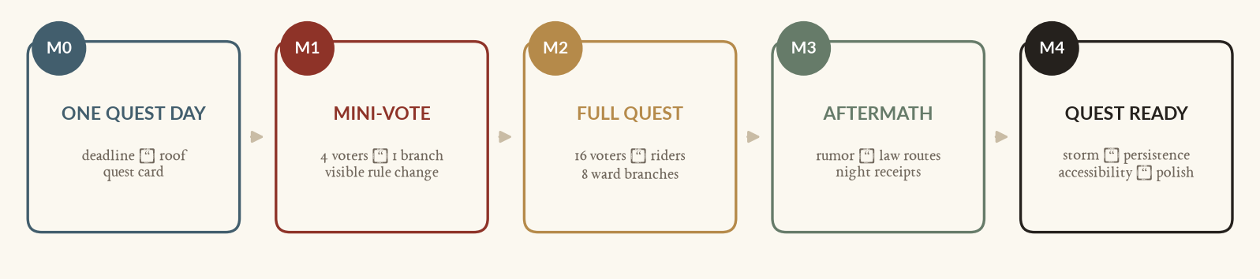
Each milestone ends in a playable civic decision. M1 is the vertical slice and the go / no-go gate.
60–90 MINUTE QUEST SLICE  ● Two days; Reed and Cloth; four benchers plus Gude Dask and 6–10 stakeholders.  ● One mini-motion: impose a Cut cart fee, with one rider and four explicit conditions.  ● One timed barrow job, one spoken message, one mark, one rumor crossing two wards.  ● One night-route decision and one Stone House route through surety or escape.  ● The mini-vote changes Cut enforcement the next morning. |  | THE SLICE SUCCEEDS IF  ● A first-time quest tester can always name a next lead and why it matters.  ● No single model reply can block completion; fake-backend play reaches the vote.  ● At least three distinct coalitions / methods are viable without economy exploits.  ● One player-spoken claim returns through another mouth by the next day.  ● The changed street rule is noticed without reading patch notes or a quest-completion card.

OUT OF SCOPE FOR THIS QUEST
This quest does not add combat, a health tree, full procedural interiors, romance, free-form generated quests, magical powers, a 20,000-person crowd target, or a solution to the Second Sun. Their presence or absence elsewhere in Cathedralbevy is outside this specification. False peals and the Cut game remain optional quest routes until the core civic loop proves fun.

Quest acceptance test: talk creates an obligation; walking spends time; code proves the deed; the city remembers; the rule changes where you can see it.
Quest dependencies. Canon: lore/core_lore/ward_politics.md, lore/core_lore/secular_government.md and lore/wells_and_water.md. Runtime: crates/cathedral-sim/AGENTS.md. Related specs: features/lore_ward_politics.md, features/rumors.md and features/implemented/.

