THE CATHEDRAL-CITY OF IMPOSSIBLE LIGHT

AN ALIBI
IN STONE
Walk the claim. Find the missing route.
Prove who used it.
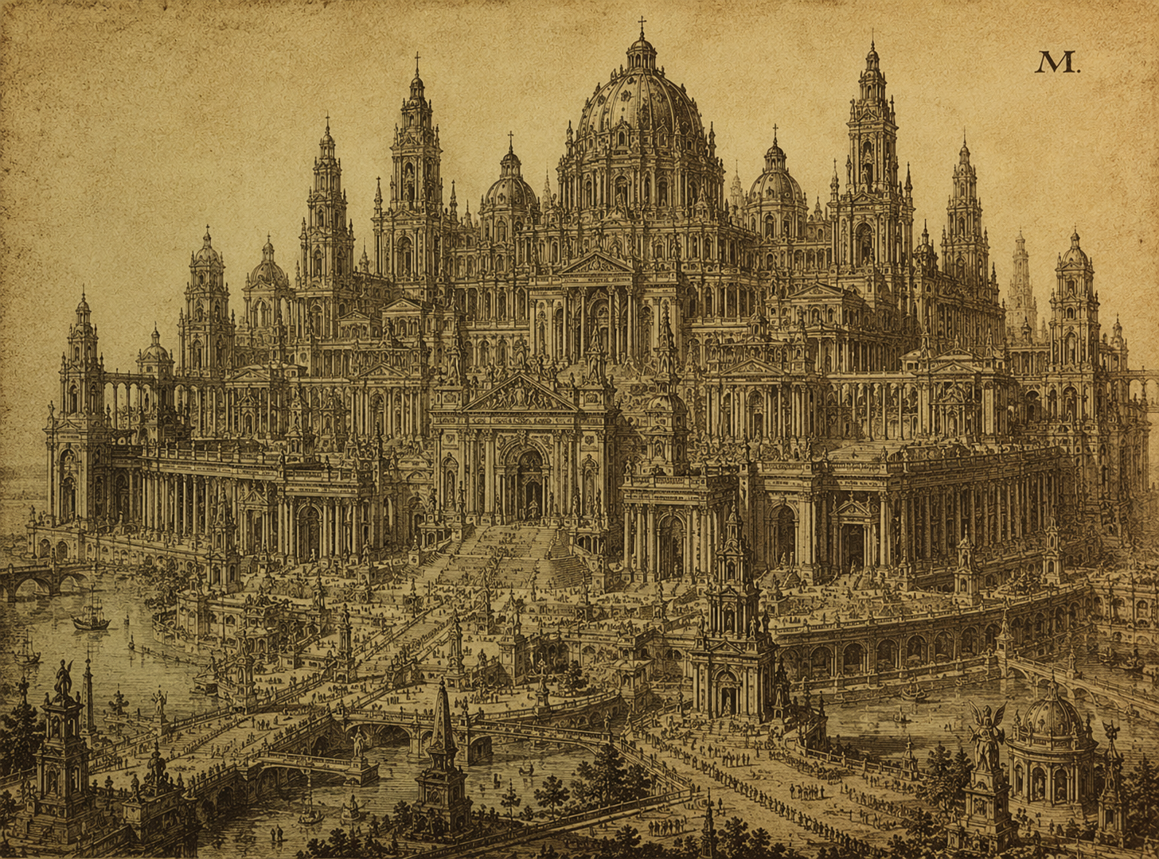
The project's existing architectural inspiration. The crime, rooms and routes in this document are proposals; this image is not their surveyed map.
A complete investigation quest for Ombreval
04 September 2026 · Quest GDD · 35 pages
An assault, a stolen packet and two genuine sightings. Reconstruct a crime through the movements, work and hidden connections of a living city.

A crime you solve with your feet
An Alibi in Stone is a first-person investigation in Ombreval. A notary has been assaulted and a packet of disputed documents stolen. A carter is being held. The man with the strongest apparent alibi was seen at the same counter before and after the attack. The player discovers what those sightings actually establish, walks the intervening routes, and reconstructs how the crime was possible.
The central pleasure is a change in understanding: you return to an ordinary wall, look up, and realise that two places you thought were far apart almost touch. Then you have to establish who used that connection. A route proves opportunity; identifying the assailant requires a further, independent chain of evidence.

The game this quest proposes
Observe a place; ask a precise question; form a hypothesis; test it by walking, watching or arranging a demonstration; decide what to disclose. Conversations produce claims and conditions. The world supplies ways to check them. The player's notebook supports memory without announcing the culprit.
This document specifies one complete case: fixed truth, timeline, cast, clues, access routes, suspect responses, alternate solutions, failures and aftermath. Its rewards are useful access, recovered property and particular relationships. It does not depend on combat, a detective statistic, a supernatural revelation or a model grading a final speech.

Reading map and spoiler boundary
Pages | Contents
3 | The player's opening encounter
4–9 | AUTHOR SPOILERS: truth, cast, incident, geography, timing and accounts
10–21 | Investigative locations, evidence and suspect behaviour
22–26 | Notebook, proof standards, public/private resolution and outcomes
27–30 | Playthroughs, unusual approaches, recovery and pacing
31–33 | System boundaries, production scope and acceptance gates
34–35 | Sources, proposal boundaries and document provenance

Scope target: a first resolution in 60–100 minutes, or 100–150 minutes for a thorough investigation including optional surveillance. These are playtest hypotheses, including pauses. An early, well-supported solution is valid.
All crime events, room additions, witness appointments and case procedures below are proposals. Existing biographies inform the casting; they do not make this incident canon. Route lengths are a greybox specification, not measurements of the current map. [S1–S6]

The opening: the wrong man holding a wound
The player reaches the Tallage during Dayspring on case day 1. A familiar working square is disrupted in one place. Warin Underbridge sits beside a watch post with his cart idle nearby. A clean rag still bears a stain from helping Odo. Averil Tarn is arguing with Sergeant Segwin Mott about releasing him. Public stairs to a nearby comparison room are cordoned for inspection.
Odo Trask was attacked there at the previous day's High Wick. Warin says he found him, steadied him and shouted for help. Odo's packet has not been found. Warin had publicly disputed a copying fee earlier, and he was the first person discovered in the room. These are grounds for suspicion and a temporary hold in this proposed procedure, not proof of guilt.

A conversation with something to act on
Mott supplies three facts: Odo is alive and can speak; the packet held originals needed to settle a disputed pledge; and Corin Copp says he was at his aunt's counter throughout the relevant interval. Mott will hear contrary evidence. He does not appoint the stranger magistrate or grant unrestricted access to the square.
Averil offers the invitation: “Ask him where I was standing when Odo cried out.” Following that lead starts useful work immediately. Warin instead describes the room and names the hired writer who can read his delivery instruction. Looking up reveals its back light above an apparently unrelated yard.
Opening action | Immediate next step
Speak to Warin | Learn his delivery, fee dispute and account of finding Odo
Ask Averil about the cry | Visit the lower beam and reconstruct her observation
Ask Mott to inspect the room | Receive supervised crime-scene access
Visit Lise's counter | Hear the reassuring alibi at first hand

No acceptance button creates the crime retroactively. It belongs to a fixed history seeded before the opening campaign clock. The local inquiry has an announced review at High Wick on day 2. The player can ignore it, arrive later, or reopen its finding with new evidence.
The hook is personal and spatial: an amiable man may lose his work because helping an injured person put him in the wrong room, while a window above the square suggests that the witnesses have not all been asked the same question.

Author truth: what actually happened
Corin Copp committed the theft and assault, alone. Warin is innocent. Lise provided an honest but incomplete alibi. There is no twin, teleportation, manipulated bell, supernatural cause or second culprit. The player's route through the evidence varies; the truth does not.
Odo was comparing an original pledge against a purported release copied by Corin. The release falsely cancelled a debt secured on workshop tools and named Corin's client as the person entitled to collect them. A craft household could lose its tools if the substitution went unexplained. Corin expected the original never to be produced. This transaction is new quest content; the household is represented by documents and later return of property, not another essential witness.

Motive, method, mistake
The packet contains the original pledge, the disputed release and Odo's signed inventory wrapper. Removing it delays the comparison and lets Corin recover his forgery. Odo has already deposited a counterfoil describing the discrepancy; Corin does not know that. Theft obstructs the inquiry without erasing every trace of it.
During a short hoist operation at Lise's shop, she leaves the counter to supervise the load in the rear yard. Corin knows an upper service connection between her pledge loft and the adjoining comparison room. He uses it, finds Odo at the desk, snatches at the packet and shoves him when he resists. Odo falls against the desk, cuts his brow and cries out. Corin takes the packet. The attack is brief and non-graphic.
In the struggle, Odo catches Corin's document wallet and its brass catch breaks. One half falls under the desk; Corin retains the damaged wallet. Lise saw the catch intact before the hoist operation and notices its awkward closure after it. This independently dates the physical connection later described in E10–E12.
Returning through the loft, Corin hides the whole packet in a disused document rack. He is back at the counter before Lise returns. Later he strengthens two genuine sightings into a false statement of continuous presence. Lise initially repeats that conclusion because she trusts him, not because she conspires.

Two separate resolutions
Clearing Warin requires establishing that the attack and his presence below coincided, or reliable evidence identifying someone else. Establishing Corin's responsibility requires connecting him to the packet or an independently corroborated admission. Finding the passage alone accomplishes neither.
Recovering the original matters independently: Odo can complete the comparison and prevent the forged release from deciding the tools' ownership. The player can help Warin, recover property and expose Corin in different combinations. The outcome follows evidence actually delivered, not a hidden “correct suspect” selection.

A cast with reasons to speak carefully
Person | Established character | Role in the proposed incident
Corin Copp, 26 | Gifted scrivener; secret forger; loyal to Lise; trained by Gile | Culprit. Wants the packet and his aunt's respect intact; may concede a smaller lie to protect the larger one.
Lise Copp, 55 | Pawn dealer; values neutrality; loves Corin; secretly cannot read | Before/after witness. Protects customers' privacy and assumes Corin stayed at the counter.
Odo Trask, 47 | Exact notary; cannot be bought; sends Corin fair-copy work | Injured victim and document authenticator. Wants the originals and a defensible account.
Warin Underbridge, 27 | Kindly, loud carter; cannot read; loves Averil | Wrongly suspected finder. Embarrassed by the fee dispute; frightened of losing his work.
Averil Tarn, 24 | Skilled toll clerk; reads the beam for her father; loves Warin | Witness to Warin below during the cry. Her relationship makes independent support useful.
Gile of Brede, 67 | Poor hired writer; reads letters aloud; taught Corin | Independent witness; holds the counterfoil. Saddened by where the questions lead.
Segwin Mott, 59 | Bench sergeant; slow to trust; dry humour | Secures the scene, revises the hold, records the reconstruction and refers supported charges.

Biographies come from individual character JSON files. The incident does not establish that Lise knowingly sells Corin's forgeries or that she can read them. Gile's pride creates discomfort, but never arbitrary refusal to provide an indispensable fact. [S2]

Seven people, different responsibilities
Corin chose the offence. Lise made an understandable inference. Mott acted too quickly on incomplete evidence. The investigation becomes interesting when the player distinguishes those responsibilities instead of treating every mistaken statement as a malicious lie.
Warin and Averil need lives after the case. Their existing relationship supplies affection and awkwardness, not an invented motive. Odo's precision can be funny: he insists Warin was found beside him, not “over him,” and charges nobody to correct the distinction.
No additional named person is required to solve the case. The absent client who paid for the forgery is identified in the packet as a later lead; exposing a wider conspiracy is outside this quest. Existing lore about other forged papers and the impossible light remains unresolved.

The fixed incident, second by second
These are author-only simulation seconds, starting with the pawnshop hoist cycle. They define a consistent reference incident. Characters remember work events, positions and relative order; they do not quote this table. At the current 24:1 clock ratio, 36 seconds span 14.4 game minutes. [S3]
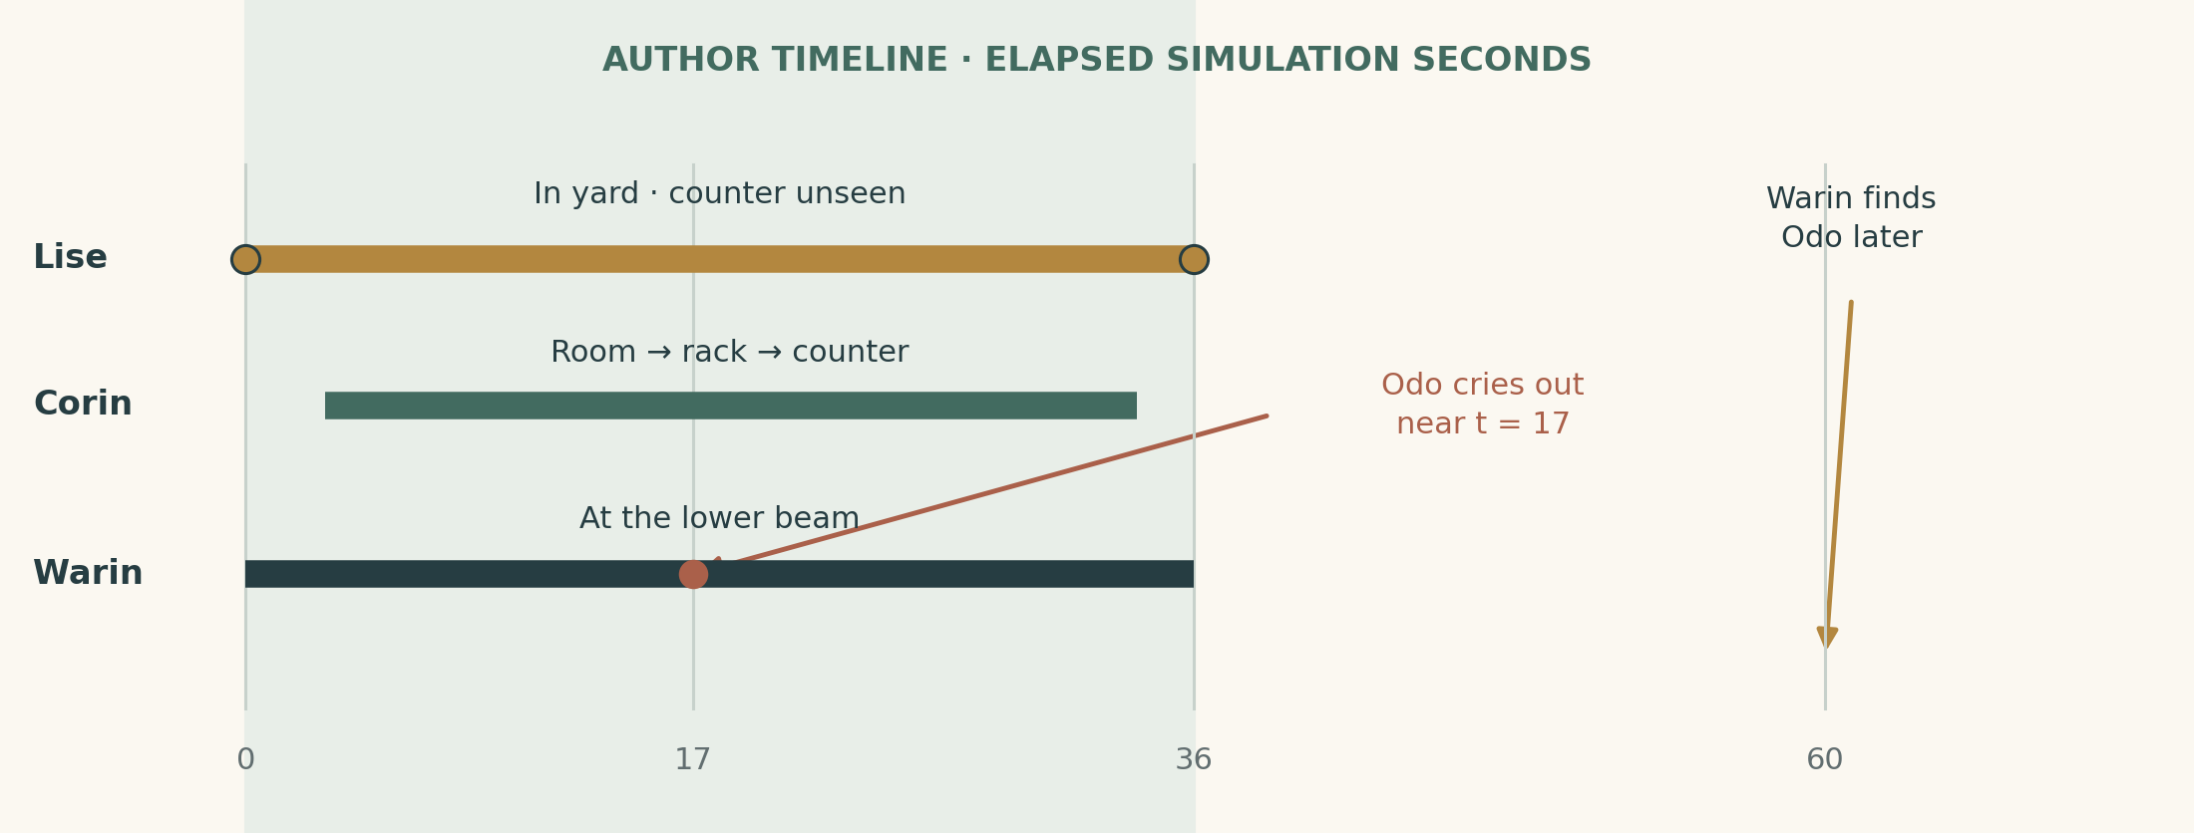
Reference incident. A short unobserved interval contains a complete private trip. Investigation establishes a conservative 32–40 second bound, not omniscient exact timestamps.
Time | Fixed event and resulting evidence
Before t = 0 | Odo inventories the packet; Gile receives its counterfoil. Warin argues over a fee, then starts a delivery below.
t = 0 | Lise sees Corin as the load leaves its marked rest. She moves into the yard; the counter leaves her sight.
t = 3–14 | Corin climbs the stair and takes the service connection: 22 m at reference NPC pace.
t ≈ 14–19 | Corin grabs the packet and shoves Odo. Near t = 17, the cry and stool fall interrupt the reading below. Averil and Gile see Warin there.
t ≈ 19–24 | Corin travels 6 m to the rack and spends three seconds hiding the packet.
t ≈ 24–34 | He returns the remaining 20 m to the counter.
t = 36 | The load reaches its upper mark; Lise returns and sees Corin again.
t ≈ 55–70 | Warin secures his load, takes the public stairs, finds Odo and calls. Averil follows; the packet is already gone.
Later | Mott holds Warin. Corin asserts continuous presence. Gile has left on an errand before questioning begins.

The observations of Warin are tied to the cry, not vaguely to “High Wick.” Sound and sight have verified local paths. The exact attack never moves retroactively to defeat a player's theory.
If the greybox cannot enact this sequence at legal speeds with the stated visibility, it has failed the scenario. Revise the chronology and every dependent clue together. The actor path and eight seconds of encounter/concealment yield a return near t = 33.9, safely before the reference sighting.

The geography is the central discovery
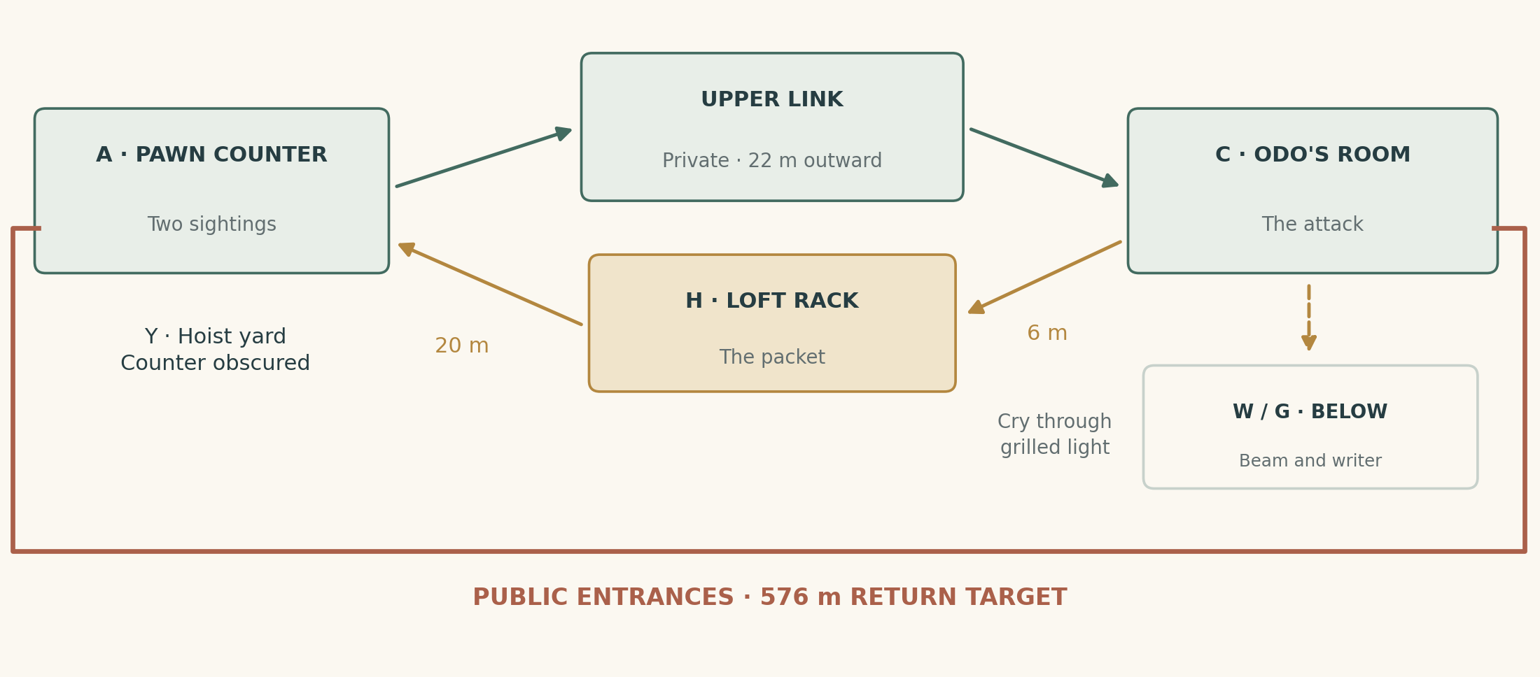
Proposed topology, not surveyed coordinates. The comparison room and pledge loft occupy adjoining rear property. Separate public entrances require a long lane circuit; the private connection crosses their upper boundary.
The Tallage, Tally Bridge and Lise's pawnshop are established places. The case adds a comparison room rented by Odo behind the shop's block, a usable pledge loft and a service connection. It does not move the canonical Tally Bridge or introduce water into the dry Cut. Placement must be reconciled with current geometry. [S4]

Every space has a purpose
A — Pawn counter: the two sightings, public alibi and Corin's conversational performance. Y — Hoist yard: the blind interval and its physical rhythm. C — Comparison room: assault, missing packet and upper entrance. W — Lower beam: Warin's position at the cry. G — Writing station: Gile's observation and counterfoil. H — Loft rack: the packet's initial hiding place.
The public walk teaches how the street-facing entrances relate. The upper route reveals how different those relationships become above ground. A small grilled back light links sound from the room to people below without being a walkable opening. Each connection can be inspected independently.

A visible connection to interpret
From the lane, mismatched shutters and a repair seam suggest two buildings nearly touch upstairs. Inside Odo's room, a service latch faces the wrong property. At Lise's shop, the stair has mundane labels for stored pledges. None glows, appears only after a dialogue flag, or bears a conveniently incriminating symbol.
The intended discovery is spatial recognition: “That back wall is the back of her shop.” It remains rewarding if found before hearing the alibi. The player can then ask better questions earlier.
The public circuit is an explicit production risk: fitting a long return route around two close properties must feel like inherited city fabric. If the actual Tallage cannot support it naturally, change the proposed room site and revalidate the case. Preserve established anchors; do not contort the city merely to protect a number.

Make the alibi mathematically fair
The premise must survive the fast player controller. Current walking/running speeds are 8/12 m/s; the ordinary NPC walk constant is 2.1 m/s. A trip that only seems impossible when walked slowly cannot justify a firm conclusion. Developer flight and teleportation are outside the case's physical rules. [S3]
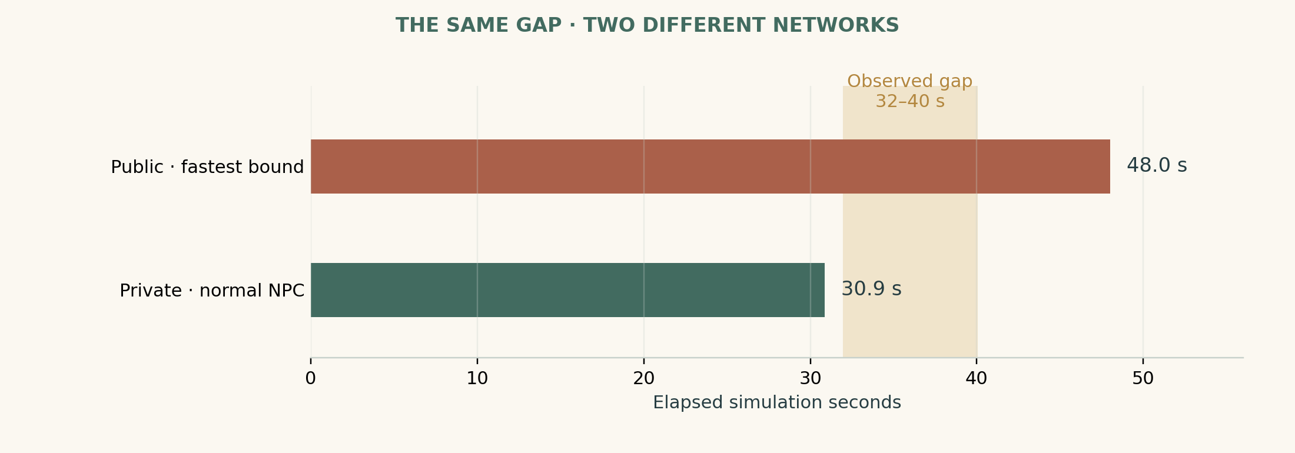
Design arithmetic, not measured navigation. Public travel alone exceeds the generous gap at the sprint ceiling. The private trip fits at NPC pace, including the offence and concealment.
Quantity | Greybox contract
Unobserved interval | Nominal 36 simulation seconds; defensible range 32–40 seconds
Shortest admissible public return trip | At least 576 m: travel alone takes 48 seconds at 12 m/s
Private circuit | 48 m: counter → room 22 m; room → rack 6 m; rack → counter 20 m
Private execution | 48 / 2.1 + 8 seconds for encounter and concealment ≈ 30.9 seconds
Result | Private trip fits the lower bound; public trip fails the upper bound

These are intended distances for adjoining properties whose public entrances face different lane networks. They are not measured existing routes. A 576 m return detour is a demanding site requirement; survey before committing this puzzle to production.

The interval belongs to work, not bells
The visible hoist follows a fixed rack travel between marked stops under a loaded, geared mechanism. Its uninterrupted operation is established by the people tending it. Supervised repeated cycles establish the conservative range. Stop it today and the demonstration records a stop; it cannot certify an uninterrupted historical interval.
No character derives precise minutes from bell strokes. The office establishes the period; a shared work event brackets the gap. At other day lengths, compare spatially meaningful elapsed durations with their recorded clock mapping. Do not multiply feasibility by a changed clock rate.
If another legal route beats the public bound, honour it. Re-author the strong “public route impossible” claim or choose another site. Do not add invisible walls, slow the player secretly, or reject a correct demonstration because it bypassed the planned passage.

What each account does and does not say
Speaker | First account | What questioning establishes | Limit
Corin | “I never left the counter.” | An explicit continuous-presence claim; he later admits loft access | A lie, not an admission of assault
Lise | “He was here while we took the load up.” | Start/end sightings; she watched the load from the yard between them | Two sightings do not cover the interval
Odo | “A hand took the packet.” | Service-side entry; cry and fall belonged to that encounter | No reliable facial identification
Warin | “I came up with the empty case.” | He was below at the cry and went upstairs afterwards | Cannot read his instruction; can identify the case
Averil | “He was beside me when Odo called.” | Warin was securing the load during the identifiable cry | Loves him; that does not invalidate sight
Gile | “The shout broke off our reading.” | He saw Warin below during it; received the counterfoil earlier | Cannot identify the attacker upstairs
Mott | “He had a grievance and was found there.” | The hold rests on the finder, fee dispute and missing property | Has no direct witness to the offence

Questions that move the case
Ask Lise “Could you see the counter from there?” Ask Averil “What were you doing when the voice came from that window?” Ask Gile “Did you look up before the carter went upstairs, or afterwards?” Ask Odo “Which side did you hear the latch?” Each turns an account into something inspectable.
The interface offers those topics after the relevant person, object or claim is known. Voice and free text remain available; no exact sentence is required. Unsupported details receive uncertainty rather than model invention.
Rumour compresses Lise's words into “his aunt watched him all the time.” The original attribution remains retrievable. Correcting her account does not turn her into a liar. A careful player can defend her honesty while exposing what Corin made it appear to prove.
Every character has a fixed knowledge boundary. Later learning updates an account with a source. No prompt grants a witness the author's hidden route or culprit flag. The case uses the shared knowledge-and-rumour system when it ships, rather than creating a parallel store. [S5]

Location one: Odo's comparison room
Mott permits supervised inspection as soon as asked. The player can also return through an appointment with Odo. Covert access is optional expansion content; the essential investigation never requires burglary.
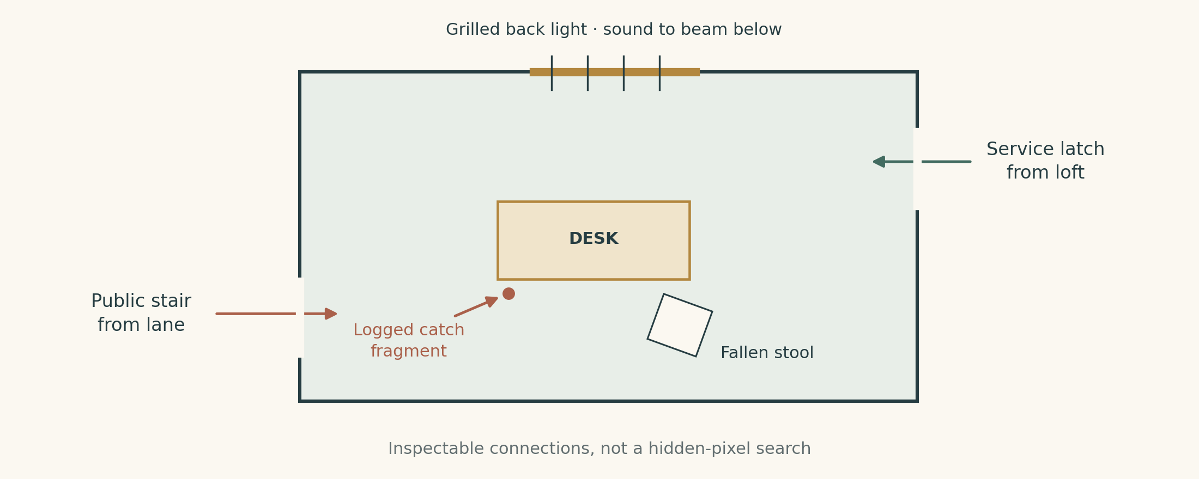
Conceptual room plan. The public stair, service latch and back light support different inferences. The attacker is not identified by a coloured footprint trail.

What the player can do
Inspect the empty packet position and ask Odo what belonged there. Compare the counterfoil when obtained. Examine the fallen stool and desk edge; their arrangement matches his account. Look through the back light toward the beam. Try the service latch from inside and notice it opens toward another property's loft.
Odo remembers without convenient total amnesia. He faced his papers, grasped for the packet, and turned into the shove. The partial view did not establish a face. He identifies the documents and entry side, not hair colour, height to the inch or an exact clock second.

Three facts, restrained deductions
The counterfoil establishes what is missing. The latch establishes an alternative entrance exists. The back light establishes the cry could reach the witnesses below. None states who committed the crime.
Ask Odo to stand at the desk and have a consenting helper speak from the relevant position. This tests audibility, not a replay of the assault. Captions carry equivalent source and timing information. Renderer geometry and sim witness calculation must agree.
Odo authenticates a recovered packet by its described contents, wrapper and matching counterfoil. He reads it aloud privately or publicly. He cannot be bought, accept a player-made substitute as an original, or identify Corin merely because the accusation sounds convincing.
The room remains available after review. Its state is recorded before cleaning, and later visits explain what moved. A late player can inspect a preserved scene sketch and repeat the sightline test, rather than losing the case to housekeeping.
Give the room enough tactile specificity to reward looking: an ink rest caught under the fallen stool, the free edge of a cord where the packet sat, and daylight through the upper seam. Those details orient the player. Only the named, validated observations enter the proof system.

Location two: the pawnshop alibi
Lise answers ordinary questions about the hoist and her nephew at the counter. Access to stored pledges requires a stated purpose because the loft holds other people's property. Her valuation fee is not a mandatory payment for essential testimony.
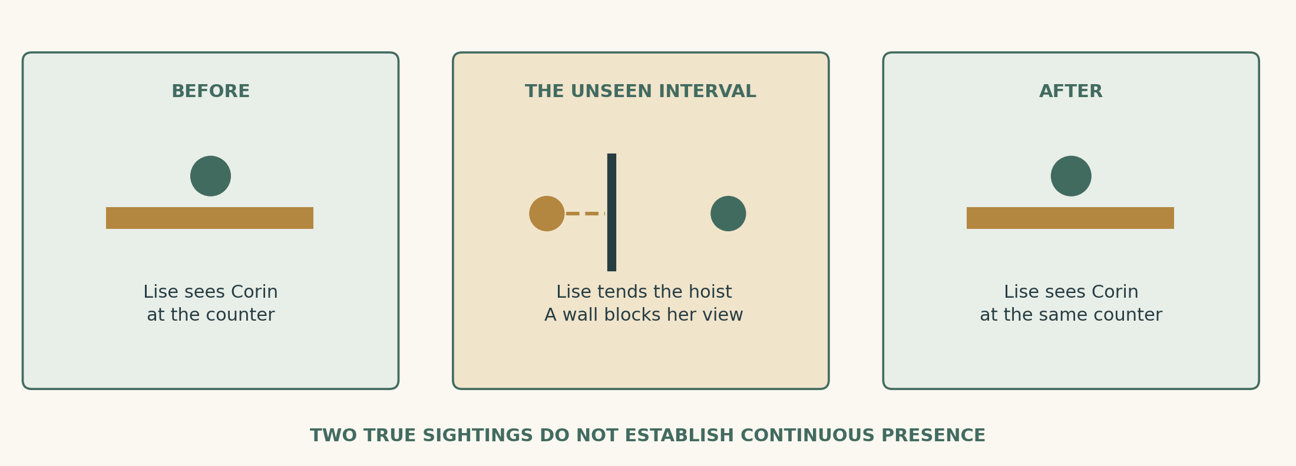
A person can honestly be seen twice without being watched continuously. Taking Lise's position makes the blind interval understandable by eye.

The first satisfying reversal
Ask her to show where she stood. Enter the yard with permission. A wall and stored goods block the public room. The last place you saw Corin is simply out of sight. Lise concedes this readily: she had work to do; she did not claim to be his keeper.
The notebook preserves two entries: Lise saw Corin at the marked start and finish; Corin claims he remained throughout. That distinction is a discovery. No red “LIAR” stamp appears over Lise's portrait.

Three ways into the loft
Ordinary access: ask to inspect the connection while Lise accompanies you. Naming the latch seen from Odo's side is sufficient reason. Official inspection: show Mott the two-door topology and request a limited route inspection. Independent exploration: enter during a supervised pledge retrieval, then ask to examine the connection while already upstairs.
All three use the same door and permissions. None requires exposing Lise's illiteracy, threatening her customers or completing an unrelated favour. A refused broad search can be answered with a narrower request to inspect the passage alone.
Lise will not knowingly certify a forgery. When text matters, she asks Odo or Gile to read it under witnessed practice. Her inability to read must never become a mandatory public revelation to unlock the solution.
Shown strong evidence against Corin, she asks to see the packet and hear his actual admission. Loyalty delays emotional acceptance, not submission of evidence elsewhere. She may remain an honest witness while withdrawing her warmth from the investigator.
If Corin is present, private questioning can warn him. The player sees that he is listening and can choose another time or room. A hidden universal suspicion meter cannot punish a conversation no one relevant heard.

Location three: the beam and Warin's alibi
Warin's position below is the fastest way to do something useful. The player can clear the wrong man's name before solving the entire crime. This creates an intermediate payoff and a genuine choice about pursuing Corin further.

Reconstruct the interrupted task
Averil shows the beam, the binding Warin was securing and Odo's window. She recalls a concrete instant: his hands were on the load when the cry interrupted Gile reading a line aloud. Warin finished securing it before going upstairs. That delay explains why he arrived after the attacker left.
Ask Warin to demonstrate and Averil to show her position. The player can see him and the window from there. Ask Gile separately what interrupted the reading. He identifies the same event and man below without first receiving Averil's account from the player.
Element | Evidential use
Averil's direct observation | Warin below at the cry; her relationship is disclosed as context
Gile's independent observation | Corroborates his position during that cry
Odo's account and local audibility | Connect the cry to the upstairs attack
Delivery instruction and case | Explain Warin's legitimate later approach, not innocence by themselves

When these align, Mott lifts the temporary hold and corrects the record. The player does not need the route puzzle first. Strong evidence against Corin also permits release if the witness chain was missed.

The human payoff
Warin goes back to his cart and checks it before saying anything elaborate. Averil stops arguing because its purpose is achieved. Warin offers one future cart journey on terms he can fulfil. He cannot grant someone else's cart or repeat that unique reward on every visit.
The fee dispute remains real. Warin can owe an honest copying charge while being innocent of assault. Odo corrects the accusation without inventing a spotless past for him. The distinction should be audible in their first conversation after release.
If only Averil is available, Mott records her account and offers provisional release under a named sponsor while seeking corroboration. Missing a second witness changes confidence and procedure; it does not erase the first observation. If the player lacks a sponsor, the free Gile route remains available.
At no point does the player have to know the hidden culprit to ask for Warin's release. Relieving a wrong and proving another person's responsibility are distinct achievements with separate state.

Location four: the man who taught Corin
Gile sits with a writing board near the Tally Bridge. His trade and usual place make him easy to find. If absent, a posted return office and people who saw him leave give a bounded lead. He is never scattered to an arbitrary corner to extend the investigation.

Start with what he saw
He remembers Warin below when the cry interrupted the reading. He did not see the attacker. He can read Warin's instruction and identify its delivery. These answers are free; affection for Corin does not make him suppress evidence clearing Warin.
His board holds Odo's duplicate counterfoil. Odo left it before comparing the originals, because moving papers without a list is bad practice. Gile permits inspection, supplies a witnessed copy or accompanies the player with it. Theft has custody consequences but is unnecessary.

What the paper establishes
The counterfoil names the original pledge, disputed release and distinctive wrapper. It records a mismatch between the release's supposed authority and the earlier instrument. It does not name the assailant. A notation says the fair copy came through Corin's desk, providing a reason to ask him about it.
Gile admits he taught Corin and recognises habits in his legitimate copying. He refuses to certify a crime from handwriting alone. He can point out a specific alteration for Odo to test against the original. Useful information stays narrow enough to be honest.

A conversation with weight
Shown the packet or a substantial contradiction, Gile stops praising the fine hand and asks whether anyone was hurt badly. He can attend the reconstruction. The player may show him evidence privately first, bring him unprepared into public proceedings, or leave him out if other proof suffices.
His reaction reflects that choice. He should not demand an unrelated errand, a persuasion roll or an unaffordable payment before stating what he witnessed. The tension is asking him to confront what the evidence may mean for someone he taught.
This location provides two independent forms of support: a direct observation about Warin and a pre-existing inventory record. Neither is manufactured after the questions begin. Creation time and custodians belong to the authored history.
Gile's counterfoil remains accessible if he is unavailable for the final scene: a witnessed copy can be lodged with Mott. That preserves the document's chain while acknowledging that a copied statement is a different thing from examining a living witness.

Walk the account before trying to disprove it
The player can ask Mott to mark the two public entrances on the learned map. The route overlay stops at known streets. It does not reveal a hidden loft, compute an unknown shortcut or draw a line through a solid building.

First walk: understand the mistake
Start at the pawn counter, leave through its public door and find the comparison room's public stair. The way winds around two separate yards. At the room, look back through the window and recognise how close the pawnshop's rear actually is. The detour has a reason in the architecture: entrances serve different lanes and property divisions persist above the street.
The walk should offer things to notice without unrelated interruptions. The sound of the same hoist carries across the two yards. A repeated painted shutter gives orientation. Looking upward reveals a service-level seam that the street route does not explain. The player learns the district while forming a new hypothesis.

Test what was claimed
The notebook can time a complete walk between nominated endpoints and record movement mode, stops and current door states. That is a measurement of today's attempt, not proof nobody could ever move faster. The case uses the conservative public minimum only after the admissible graph and speed ceiling are established in production.
Player result | Honest conclusion
Slow public walk takes longer than the gap | This attempt failed; a faster route or pace remains possible
Verified public lower bound exceeds the gap | The claim cannot be explained by the known public network
Player finds a faster legal route | The strong public-impossibility claim is false; preserve the valid discovery
A private route fits | At least one physically possible trip exists; its user is not yet identified

Do not require repeated sprint attempts. A successful measurement stays in the notebook. A guided reconstruction can later reproduce the route with a helper while the player watches the critical doorway.
If the player stops investigating after exposing the gap, the public record may remain “alibi incomplete.” That is useful progress, but it does not justify arresting the person the player dislikes most. The next question is who had access and what connects them to the missing property.

Find the upper way
The service route should feel like something work created and habit concealed. A narrow stair climbs above Lise's pledges; a short covered connection crosses a property seam; the comparison room's inner latch lies on the far side. It is mundane, awkward and extremely useful.

Discovery has three entrances
From the crime scene: inspect the service latch and ask where it goes. Odo knows it reaches the neighbouring upper property but normally leaves it alone. From the street: connect the back light and loft shutters, then ask Lise about her stair. From work: accompany a pledge retrieval and notice the short upper connection firsthand.
These clues coexist from the start. There is no hidden-route visibility flag unlocked by hearing the correct NPC sentence. Knowing what a doorway connects can add it to the map; discovery does not grant permission to use it.

What proves access at the relevant time
Lise confirms Corin routinely retrieves papers from the loft and used its key before the incident. Odo confirms the service latch was left unbarred for document transfer that morning. Those statements establish opportunity only. Neither remembers watching Corin cross during the attack.
The player can repeat the trip under supervision, entering the room and returning to the same counter. The 48 m reference circuit includes stairs and valid door interactions. It is not a line through roofs available only to the developer camera. A consenting stand-in at normal NPC pace can perform the route; no precision jumping is needed.

An additional discovery, not an automatic solution
The old rack H sits just off the return leg. It is reachable during route inspection, but a search of stored papers needs Lise's consent or Mott's narrower evidence authority. If the player inspects it before Corin's later retrieval, the packet is physically there. Its wrapper matches the missing inventory. Shared access means this does not prove who placed it.
Once the case ends, access to the passage may be granted, restricted to daylight, or barred by Lise. The player still knows the spatial connection. A later job can make that knowledge useful even if they must negotiate access anew.
The reward for discovery is immediate understanding and future capability. The route must remain interesting after its role in the mystery is known; otherwise it was only a disguised keyhole for one quest.

Stage a reconstruction people can watch
A reconstruction is a supported operation: choose a known claim, name its endpoints, obtain permission and ask a consenting helper to enact it. The player can carry the evidence, watch a blind corner, or walk alongside. They are arranging an experiment inside the city rather than solving a diagram in a menu.

The pawnshop experiment
Invite Lise and Mott; set the hoist to its marked starting rest; appoint a stand-in. Lise tends a comparable uninterrupted cycle in the yard. The stand-in leaves the counter, takes the authorised service route, pauses at the desk for the specified encounter interval, visits the rack and returns. Mott watches the relevant transitions and records the result.
When Lise comes back and finds the stand-in at the counter, the player sees the point of the case. Her original sightings can both be true. The demonstration does not imply she was lying or that the stand-in committed yesterday's crime.

Rules that keep the experiment honest
The action preview names route, movement speed, access states, expected duration and the claim being tested. No one is attacked. The encounter uses a short neutral “collect the marked packet” stand-in action. A stopped hoist, barred door, obstructed actor or player interruption invalidates that run's timing certificate and explains why.
The player can retry without paying a fee. A prior successful certificate survives later obstruction. If a witness leaves, Mott can record his own direct observation and arrange a later presentation. Multiple people need not be herded manually across the whole city.

Two useful outcomes
Fits: the alibi's claim of impossibility is refuted. Mott can authorise a specific further inspection when additional evidence makes it relevant. Does not fit: the current route or setup cannot establish the proposed opportunity. The notebook keeps the failed conditions; it does not quietly award success because the author knows Corin is guilty.
At normal clock settings this operation should take roughly two minutes including setup and acknowledgement. A skip option may advance a validated, already-seen reconstruction while presenting its result, but the first demonstration must be watchable. Text, captions and a simple interval bar communicate the same result for players who cannot depend on sound or precise visual timing.
The best line afterward belongs to Lise: “I saw him twice. I did not see him stay.” It summarises a discovery the player has already made with their eyes.

Evidence catalogue: the incident and alibis
Evidence IDs below are author-facing references. Player entries use human descriptions and sources. Each row states a fact's actual strength, so the implementation cannot silently upgrade a clue into a verdict.
ID | Evidence and acquisition | Establishes | Does not establish
E01 | Odo's recorded account; scene interview | Service-side encounter, cry/fall, missing packet | Attacker's identity
E02 | Inventory counterfoil held by Gile | Contents and wrapper existed before theft; disputed release came through Corin's copying work | Who removed it or struck Odo
E03 | Lise's start/end observations | Corin at counter at both hoist markers | Continuous presence
E04 | Yard sightline test | Counter invisible from her working position | That Corin actually departed
E05 | Uninterrupted historical lift account plus comparable-cycle measurements | Conservative 32–40 second absent-observation interval | Omniscient exact time or guilt
E06 | Averil's observation tied to Odo's cry | Warin at beam during the attack cue | Corin upstairs
E07 | Gile's separately recorded observation; audibility confirmed | Independent support for Warin below at the same cry | Authoritative identity of every sound source without Odo's matching account
E08 | Route inspection and reconstruction | Private trip physically possible with relevant historical access | Who used it

Independence is stored, not guessed from eloquence
Record whether a witness directly perceived an event or learned about it from another person. Gile repeating Averil's story is not a second independent observation. The authored Gile observation is first-hand and available before he hears her version. Later rumours do not overwrite its provenance.
The casebook links E06/E07 to the same cry via the independently described interrupted reading, Odo's account and verified sound path. This is specific enough for the player to test. “They were both somewhere in the Tallage that afternoon” would not be sufficient.
Evidence acquisition is open-order. Inspecting the route before the room adds E08 without inventing E01. A player can remember a conclusion personally; the official reconstruction still needs the underlying learned facts when asked to certify it.
No clue expires merely because a short-term LLM history buffer fills. Shared fact storage and case evidence references preserve it. Free-text recollection, a model's confidence and a rumour's popularity are never substitutes for a direct observation. [S5]

Evidence catalogue: connecting a person
The identity chain supplies the step a route puzzle alone cannot: evidence that Corin was involved in this particular removal and assault.
ID | Evidence and acquisition | Evidential use and limit
E09 | Actual packet, authenticated by Odo against E02 | Recovers the stolen originals. Found in a shared loft, it does not identify the concealer.
E10 | Broken brass catch half, logged under Odo's desk before player access | A physical part left during the struggle; Odo recalls grabbing the document wallet as the catch broke.
E11 | Matching damaged catch on Corin's wallet; consensual or authorised comparison | Two fracture surfaces fit as one object. A generic similar clasp is insufficient.
E12 | Lise's specific before/after wallet observation | She saw the catch intact before the lift and Corin struggling with it afterward; dates the break across the gap.
E13 | Directly witnessed Corin retrieval or custody of E09, recorded with continuity | Connects him to the stolen packet. A glimpse of an unidentified paper bundle does not qualify.
E14 | Recorded, confirmed Corin admission naming his own acts | Can support theft and/or assault as admitted; requires independent material corroboration and voluntary confirmation.
E15 | Corin's recorded continuous-presence claim and later incompatible account | Establishes a contradiction in his alibi, not guilt by itself.
E16 | Odo's comparison of original pledge and disputed release | Establishes the attempted documentary fraud and a motive to remove the packet; handwriting resemblance alone does not.

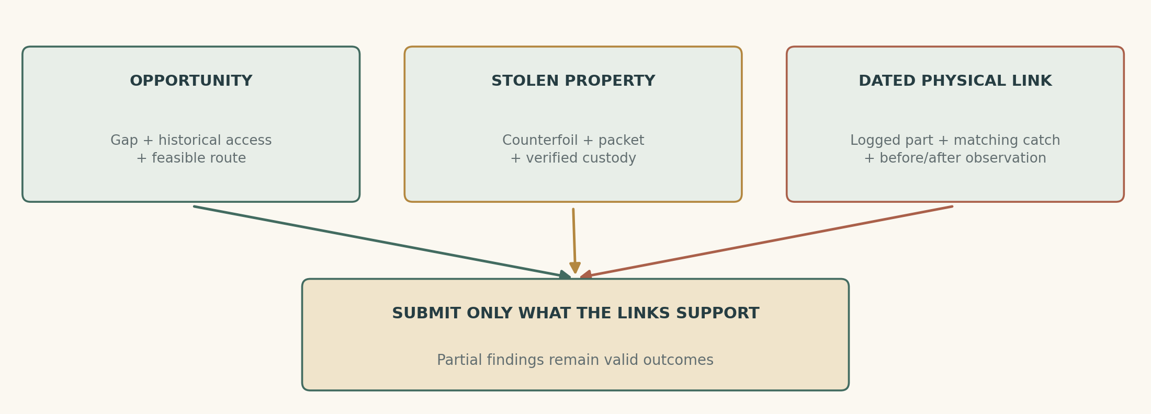
Independent links matter. Opportunity, recovered property and a dated physical connection converge; no single convenient clue announces the solution.
Additional author truth: during the brief struggle, Odo catches Corin's wallet as the packet is pushed into it. Its brass catch breaks; one half falls under the desk. Lise noticed the intact catch when Corin opened the wallet before the lift and its awkward closure afterward. This is an authored visual event and witness memory, not a forensic ability available on every item.
Mott's pre-inspection log protects E10's origin. If the player pockets, plants or alters a different fragment, its actual history follows it. Presentation cannot turn it into the logged piece. The player can manipulate or conceal evidence, but must accept that materially weaker or tainted evidence may fail to support a finding.
The catch comparison is a simple fitted-object inspection with enlarged shapes and text equivalents. It asks the player to connect places, objects and times; it does not require pixel hunting for a tiny metal speck.

The packet continues to exist
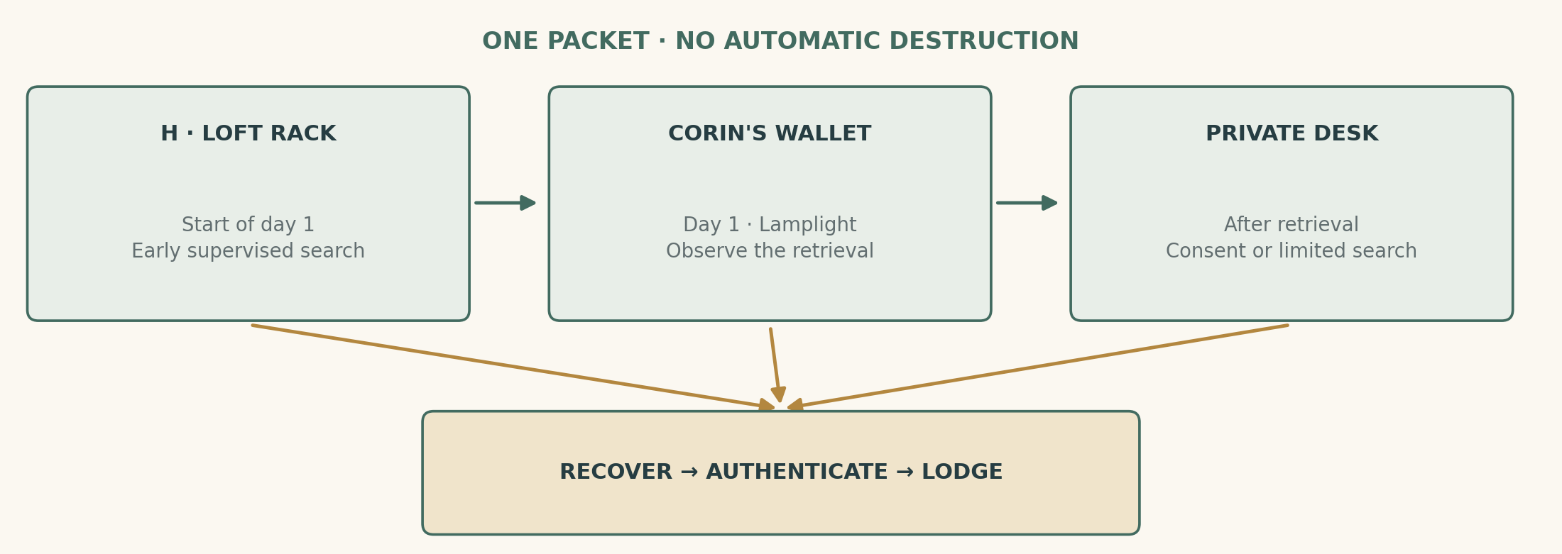
Default packet itinerary after the fixed crime. Early recovery prevents later moves; alert changes how Corin attempts retrieval, never teleports the evidence.

Three places, one object identity
At the start of day 1, E09 is in loft rack H. At Lamplight on day 1, if it remains there, Corin attempts to retrieve it and carry it to his locked writing desk in the pawnshop's private upper room. After the day-2 review, unresolved possession can move to sealed official custody if an inspection is authorised. Otherwise it remains in that desk for a reopened case.
The first version has no automatic burning or off-map sale. Missing the evening observation changes the evidential route without deleting the investigation. A later expansion could threaten destruction only after preserving another complete, explicitly authored way to establish responsibility.

Four acquisition routes
Inspect the rack: get Lise's permission or a limited official search; recover the packet early. Observe the retrieval: follow Corin, identify the packet at pickup or through a continuous witnessed chain, then request intervention. Inspect the desk: establish relevant grounds and have Corin or Mott open it. Negotiate surrender: secure a private, confirmed admission and let Corin produce the packet himself.
Finding the packet first is allowed. Odo's authentication gives it meaning. The person who happened to possess it later is not automatically its original thief; the case keeps acquisition and custody histories distinct.

Bounded official authority
Mott authorises a specific rack inspection when the authenticated missing-packet description, service-side entry and relevant access converge. A wallet comparison additionally needs the logged catch fragment and Lise's recognition of Corin's damaged catch. These thresholds describe investigative grounds, not findings of guilt. The same rules apply to any relevant holder.
A stolen key can make entry physically possible without creating lawful authority. The core version offers consent and official paths; covert seizure requires reliable entry/witness mechanics before it becomes a supported alternative.
On handover, the item moves to a named evidence holder and the notebook records a receipt. The player can retain a witnessed copy of its text. Odo cannot keep authenticating a packet already destroyed, and the LLM cannot conjure a replacement because the story needs one.

Corin's story changes under pressure
Corin is entertaining company until the questions become precise. He asks after people's families, makes a useful suggestion and explains why Warin's temper looked suspicious. His warmth is part of his established character. It must not function as an omnipotent charm spell against either the player or the officers.
Information shown to him | Supported response and resulting play
General questions only | Maintains E15: he stayed at the counter. Offers plausible directions toward witnesses.
Lise's blind interval | Admits she stepped away; repeats that he did not. No confession or new evidence appears.
Service route and access established | Concedes loft familiarity for legitimate copying. May offer to show the player an innocuous part of it.
Authenticated packet recovered from the rack | Claims someone else placed it there. Shared access makes that a possible defence, not a magical dismissal.
Packet retrieval observed or physical catch chain assembled | Seeks a private discussion; may offer surrender and a recorded admission. He can also refuse and face official inspection.
Reliable admission accepted | States exactly which acts he accepts; transfers real property under the negotiated terms.

The contradiction is preserved
The player can present the earlier claim beside the amended one. Corin may say he meant the shop generally, but the original wording remains available. The notebook does not silently replace “counter” with “building.” Nor should every small correction become a criminal lie.
His strategy is selected from bounded states using what he has actually learned. Questions asked privately of Gile do not alert him. Being shown the recovered packet does. Supported denial, evasion and negotiation give the LLM room for phrasing without letting it invent a new witness, an identical wallet or an unmodelled tunnel.

Make the offer tempting for a reason
He can offer a voluntary recorded account in a closed room, surrender the packet and pay a fixed restitution of eight sparks for Warin's lost work. That number is a design value, not established tariff. In return he asks for a private evidentiary submission that avoids broadcasting unrelated customer papers or humiliating Lise. He cannot purchase erasure of an assault record from Odo or Mott.
A player can also accept hush money and conceal evidence. That is a separate compromised outcome, with the inquiry remaining unresolved or mistaken according to what it received. The UI states what is being promised before the player commits.
No required confession relies on finding the right insult. A clear action list and typed/voice equivalents expose supported proposals once their conditions exist.

Optional operation: watch the return trip
This is the case's most active sequence. The player knows where an object might be, suspects who will come for it, and chooses a position before the suspect moves. It should feel like applying knowledge, not following a marker down a fixed corridor.

Plan the observation
The player can watch from the public yard, request a supervised loft observation, or ask Mott to place one officer at a lawful vantage while they cover the other end. A preview distinguishes what each position can see. The public yard can establish that Corin entered the loft; only a view of the rack or an unbroken object chain can establish retrieval of E09.
At day-1 Lamplight, Corin follows a real route if the packet remains hidden. If warned and he notices the observation position through valid perception, he may delay one attempt, take an already-defined alternative entrance, or abandon the retrieval for that office. He does not know about the player through a global alert radius or a camera through walls.

Three meaningful outcomes
Clear observation: the player sees the distinctive wrapper emerge and tracks it into his wallet. Mott's own view or a subsequent inspection can corroborate the identification. Partial observation: Corin enters and exits, but the packet stays unseen. The result is a useful lead, not E13. Detected: Corin asks what the player wants or turns away. A direct confrontation remains possible; the case has not failed.
If intercepted, Corin may try to reach the busy counter and argue in front of Lise. This is a short movement-and-conversation scene, not a combat encounter. The player can stay with him, call the already-positioned officer, or let him go and seek a warrant from recorded evidence.

Keep following optional
The packet can still be recovered from the desk. The catch chain and admission route remain available. Players uncomfortable with surveillance timing can arrange official observation or choose those alternatives without losing access to a sound conclusion.
Do not ship the detection branch while sight is still stubbed. The first slice can run a supervised observation with explicit visible positions and no covert-awareness claim. Advanced following belongs after tested occlusion, facing and line-of-sight rules. The proposed operation must never teach the player that a citizen behind two walls can see them waiting. [S6]

The notebook keeps claims apart
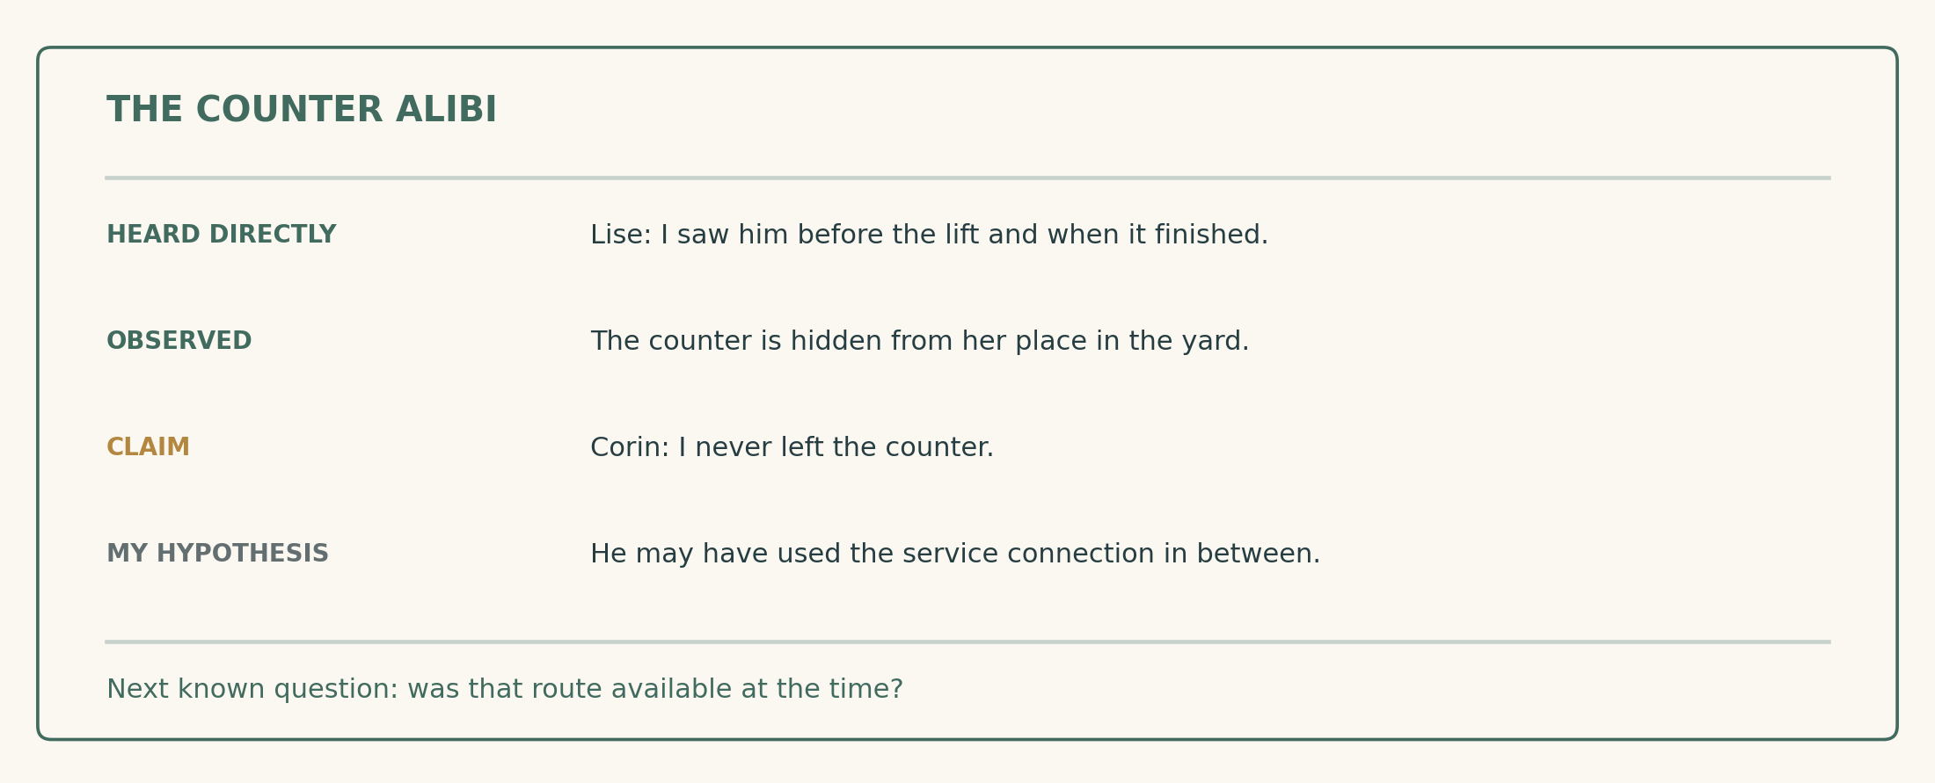
Proposed casebook view. Learned observations, source, uncertainty and a player hypothesis coexist. The interface does not announce the culprit or display hidden timestamps.
The notebook has four views: people's accounts, places and routes, objects and custody, and my reconstruction. All draw from the completed knowledge system's learned facts and receipts. A case-specific view may arrange them; it must not create a second authoritative truth store. [S5]

The player builds a reconstruction
Select an account, attach the work event that brackets it, and connect it to a location. A route can be linked as “possible journey” after it has been learned. Direct observations appear with their witness and date. Hearsay carries its source chain. Personal notes are visibly separate from certified facts.
Useful system statements are narrow: “Lise did not see the counter during this interval”; “This observed trip fits”; “The packet's wrapper matches the counterfoil.” Avoid “Corin is lying” or a percentage guilt gauge. The player should perform the act of interpretation.

An accusation is reviewable before submission
The evidence bundle preview lists the exact claims being advanced, the supporting objects/statements, missing corroboration and whether any evidence has a disputed custody chain. It never supplies an unknown clue. The player can submit a limited request—release Warin, search the loft, authenticate the packet—without selecting a culprit.
The interface supports free speech with a compact evidence picker. “Show what Lise said about the lift” selects the same learned claim as clicking it. A misrecognised name prompts confirmation; it does not accuse the wrong person in public.

Returning after a break
On load, show where the investigation stood, the next announced appointment and the last confirmed custodian of each important object. Do not give omniscient live tracking. If Corin moved a packet out of sight, the notebook still says it was last confirmed in the rack until the player learns otherwise.
A layered reminder can offer a known unanswered question, then suggest a person who might answer it. The final hint may restate a learned contradiction. It cannot reveal the upstairs connection before any source or observation has made it available.

Opportunity is not identity; identity is not proof of every charge
The resolver evaluates submitted, admissible facts without reading the hidden culprit. These thresholds support correction, investigation and referral in this fictional inquiry. “Substantiated” means sufficient grounds to refer an allegation, not a final conviction or deductive certainty against every imaginable alternative.
Requested finding | Sufficient supported bundle | Insufficient substitute
Correct the continuous alibi | E03 + E04: two sightings with an unseen gap | A rumour that Lise is dishonest
Establish private-route opportunity | E03–E05 + E08, including relevant historical access | Knowing a passage exists today
Clear Warin on the witness route | E01 + E06 + E07, with verified shared cry and local sight/sound | Averil's affection or an unrelated delivery receipt
Record recovery of stolen property | E02 + authenticated E09 with custody | A visually similar paper bundle
Substantiate Corin's theft | Recovery plus verified E13 and E15; OR corroborated E14 naming theft | Packet found in a shared room plus motive
Substantiate Corin's assault | E01 + E10 + E11 + E12; OR corroborated E14 naming the shove | Mere opportunity or later possession of stolen papers

An admission needs material corroboration: E09 authenticated against E02 for theft, and the victim's independently recorded E01 plus either the dated catch chain or a confirmed detail of the assault not supplied by the interrogator for assault. The admitted act, not a vague “I did it,” must be recorded and voluntarily confirmed.
The physical chain deliberately combines origin, match and time. A catch fragment under the desk, a wallet that fits it, and an intact-before/broken-after observation connect that wallet to this struggle. Without the timing link, a past innocuous visit remains a possible explanation. If one part is missing, ask for it rather than silently filling it from author truth.

Evidence can justify a partial conclusion
Theft can be substantiated while assault remains unresolved. Warin can be cleared while nobody else is identified. Corin can confess privately without the upper-route demonstration. Those are legitimate outcomes with different records and consequences.
Mott records the finding, lifts or applies appropriate restraints under the case procedure, secures property and refers charges to the Bench. This quest does not stage a final criminal trial, choose a sentence or make the injured Odo judge his own case. What the player sees is the correction of an accusation and the supported next action.

The public reconstruction
The announced review happens at High Wick on day 2 in the Tallage. The player can request an earlier limited finding once a sufficient bundle exists. The event should gather the necessary people and objects within a small scene; it must not require individually escorting seven NPCs through a large city.

A playable sequence, not a final speech puzzle
1. State the request. Release Warin, record a defective alibi, authorise a search, substantiate a particular offence, or defer judgment. The preview shows the claims and evidence the player is choosing to disclose.
2. Hear the relevant accounts. Mott invites only witnesses needed for those claims. The player can ask one of the learned clarification questions or show a contradiction. Each witness's essential recorded proposition is deterministic; the model supplies phrasing and reaction around it.
3. Put a claim into the world. Demonstrate Lise's blind position, repeat the private trip, align the catch pieces or have Odo compare the packet. The player chooses an appropriate demonstration, and the observers see the same geometry and object state.
4. Receive an explicit finding. Mott says what the evidence supports and what it does not. A deficient bundle names the missing link without revealing an unknown solution. The player may continue collecting evidence and return.

Where drama enters
Corin can amend his claim, refuse a voluntary comparison or request a private submission. Lise can correct the crowd's “she watched him” account and still defend her nephew. Warin can interrupt a description of his supposed anger. Odo asks that the actual disputed paper be read, not a colourful account of it. These reactions respond to the player's chosen disclosures.
The physical payoff is immediate. A cleared Warin stands and returns to work. An authenticated packet goes into named custody. A supported case against Corin prompts Mott to approach and escort him, if present, or issue a targeted warrant if absent. No victory animation substitutes for those actions.
The player is not forced to broadcast unrelated pledge holders' private information or Lise's illiteracy. The same material can be authenticated in a closed comparison and its narrow conclusion read publicly. Preserving privacy should not require deliberately weakening an otherwise complete case.
If the player is absent, the scheduled review resolves from what was actually lodged. It does not invent their unsubmitted deductions. New evidence later permits a correction and visible amended notice.

A quieter resolution—and a compromised one
The case should support discretion without implying that every official can be bought. Odo's established refusal of bribes is binding. Corin can bargain over how he gives evidence and makes restitution, not over whether a witnessed assault happened.

Private submission
With enough pressure from the recovered packet, observed retrieval or catch chain, the player can propose a closed meeting with Corin, Odo and Mott. Corin confirms a typed account of the acts he admits, produces the packet and offers eight sparks to Warin for lost work. Payment transfers real coins and cannot exceed what the scenario has seeded in his purse.
Odo authenticates the originals. Mott records the admission and applies the same corroboration standard as a public submission. Warin's correction can be public while unnecessary customer details stay sealed. Corin's case still goes to the Bench. The reward is a defensible resolution with less public humiliation, not an erased offence.
Lise may appreciate discretion while refusing to thank the player for uncovering her nephew's conduct. Gile can hear the result privately before the square. These are specific later reactions, not a universal reputation bonus for choosing the “nice” option.

Hush agreement
Corin can separately offer eight sparks for the player to withhold the packet or a witness account. The offer card states what silence covers and who may remain suspected. Accepting does not stop Averil, Gile or other informed people from giving their own accounts, and it does not make already-submitted records disappear.
If the player takes payment then discloses the evidence, Corin has a personal grievance about the broken arrangement; the evidence's truth is unchanged. If they genuinely conceal it, the official result follows the surviving evidence. Warin may still be cleared through the independent witness chain, while Corin's responsibility remains unresolved.

Refuse the bargain
The player can submit a sound case without negotiating. No essential object is locked behind an agreement to spare Corin, protect Lise or accept money. That matters because the most satisfying version for some players is simply doing the investigation carefully and refusing to trade its conclusion.
Discretion, restitution and concealment are presented as separate choices. The document should never blur them into one morally convenient “settle quietly” button. The player sees exactly which facts remain on record and what action follows.

Endings are several records, not one score
The quest tracks Warin's status, packet recovery, supported allegations against Corin, disclosure scope and any restitution separately. The following are representative combinations, not mutually exclusive dialogue endings.
Result | Immediate scene | What changes on a later visit
Warin cleared; culprit unresolved | Mott corrects the accusation; Warin returns to his cart | His one cart favour becomes available. Corin remains at work; the case can reopen.
Packet recovered; identity unresolved | Odo authenticates it and resumes the pledge comparison | The craft household's tools can be released to their rightful holder; the alibi may remain disputed.
Theft supported; assault unresolved | Corin's possession/removal is recorded; further examination ordered | He loses unsupervised document access. The assault remains an open question.
Full public case | Packet and catch shown; Warin cleared; Mott secures Corin or issues a targeted warrant | Amended public notice, changed shop access, visible return of tools and specific witness reactions.
Corroborated private admission | Closed comparison; narrow public correction; real restitution | Same supported charges, fewer unrelated disclosures; Lise's later conduct reflects discretion.
Hush money, insufficient lodged proof | No automatic clearing of the record; review proceeds on other testimony | Unresolved suspicion and a private broken-or-kept bargain, with the packet still recoverable.
Player absent or inconclusive | Review records uncertainty; temporary hold ends, inquiry remains open | Warin has lost work and remains publicly suspected until corrected. The player can still investigate.

Bound the consequences
This quest does not execute anyone, confiscate every family property or permanently imprison Warin for lack of player attention. The initial hold is temporary. A supported case against Corin leads to referral, custody or a warrant under existing law mechanics; sentencing is outside this authored sequence.
Formal innocence has a visible benefit beyond provisional release: the notice changes, ordinary work resumes and people stop treating the original allegation as established. The game should show that correction at the cart stand and through relevant conversations, not just print a completion message.
Lise decides future access based on the actual incident and what the player disclosed. A lawful, discreet inspection may preserve a supervised shortcut; an unauthorised search may close it. She cannot erase the player's geographical knowledge. No universal reputation number makes unrelated citizens instantly react.
The final line in the notebook lists the settled facts and remaining questions. It must be possible to end with “Warin cleared; stolen packet recovered; assailant not established” and feel that real work was accomplished.

Full playthrough: from suspicion to reconstruction
This is an illustrative first run, not evidence of an implemented playtest. Times indicate a desired rhythm, not gates that prevent faster reasoning.
0–10 minutes: take an interest. The player meets Averil and Warin, hears the fee dispute and asks Mott to inspect the room. Upstairs, Odo describes the service-side entry. The player looks through the back light, recognising the beam below, then notes the latch into another upper property.
10–25 minutes: separate the witnesses. Averil explains what she saw at the cry. Gile independently remembers the reading stopping and Warin below. He produces the counterfoil and reads the missing packet's contents. The player returns to Mott with a limited request: clear Warin. Mott does; the cart becomes active again. The player has already achieved something worthwhile.
25–40 minutes: test the comfortable story. At Lise's counter, Corin says he stayed there. Lise gives the start/end sightings. Asked to show her working position, she leads the player into the yard. The counter vanishes behind a wall. Walking the public circuit makes the adjoining properties' strange separation legible.
40–55 minutes: discover the other way. The player asks about the latch and gets a supervised loft visit. The upper trip is short. A reconstruction demonstrates that a person can leave, reach the desk and return between sightings. Lise corrects her account. The player has established opportunity without yet accusing anyone.
55–75 minutes: connect objects to the event. Mott's scene inventory includes the broken catch. Lise recalls Corin's damaged wallet and its intact appearance before the lift. The player requests a comparison. The pieces fit. A limited rack or desk inspection recovers the packet, depending on whether Corin's evening retrieval has happened. Odo authenticates it against Gile's counterfoil.
75–100 minutes: decide what to disclose. Corin asks for a private conversation. The player can hear his offer, then choose a public reconstruction. At the review, the alibi, catch and authenticated packet are presented in that order. Mott records only supported allegations and corrects Warin's status. The original pledge comparison resumes.

The return visit
Warin is working, the amended notice is posted and Gile's greeting is quieter. Lise grants supervised passage access but says little about Corin. The player now recognises the upper connection from the street. A solved mystery has changed how the city is read and how a familiar route can be used.
The sequence contains two payoffs before the final case: freeing Warin and making the alibi collapse in a visible experiment. Avoid postponing every satisfying moment until the last hearing.

Other complete ways through the case

The explorer finds the packet first
The player visits the loft with permission before fully understanding the allegation and notices Odo's wrapper in rack H. Lise permits its presentation to Odo. Authentication establishes stolen property in shared space. It does not accuse Corin. The player then asks who used the loft, records the alibi and pursues either the catch comparison or a private admission. The case accepts the reversed order without replaying introductory discoveries.

The compassionate investigator stops early
The player speaks to Averil, Gile and Odo, verifies the shared cry and submits Warin's exonerating bundle. Warin is released and publicly cleared. The player declines further involvement. The case remains open as an optional thread; there is no false “incomplete” screen denying the achieved result.

The watcher skips the loft search
After learning the route, the player watches the rack at Lamplight with consent and asks Mott to cover the exit. Corin retrieves the identifiable packet. The observation survives a continuous handoff into his wallet; Mott's inspection confirms it. Corin offers a private admission. With independent corroboration, the player can resolve the case without searching his desk or staging every available demonstration.

The official investigator avoids intimate disclosures
The player collects the counterfoil, records Odo's entry-side account and documents the sightline gap. They ask Mott for a limited inspection, locate the packet, then request the catch comparison using the logged fragment and Lise's object recognition. The same substantive case can be made without exposing Lise's literacy or customers, bargaining with Corin or pretending friendship.

The late arrival reopens the record
The first review has passed; Warin is provisionally free but still suspected. Corin has moved the packet to his desk. Preserved scene notes, the counterfoil and the direct witness records remain. The player obtains the catch comparison or an admission, recovers the packet and asks for a corrected finding at the next High Wick. The amended notice is visible. The missed surveillance opportunity changes the route, not the existence of a solvable case.
All these paths settle through the same rules and world state. There is no separate “quest complete” verb that one branch receives and another forgets. Missing a preferred scene is not a reason to reject an otherwise sound case.

When players do the unexpected
Action or failure | What the world does | Continuing route
Accuse Corin immediately | Records an unsupported allegation; no arrest from a guessed name | Ask for evidence, inspect the room, or retract the claim
Search the wrong suspect's belongings | Consent and scope rules apply normally | Nothing creates incriminating evidence because the player selected someone
Recover the packet and conceal it | Its actual holder changes; no handover receipt is minted | Return it later, submit other proof, or accept a compromised outcome
Plant a packet in another room | Casual observers may be misled; no omniscient accusation of planting | Formal findings still require independent links beyond location
Warn Corin too early | He changes a bounded retrieval strategy once informed | Rack/desk search, catch comparison and private admission remain
Miss the retrieval | Packet reaches the desk through real movement | Obtain a limited inspection or negotiated surrender
Interrupt a reconstruction | Certificate reports the altered conditions | Reset with consent; retry free; retain earlier valid evidence
Lose a document | Notebook keeps last confirmed custody, not a live tracker | Counterfoil copy, official storage receipt or current holder supplies recovery
Leave during the hearing | Mott resolves only the lodged request and evidence | Return with another bundle or request correction later
Provider/STT unavailable | Deterministic essential propositions and supported action cards remain | Continue with text/action list and authored fallback responses

Accept genuine lateral solutions
A faster valid public route refutes a claim of impossibility. A stolen key may grant physical access, with separate permission consequences. An early voluntary, confirmed admission with adequate corroboration may end the case. A player who establishes Warin's position need not find Corin first.
The engine must not use private author knowledge to make every official infallible. Unobserved planting can fool a casual witness. A broken custody chain is disqualifying only when that gap or discrepancy is knowable in the submitted evidence. The strongest formal bundles require independent physical/time links so a paper's new location alone cannot prove assault.
False or unsupported model claims never mint physical evidence. They remain statements with speakers and sources. No model can announce that a route was measured, a witness attended or a fragment matched when the corresponding operation did not occur.
The game has no required combat route. If future systems allow a key witness to be incapacitated, use preserved observations and physical alternatives; do not silently resurrect them or give another character their unshared knowledge.

Time, accessibility and a case worth returning to
Case day 0 contains the fixed crime at High Wick. The opening is day 1 at Dayspring, 07:00. Corin's optional retrieval is day 1 at Lamplight, 18:00. Review is day 2 at High Wick, 12:00. At the current one-hour day, those are 27.5 and 72.5 real minutes after the opening, before pauses. [S3]

Pressure without a disappearing mystery
The retrieval window offers a useful observation. Missing it sends the packet to a known recoverable property. Missing review produces a provisional record that can be corrected. The player can request one scheduled deferral by lodging a concrete pending examination; that moves the public appointment without freezing everyone else's work.
In the proposed single-player case mode, world-clock advancement pauses while blocking evidence selection, text composition, menus or required response delivery prevent action. Schedules pause with it. During a timed reconstruction, conversation is queued or the experiment reports interruption; never silently run its actor clock while pausing only the hoist.
Waiting previews the destination office, known appointments and consequences. Past-incident elapsed timings keep their original mapping if the user changes day length. Measured physical feasibility always uses route distance, allowed movement and required interaction time, not the cosmetic number of game minutes shown.

Several ways to perform the same reasoning
Every essential voice exchange has typed and action-list equivalents. Captions identify the cry's source and its relation to the interrupted task. A transcript preserves exact claims. Large-print document excerpts and read-aloud authentication avoid tiny handwriting puzzles. Catch alignment has an enlarged model and textual result.
The player can appoint a stand-in for the route demonstration. No motor-speed test decides whether a clue is true. Map annotations, reduced camera motion, UI scaling and a layered hint system support orientation without revealing unknown information.

Stop whenever you need to
Save anywhere. Persist evidence, clock, custody, doors, NPC intents, pending review and any in-progress operation coherently. On returning, show the last established result, next appointment and known unresolved question. A lodged case is not lost because the player ended a session.
The first human playtest should ask whether the player wanted to continue after clearing Warin. If the remaining investigation feels like paperwork, strengthen the spatial discovery and confrontation before adding another suspect or a longer deadline.

What exists, and what this case must add
The repository provides useful foundations: a pure authoritative sim, typed item/action semantics, actor schedules, speech and chat, place knowledge, law/custody, map and first-person movement. It does not yet establish every promise required by this case. [S1, S6]
Layer | Existing foundation | Required case work
People and time | Cast, rounds, clock, staged cognition, Night Office | Fixed incident facts, bounded case appointments and suspect operation
Knowledge | Feature plans and M0 experiment evidence; main status still spec-only | Finish the agreed shared feature before quest implementation; consume its shipped API
Physical play | Exterior city, Lanthorn interior, rapid player movement | Selected real interiors, service link, hoist fixture, safe inspection positions
Access | Keys/permissions have a detailed proposal | Implement the necessary authored thresholds and consent/inspection scope
Evidence | Items, holders, events and existing law | Counterfoil, paired catch parts, provenance-preserving operations and evidence bundles
Perception | Hearing recipient calculation; some witness machinery | Verified local sight/sound; current default sight stub cannot support covert following
Persistence | Public snapshots; no established general full save/load | Versioned complete checkpoint and coherent restoration of operations

Preserve the existing authority boundary
The sim owns items, permission, movement operations, facts, timing certificates, submissions and findings. Bevy displays those results and supplies validated spatial observations. The LLM chooses permitted speech/actions from the character's knowledge and current strategy; it cannot certify a measurement or create a physical clue. IO and save files stay in the host/backends.
Do not build another quest-specific knowledge graph that competes with the shared fact system. Case state references fact and item IDs. Personal hypotheses are a presentation layer. Night reflection can affect tone and future personal choices; skipped night calls cannot delete evidence or decide whether Warin was cleared.
The first slice can operate with seven focal actors and ordinary background crowds. The crime, packet transfer and hearing skeleton must run under the fake backend. Live cognition adds individual voice and flexible phrasing, not correctness of the solution.
All new geometry and biographies remain proposals until reconciled. The code's actual speed and collision rules take precedence over attractive route numbers in this document. A convincing mathematical table cannot substitute for walking the site.

State, content and scope of the first build
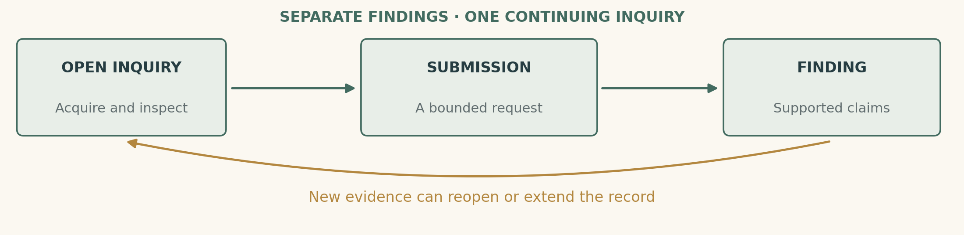
A case can be partially resolved, reopened or left alone. Packet custody and individual findings remain separate from the high-level inquiry phase.

Minimum domain records
A fixed incident record stores authored events, observation provenance, initial object holders and historical access states. The inquiry references acquired evidence, submitted bundles, findings, review time and disclosure choices. Separate operation records describe route demonstrations and Corin's retrieval, including participants, route, phase and interruption reason.
Track Warin's hold/clearance, authenticated packet custody, theft finding, assault finding and restitution independently. Corin's private role in the seed may drive his truthful internal knowledge and strategy; the findings evaluator must have no access to a “player guessed culprit” shortcut.
Content | First-build cap
Principal cast | Seven existing named people; no extra essential client or household witness
Rooms and route | Pawn counter, yard, loft/rack, comparison room, private desk; existing nearby public workstations
New significant objects | Original packet and counterfoil; two matching catch parts including wallet; evidence copies with provenance
Reusable interactions | Inspect, ask about a learned claim, consent/limited entry, show/compare, lodge evidence, appoint stand-in, reconstruct
Outcomes | Warin clearance, property recovery, theft/assault findings, public/private submission and reopened inquiry
Optional operation | One bounded packet retrieval; advanced covert detection only after sight is reliable

A complete first slice
Implement the room, counterfoil, two sightings, sightline gap, private route, paired catch and a small public reconstruction. Include at least the independent-Warin route and a full physical-evidence case against Corin. Then add private admission and moving-packet observation as alternatives on the same state model.
The earliest process-only prototype must be labelled as such. Full save/load is required before calling the multi-day investigation delivered. Existing knowledge work ships first, as already decided in its README; this GDD does not change backlog order. [S5]
Defer a general trial simulator, procedurally generated crimes, universal forensic traces, city-wide surveillance, combat, a new political campaign and a supernatural explanation. The successful first release is one case whose facts survive close inspection and whose places are enjoyable to investigate.

Milestones and tests that can reject the design
Milestone | Deliverable | Advance only when…
M0 — prove the site | Survey existing geometry; build proposed paths and sightlines; reconcile cast and knowledge API | Public/private timing inequality and local cry/visibility work without artificial blockers
M1 — one honest case | Fixed incident, room, packet/counterfoil, witness accounts, catch chain and simple findings | An offline run can clear Warin and substantiate Corin through independent evidence
M2 — walk and demonstrate | Doors, consent, notebook, stand-in reconstruction and public scene | Players discover the gap and can explain possibility versus guilt
M3 — alternate approaches | Early packet recovery, private admission, late reopening and bounded retrieval | Solutions survive changed order, absence and partial observation
M4 — persist and polish | Full checkpoint, input parity, final presentation and return-state behaviour | Quit/reload at every important transition preserves a coherent case

Deterministic acceptance
Check all legal paths against timing, including sprinting and changed doors; the private incident with actual NPC motion; intact-before/broken-after catch timing; custody conservation; facts limited to actual recipients; no false independence from repeated hearsay; interrupted experiments; early packet recovery preventing later pickup; admission limited to corroborated acts; and findings computed without reading culprit identity.
Enumerate evidence subsets around each threshold. Removing one essential link must downgrade the corresponding finding. Adding a rumour or personal accusation must not restore it. The companion design validator checks the numeric proposal and these illustrative proof recipes; it does not certify navigation, NPC performance or the final game implementation.

Human acceptance
With five to eight formative testers, look for three unaided discoveries: two sightings are not continuous observation; the upper connection changes the possible journey; opportunity is insufficient to identify an assailant. Ask them to explain their own conclusion before showing any author solution.
At least two approaches should lead to satisfying conclusions. Players who stop after clearing Warin should recognise that as a legitimate achievement. Voice, typing and action-list testers must reach equivalent evidence. A slow reader must not lose the whole mystery while reading a document.
If testers merely collect highlighted clues until the notebook names Corin, the design has failed. If the geometry needs a contrived detour to preserve its number, revise the site. If the case is solvable but dull, improve the demonstrations and character reactions before multiplying crimes. Validate visuals using CATHEDRAL_HEADLESS=1; actual enjoyment still requires human play.

Sources: architecture, cast and geography
This rewrite is grounded in the local working tree inspected on 4 September 2026, HEAD f56a2c306ec1523fc569c7c2de232b8c90d4d4ef, including visible uncommitted knowledge-design material. Bracketed IDs refer to the following repository-relative sources. source_manifest.json records their hashes at generation.
[S1] Architecture and existing systems. AGENTS.md; crates/​cathedral-sim/​AGENTS.md; crates/​cathedral-sim/​src/​{lib,engine,actions,world,round,night,event,snapshot}.rs; src/​smart_​actors/​{local_​engine,interaction,chat,inventory_​ui}.rs. Establish the pure in-process sim, typed actions, schedules, model boundary and projection. Representative sections were inspected; this is not a whole-repository implementation audit.
[S2] Cast, directly read. lore/​characters/​scribe_​and_​clerk/​fc9rn_​corin_​copp.json; money_​dealer/​fl5cp_​lise_​copp.json; court_​officer/​fo6gl_​odo_​trask.json; cargo_​worker/​fw7ub_​warin_​underbridge.json; revenue_​worker/​fa8tn_​averil_​tarn.json; scribe_​and_​clerk/​fg4br_​gile_​of_​brede.json; bailiff_​and_​gaoler/​p00a3_​segwin_​mott.json, all under lore/​characters/​. These supply personalities, occupations and relationships. Every crime action, case memory and appointment is a new proposed override, not an assertion that the authored cast has already done it.
[S3] Movement and time. src/​controller.rs: WALK_SPEED = 8, RUN_SPEED = 12; crates/​cathedral-sim/​src/​lib.rs: WALK_SPEED_MPS = 2.1; crates/​cathedral-sim/​src/​clock.rs: Dayspring 07:00, High Wick 12:00, Waning 15:00, Lamplight 18:00, Snuffing 21:00; config.ron: seconds_per_day = 3600. These inspected values motivate the explicit separation of game-clock labels and elapsed physical travel time.
[S4] Place and canon. lore/​places/​00_​city_​plan.md and 02_canonical_gazetteer.md, particularly the Tallage, Tally Bridge and Lise's pawnshop; assets/​world/​areas.json; lore/​the_​dry_​boatmen.md; lore/​second_​sun/​00_​canon.md. The Tally Bridge connects the toll-house and bonded warehouse above a dry street; Lise's shop faces it. New rear rooms and their geometry require site reconciliation. The Second Sun has no physical causal role in this crime, and the investigation resolves no protected cosmological ambiguity.
[S5] Knowledge and rumour. features/​knowledge_​and_​rumor/​README.md; plan/​M1.md and plan/​M5.md; m0_​evidence/​NOTES.md. The README still says spec-only while experiments and milestone plans exist. Its explicit rule is to finish the shared feature end-to-end before quest work and reconcile quest interfaces against what ships. This proposal respects that order and owns no competing fact store.

Sources: scope, artefacts and verification
[S6] Access, law and perception gaps. features/​keys_​and_​locked_​places.md; crates/​cathedral-sim/​src/​{traits,notices,custody,marks}.rs; features/​implemented/​law_​and_​order.md; src/​map.rs. Existing façade doors do not imply playable rooms, physical keys do not imply permission, and no established general whole-world save is identified. The default sight implementation returns true; advanced covert following requires real tested perception.
[S7] Related quest work. features/​quest_​the_​bale_​that_​gained_​forty_​pounds/​README.md; features/​quest_​ring_​a_​dead_​womans_​name_​at_​marenstide/​README.md; features/​quest_​secure_​votes_​for_​a_​drainage_​funding_​plan_​before_​the_​rain/​README.md; features/​systemic_​quest_​suggestions.md. These establish the project's preference for physical evidence, multiple approaches and persistent aftermath. This case is a new incident, with no changes to those specs and no dependency on their stale knowledge-related interfaces.

What is specified and what remains to be proven
The culprit, motive, event order, object identities, witness boundaries, clue functions, suspect responses and outcome rules are specified. Proposed geometry and route distances are explicit targets awaiting a real site survey. Durations of human play, restitution price and usability thresholds are tuning hypotheses. No fresh game run or human playtest was performed to produce this document.
The numerical companion validates internal design arithmetic and example evidence combinations. Its success means those written proposals agree with one another; it does not prove that a 576 m public return detour or a 48 m private circuit exists in current Ombreval. The first implementation milestone can reject the site.

Document provenance
The cover uses docs/​reference_​image.png, the project's existing architectural reference, unchanged. It is visual inspiration, not a surveyed map or a depiction of the crime. All investigation diagrams are original code-generated figures, labelled schematic where relevant. They depict proposed states, not gameplay screenshots.
manuscript.md is the editable text. generate_gdd.py uses python-docx and the quest_figures.py module, then runs soffice in headless mode to convert the DOCX to PDF. The pinned dependencies are declared as a uv inline script. quest_model.json and validate_quest.py contain the inspectable design arithmetic and proof recipes; quest_validation.json reports their checks.
README.md lists the regenerated documents and command. source_manifest.json records source/​image hashes. validation.json records PDF pagination, heading placement and text-bound checks; previews/ contains rendered pages and contact sheets for visual review. The final PDF is opened after generation, as requested.
The selected game is an embodied investigation: learn where people were, discover the way between their sightings, connect an object to a particular event, and decide what your evidence justifies saying in front of the city. A solved case leaves behind a city the player can read differently.

