UC-1 Sign-Up / Login (Cognito Hosted UI)
Story – The user clicks Login, authenticates in Cognito, the browser exchanges code → tokens, stores them in memory, and renders the signed-in UI.
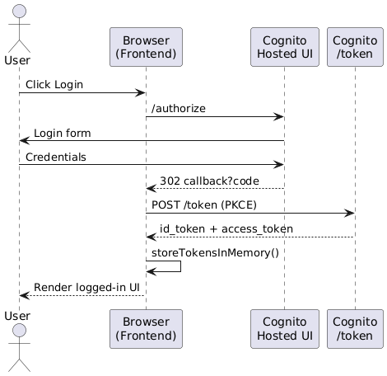

UC-2 Generate Image (Prompt → Queue)
Story – The user enters a prompt; the Lambda validates the JWT, writes a pending record in DynamoDB, and pushes a message to SQS.
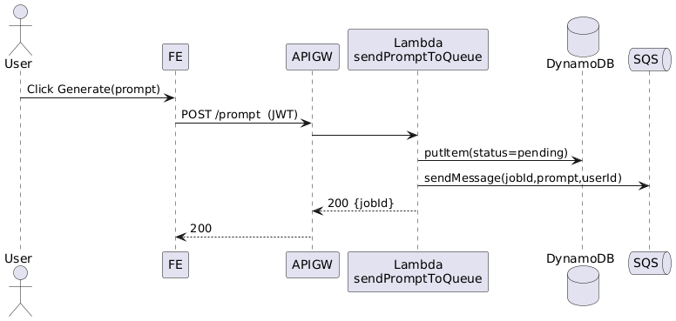
UC-3 Track Status (Polling / WebSocket)
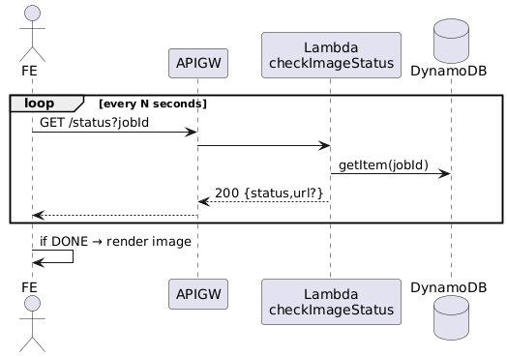
Story – The browser periodically checks the job status until the image is ready.
UC-4 Personal Gallery
Story – The user opens /gallery; the Lambda returns presigned S3 URLs for that user’s images.
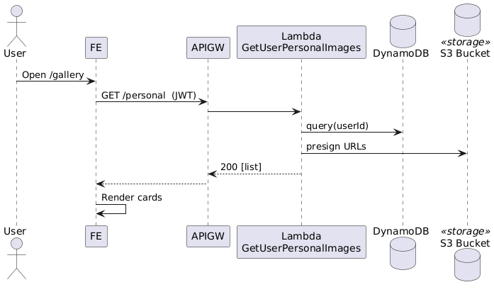
UC-5 Delete Image
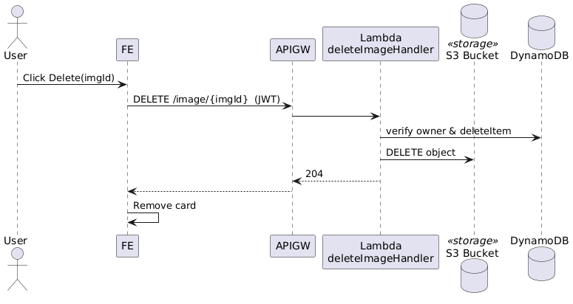
Story – The user deletes an image; the Lambda removes the object from S3 and the record from DynamoDB.

UC-6 Public Feed (Home)
Story – The browser fetches public/trending images without authentication.
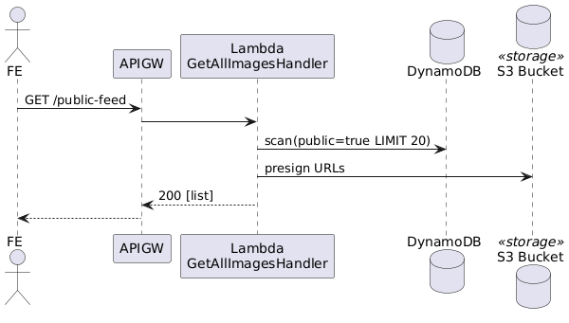
UC-7 Admin Dashboard
Story – An admin retrieves statistics from SQS, DynamoDB, and CloudWatch Logs.
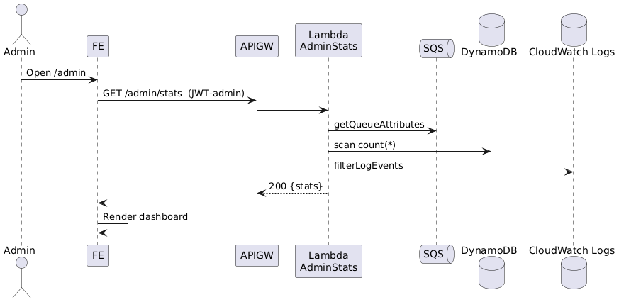
UC-8 Disable / Delete User (Admin)
Story – An admin disables a user; the Lambda updates Cognito and flags that user’s items.
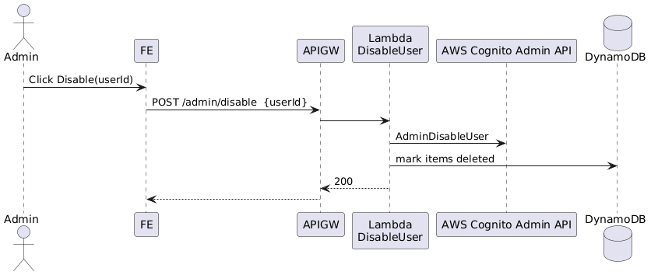
UC-9 Chat with Gemini Assistant
Story – The user sends a chat message; the Lambda calls the Gemini API and returns a reply.
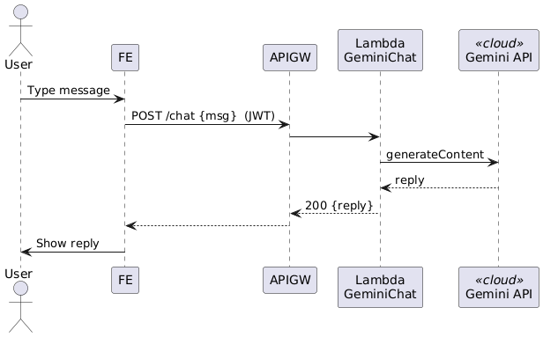
UC-10 Style → Image Shortcut (Chat triggers Image)
Story – The Lambda combines a chosen style with the prompt and invokes the image-generation flow (UC-2).
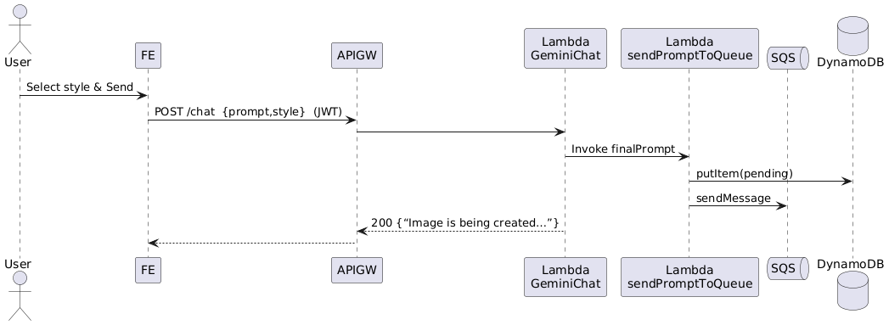
UC-11 Download Image (High-Res Presign)
Story – The browser requests a short-lived presigned URL and downloads the file.
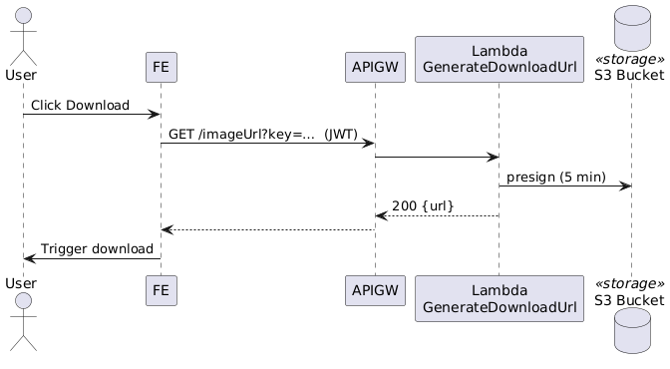
UC-12 Auto-Onboarding (Post-Confirmation Trigger)
Story – After sign-up, a Lambda trigger adds the new user to the Users group.
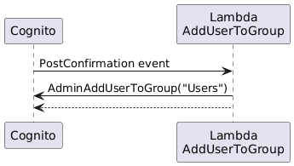
UC-13 Backend Worker (Queue → Stable Diffusion)
Story – A background worker pulls the SQS message, generates the image, uploads it to S3, and updates DynamoDB.
