**Assignment Test**

**Test 1: Find as many unreasonable points:**

1. The absence of Hide and Close tab buttons at the top right of the tab.

2. The lack of a zoom-out (-) button alongside the existing zoom-in (+) button at the bottom of the page preview section.

3. The duplication of the "Print as Grayscale" checkbox at the bottom left of the tab.

4. Units are currently placed below the numerical values in the preview section; they should be positioned right next to the number.

5. There's potential confusion between In and Cm units.

6. Discrepancies between the document width indicated on the Scale (1.5) and the information section below (8.5).

7. An empty checkbox above the "Auto-Rotate" checkbox lacks content or purpose.

8. Consider refining the terminology, as "Print What" may not be the most appropriate choice of words.

9. Redundancy in having separate buttons for "Page from" and "Pages."

10. There's no button in the page preview section to jump directly to the final page of the document.

11. Lack of a cancel button adjacent to the OK button for users to cancel the printing action.

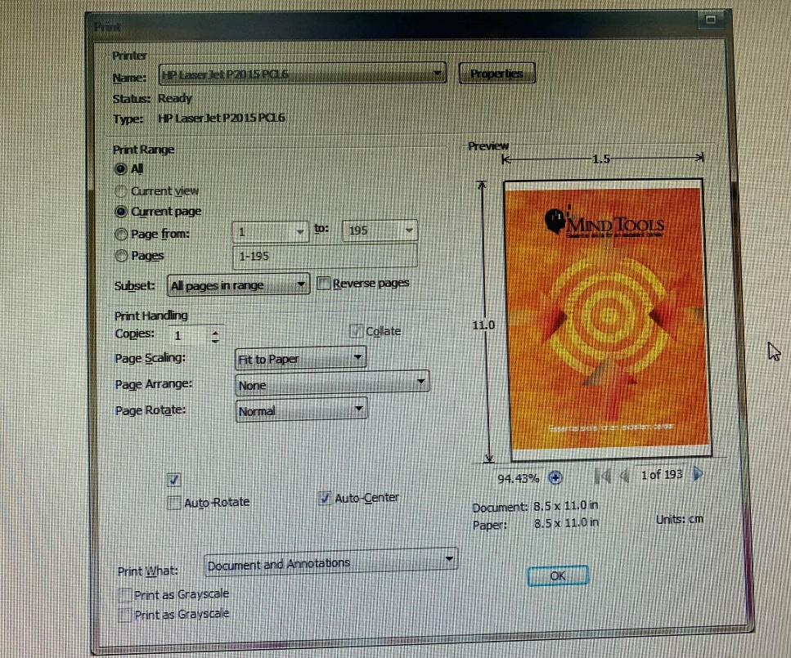

**Test 2:** 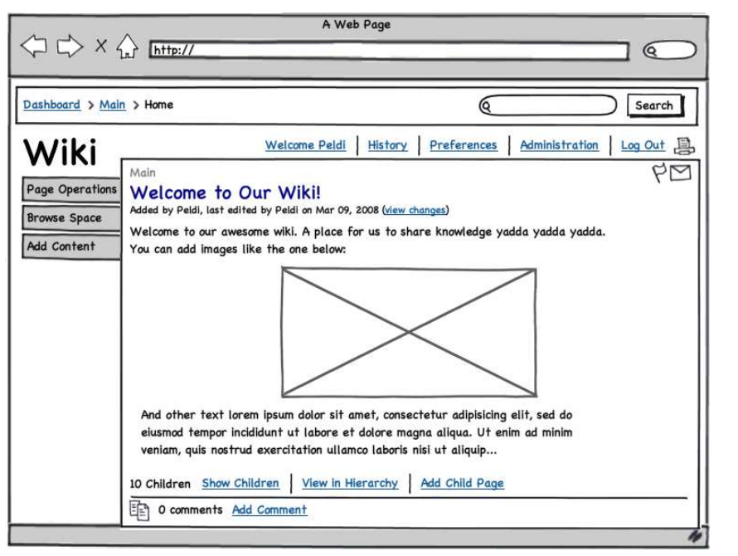

Task 1: Take a look at the picture below and come up with suggestions on how this design could adapt to different devices (mobile, tablets etc.). Things we're looking for is how the layout should change and look for mobile users, basic UX things to keep in mind and other best practices when developing responsive websites.

To this design could adapt to different devices (mobile, tablets etc) i have some suggesstion for it:

* Start designing for mobile devices first and then progressively enhance the layout for larger screens. This ensures a better user experience on smaller screens and simplifies the process of scaling up.
* Use a flexible grid system that can adapt to various screen sizes. CSS frameworks like Bootstrap or Flexbox can help in creating responsive grid layouts.
* Use CSS to ensure that images scale appropriately based on the screen size. Consider using the max-width: 100% property to prevent images from overflowing their containers.

**Navigation**:

* Use a hamburger menu or other mobile-friendly navigation patterns to conserve screen space.
* Ensure navigation items are easily tappable and well-spaced.

**Content Prioritization:**

* Prioritize essential content for mobile users. Consider displaying key information prominently and minimizing non-essential elements.

**Font Size and Line Spacing:**

* Increase font size for readability on smaller screens.
* Adjust line spacing to improve text legibility.