Global Employment Rate

Hui Liu, 29228751

Dashboard: <https://rankki.xyz/fit3179/asgn2/>

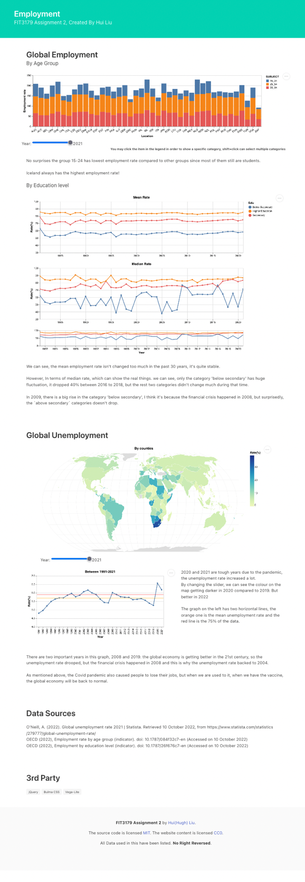

We know there are a lot of things that can affect the global economy, but how? Are there any things other than GDP than describe it? In this data visualisation, I created some graphs to show how the global economy impacted our employment rate because a low employment rate means fewer people have jobs, no jobs mean no income, and you cannot live without money.

I have used three data sources in this visualisation and combined these data to create graphs that have different sights from reading numbers in spreadsheets. Also, I wrote a Python script to manipulate those data because the loading performance is important, I must minimise the file size by deleting unused columns. After cleaning, the file size was reduced to 100KB from 1300KB.

The first dataset is the global unemployment rate 2021 (O'Neill, 2022), I want to show the trends of the unemployment rate in the past 20-30 years. The second and third datasets are from the same place but in a different category. In these datasets, I can show the employment rate in different aspects, like age group, and education levels.

Figure 1 Global Employment by age group

The first graph (Figure 1) is a simple stacked bar chart. I provided some interactive like the legends is clickable, and user can filter these data by selecting one or more categories in the legends in case they want to focus on a specific age group. There is a slider at the bottom, which can filter data by years, so we now can compare how the employment rate changes over time.

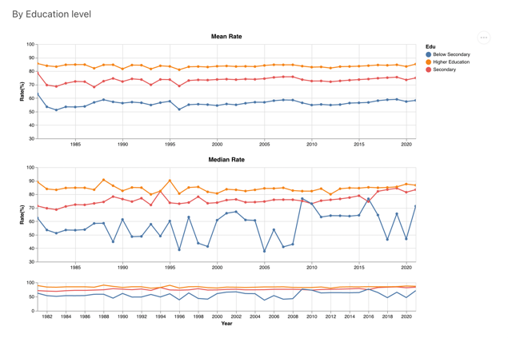

Figure 2 Global Employment by Education levels

I think it is also important to see the employment rate by the education level, the higher education level should have a higher employment rate because they have more opportunities to get a job.

The mean value sometimes will lie, for example, the average salary of I and Bill Gates is 50B dollars, which means nothing. So, I added another graph (Figure 2) to show the median value of the employment rate by education level, and indeed, we can see those two graphs are hugely different. The median rate graph provides more information than the average rate, such that, the category ‘below secondary’ changed a lot compared to the rest of the categories.

Moreover, for those who want to see a more specific time range, they can click the third graph in Figure 2 to select a range.

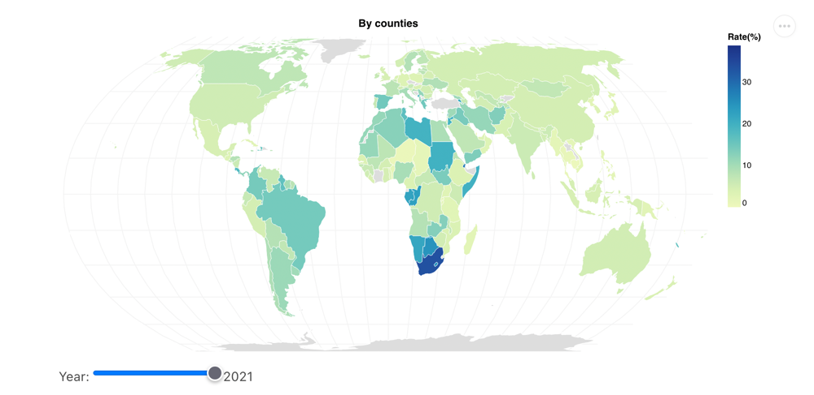

Figure 3 Global Unemployment Rate

The Choropleth map used here to shows the unemployment rate and compare the rate by country, by changing the slider we also know how the rate change over time. For example, if we scroll to 2019 and 2020, we can see the colour is getting darker around the world.

I have put some text on the right of the graph because the graph doesn’t need whole space, the graph gets wired if it has full width. So, I set a limit to the width, as result, the right part is blank, but became balanced after adding text to it

For the typography, I didn’t set the font family of it since the default font style is good enough, however, I still followed the standard, like the size difference between the title and subtitle, some annotation is bold to remind the audience to look at it. Also, I break the paragraph into two sections, therefore, I added more blanks between it, to make it more like two parts, not just a new line.

The reading guideline is top-down, like a normal webpage. I divided this visualisation into a few groups, the header, employment, unemployment, the data sources, third-party library, and the footer.

# Bibliography

Employment by education level. (2022). *Employment*. doi: 10.1787/26f676c7-en

Employment rate by age group. (2022). *Employment*. doi: 10.1787/084f32c7-en

O'Neill, A. (2022). Global unemployment rate 2021 | Statista. Retrieved 10 October 2022, from <https://www.statista.com/statistics/279777/global-unemployment-rate/>