Notes:

* this crackMe challenge can be solved both on android emulator and on android device
* Android Studio version: 3.0.1
* API 23



Before we start:

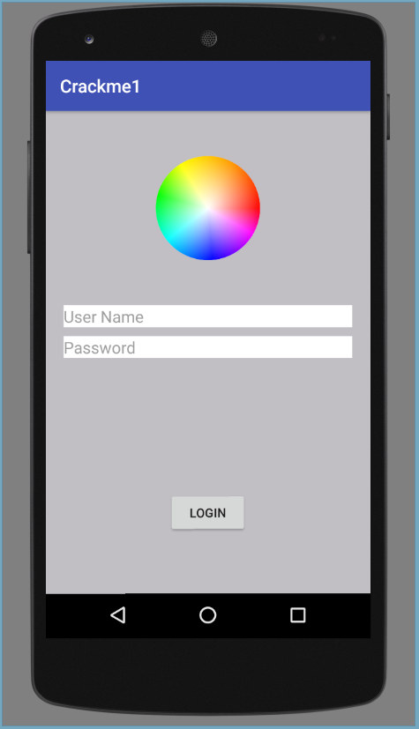

Find the USER

**Step 1:**

run appie.exe and enter dex2jar command on the apk file.

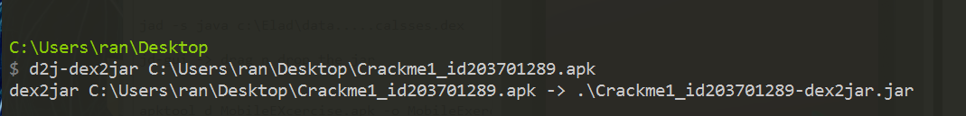

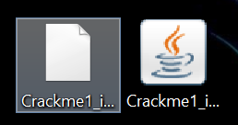

**Step 2:**

we can view the files jar and notice their .class files, so we'll run jd-gui.

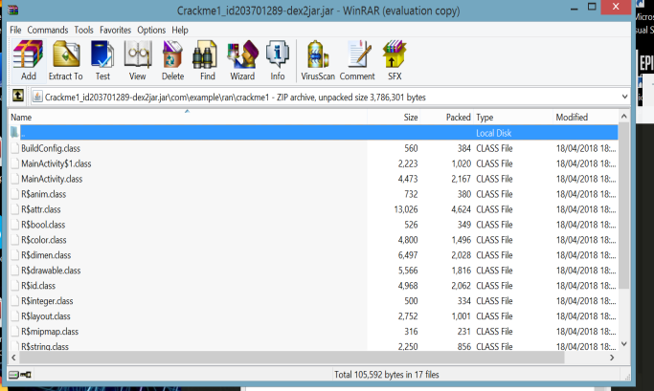

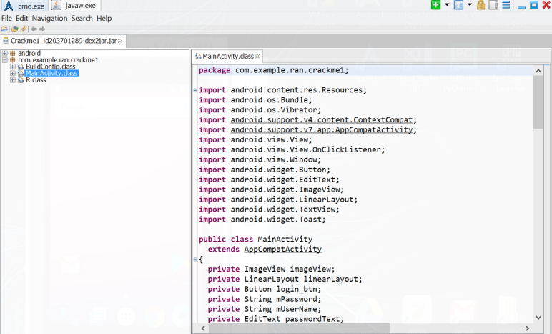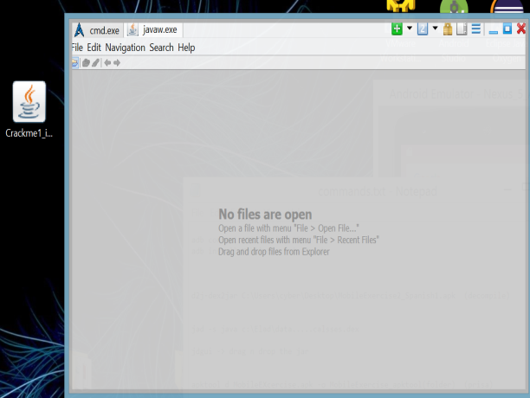drag n drop the .jar file into jd-gui

**Step 3:**

after digging the code a little bit we notice there is an interesting function called "secret()" that being called after we pressed the "login" button.

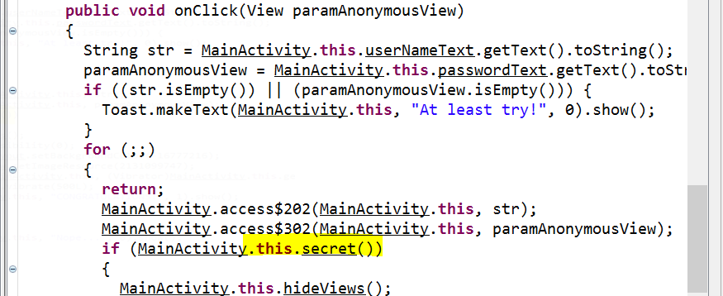

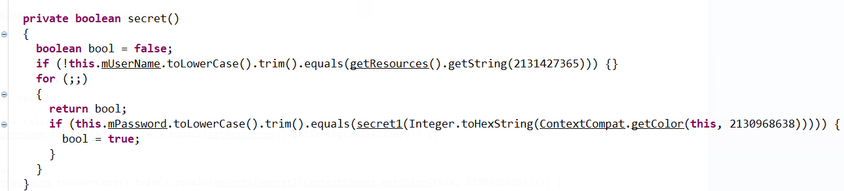

we can see that the function checking if the user input equal to some String from the resources String folder but we can't see the actual value.

**Step 4:**

we'll run apktool and go to the "values" folder to open the "strings.xml" file

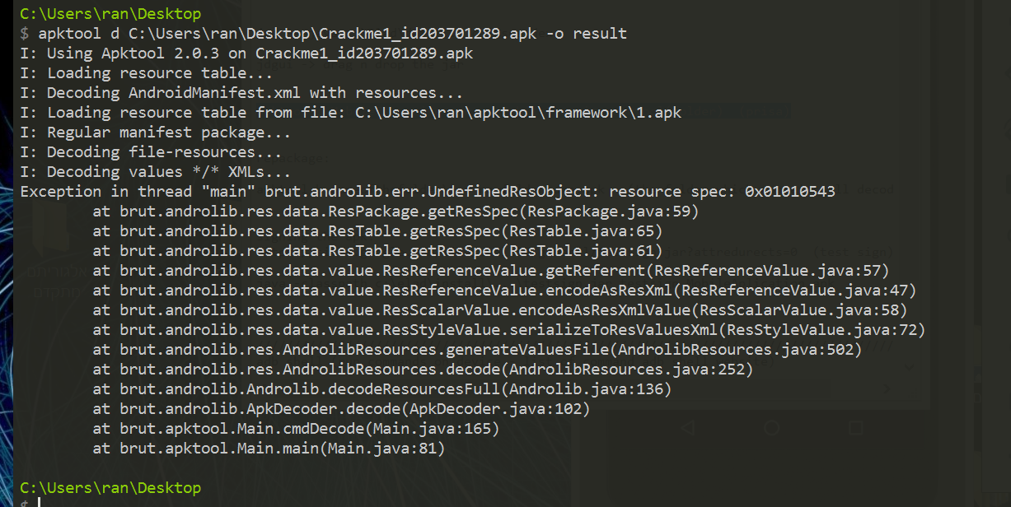





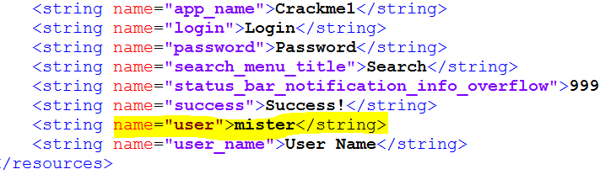

we found the user!

Find the PASSWORD

let's examine closer the code in the jd-gui:



we can see that the password that the user entered is being compared to some String.

the String is some color from the resources. we also see that this color string is sent to a function from the Integer class and the function convert the input to Hex String.

the output of the function which is an hex code (String type) is being sent to another function called "secret1" and the output of the function is the password.

in the next steps were about to figure out the "getColor" value and also the what the function "secret1" does and then will know the password.

*Get the HexCode Value (**alternative way**)*

**Step 1:**

in jd-gui, copy the integer code - "2130968638"

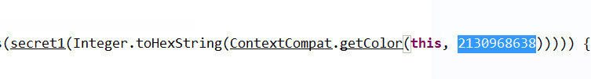

**Step 2:**

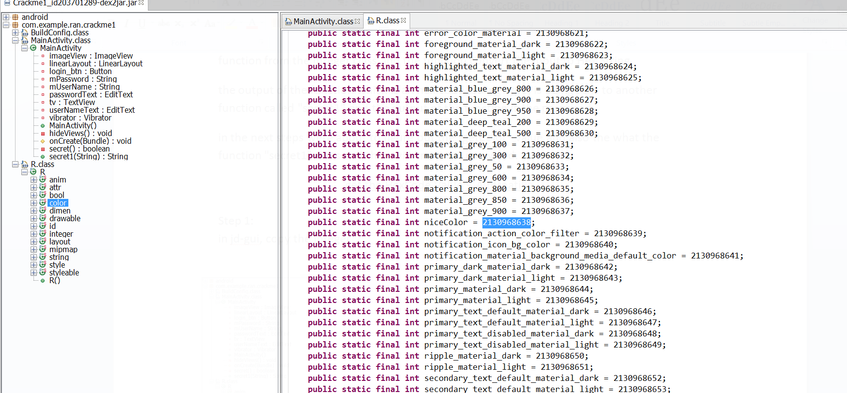go to the "color" folder in jd-gui and press ctrl + f (find) and paste the code from step before.

we can see that this code belong to the string variable "niceColor".

**Step 3:**

on the output folder after using apktool in the previous steps(find the user name- step 4),

go to "res" -> "values" -> "colors.xml" and open it with notepad.

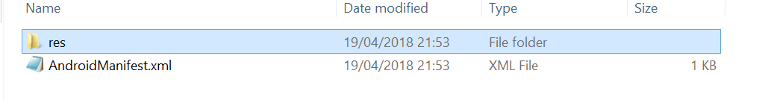





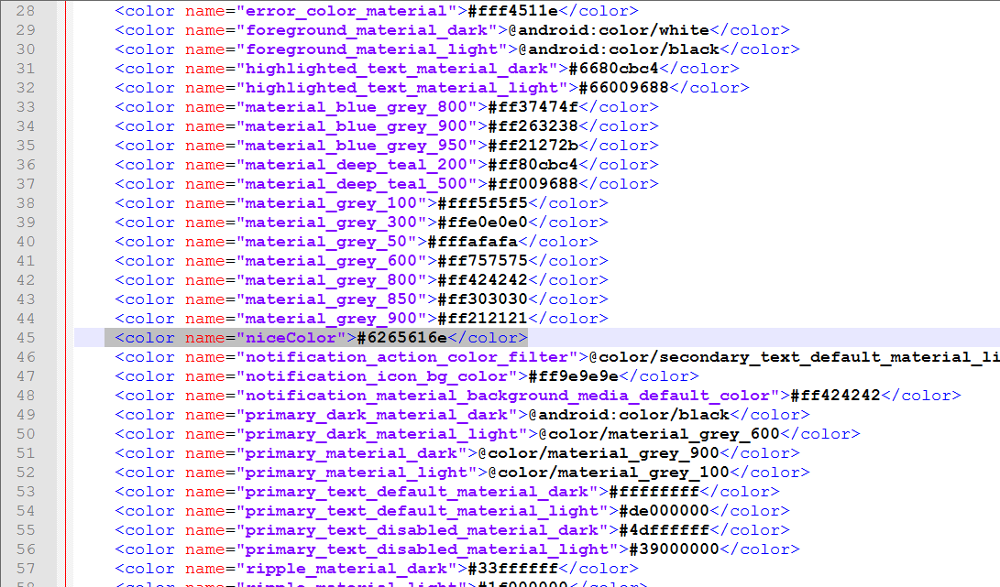

we can see the hex code value, let's copy it and continue to next step - 6265616e.

*Find Secret1 functionality*

**Step 1:**

we'll open the the jar file in jd-gui and try to examine the function based on the fact we figure out that the function input is an hex code (String type)

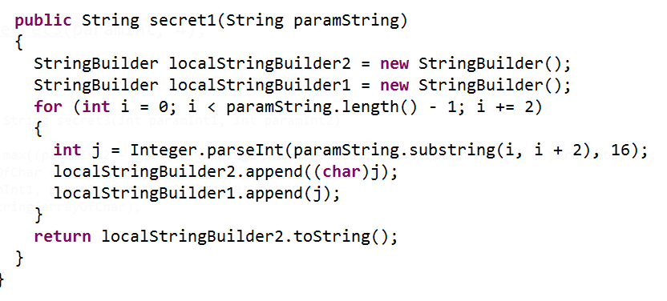

**Step 2:**

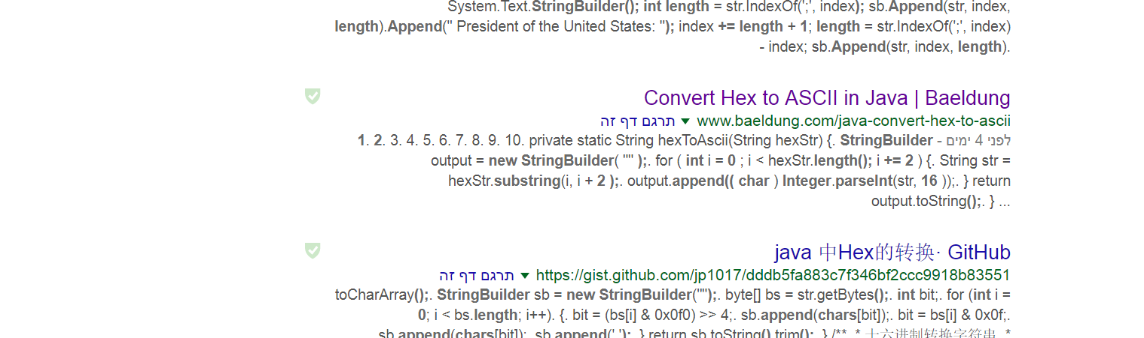let's copy the function and paste it on Google search to see what we can find.

we can see in the results that the function is a known function that converting a string hex code to string ascii

***the original code was taken from this site:

https://www.mkyong.com/java/how-to-convert-hex-to-ascii-in-java

**Step 3:**

let's try to convert the hex code that we find into an online converter.

(I used this site - https://codebeautify.org/hex-string-converter)

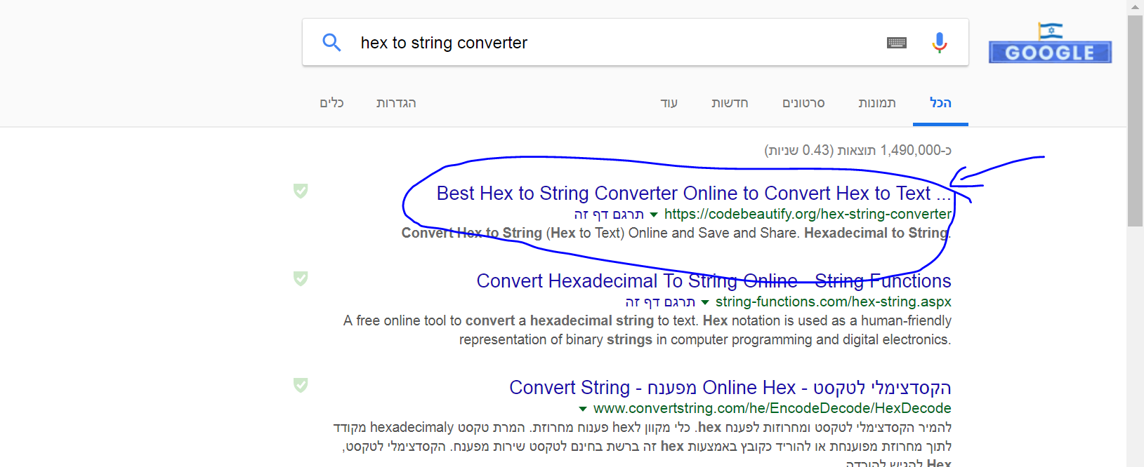

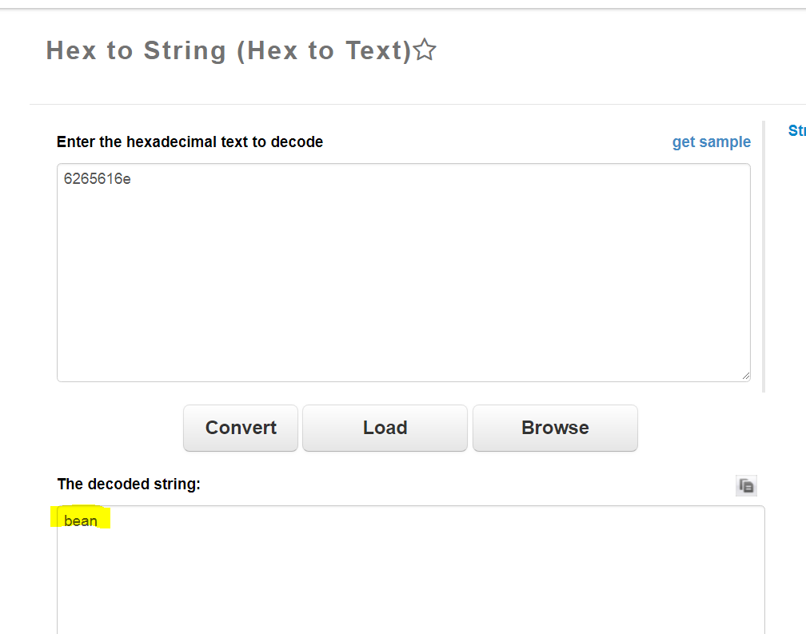

we got our answer! surprisingly the password is "bean".

**USER - "mister" , PASSWORD - "bean"**

 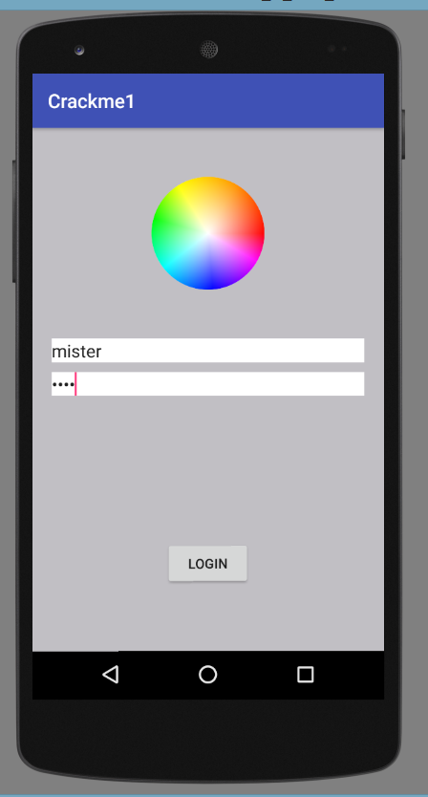

**\*\*\*End of the challenge!\*\*\***

Get the HexCode Value - Alternative Way

figure out from the application activity that the password is an RGB code based on the picture presented.

on the output folder after using apktool go to "layout" -> "activity_main.xml" in order to see the hex code for the background color presented in the activity.



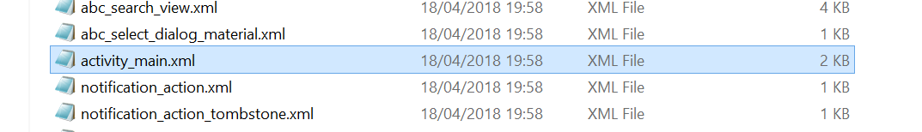

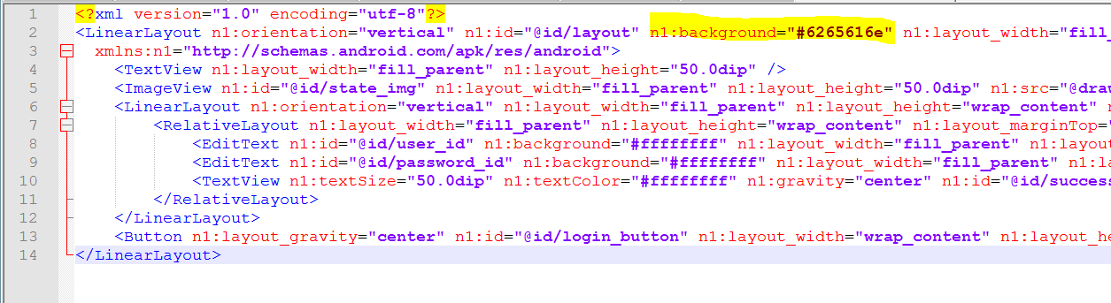

we can see that the background color hex code is : "6265616e".