Notes:

* tested on emulator - Nexus 5 API 24
* 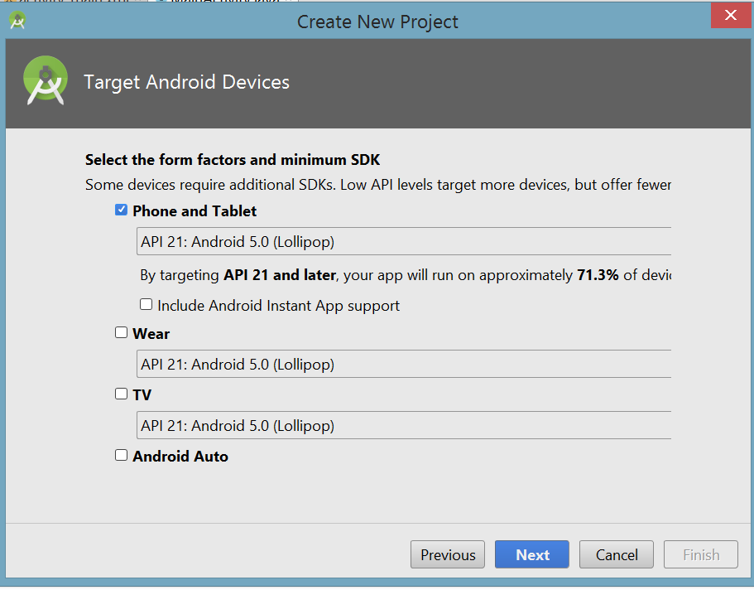Android Studio version: 3.0.1

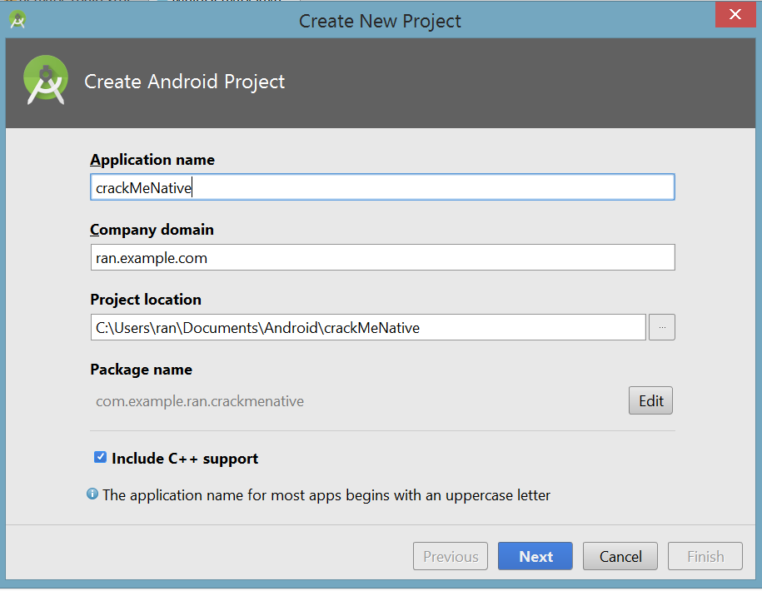

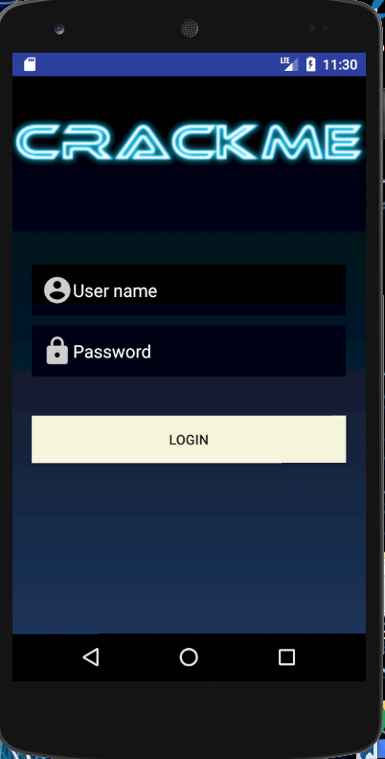

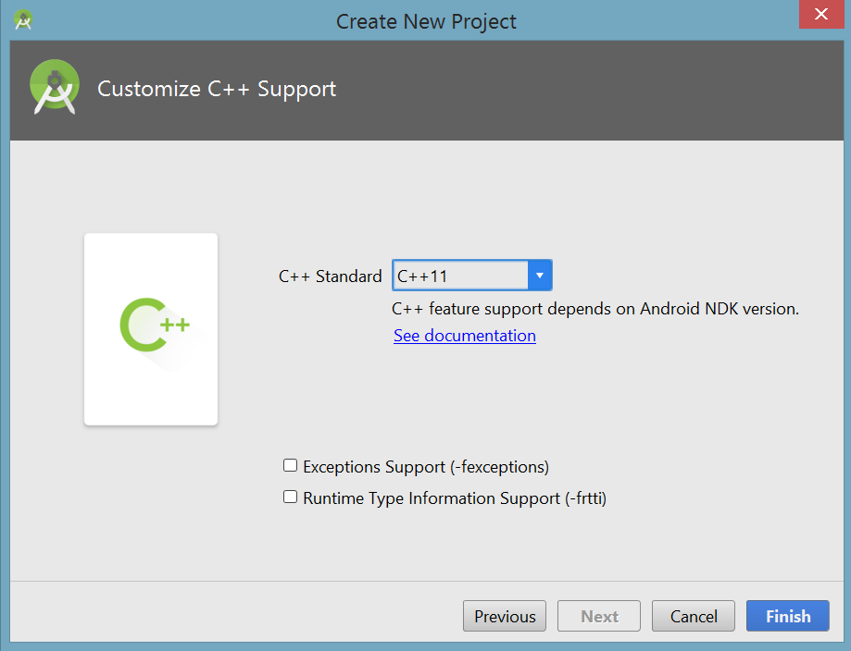

Find the USER

**Step 1:**

use dex 2 jar on the apk file

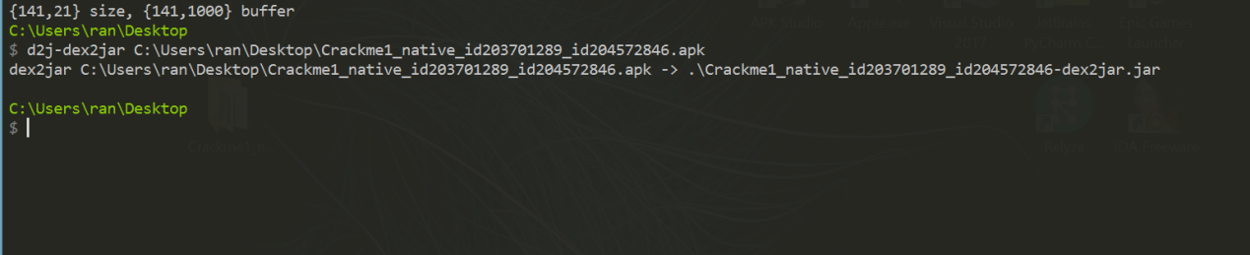

**Step 2:**

drag to jar file to 'jdgui'

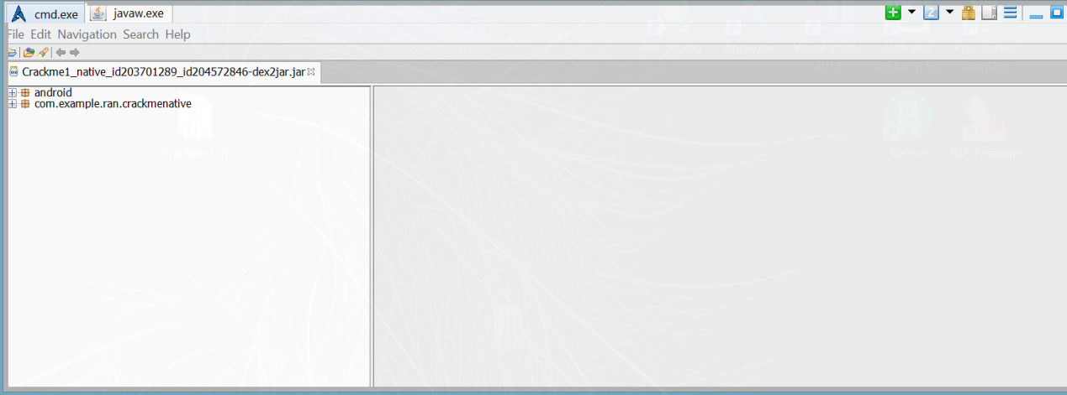

we can see that there is native library

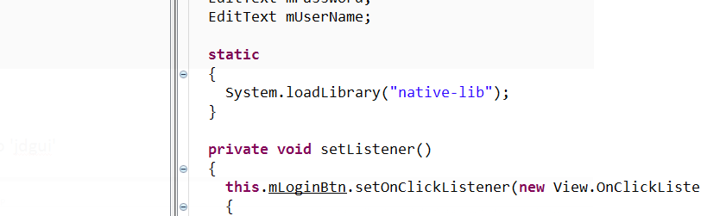

we can see that the login button goes to a function calld "validate"

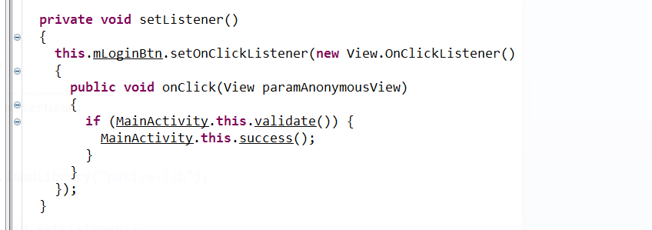

in the validate function we can see the user name is from the resources in the string folder and the password is from JNI.

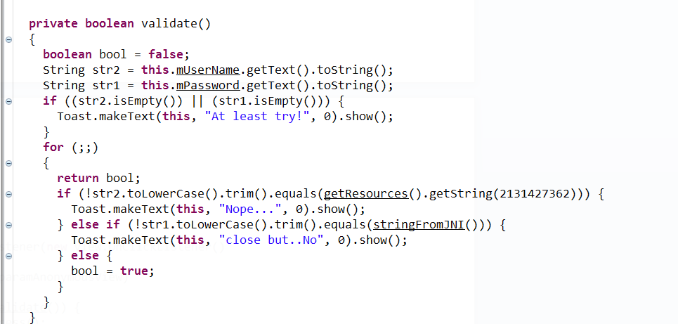

Step 3:

decompile the apk with apk tool to see the strings folder.

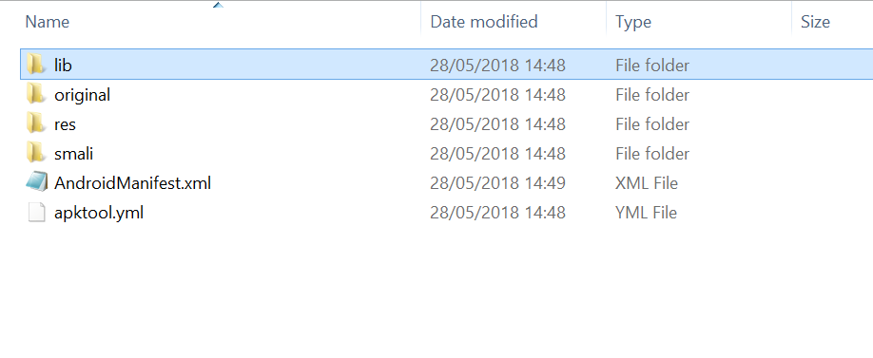

go to res -> values ->strings.xml

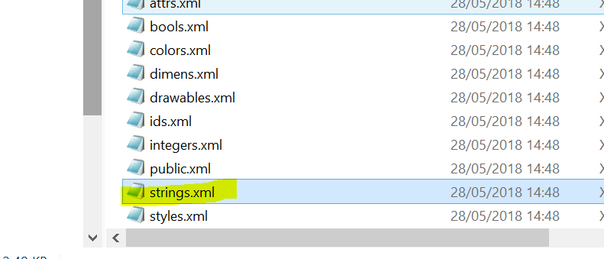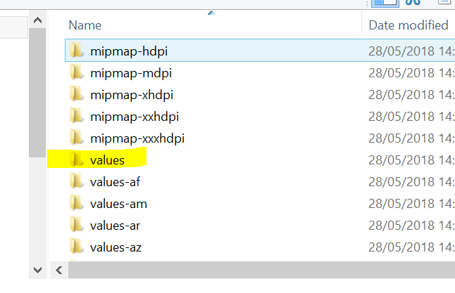

**Step 4:**

open the file with notepad and we can see the user name = "kevin"

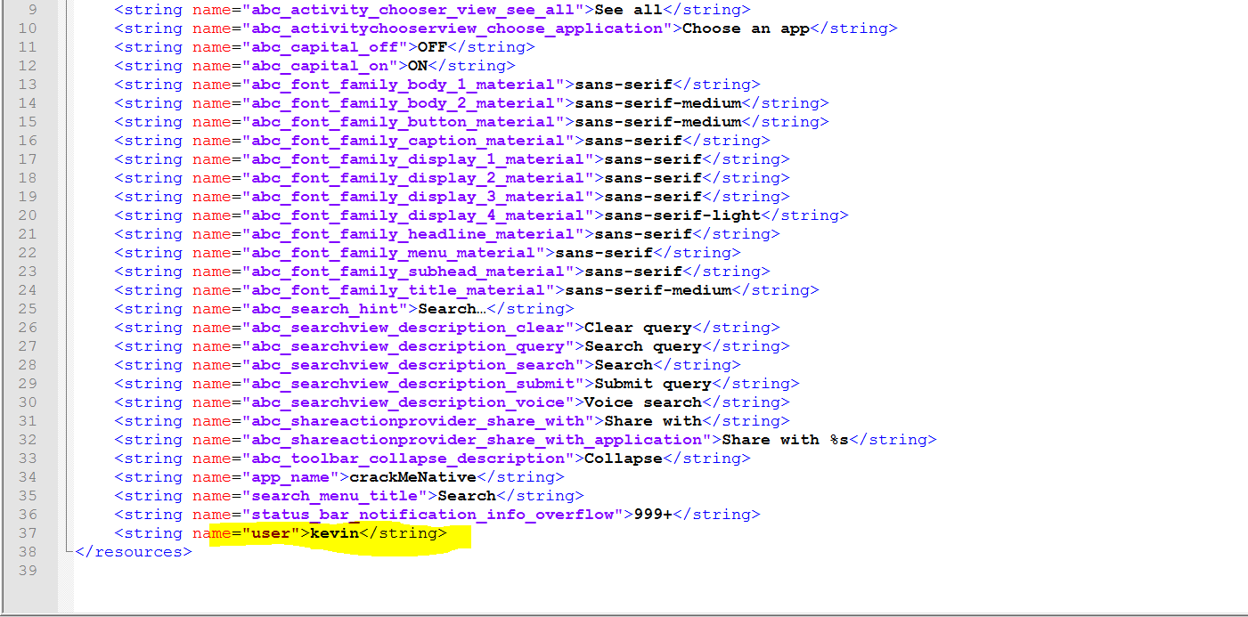

**user = "kevin"**

Find the PASSWORD

**Step 1:**

open IDA freeware choose new file

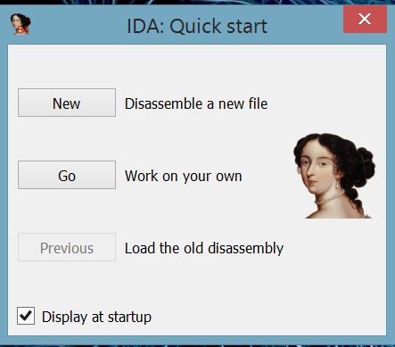

select the lib->x86 and open the .so file

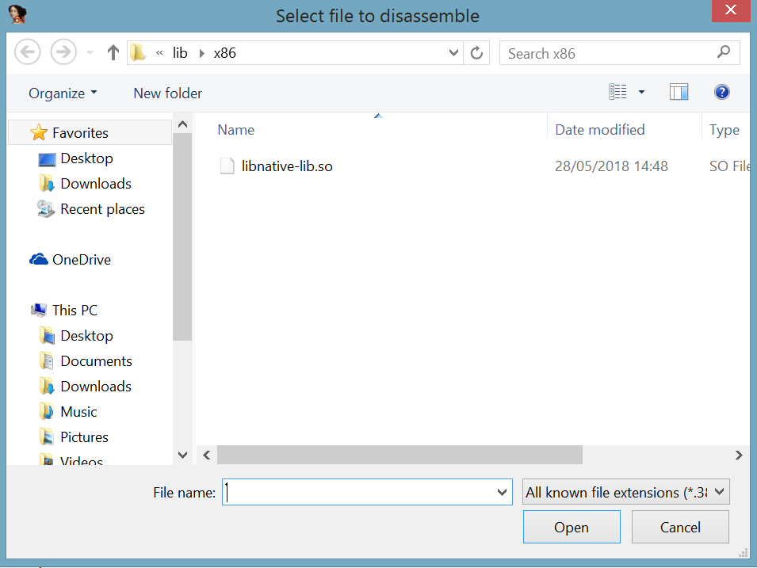

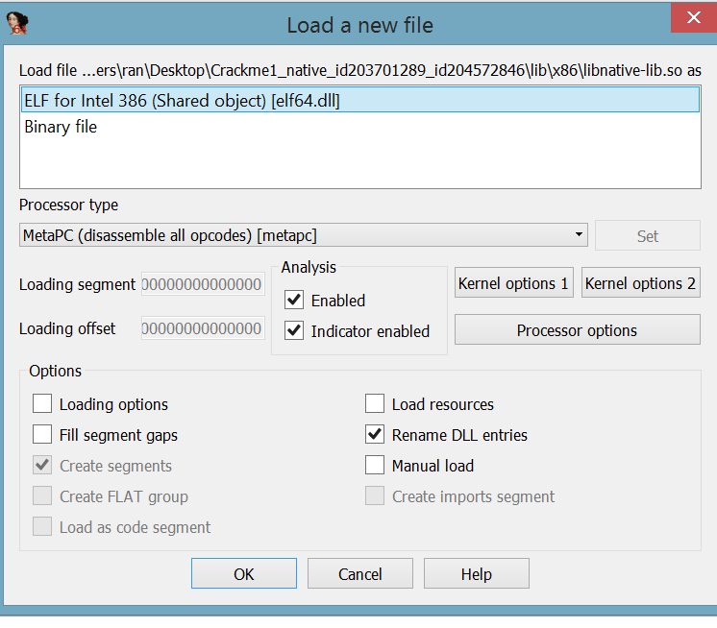

press ok.

**Step 2:**

in the function window on the left pane we should look for our function "stringFromJNI"

we can find as it shows in the picture below.

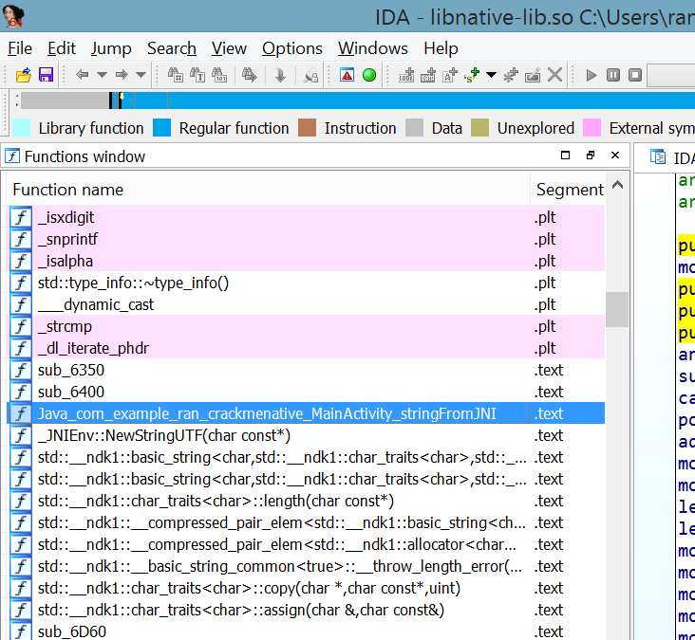

**Step 3:**

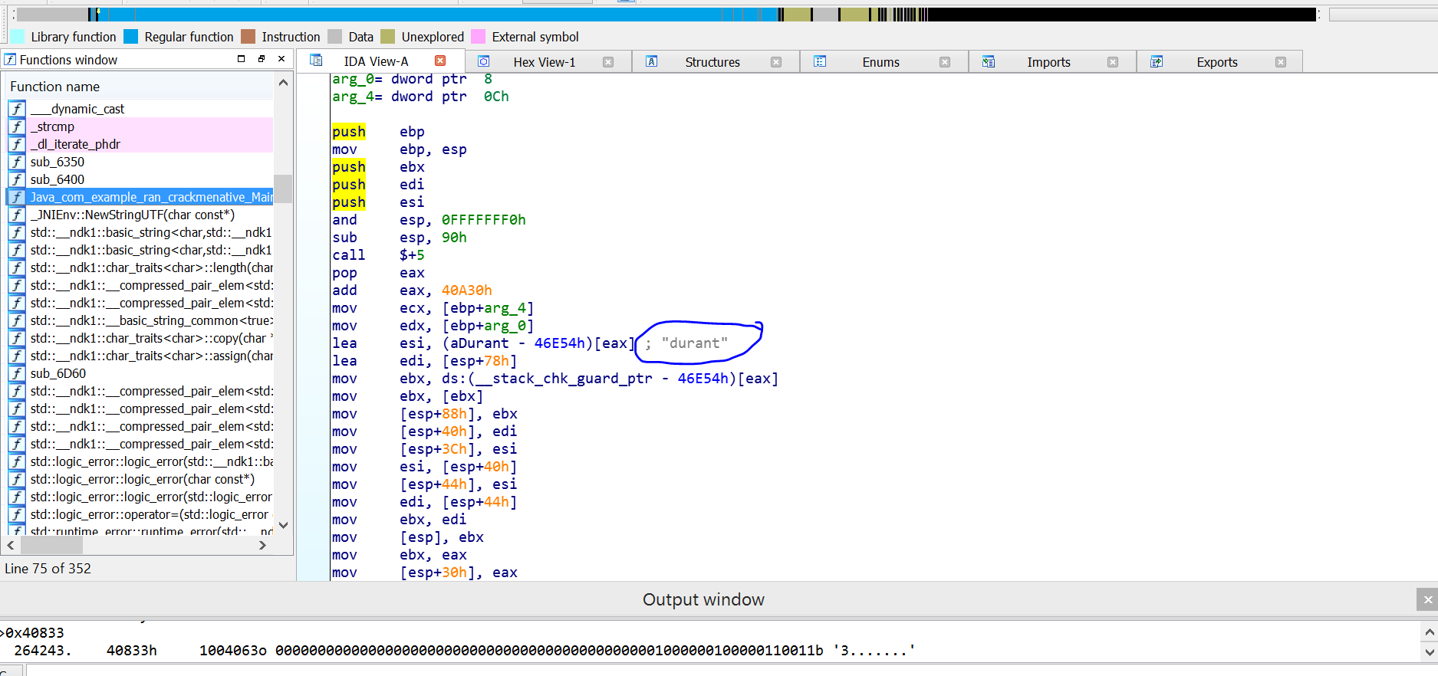on the right pane we can see the our password text "durant".

password = "durant"

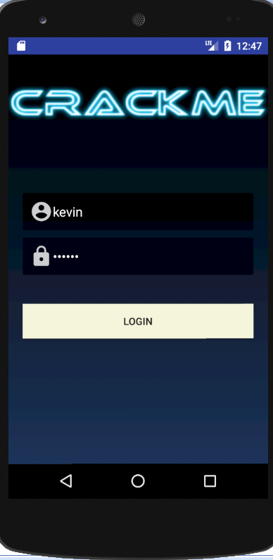 

***\*\*\*End of Challenge\*\*\****