Mapping Brain Metastases Intercellular Communication Pathways Between Fibroblast and Myeloid Subclusters Using Single-Cell RNA Sequencing

Group project
Abdulrahman Alaa | [https://github.com/abdul-rahman-alaa]
Fayza Khaled | [https://github.com/fayzakhaled396-creator]
Jasmine Mohamed | [https://github.com/jasminemohamed-bio]
Rana Mohamed | [https://github.com/Rana-Elromh]
Mostafa Hassanein | [https://github.com/mostafahassaneinn]
By

Date of submission: 30th September 2026
Available on GitHub
[https://github.com/Rana-Elromh/scRNAseq-brain-metastases-microenvironment-reanalysis-]

Project Description
Brain metastases are a major clinical challenge with a specialized tumor microenvironment (TME). This project re-analyzes single-cell RNA sequencing (scRNA-seq) to study cellular architecture and interactions. Using high-resolution transcriptomics and ligand-receptor network modeling, it maps cell states and signaling between tumor-associated fibroblast (TAF) clusters and M1 macrophages. These pathways offer insights into TME remodeling, indicating potential therapeutic targets.
Rationale (Research Question)
How do tumor-associated fibroblasts (TAFs) drive immunosuppressive and structural remodeling of the brain metastatic microenvironment through ligand-receptor crosstalk with M1 macrophage populations, and what specific communication axes reveal novel therapeutic vulnerabilities?
Data Availability & Reference
The single-cell RNA-seq data (5 samples) used in this reanalysis is available in the NCBI Gene Expression Omnibus (GEO) database under accession number GSE234832. If you use this data, please cite the original study: Song Q, Ruiz J, Xing F, Lo HW et al. (2023). Single-cell sequencing reveals the landscape of the human brain metastatic microenvironment. Commun Biol 6, 760. DOI: 10.1038/s42003-023-05124-2IF: 5.8 Q1 | PMID: 37479733IF: 5.8 Q1
Methods
Preprocessing & Integration: Within the Seurat pipeline, single-cell RNA-seq data from five samples underwent quality control using adaptive MAD thresholds, doublet removal via scDblFinder, log-normalisation, feature scaling, and Harmony batch integration.
Clustering & Cell Annotation: Unsupervised clustering and UMAP/t-SNE visualization were performed. Cell types were annotated using SingleR and canonical markers, with a primary focus on isolating and sub-clustering the myeloid population.
Polarization & Enrichment Analysis: Myeloid cells were evaluated for M1-like (pro-inflammatory) and M2-like (immunosuppressive) functional states using module scoring. Differentially expressed genes and functional pathway enrichments (GO, KEGG, Reactome) were analyzed across clusters and polarization states.
Cell-Cell Communication: The CellChat framework modeled ligand-receptor interactions to map microenvironmental crosstalk, specifically evaluating communication pathways between fibroblasts and M1/M2-polarized myeloid sub-clusters.
Results
Quality Control, Doublet Removal, Normalization, Identification of Variable Features, and Scaling
Quality control filtering and doublet removal of the single-cell RNA sequencing data yielded a robust dataset for downstream analysis. Initially, a total of 10,896 cells were processed before quality control, of which 7,158 cells successfully passed filtering criteria. Doublet detection removed 323 doublets, leaving 6,835 singlet cells for clustering and annotation. Normalisation identified 2,000 highly variable genes out of 33,538, with ACY3 and COL3A1 showing highest variance.
Principal Component Analysis (PCA), Integration, and Visualisations (UMAP and t-SNE)
Principal component analysis effectively captured major biological axes of variation across the dataset while highlighting opposing transcriptional. Unsupervised clustering identified 16 distinct transcriptomic clusters, which initially exhibited strong sample-specific separation in uncorrected embeddings. However, the application of Harmony batch correction successfully resolved these sample-driven biases, aligning multi-sample shared clusters and producing consistent UMAP spatial topologies that preserved true biological heterogeneity across patient origins.

Identification and Sub-clustering of Myeloid Cells
The subset is heavily enriched for myeloid, microglia and macrophage populations (7 sub-clusters)

Differential expression annotation of the defined clusters
Differential expression analysis using FindAllMarkers identified distinct gene profiles for all 15 clusters (0–14).
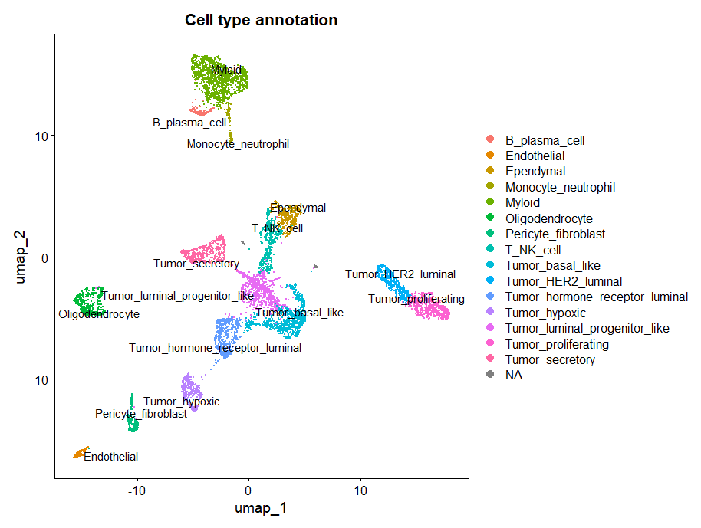
Figure 1. Global cellular landscape and marker gene expression in brain metastases. UMAP visualization of integrated single cells colored by major cell type annotations, encompassing malignant epithelial subsets, stromal populations, neuro-glial lineage, and immune compartments.
Differential expression annotation of the Myeloid sub-clusters
Sub-clustering restricted to the myeloid compartment further dissected four distinct sub-populations: Macrophages, Macrophage_MMP9_high_mito, Microglia, and type 2 conventional dendritic cells (cDC2).

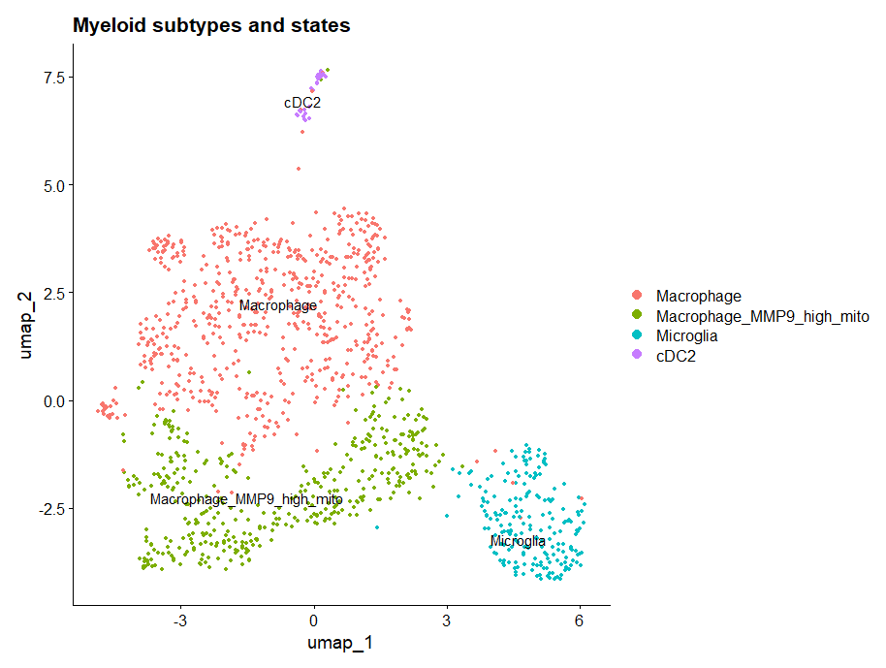
Figure 2. Myeloid subtype characterization and M1/M2 polarization states.UMAP embedding of high-resolution sub-clustered myeloid populations identifying Macrophages, Macrophage_MMP9_high_mito, Microglia, and cDC2s.

M1 and M2 states
Differential M1 minus M2 scoring projected across UMAP space highlighted continuous spatial gradients of polarization rather than discrete binary phenotypes. Quantitative proportion analysis confirmed that M1-like state activation predominated in both lineages, accounting for 85.4% of microglia and 50.7% of macrophages, whereas M2-like state polarization (24.5%) and intermediate states (24.9%) were substantially more prevalent within macrophages.

Differential Expression and Pathway Enrichment Analysis
Fibroblasts
Downstream functional profiling across REACTOME, KEGG, and GO sub-ontologies confirmed strong positive enrichment for biological processes related to collagen organization.
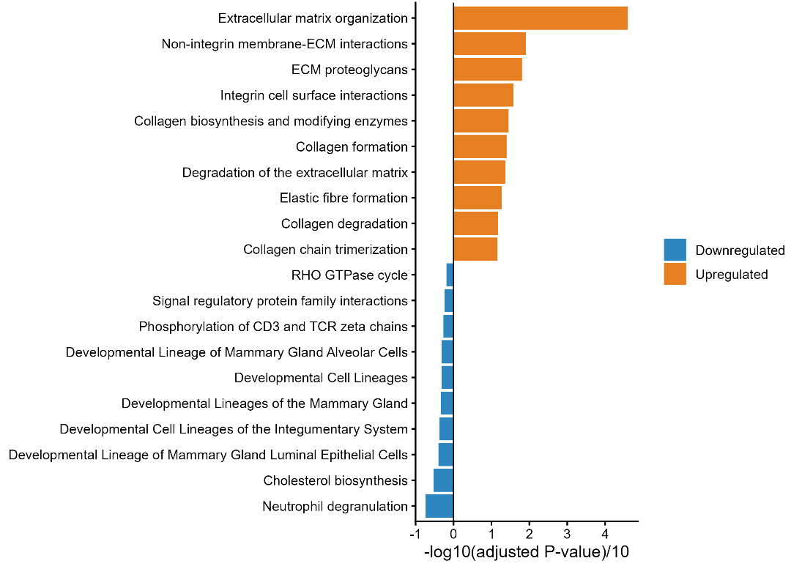
Figure 3. Differential expression and functional enrichment of fibroblasts. Diverging bar plot showing enriched REACTOME pathways for upregulated (positive values) and downregulated (negative values) genes in fibroblasts.
M1-like vs. M2-like Macrophages
Transcriptional module scoring effectively separated the macrophage cluster into M1-like, M2-like, and intermediate states. Differential expression analysis between M1-like and M2-like macrophages showed clear marker differences. Enrichment analysis confirmed distinct metabolic and signaling profiles between M1-like and M2-like phenotypes.
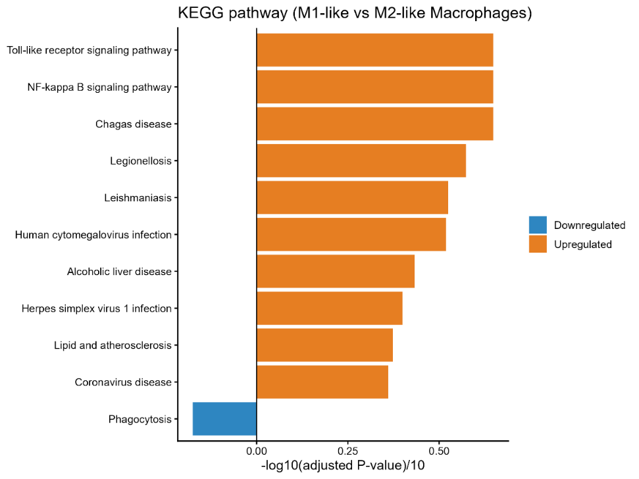
Figure 4. Differential expression and functional enrichment of macrophage polarization states. Diverging bar plot showing enriched KEGG pathways for upregulated (positive values) and downregulated (negative values) genes in M1-like versus M2-like macrophages.

Transcriptional Module Scoring of M1-like vs. M2-like Macrophages
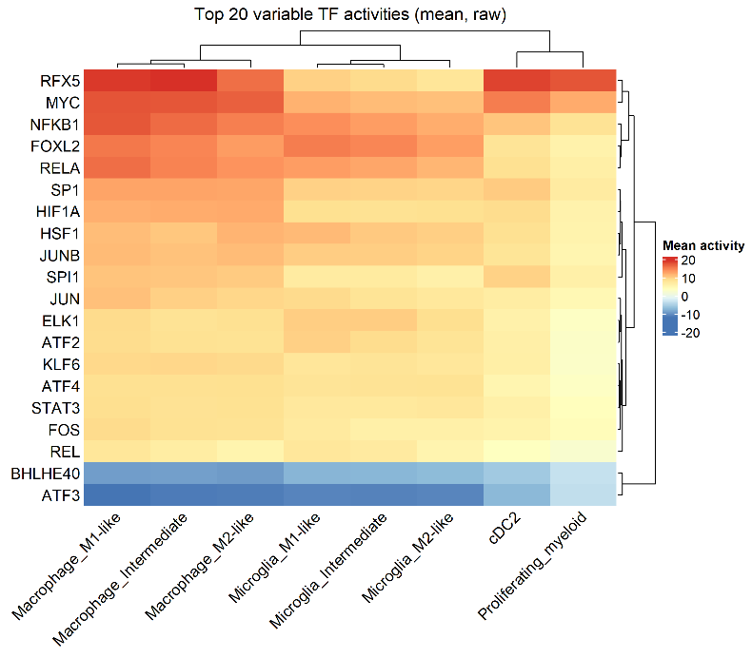
Figure 5. Transcription factor activity analysis of macrophage polarization states. Heatmap displaying the top 20 transcription factors with differential activity between M1-like and M2-like macrophages, inferred from regulon analysis.
Overall Communication Network using CellChat Model
Aggregated cell-cell communication analysis across all signaling pathways revealed extensive crosstalk among microenvironmental cell populations. Overall interaction counts and weights were heavily dominated by bidirectional signaling between Macrophage_M1-like and Macrophage_M2-like subsets. Pericyte_fibroblasts additionally exhibited robust paracrine communication with both macrophage polarization states, whereas Microglia populations displayed comparatively fewer total interactions across the network.
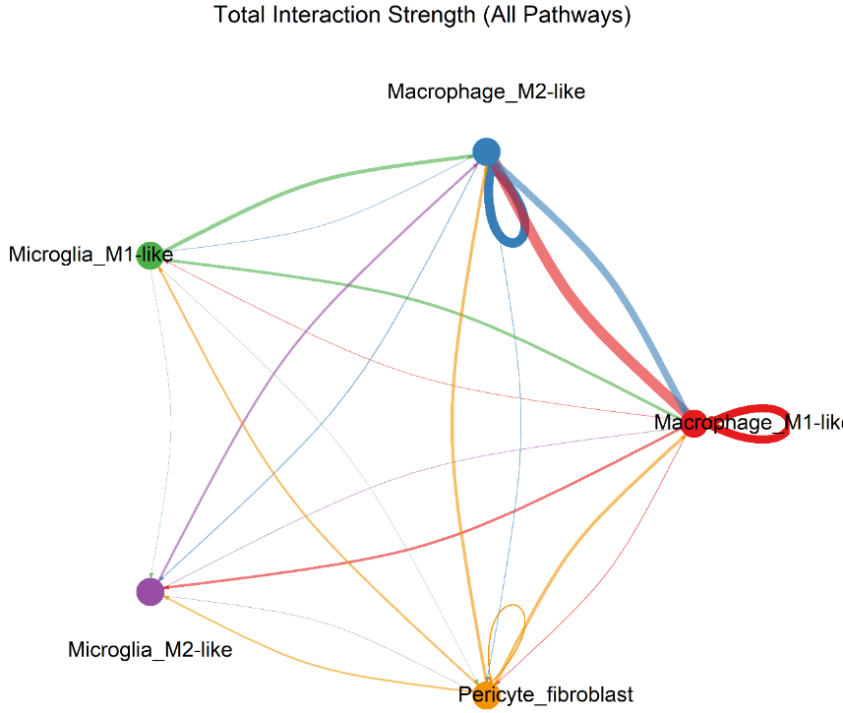
Figure 6. Global cell-cell communication network across the brain metastasis microenvironment. Circular network plot displaying the total interaction strength (weighted communication probability) aggregated across all signaling pathways. Edge thickness corresponds to signaling strength

Ligand-Receptor Interactions
Detailed evaluation of ligand-receptor pairs (p < 0.01) demonstrated significant variation across target cell pairs. Evaluation of fibroblast-derived signaling revealed distinct receptor-binding preferences across recipient myeloid populations, particularly regarding Syndecan-4 (SDC4) interactions. Fibroblasts engaged M1-like macrophages (Pericyte_fibroblast -> Macrophage_M1-like) through collagen–SDC4 pairs (COL1A1–SDC4, COL6A1–SDC4, and COL9A3–SDC4) as well as MDK–SDC4 signaling. Crucially, these SDC4-mediated interactions were completely absent in M2-like macrophages (Pericyte_fibroblast -> Macrophage_M2-like), which interacted with fibroblast-derived collagens exclusively via CD44 (COL1A1–CD44, COL6A1–CD44, COL9A3–CD44). A similar polarization pattern was mirrored in microglia, where M1-like microglia retained low-level COL1A1–SDC4 communication while both M1- and M2-like microglia primarily engaged CD44.
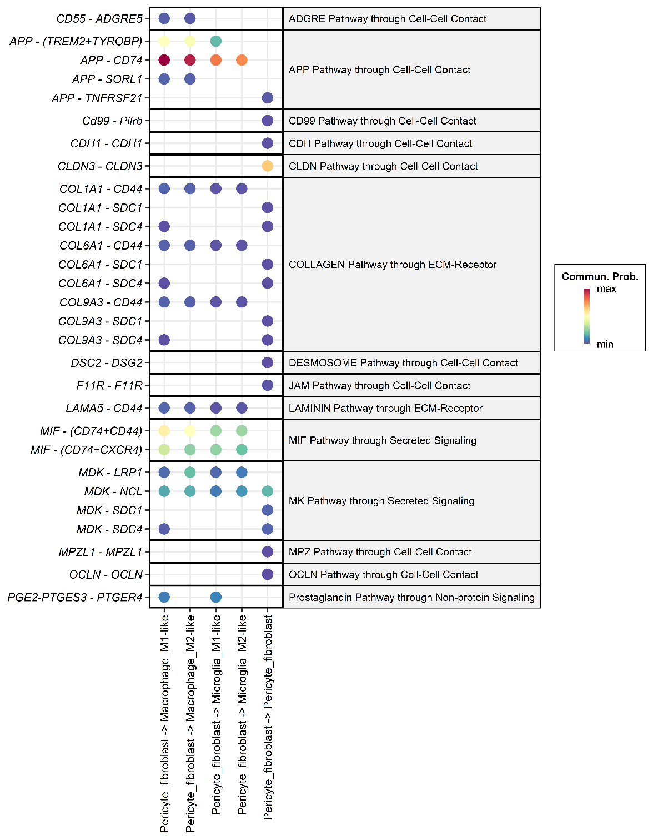
Figure 7. Fibroblast-centric ligand-receptor communication landscape.Faceted dot plot displaying significant (p < 0.01) ligand-receptor interactions originating from Pericyte_fibroblasts across target recipient cell types. Color intensity represents communication probability. Collagen and Midkine signaling demonstrate selective SDC4 receptor engagement in M1-like macrophages compared to CD44-predominant binding in M2-like macrophages.

Discussion
1.Research Hypothesis and Interpretation of Findings
We hypothesized that tumor-associated fibroblasts (TAFs) contribute to structural and immunoregulatory remodeling of the brain metastatic microenvironment through distinct ligand-receptor crosstalk with M1-like macrophages. This hypothesis makes three testable predictions: (1) fibroblasts have a matrix-remodeling phenotype and are a source of stromal ligands; (2) M1-like macrophages have an activated inflammatory program and express receptors able to receive those ligands; (3) fibroblast-to-M1 interactions are distinct from those directed to M2-like macrophages, strong enough to be plausible drivers of the M1 state, and include at least some immunoregulatory signals. Predictions 1 and 2 were clearly supported and agree with Song et al. (2023). Prediction 3 was only partly supported: we found a small set of interactions restricted to M1-like macrophages (SDC4-based), but with low predicted communication probabilities. The data therefore support a fibroblast-M1 axis as a candidate but do not show that fibroblasts shape the M1 state.

1.1 Fibroblasts are matrix-remodeling cells and a major source of stromal ligands (Prediction 1)
The pericyte/fibroblast cluster was defined by ECM genes, with upregulated genes enriched for ECM organization, collagen formation/degradation, elastic fibre formation, integrin interactions, focal adhesion and PI3K-Akt signaling. Downregulated terms mainly reflected epithelial/tumor and immune programs, as expected when comparing a stromal cluster against all other cells. This matches Song et al., who described collagen-high fibroblasts enriched for ECM organization, including TIMP3 among upregulated genes—also among the top genes in our fibroblast volcano plot. Since fibroblasts express collagens, laminins (LAMA4/LAMA5), MDK, MIF and APP, they are well placed to act as senders toward the myeloid compartment.

1.2 M1-like macrophages carry a TLR/NF-κB-driven cytokine and chemokine program (Prediction 2)
TNF, IL1B, CCL3L1, CCL4L2, NFKBIA and C3 were higher in M1-like cells, while CD163, MRC1, STAB1, CD209, LYVE1, F13A1 and COLEC12 were higher in M2-like cells. KEGG enrichment was led by Toll-like receptor and NF-κB signaling; Reactome enrichment by IL-1 signaling, TRAF6-mediated NF-κB activation, pyroptosis and pro-inflammatory recruitment. Scavenger receptor binding and phagocytosis were the main downregulated terms, in line with the M2-like profile—consistent with Song et al.’s report of elevated IL-1B, TNF, CCL3/4. Our contribution is resolving this program at the M1-like vs. M2-like level, separated from microglia.
Two caveats: the “Interleukin-10 signaling” term largely reflects NF-κB-dependent cytokines (TNF, IL1B, CCL3/4) rather than anti-inflammatory activity, consistent with the modest STAT3 activity seen in the TF analysis; and disease-named KEGG terms (Chagas, Legionellosis, Leishmaniasis, CMV/HSV) reflect shared innate immune genes, not actual infection.
Inferred TF activity supported the same picture: NFKB1 and RELA were most active in M1-like macrophages; AP-1 members, HIF1A, SPI1 and MYC were also high. RFX5 (MHC-II regulator) was the most active TF overall, consistent with the HLA-DRA-high phenotype. NF-κB and AP-1 are canonical TLR/MAPK effectors, linking this TF result to the KEGG/Reactome findings and to NFKBIA among the top M1-like genes.

1.3 Fibroblast-to-M1 communication (Prediction 3)
A shared stromal-myeloid axis (APP/MIF to CD74) showed the strongest fibroblast-derived interactions (APP-CD74; MIF-CD74/CD44/CXCR4), present across both M1-like and M2-like macrophages and microglia—indicating general fibroblast-myeloid communication rather than M1-specific signaling. MIF is pro-inflammatory and can activate NF-κB/ERK via CD74/CD44, compatible with but not proof of the chemokine signatures above; CD74 and APP are broadly expressed, so high CellChat scores may partly reflect expression level rather than specificity.
In M1-restricted interactions, COL1A1/COL6A1/COL9A3-SDC4 and MDK-SDC4 appeared only in the fibroblast-to-M1-like column, the most direct support for a distinct axis. SDC4 is TLR/NF-κB-inducible and could help anchor/stabilize M1-like cells in fibroblast-rich stroma. Song et al. described SDC1/SDC4/CD44 as fibroblast-collagen receptors on tumor cells; SDC4 on M1-like macrophages is a new observation. However, all these interactions had the lowest predicted probabilities, and three collagens converging on one receptor reflects co-expression/shared database entries rather than interaction strength—so these should be read as predictions, not established signaling.
CD44-mediated ECM signaling (collagen/laminin to CD44) reached all four myeloid populations, again at low probability—replicating Song et al.’s observation that fibroblast-myeloid communication is mainly CD44-based, with SDC4 as an M1-associated addition.

2.Agreement with Song et al. and novel findings
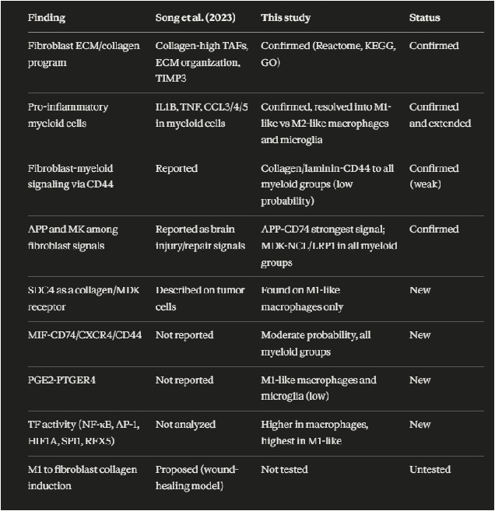
Table 1. Comparison of findings: agreement with Song et al. and our novel discoveries.

Two differences: Song et al. treated myeloid cells as one population and inferred M1 activation from cytokine expression, while we scored individual cells into M1-like/M2-like/intermediate states; and they listed TGFB1 as an M1 hallmark gene, whereas we included it in the M2 gene set—marker definitions for M1/M2 differ between studies.

3.Does the evidence support the hypothesis?
Supported: fibroblasts are a matrix-remodeling, ligand-rich population (Prediction 1); M1-like macrophages have a TLR/NF-κB-driven program (Prediction 2).
Partly supported: a distinct set of fibroblast-M1 interactions exists (SDC4-, PTGER4-based), one of which (PGE2-EP4) is potentially immunoregulatory.
Not supported (yet): that fibroblasts drive or reshape the M1 state—M1-restricted interactions were weak, strong ones were shared with M2-like cells, and the M1 program is well explained by intrinsic TLR/NF-κB activity.

4.Limitations
1.Limited dataset size: five patients (three breast, two lung); rare states—especially M1-like macrophages—contain few cells, limiting DEG and pathway power.
2.Weak predicted interactions: M1-restricted interactions had low communication probabilities—low-confidence, not proof of unimportance.
3.Restricted cell-type set: CellChat included only five populations with fibroblasts as sole sender; other potential M1-shaping senders (tumor cells, T/NK cells, endothelial cells, other myeloid cells, oligodendrocytes, B/plasma cells) were excluded.
4.Direction not tested: we analyzed fibroblast-to-myeloid signals only; the reverse (M1-to-fibroblast, per Song et al.) remains untested.
5.Prediction, not measurement: CellChat/decoupleR infer communication and TF activity from mRNA alone, with no protein, spatial or functional validation.
6.M1-like/M2-like definition: based on a small marker set with an arbitrary ±0.1 threshold; some defining genes overlap with DEG results by construction. 85.4% of microglia were called M1-like, suggesting the score partly reflects baseline expression. The M1/M2 dichotomy simplifies a continuum, and the MMP9_high_mito subcluster (merged with macrophages) may include stressed cells.
7.Statistical dependency: Wilcoxon tests treat cells as independent, which can inflate significance given within-patient correlation; pseudobulk testing would be more conservative.

Conclusion
Overall, our re-analysis reproduces the central findings of Song et al. (a collagen-rich fibroblast population and a pro-inflammatory myeloid compartment) and adds new candidate features: an M1-restricted fibroblast-SDC4 axis, a shared MIF/APP-CD74 axis, and a TLR/NF-κB TF signature in M1-like macrophages.
