Mapping Brain Metastases Intercellular Communication Pathways Between Fibroblast and Myeloid Subclusters Using Single-Cell RNA Sequencing

Group project (Group 4)
Abdulrahman Alaa | [https://github.com/abdul-rahman-alaa]
Fayza Khaled | [https://github.com/fayzakhaled396-creator]
Jasmine Mohamed | [https://github.com/jasminemohamed-bio]
Rana Mohamed | [https://github.com/Rana-Elromh]
Mostafa Hassanein | [https://github.com/mostafahassaneinn]
By

Date of submission: 30th September 2026
Available on GitHub
[https://github.com/Rana-Elromh/scRNAseq-brain-metastases-microenvironment-reanalysis-]

Project Description
Brain metastases are a major clinical challenge with a specialized tumor microenvironment (TME). This project re-analyzes single-cell RNA sequencing (scRNA-seq) to study cellular architecture and interactions. Using high-resolution transcriptomics and ligand-receptor network modeling, it maps cell states and signaling between tumor-associated fibroblast (TAF) clusters and M1 macrophages. These pathways offer insights into TME remodeling, indicating potential therapeutic targets.
Rationale (Research Question)
How do tumor-associated fibroblasts (TAFs) drive immunosuppressive and structural remodeling of the brain metastatic microenvironment through ligand-receptor crosstalk with M1 macrophage populations, and what specific communication axes reveal novel therapeutic vulnerabilities?
Data Availability & Reference
The single-cell RNA-seq data (5 samples) used in this reanalysis is available in the NCBI Gene Expression Omnibus (GEO) database under accession number GSE234832. If you use this data, please cite the original study: Song Q, Ruiz J, Xing F, Lo HW et al. (2023). Single-cell sequencing reveals the landscape of the human brain metastatic microenvironment. Commun Biol 6, 760. DOI: 10.1038/s42003-023-05124-2IF: 5.8 Q1 | PMID: 37479733IF: 5.8 Q1
Methods
Preprocessing & Integration: Within the Seurat pipeline, single-cell RNA-seq data from five samples underwent quality control using adaptive MAD thresholds, doublet removal via scDblFinder, log-normalisation, feature scaling, and Harmony batch integration.
Clustering & Cell Annotation: Unsupervised clustering and UMAP/t-SNE visualization were performed. Cell types were annotated using SingleR and canonical markers, with a primary focus on isolating and sub-clustering the myeloid population.
Polarization & Enrichment Analysis: Myeloid cells were evaluated for M1-like (pro-inflammatory) and M2-like (immunosuppressive) functional states using module scoring. Differentially expressed genes and functional pathway enrichments (GO, KEGG, Reactome) were analyzed across clusters and polarization states.
Cell-Cell Communication: The CellChat framework modeled ligand-receptor interactions to map microenvironmental crosstalk, specifically evaluating communication pathways between fibroblasts and M1/M2-polarized myeloid sub-clusters.
Results
Quality Control, Doublet Removal, Normalization, Identification of Variable Features, and Scaling
Quality control filtering and doublet removal of the single-cell RNA sequencing data yielded a robust dataset for downstream analysis. Initially, a total of 10,896 cells were processed before quality control, of which 7,158 cells successfully passed filtering criteria. Doublet detection removed 323 doublets, leaving 6,835 singlet cells for clustering and annotation. Normalisation identified 2,000 highly variable genes out of 33,538, with ACY3 and COL3A1 showing highest variance.
Principal Component Analysis (PCA), Integration, and Visualisations (UMAP and t-SNE)
Principal component analysis effectively captured major biological axes of variation across the dataset while highlighting opposing transcriptional. Unsupervised clustering identified 16 distinct transcriptomic clusters, which initially exhibited strong sample-specific separation in uncorrected embeddings. However, the application of Harmony batch correction successfully resolved these sample-driven biases, aligning multi-sample shared clusters and producing consistent UMAP spatial topologies that preserved true biological heterogeneity across patient origins.

Identification and Sub-clustering of Myeloid Cells
The subset is heavily enriched for myeloid, microglia and macrophage populations (7 sub-clusters)

Differential expression annotation of the defined clusters
Differential expression analysis using FindAllMarkers identified distinct gene profiles for all 15 clusters (0–14).
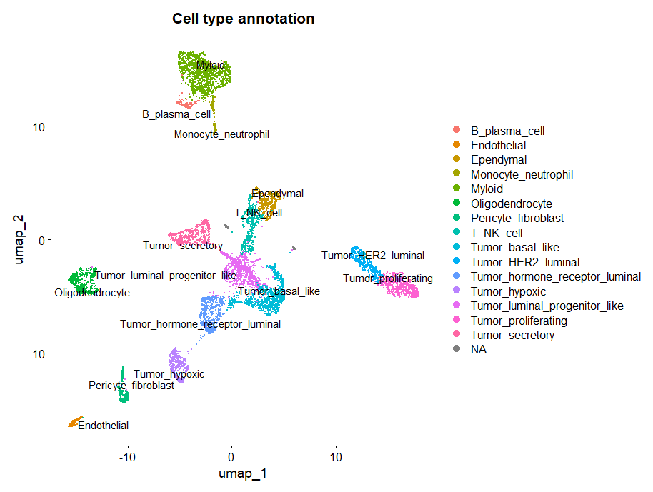
Figure 1. Global cellular landscape and marker gene expression in brain metastases. UMAP visualization of integrated single cells colored by major cell type annotations, encompassing malignant epithelial subsets, stromal populations, neuro-glial lineage, and immune compartments.
Differential expression annotation of the Myeloid sub-clusters
Sub-clustering restricted to the myeloid compartment further dissected four distinct sub-populations: Macrophages, Macrophage_MMP9_high_mito, Microglia, and type 2 conventional dendritic cells (cDC2).

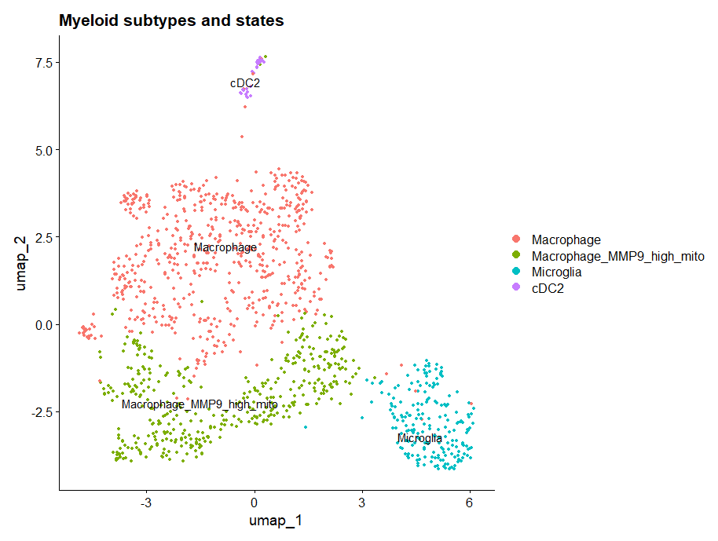
Figure 2. Myeloid subtype characterization and M1/M2 polarization states.UMAP embedding of high-resolution sub-clustered myeloid populations identifying Macrophages, Macrophage_MMP9_high_mito, Microglia, and cDC2s.

M1 and M2 states
Differential M1 minus M2 scoring projected across UMAP space highlighted continuous spatial gradients of polarization rather than discrete binary phenotypes. Quantitative proportion analysis confirmed that M1-like state activation predominated in both lineages, accounting for 85.4% of microglia and 50.7% of macrophages, whereas M2-like state polarization (24.5%) and intermediate states (24.9%) were substantially more prevalent within macrophages.

Differential Expression and Pathway Enrichment Analysis
Fibroblasts
Downstream functional profiling across REACTOME, KEGG, and GO sub-ontologies confirmed strong positive enrichment for biological processes related to collagen organization.
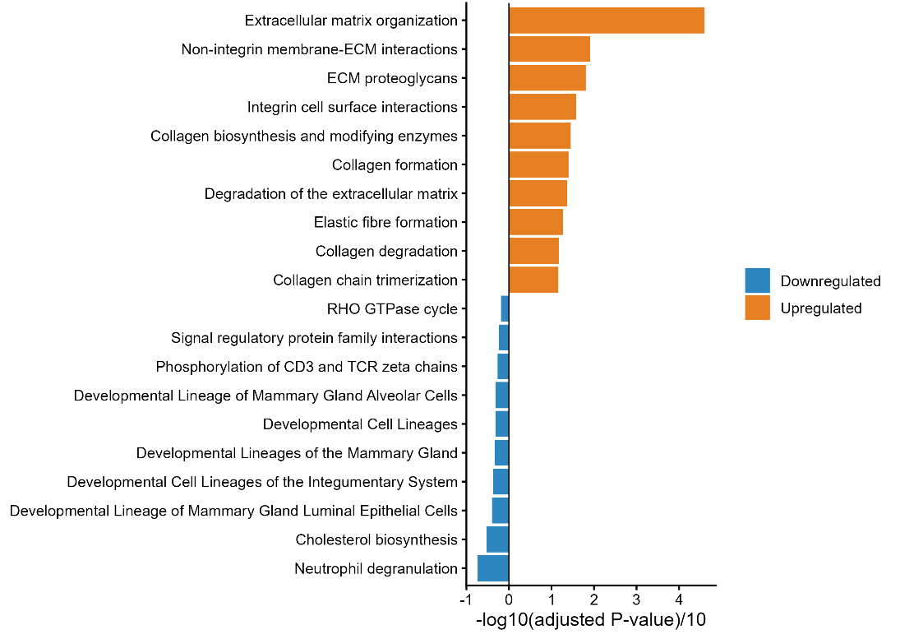
Figure 3. Differential expression and functional enrichment of fibroblasts. Diverging bar plot showing enriched REACTOME pathways for upregulated (positive values) and downregulated (negative values) genes in fibroblasts.
M1-like vs. M2-like Macrophages
Transcriptional module scoring effectively separated the macrophage cluster into M1-like, M2-like, and intermediate states. Differential expression analysis between M1-like and M2-like macrophages showed clear marker differences. Enrichment analysis confirmed distinct metabolic and signaling profiles between M1-like and M2-like phenotypes.
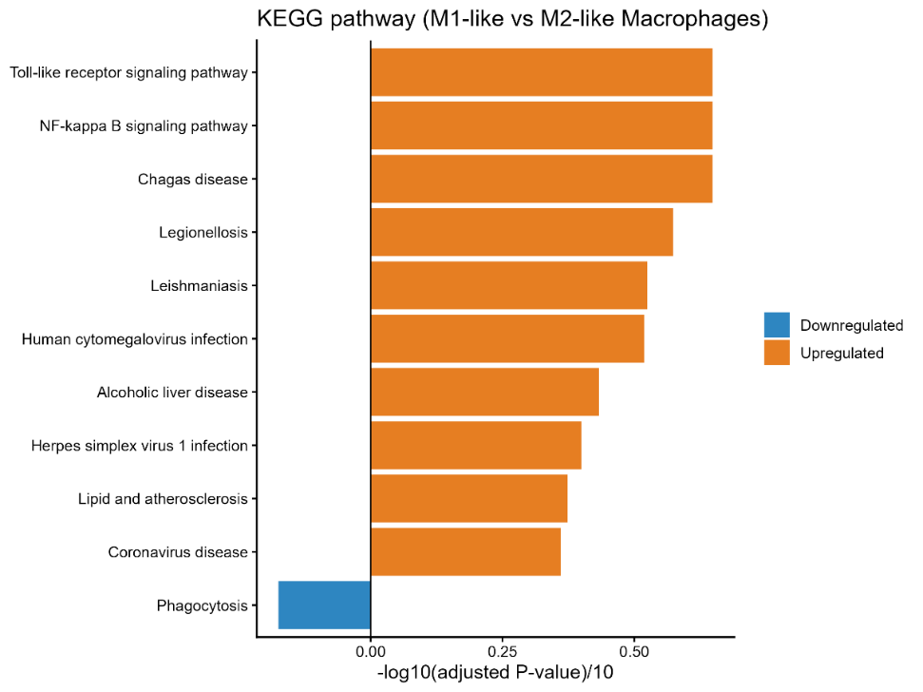
Figure 4. Differential expression and functional enrichment of macrophage polarization states. Diverging bar plot showing enriched KEGG pathways for upregulated (positive values) and downregulated (negative values) genes in M1-like versus M2-like macrophages.

Transcriptional Module Scoring of M1-like vs. M2-like Macrophages
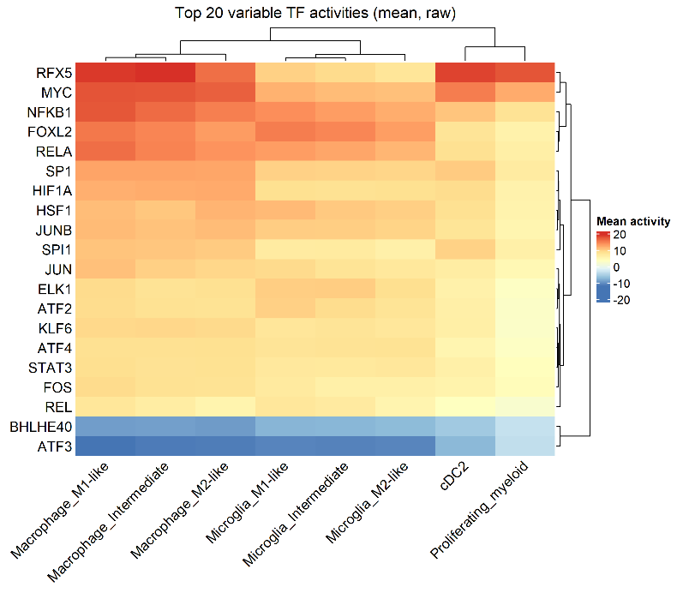
Figure 5. Transcription factor activity analysis of macrophage polarization states. Heatmap displaying the top 20 transcription factors with differential activity between M1-like and M2-like macrophages, inferred from regulon analysis.
Overall Communication Network using CellChat Model
Aggregated cell-cell communication analysis across all signaling pathways revealed extensive crosstalk among microenvironmental cell populations. Overall interaction counts and weights were heavily dominated by bidirectional signaling between Macrophage_M1-like and Macrophage_M2-like subsets. Pericyte_fibroblasts additionally exhibited robust paracrine communication with both macrophage polarization states, whereas Microglia populations displayed comparatively fewer total interactions across the network.
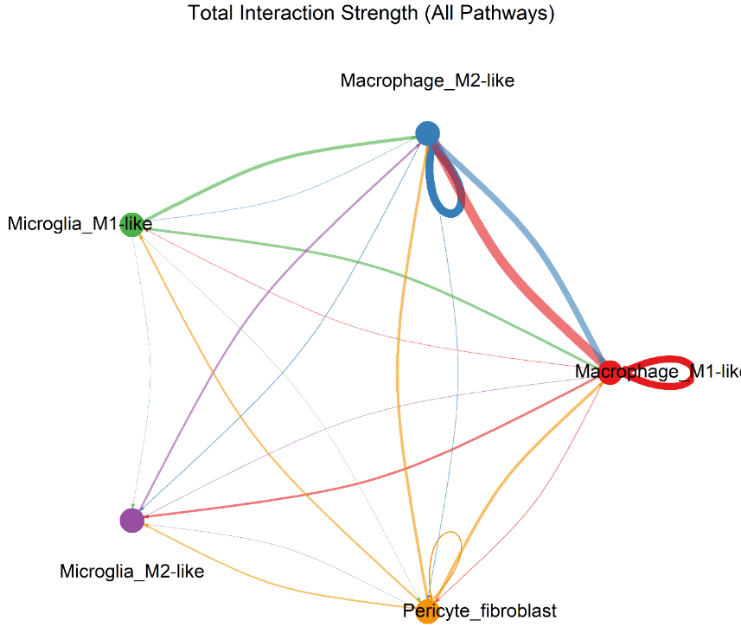
Figure 6. Global cell-cell communication network across the brain metastasis microenvironment. Circular network plot displaying the total interaction strength (weighted communication probability) aggregated across all signaling pathways. Edge thickness corresponds to signaling strength

Ligand-Receptor Interactions
Detailed evaluation of ligand-receptor pairs (p < 0.01) demonstrated significant variation across target cell pairs. Evaluation of fibroblast-derived signaling revealed distinct receptor-binding preferences across recipient myeloid populations, particularly regarding Syndecan-4 (SDC4) interactions. Fibroblasts engaged M1-like macrophages (Pericyte_fibroblast -> Macrophage_M1-like) through collagen–SDC4 pairs (COL1A1–SDC4, COL6A1–SDC4, and COL9A3–SDC4) as well as MDK–SDC4 signaling. Crucially, these SDC4-mediated interactions were completely absent in M2-like macrophages (Pericyte_fibroblast -> Macrophage_M2-like), which interacted with fibroblast-derived collagens exclusively via CD44 (COL1A1–CD44, COL6A1–CD44, COL9A3–CD44). A similar polarization pattern was mirrored in microglia, where M1-like microglia retained low-level COL1A1–SDC4 communication while both M1- and M2-like microglia primarily engaged CD44.
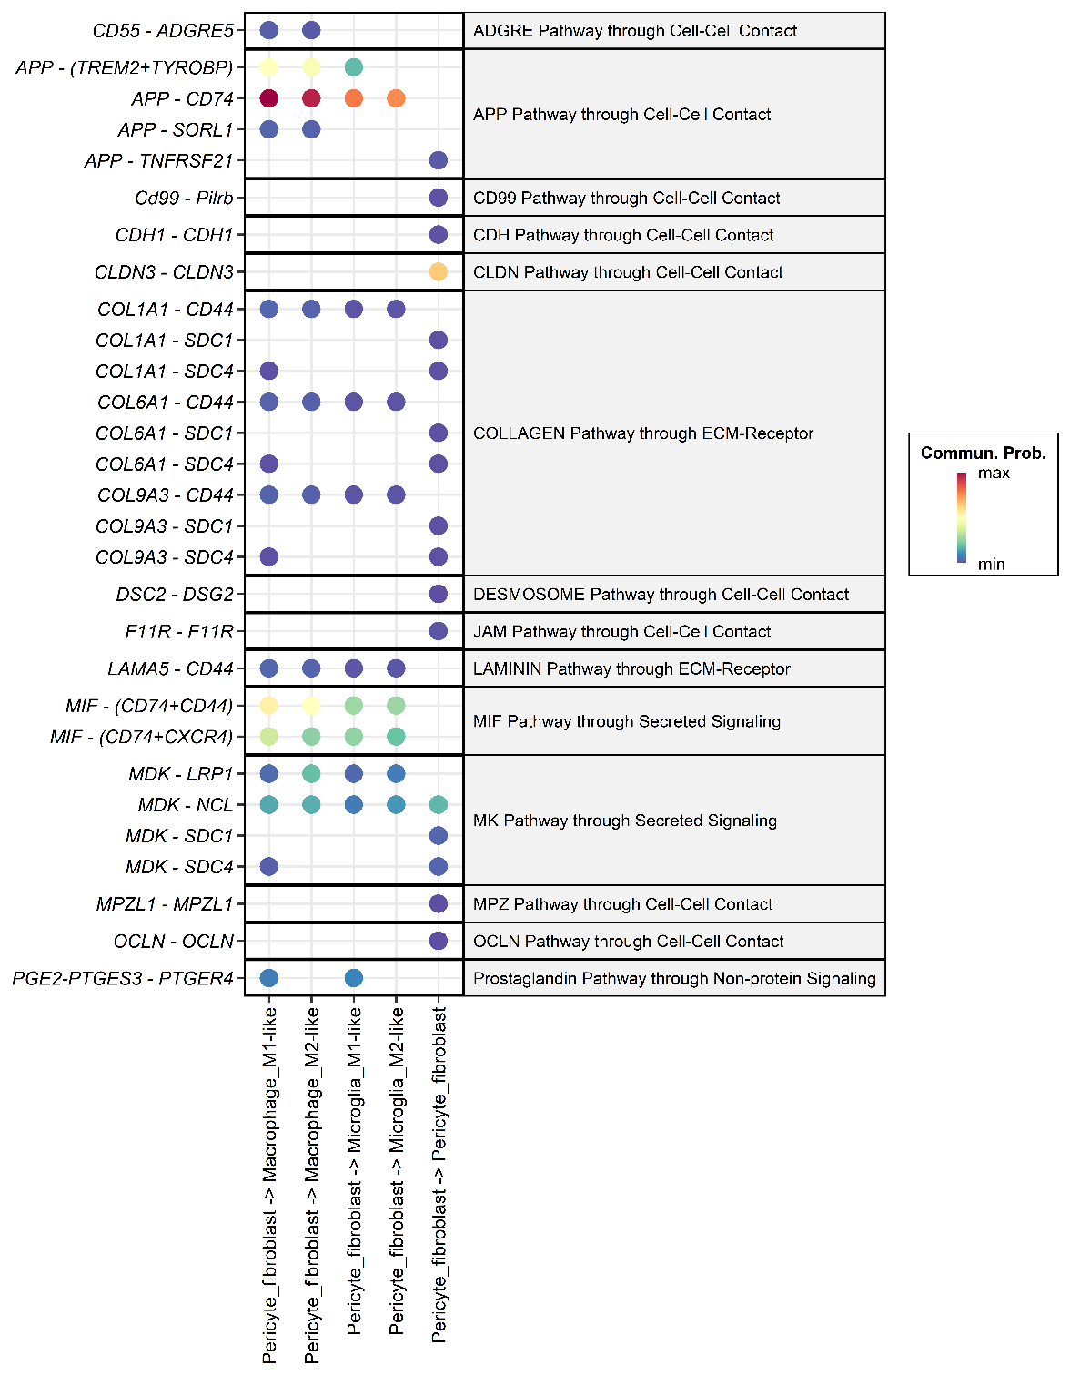
Figure 7. Fibroblast-centric ligand-receptor communication landscape.Faceted dot plot displaying significant (p < 0.01) ligand-receptor interactions originating from Pericyte_fibroblasts across target recipient cell types. Color intensity represents communication probability. Collagen and Midkine signaling demonstrate selective SDC4 receptor engagement in M1-like macrophages compared to CD44-predominant binding in M2-like macrophages.
Discussion
This study evaluated whether tumor-associated fibroblasts (TAFs) drive structural and immunoregulatory remodeling in the brain metastatic microenvironment through targeted crosstalk with M1-like macrophages, evaluating three core predictions against existing literature (Song et al., 2023).
TAF Matrix-Remodeling Profile (Prediction 1 — Supported): TAFs act as a primary source of extracellular matrix (ECM) structural components (collagens, laminins) and stromal ligands (MIF, APP, MDK, TIMP3), confirming their role as signaling senders to the myeloid compartment.
M1 Macrophage Inflammatory Program (Prediction 2 — Supported): M1-like macrophages express an active pro-inflammatory profile distinct from M2-like cells and microglia. This program is driven by Toll-like receptor (TLR) and NF-κB signaling, supported by high transcription factor activity (NFKB1, RELA, AP-1, HIF1A, RFX5).
Fibroblast-to-M1 Crosstalk (Prediction 3 — Partially Supported):
- Shared Axis: Robust APP/MIF-to-CD74/CD44/CXCR4 signaling occurs universally across M1, M2, and microglial cells, reflecting general stromal-myeloid communication rather than M1-specific regulation.
- M1-Restricted Axis: Collagen/MDK-to-SDC4 interactions were exclusive to M1-like macrophages. However, low predicted interaction probabilities indicate SDC4 acts as a candidate anchoring/stabilization signal rather than a proven driver of the M1 phenotype.

Hypothesis Testing & Key Findings
- Prediction 1 (Supported): Fibroblasts act as matrix-remodeling stromal ligand sources, expressing collagens, laminins (LAMA4/5), TIMP3, MDK, MIF, and APP.
- Prediction 2 (Supported): M1-like macrophages exhibit a TLR/NF-κB/IL-1-driven cytokine program (TNF, IL1B, CCL3/4, C3) regulated by key TFs (NFKB1, RELA, AP-1, HIF1A, RFX5).
- Prediction 3 (Partially Supported): An M1-restricted SDC4 axis (collagens/MDK to SDC4) and an M1/microglial PGE2-PTGER4 axis were identified, but display low predicted communication probabilities. Stronger interactions (APP/MIF-CD74, CD44) are broadly shared across all myeloid populations.
- Hypothesis Verdict: The evidence supports candidate fibroblast–M1 communication axes but does not prove fibroblasts drive or reshape the M1 state, as M1-restricted signals are weak and the M1 program is well-explained by intrinsic TLR/NF-κB activity.

Comparison with Song et al. (2023) (Original article)
Confirmed Features: Replicated collagen-high TAFs, pro-inflammatory myeloid cells, CD44 signaling, and APP/MDK stromal ligands (identifying APP–CD74 as the strongest signal).
Novel Features: Uncovered M1-restricted SDC4 expression, a pan-myeloid MIF-CD74/CXCR4/CD44 axis, a PGE2-PTGER4 axis, and M1-enriched TF signatures.
Methodological Differences: Resolved individual cells into M1-like, M2-like, and microglial states rather than treating myeloid cells as a single population, and classified TGFB1 within the M2 gene set rather than M1. M1-to-fibroblast feedback proposed by Song et al. remains untested.
Key Limitations
- Sample & Signal Constraints: Small dataset size (n=5 samples) and low predicted communication probabilities for M1-restricted signals
- Validation Constraints: Relies strictly on mRNA-based in silico inference without protein, spatial, or functional validation.
- Methodological Artifacts: Simplified binary M1/M2 thresholding led to baseline scoring distortion (85.4% of microglia scored as M1-like), while single-cell Wilcoxon testing risks inflating statistical significance compared to pseudobulk analysis.

Conclusion
Overall, our re-analysis reproduces the central findings of Song et al. (a collagen-rich fibroblast population and a pro-inflammatory myeloid compartment) and adds new candidate features: an M1-restricted fibroblast-SDC4 axis, a shared MIF/APP-CD74 axis, and a TLR/NF-κB TF signature in M1-like macrophages.
