Cell-Cell Communication Analysis Report
Methods
The analysis characterizes the inferred cell-cell communication networks among five distinct cell populations: Macrophage_M1-like, Macrophage_M2-like, Microglia_M1-like, Microglia_M2-like, and Pericyte_fibroblast. The methodology evaluates global network connectivity by calculating the total number of interactions and the total interaction strength across all aggregated signaling pathways. To determine the specific molecular drivers of this network, communication probabilities for individual ligand-receptor pairs were quantified. Finally, the individual ligand-receptor pairs were categorized into broader functional signaling pathways to assess higher-order communication modules.
Results
The global interaction network is characterized by dense communication among the analyzed cell populations. The total interaction counts reveal that Macrophage_M2-like cells are highly active, sending 28 interactions to Macrophage_M1-like cells and establishing 31 autocrine interactions. The aggregated interaction strength network visually confirms that the most robust signaling axes exist between the Macrophage_M1-like and Macrophage_M2-like populations, characterized by highly weighted connecting lines and autocrine loops.
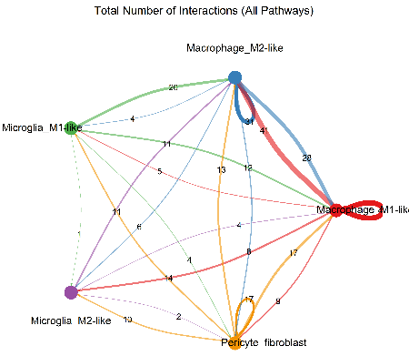
Fig.1: This network plot displays the total number of interactions across all pathways among the five analyzed cell types. Edge thicknesses and numerical labels indicate the discrete count of signaling interactions occurring between and within the cell populations.
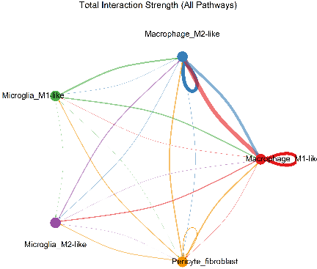
Fig. 2: This network visualization illustrates the total interaction strength across all cellular pathways. The width of the connecting lines visually represents the magnitude of signaling strength, highlighting dominant communication hubs.
Analysis of specific ligand-receptor interactions, excluding self-signaling, highlights several dominant pathways. The APOE-TREM2 interaction demonstrates the maximum communication probability, driven primarily by Macrophage_M1-like, Macrophage_M2-like, and Microglia_M1-like cells acting as signaling sources targeting Macrophage_M2-like, Macrophage_M1-like, and Macrophage_M2-like cells, respectively.
Pericyte_fibroblasts emerge as key signaling nodes in both the APP pathway, communicating via APP-CD74 to Macrophages and Microglia, and the Extracellular Matrix (ECM)-receptor pathways. Specifically, Pericyte_fibroblasts are the exclusive senders of COLLAGEN (e.g., COL1A1, COL6A1) and LAMININ signals.
When autocrine (self) interactions are included in the analysis, significant self-regulation is observed within specific populations. Macrophage_M1-like and Macrophage_M2-like cells exhibit maximum-probability autocrine signaling via the APOE-TREM2 axis. Furthermore, the inclusion of self-interactions reveals a suite of cell-cell contact pathways that were entirely absent in the paracrine-only analysis. These include the CADM, CDH, CLDN, DESMOSOME, JAM, MPZ, and OCLN pathways, which are almost exclusively restricted to Pericyte_fibroblast autocrine and homotypic signaling.
Discussion
The analysis maps a highly compartmentalized cellular microenvironment dominated by two primary axes: reciprocal macrophage regulation and pericyte/fibroblast structural signaling. The dense interaction counts and pronounced signaling strengths between the M1-like and M2-like macrophage populations indicate extensive immunological crosstalk and potential phenotypic tuning between these states.
A central molecular driver of this immune crosstalk is the APOE-TREM2 pathway, which exhibits the highest communication probabilities across the network. The robust paracrine and autocrine APOE-TREM2 signaling observed among macrophages and microglia suggests a critical role in lipid metabolism, debris clearance, or localized immune modulation.
Meanwhile, Pericyte_fibroblasts function as the structural anchor of the microenvironment. They mediate extensive ECM-receptor interactions, uniquely providing LAMININ and COLLAGEN signaling to the macrophage populations. The addition of autocrine signaling to the analysis uncovers that Pericyte_fibroblasts also heavily self-regulate via cell-cell adhesion pathways (such as CLDN, OCLN, and DESMOSOME). This suggests that while pericytes/fibroblasts broadcast structural signals outward to immune cells, they rely on tight junction and adhesion pathways internally to maintain their own tissue integrity and network architecture.
Original article (Fibroblast):
- includes collagens (type I, IV, and VI) and fibronectin (FN1), with receptors including integrin αVβ8 (ITGAV and ITGB8), syndecan 1 and 4 (SDC1 and SDC4), and CD44
New analysis (Fibroblast):
- presence of collagens (type I, VI, and IX), with receptors including SDC4 and CD44
- absence of fibronectin (FN1) with receptors including integrin αVβ8 (ITGAV and ITGB8)

