AI Course
Capstone Project
Final Report

For students (instructor review required)

ⓒ2025 SAMSUNG. All rights reserved.
Samsung Electronics Corporate Citizenship Office holds the copyright of this document.
This document is a literary property protected by copyright law so reprint and reproduction without permission are prohibited.
To use this document other than the curriculum of Samsung Innovation Campus, you must receive written consent from copyright holder.

< Project Title >

< Date (DD/MM/YY) >

Team Name

<Member 1>
<Member 2>
<Member 3>
<Member 4>
<Member 5>

Content
1. Introduction
1.1. Background Information
1.2. Motivation and Objective
1.3. Members and Role Assignments
1.4. Schedule and Milestones

2. Project Execution
2.1. Data Acquisition
2.2. Training Methodology
2.3. Workflow
2.4. System Diagram

3. Results
3.1. Data Preprocessing
3.2. Exploratory Data Analysis (EDA)
3.3. Modeling
3.4. User Interface
3.5. Testing and Improvements

4. Projected Impact
4.1. Accomplishments and Benefits
4.2. Future Improvements

5. Team Member Review and Comment

6. Instructor Review and Comment

1. Introduction

1.1. Background Information

1.2. Motivation and Objective

1.3. Members and Role Assignments

1.4. Schedule and Milestones

2. Project Execution

2.1. Data Acquisition

2.2. Training Methodology

2.3. Workflow

2.4. System Design

3. Results

3.1. Data Preprocessing

3.2. Exploratory Data Analysis (EDA)

3.3. Modeling

3.4. User Interface

Balaagh AI was designed as a responsive command center for reviewing Arabic crisis reports in the Libyan context. The interface keeps the original Arabic report visible while converting it into a structured, reviewable record. The dashboard is intentionally a decision-support prototype: it does not dispatch emergency services, contact authorities, or claim real-time prediction.
Dashboard / Command Center
The dashboard gives the analyst an immediate overview of the saved demo dataset and the current review workload. It combines four headline indicators with recent reports and distribution views so that the most important patterns can be scanned before opening a detailed record.
• Total reports: the number of saved analyses in the current dataset.
• Critical reports and High priority: reports requiring focused human review.
• Reports today: a time-based activity indicator for the current day.
• Recent reports: a direct path to the latest structured records.
• Priority mix and incident classes: compact visual summaries of the saved reports.
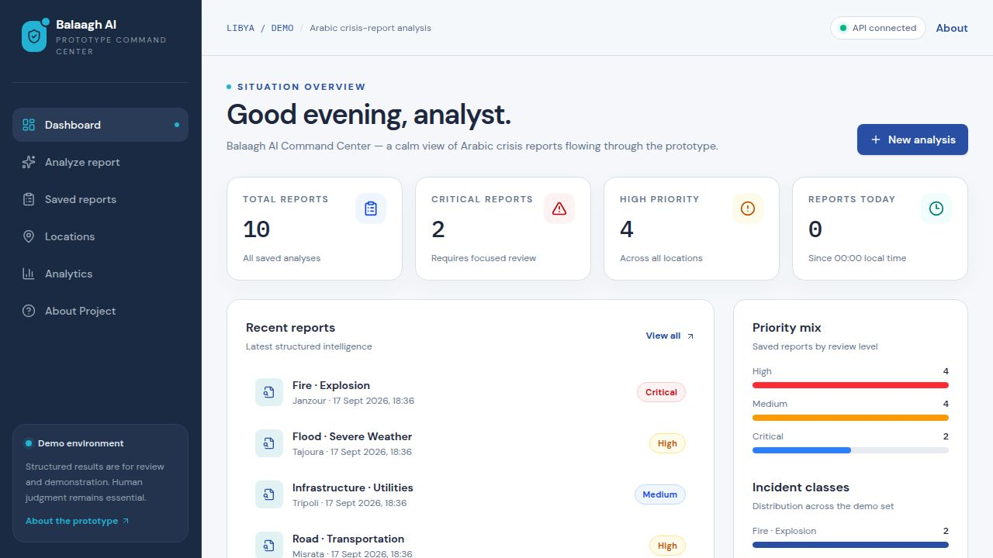
Figure 3.4.1. Balaagh AI Command Center dashboard with live demo data, recent reports, priority mix, and incident-class distribution.
Analyze Report Workspace
The Analyze Report screen is the main user flow. The analyst pastes an Arabic report into an RTL-ready input area, submits it for analysis, reviews the structured output, and saves the reviewed result. The screen shows a clear prototype disclaimer and keeps the original text available for verification.
• Arabic RTL input with an example report: “مثال: في حريق في منزل في جنزور وفي طفلين داخل البيت”.
• Structured output for incident class, priority, location, people at risk, required support, relevance, and summary.
• Loading, error, empty, and saved states so the workflow remains understandable during API requests.
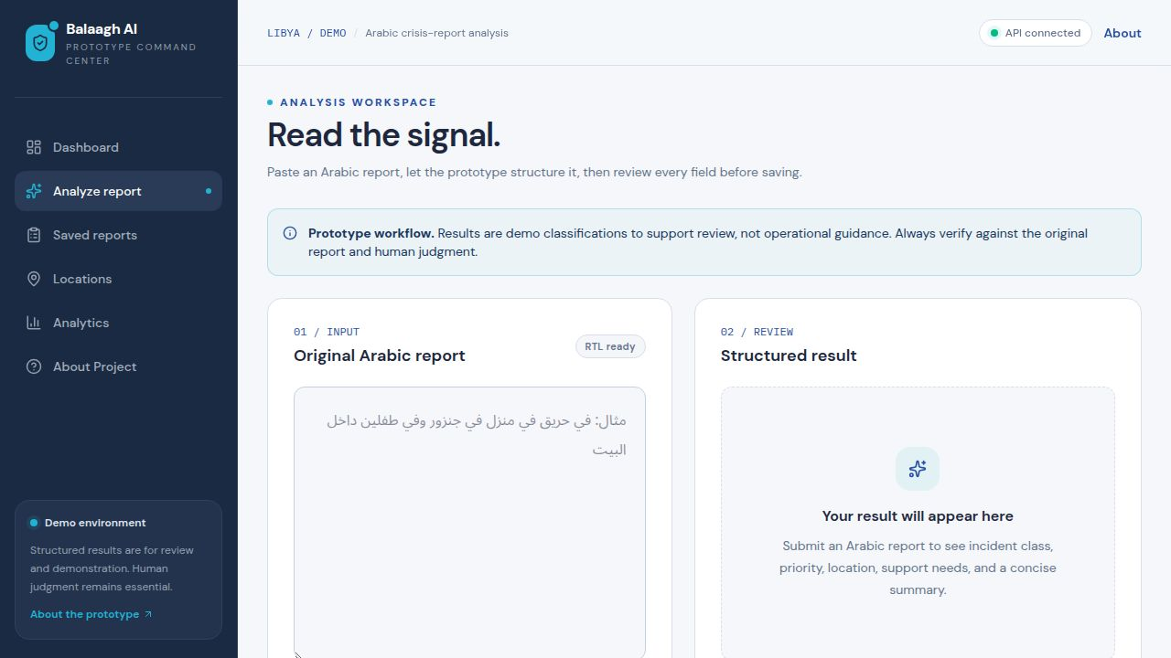
Figure 3.4.2. RTL Arabic report input and structured-review workspace.
Reports, Locations, and Analytics
Supporting screens extend the dashboard into a small review system. Saved Reports provides search, sorting, filters, detail views, and deletion. Locations summarizes reporting areas and potential risk indicators. Analytics compares incident classes, support needs, priorities, locations, and illustrative model-evaluation values.
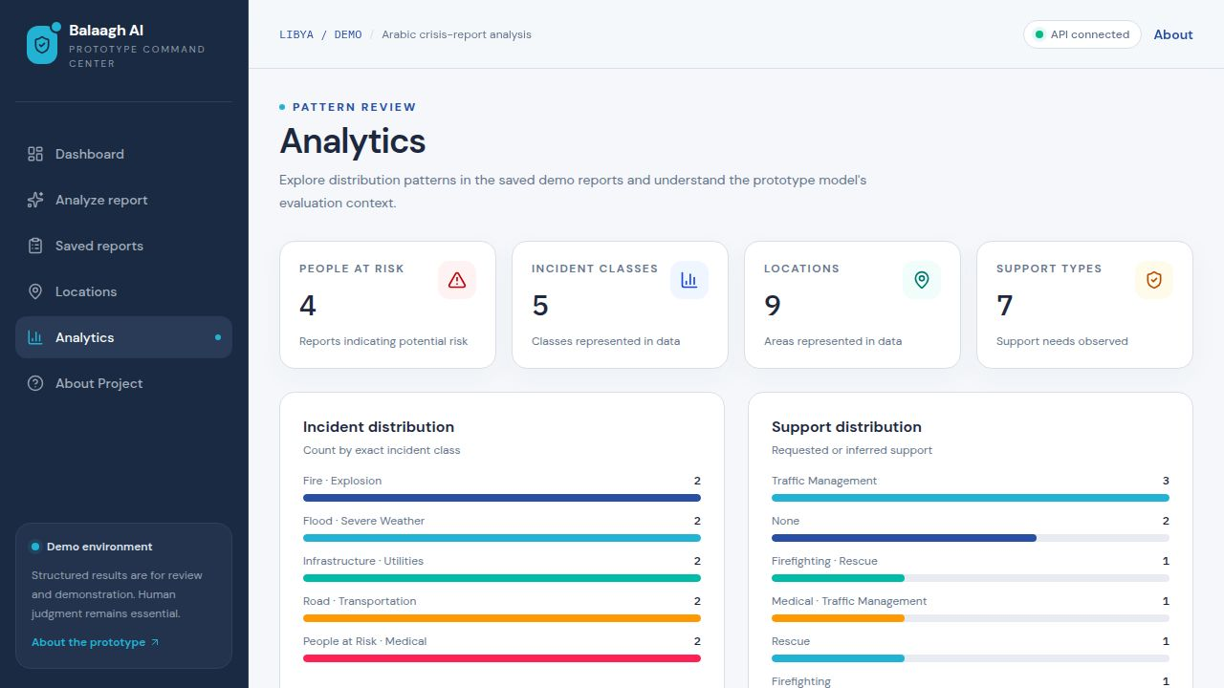
Figure 3.4.3. Analytics screen showing incident distribution, support distribution, and high-level metrics.
AI Approach Represented in the UI
The current implementation uses a transparent keyword-based Arabic baseline so that every result can be explained during the capstone demonstration. The modular design leaves a clear path for a trained NLP model: MARBERT or AraBERT can be fine-tuned for incident classification, Arabic named-entity recognition can extract locations and people, and a separate rule layer can combine model signals with priority and support checks. The interface labels evaluation values as demo or placeholder results and does not present them as production performance.
Usability, Accessibility, and Responsible Use
• Responsive layout with a collapsible navigation menu for smaller screens.
• Clear hierarchy, color-coded priority badges, readable status indicators, and consistent loading and empty states.
• Arabic text is preserved in RTL presentation while the surrounding dashboard remains easy to scan in English.
• Human verification is required before treating any structured result as meaningful. The prototype is not emergency dispatch software and should not replace local expertise, source verification, or safety protocols.
3.5. Testing and Improvements

4. Projected Impact

4.1. Accomplishments and Benefits

4.2. Future Improvements

5. Team Member Review and Comment

<ATTACH A TEAM PICTURE HERE>

NAME | REVIEW and COMMENT

6. Instructor Review and Comment

CATEGORY | SCORE | REVIEW and COMMENT
IDEA | __/10
APPLICATION | __/30
RESULT | __/30
PROJECT  MANAGEMENT | __/10
PRESENTATION & REPORT | __/20
TOTAL | __/100

