

**NAME : IMRAN ALI**

**ROLL NO : 110855**

**SEMESTER : THIRD**

**DEPARTMENT : INFORMATION TECHNOLOGY**

**TOPIC : SEMESTER PROJECT**

**SUBMITTED TO : MISS SAHRISH KHAN**

**SEMESTER PROJECT**

**TELNET CONNECTION WITH SECURE VPN**

**DEFINATION:**

A telnet connection is a type of connection that allows a user to access and control a remote computer or device over the internet or a local area network .Telnet is a protocol that enables remote access to a command line interface on a remote device.

**KEY CHARACTERISTICS:**

1: remote access

2: command line interface

3: tcp /ip protocol

**Structure:**

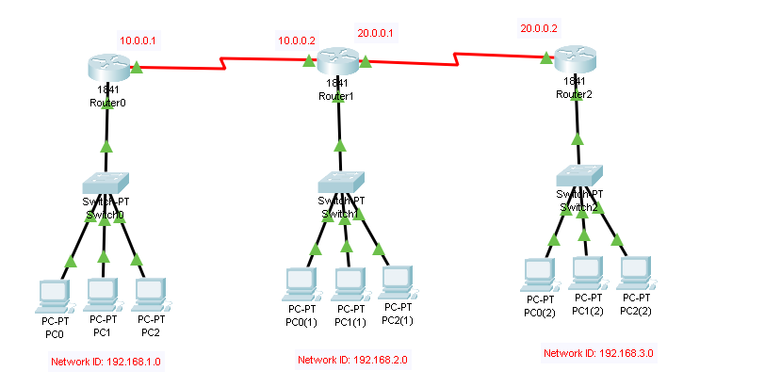

**ARRANGMENTS:**

First we take 3 routers.

Then we take 3 switchs.

Then we take 3 pcs for indivisual lan network.

We will creat 3 lans.

Then we will connect them and creat wan network.

**ADRESSING IPS**