Prepared by: Mai Ashraf

Project Managemenet Plan

Learning Hub Web Application

9/4/2022

V 1.0

**Table of Contents**

Revision History 3

1. Introduction 4

1.1 Purpose of Project Management Plan 4

1.2 Summary of Project Charter 4

1.2.1 Introduction 4

1.2.2 Business need 4

1.2.3 Timeline 4

1.2.4 Team 4

1.2.5 Conclusion 5

1.3 Assumptions, Constraints & Tools 5

1.3.1 Assumptions 5

1.3.2 Constrains 5

1.3.3 Tools 6

1.4 Scope Management 6

1.5 Work Breakdown Structure 6

2. Schedule/Time Management 7

2.1 Milestones 7

2.2 Project Schedule & Dependencies 7

3. Quality Management 8

4. Configuration Management 9

4.1 Tracking and Tailoring 9

4.2 Guidelines of CM Tool 9

4.3 Folder Structure 9

5. Communication Management 10

6. Risk Management 11

6.1 Risk Management Plan 11

6.2 Risk log 11

7. Issues & Escalation Management 11

7.1 Issue Management Plan 11

Appendix A: References 11

# Revision History

|  |  |  |  |
| --- | --- | --- | --- |
| Name | Date | Version | Revision Date |
| Mai Ashraf | 9/4/2022 | 1.0 |  |
|  |  |  |  |
|  |  |  |  |

# Introduction

## Purpose of Project Management Plan

The intended audience of the Learning Hub PMP is all project stakeholders including the project sponsor, senior leadership, and the project team.

The Learning Hub will act as an online free encyclopedia that has multiple information so that the users can explore and receive knowledge in different life domains and be part of a community to contribute and share their knowledge.

## Summary of Project Charter

### Introduction

Our mission is that every person can access the website to learn, they can also share their knowledge in the form of articles, videos, and records. Which will help spread knowledge across the world.

Our vision is to facilitate self-learning tasks for people to gain more knowledge.

### Business need

Needed a website which gathers many sections for different fields and gets notified with all the updates of the user's interests.

### Timeline

The Project will be delivered within 4 weeks and 5 days. Starting date from 4/9/2022 and End date in 20/5/2022. We plan to provide four milestones for the project as it needs approximately 480 hours.

### Team

Our team consists of 6 members:

* Mai Ashraf: Project Manager
* Rana Mostafa: Configuration Manager
* Yara Emad: Developer
* Fatma Mekhemer: Developer
* Radwa Kamal: Tester
* Maha Mohamed: Tester

### Conclusion

Launching an online free encyclopedia with a variety of material, allowing users to discover and receive knowledge in a variety of life domains.

For further information, See reference in Appendix A: References “Project Charter”.

## Assumptions, Constraints & Tools

### Assumptions

|  |  |  |  |  |
| --- | --- | --- | --- | --- |
| **No.** | **Assumptions** | **To be validated** | **Status** | **Comments** |
| 1 | User Password must contain more than 8 characters with a pattern (“^(?=.\d)(?=.[a-z])(?=.*[A-Z]).{8,20}$“) | Esraa Abdelhallem  Maha Mohamed | Agreed |  |
| 2 | Video size is 1min minimum and 2 mins max with no specific extensions | Esraa Abdelhallem  Radwa Kamal | Agreed |  |
| 3 | Voice recorded size uploaded must be a 30 sec to 1 min with (“mp3”) extension | Esraa Abdelhallem  Rana Mostaf | Agreed |  |

### Constrains

|  |  |  |  |
| --- | --- | --- | --- |
| **No.** | **Area** | **Constrain** | **Comment** |
| 1 | Project Scope | Project is a web-based application. | Understood and Agreed |
| 2 | Non-functional Requirements | Project is PC-based only and compatible with all OS of devices | Understood and Agreed |
| 3 | Database | User IDs are unique and auto generated by DB | Understood and Agreed |
| 4 | Functional Requirements | 4 Admin features are supported and described in functional Requirements. | Understood and Agreed |

### Tools

|  |  |  |
| --- | --- | --- |
| **No.** | **Area** | **Tool** |
| 1 | Front-End | HTML, CSS, JS |
| 2 | Back-End | .net C# |
| 3 | Database | phpMyAdmin XAMPP |

## Scope Management

Scope Management plan provide with defined scope for project within the required timeline and budget. For further information, See reference in Appendix A: References “Scope Management Plan”.

## Work Breakdown Structure

The Work Breakdown Structure has 4 levels as shown below in Figure-1.

For WBS dictionary, See reference in Appendix A: References “WBS Dictionary”.

**Figure ‎1‑1**

# Schedule/Time Management

## Milestones

The Project Has four milestones. The table below lists the milestones for this project, along with their estimated completion timeframe.

|  |  |  |
| --- | --- | --- |
| **Milestones** | **Date** | **Deliverables** |
| Milestone 1 | 15/04/2022 | PMP, SRS, SiQ, Schedule, CM Tool |
| Milestone 2 | 22/04/2022 | TBD |
| Milestone 3 | 29/04/2022 | TBD |
| Milestone 4 | 06/05/2022 | TBD |

## Project Schedule & Dependencies

The Figures below show the project schedule, the dependencies are shown in Schedule sheet. See reference in Appendix A: References “Project Schedule & Dependencies”.

**Figure ‎2‑1**

**Figure ‎2‑2**

**Figure ‎2‑3**

# Quality Management

Project Quality Management Plan documents the necessary information required to effectively manage project quality from project planning to delivery. It defines a project’s quality policies, procedures, criteria for and areas of application, and roles, responsibilities, and authorities. See reference in Appendix A: References “Quality Management Plan”.

# Configuration Management

## Tracking and Tailoring

We will track all our documents, code, testing, monitor & control phases through the software life cycle (SDLC).

We tailored our Configuration Management tool to use Git and GitHub instead of TortoiseSVN.

## Guidelines of CM Tool

* There are two branches:
  + The first one is for the baseline.
  + The other one is for the internal changes between the releases.
* Pull requests are required for the master branch only.
* Tags will be used to distinguish between baselines.
* Tags must be in this format (DayMonthYear-Inter/Release-no of release) ex:160422-Release-01

## Folder Structure

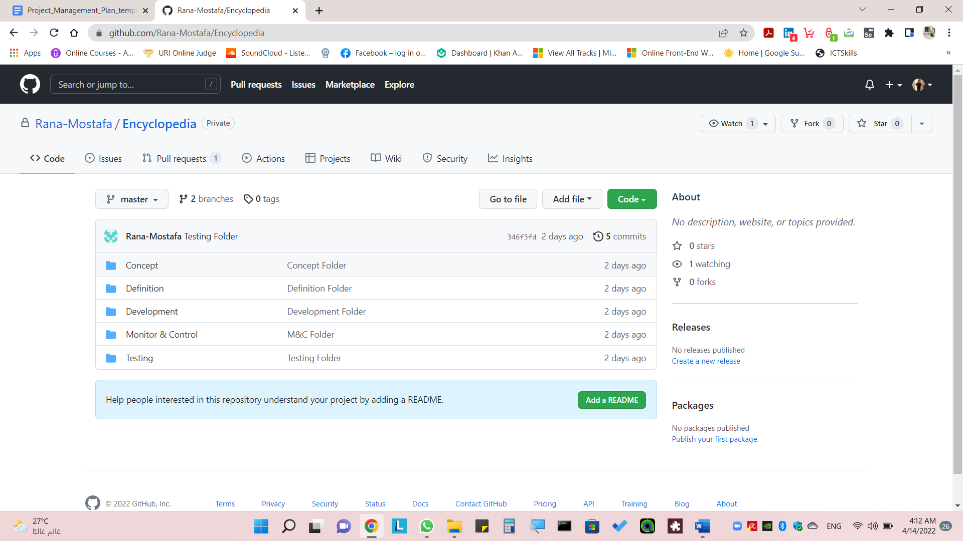This structure of files and plans for the project as shown below in GitHub. For live repository, See reference in Appendix A: References “Quality Management Plan”.

**Figure ‎4‑1**

|  |  |  |  |  |
| --- | --- | --- | --- | --- |
| **Main Folder** | **Description** | **Child Folder Included** | **Grandchild Folder Included** | **Files Included** |
| Concept | Contains the main plans for the project | - | - | PMP  Project Charter  Scope Management Plan  Schedule  WBS |
| Definition | Contains main designs and requirements | Design | HLD |  |
| LLD |
| Requirements | - | SIQ  SRS |
| Development | Contains DB, Code and layout designs | Back-End |  |  |
| Front-End |  |  |
| Middleware |  |  |
| Monitor and Control | Contains plans for quality, risk, change management to review project progress | Change Request |  |  |
| Quality Management | - | Quality Management Plan  Traceability Matrix  Issue Management and Escalation plan  Reviews |
| Risk Management | - | Risk Management Plan  Risk Log |
| Testing | Contains test cases and reports | Reports |  |  |
| Specs |  |  |

# Communication Management

**Communication Matrix:**

|  |  |  |  |
| --- | --- | --- | --- |
| **Communication Goal** | **Communication Tool** | **Audience** | **Frequency** |
| Team Standup | Online Meeting | Project Team | Daily |
| Project Review | Physical Meeting | Project Team | Weekly |
| Customer Collaboration | Formal Email/Frequent Touch Points | Project Team - Customer | When needed |

# Risk Management

## Risk Management Plan

To ensure that our project is on track, and try to avoid any obstacles in our way, we are creating a Risk Management document that will define the possibility of a risk, and the impact that might encounter us, and it will be defined, acknowledged, and monitored by the project manager and all team members.

See reference in Appendix A: References “Risk Management Plan”.

## Risk log

Risk Log document that will define the possibility of a risk, and the impact that might encounter us, response Strategies to deal with possible risks. See reference in Appendix A: References “Risk Management Log”.

# Issues & Escalation Management

## Issue Management Plan

Issue Management Plan defines and documents the activities, the roles and responsibilities of those involved in identifying, assessing, assigning, resolving and controlling project issues. See reference in Appendix A: References “Risk Management Log”.

# Appendix A: References

The following table summarizes the documents referenced in this document.

|  |  |
| --- | --- |
| Document Name | Location |
| Project Charter |  |
| Scope Management Plan |  |
| WBS Dictionary |  |
| Project Schedule & Dependencies |  |
| Quality Management Plan |  |
| Risk Management Plan |  |
| Risk Management Log |  |
| References “Risk Management Log |  |