Rana Aldosari 20193017
B.1 -Design a toolbar for the major APS use cases
● Make a copy of MenuView.fxml, then use SceneBuilder to add a toolbar below the menu bar, as shown in Figure 1.
● The icons on the buttons are not graphics but MS-Office fonts (hint: the font name is Segoe UI Symbol).
● Update the controller to handle the ActionEvents generated by the toolbar buttons.

Screenshot:
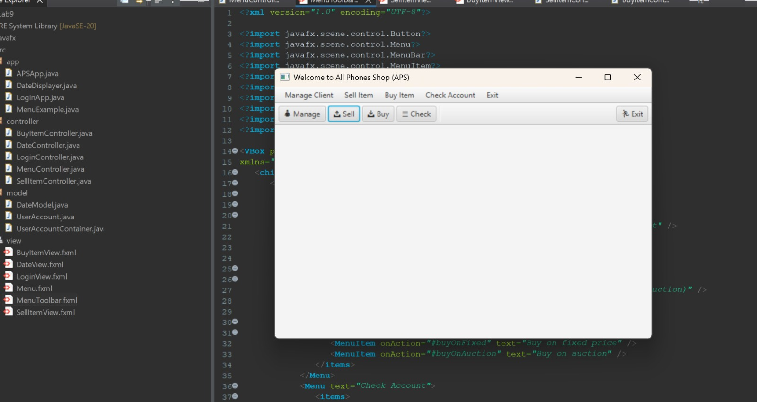

Code:
MenuController.java (Code):
package controller;

import java.io.IOException;

import javafx.event.ActionEvent;
import javafx.fxml.FXML;
import javafx.fxml.FXMLLoader;
import javafx.scene.Parent;
import javafx.scene.Scene;
import javafx.scene.control.Alert;
import javafx.scene.control.Alert.AlertType;
import javafx.scene.control.MenuBar;
import javafx.stage.Stage;

public class MenuController {
@FXML
private MenuBar menuBar;

@FXML
void buyOnAuction(ActionEvent event) {
displayMessage("Buy on Auction is waiting to be implemented", AlertType.CONFIRMATION);
}

@FXML
void buyOnFixed(ActionEvent event) {
openForm("/view/BuyItemView.fxml", "Buy on Fixed Price");
}

@FXML
void checkShoppingBasket(ActionEvent event) {
displayMessage("Checking the shopping basket is waiting to be implemented", AlertType.CONFIRMATION);
}

@FXML
void deleteClient(ActionEvent event) {
displayMessage("Delete a client (by corporate clients only) is waiting\nto be implemented", AlertType.CONFIRMATION);
}

@FXML
void exit(ActionEvent event) {
System.exit(0);
}

@FXML
void findBill(ActionEvent event) {
displayMessage("Finding a bill is waiting to be implemented", AlertType.CONFIRMATION);
}

@FXML
void getReceipt(ActionEvent event) {
displayMessage("Getting a receipt is waiting to be implemented", AlertType.CONFIRMATION);
}

@FXML
void registerNewClient(ActionEvent event) {
displayMessage("Registering a new client is waiting to be implemented", AlertType.CONFIRMATION);
}

@FXML
void sellItem(ActionEvent event) {
openForm("/view/SellItemView.fxml", "Sell Item");
}

// Opens a form (FXML file) in a new window
private void openForm(String fxmlPath, String title) {
try {
Parent root = FXMLLoader.load(getClass().getResource(fxmlPath));
Stage stage = new Stage();
stage.setTitle(title);
stage.setScene(new Scene(root));
stage.show();
} catch (IOException e) {
displayMessage("Could not open the form: " + fxmlPath, AlertType.ERROR);
}
}

public void displayMessage(String message, AlertType type) {
Alert alert = new Alert(type);
alert.setTitle("APS Message");
alert.setHeaderText(null);
alert.setContentText(message);
alert.showAndWait();
}
}

MenuToolbar.fxml (Code):
<?xml version="1.0" encoding="UTF-8"?>

<?import javafx.scene.control.Button?>
<?import javafx.scene.control.Menu?>
<?import javafx.scene.control.MenuBar?>
<?import javafx.scene.control.MenuItem?>
<?import javafx.scene.control.Separator?>
<?import javafx.scene.control.ToolBar?>
<?import javafx.scene.layout.HBox?>
<?import javafx.scene.layout.Pane?>
<?import javafx.scene.layout.VBox?>
<?import javafx.scene.text.Font?>

<VBox prefHeight="400" prefWidth="600" xmlns:fx="http://javafx.com/fxml/1"
xmlns="http://javafx.com/javafx/11.0.1" fx:controller="controller.MenuController">
<children>
<MenuBar fx:id="menuBar">
<menus>
<Menu text="Manage Client">
<items>
<MenuItem onAction="#registerNewClient" text="Register New Client" />
<MenuItem onAction="#deleteClient" text="Delete Client" />
</items>
</Menu>
<Menu text="Sell Item">
<items>
<MenuItem onAction="#sellItem" text="Sell item (Fixed price or Auction)" />
</items>
</Menu>
<Menu text="Buy Item">
<items>
<MenuItem onAction="#buyOnFixed" text="Buy on fixed price" />
<MenuItem onAction="#buyOnAuction" text="Buy on auction" />
</items>
</Menu>
<Menu text="Check Account">
<items>
<MenuItem onAction="#checkShoppingBasket" text="Check shopping basket" />
<MenuItem onAction="#findBill" text="Find bill" />
<MenuItem onAction="#getReceipt" text="Get receipt" />
</items>
</Menu>
<Menu text="Exit">
<items>
<MenuItem onAction="#exit" text="Exit APS" />
</items>
</Menu>
</menus>
</MenuBar>

<ToolBar fx:id="toolBar">
<items>
<Button mnemonicParsing="false" onAction="#registerNewClient" text="&#x1F464; Manage">
<font><Font name="Segoe UI Symbol" size="12.0" /></font>
</Button>
<Button mnemonicParsing="false" onAction="#sellItem" text="&#x1F4E4; Sell">
<font><Font name="Segoe UI Symbol" size="12.0" /></font>
</Button>
<Button mnemonicParsing="false" onAction="#buyOnFixed" text="&#x1F4E5; Buy">
<font><Font name="Segoe UI Symbol" size="12.0" /></font>
</Button>
<Button mnemonicParsing="false" onAction="#checkShoppingBasket" text="&#x2630; Check">
<font><Font name="Segoe UI Symbol" size="12.0" /></font>
</Button>
<Separator orientation="VERTICAL" />
<Pane HBox.hgrow="ALWAYS" />
<Button mnemonicParsing="false" onAction="#exit" text="&#x1F3C3; Exit">
<font><Font name="Segoe UI Symbol" size="12.0" /></font>
</Button>
</items>
</ToolBar>
</children>
</VBox
B.2 Design forms for the Sell Item and Buy on Fixed use cases
● Each form must have at least four text fields and one "Enter" button.
● The client (actor) can enter input data in the four fields, such as the item model, make, capacity and color.
● Create one FXML file for each form: the Sell Item FXML and the Buy Item FXML.
Screenshot:
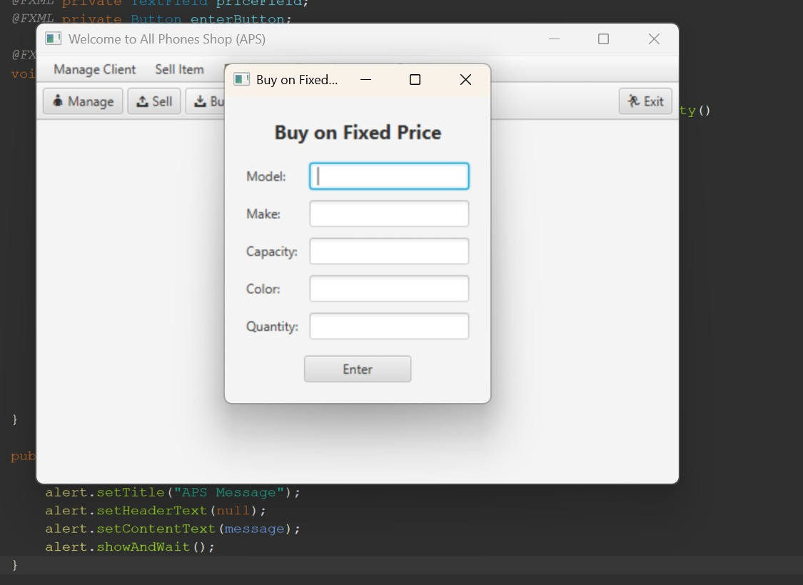
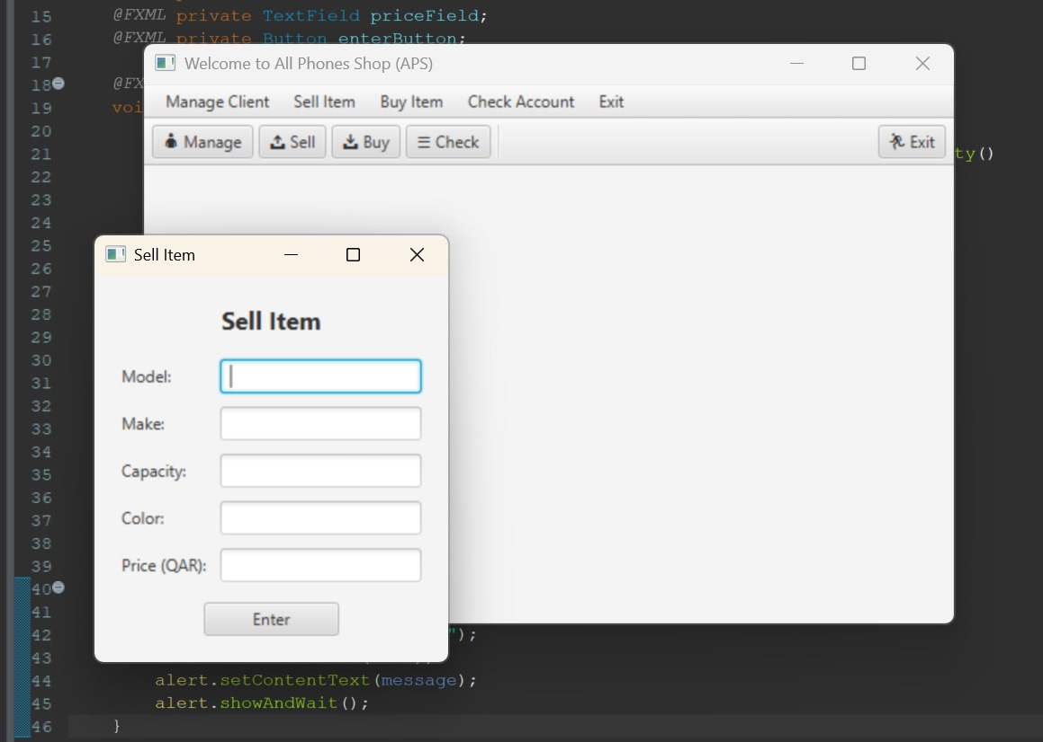
Code:
SellItemController.java (Code):
package controller;

import javafx.event.ActionEvent;
import javafx.fxml.FXML;
import javafx.scene.control.Alert;
import javafx.scene.control.Alert.AlertType;
import javafx.scene.control.Button;
import javafx.scene.control.TextField;

public class SellItemController {
@FXML private TextField modelField;
@FXML private TextField makeField;
@FXML private TextField capacityField;
@FXML private TextField colorField;
@FXML private TextField priceField;
@FXML private Button enterButton;

@FXML
void enter(ActionEvent event) {
if (modelField.getText().isEmpty() || makeField.getText().isEmpty()
|| capacityField.getText().isEmpty() || colorField.getText().isEmpty()
|| priceField.getText().isEmpty()) {
displayMessage("Please fill in all the fields.", AlertType.ERROR);
return;
}
displayMessage("Item submitted for sale:\n"
+ "Model: " + modelField.getText() + "\n"
+ "Make: " + makeField.getText() + "\n"
+ "Capacity: " + capacityField.getText() + "\n"
+ "Color: " + colorField.getText() + "\n"
+ "Price: " + priceField.getText() + " QAR",
AlertType.INFORMATION);
modelField.clear();
makeField.clear();
capacityField.clear();
colorField.clear();
priceField.clear();
}

public void displayMessage(String message, AlertType type) {
Alert alert = new Alert(type);
alert.setTitle("APS Message");
alert.setHeaderText(null);
alert.setContentText(message);
alert.showAndWait();
}
}

SellItemView.fxml (Code):
<?xml version="1.0" encoding="UTF-8"?>

<?import javafx.geometry.Insets?>
<?import javafx.scene.control.Button?>
<?import javafx.scene.control.Label?>
<?import javafx.scene.control.TextField?>
<?import javafx.scene.layout.GridPane?>
<?import javafx.scene.layout.VBox?>
<?import javafx.scene.text.Font?>

<VBox alignment="CENTER" spacing="15.0" xmlns="http://javafx.com/javafx/11.0.1"
xmlns:fx="http://javafx.com/fxml/1" fx:controller="controller.SellItemController">
<children>
<Label text="Sell Item">
<font><Font name="System Bold" size="18.0" /></font>
</Label>
<GridPane hgap="10.0" vgap="10.0">
<children>
<Label text="Model:" GridPane.rowIndex="0" />
<TextField fx:id="modelField" GridPane.columnIndex="1" GridPane.rowIndex="0" />
<Label text="Make:" GridPane.rowIndex="1" />
<TextField fx:id="makeField" GridPane.columnIndex="1" GridPane.rowIndex="1" />
<Label text="Capacity:" GridPane.rowIndex="2" />
<TextField fx:id="capacityField" GridPane.columnIndex="1" GridPane.rowIndex="2" />
<Label text="Color:" GridPane.rowIndex="3" />
<TextField fx:id="colorField" GridPane.columnIndex="1" GridPane.rowIndex="3" />
<Label text="Price (QAR):" GridPane.rowIndex="4" />
<TextField fx:id="priceField" GridPane.columnIndex="1" GridPane.rowIndex="4" />
</children>
</GridPane>
<Button fx:id="enterButton" mnemonicParsing="false" onAction="#enter" prefWidth="100.0" text="Enter" />
</children>
<padding>
<Insets bottom="20.0" left="20.0" right="20.0" top="20.0" />
</padding>
</VBox>

