Class name | Typed attributes | Evidence and justification
Clint | Name: string , address: string , regNo: int | APS stores client name, address and registration number.
Individual |  | Individual is a specialization of Client.
Corporate |  | Corporate is a specialization of Client and can remove registration.
Item | Model: string , color: string  Make: string , itemId: int ,status: string ,  image: String , item Type: string ,capacity : string. | APS records the item details, assigns an ID, creates a display image and tracks its status.
Smart phone |  | Smartphone is a type of Item.
Apple Iphone |  | Apple iPhone is a smartphone subcategory.
Samsung Galaxy |  | Samsung Galaxy is a smartphone subcategory.
Normal mobile phone |  | Normal mobile phone is one of APS's phone types.
Land phone |  | Land phone is one of APS's phone types.
bid | start Price: double  endAuctionTime:Local Time , amount: double. | Auction bidding uses a starting price, end time and bid amount.
Shopping basket | Status: string | APS creates and saves a shopping basket for fixed-price purchases.
catalog | itemList: List<item> | APS maintains a product catalog containing items for sale.
invoice | Status: string , InvoiceNo: int , amount: double, data: LocalDate. | APS prepares invoices, attaches them to the registration and tracks their status.
Penalty | Amount: double | APS charges a 10% penalty in specified cases.
Rana Aldosari
20193017

B.1- Identify Classes and Typed Attributes

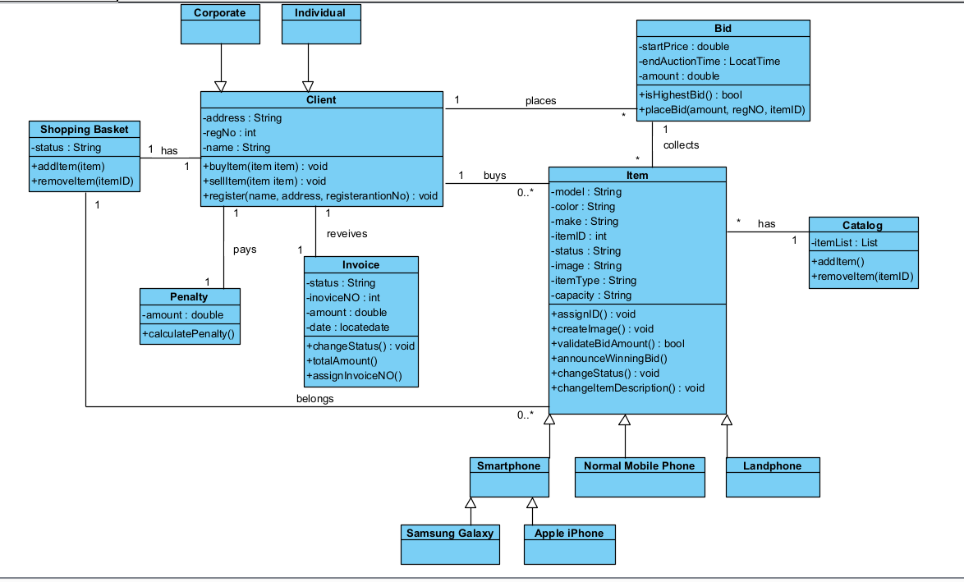
B.2 - Develop the APS class diagram

B.3 Assign operations from the use case specifications

Class | Operation with parameter and return types | Use case step and placement reason
Client | +register(name: string, address: string):void | UC001- Registers client: Register the client using the provided name and address
Client | +assignRegistrationNo():int | UC001- Register client: APS assigns a unique registration number to the client
Item | +create Item(model: String, make : string , capacity: string , color: string): Item | UC003- List item for sale: Records the item details provided by the client.
Item | +assignID(): void | UC003- List item for sale: APS assigns an ID to the item.
Item | +createImage(): void | UC003- List item for sale: APS create a display image for the item .
Bid | +placeBid(amount: double, regNo: int, itemID: int): void | UC006- Place bid: Records the client’s bid for the selected item
Bid | +isHighestBid(): Boolean | UC006- Place bid: checks whether the bid is higher than the previous bid.

