Architecture

Architecture diagram:

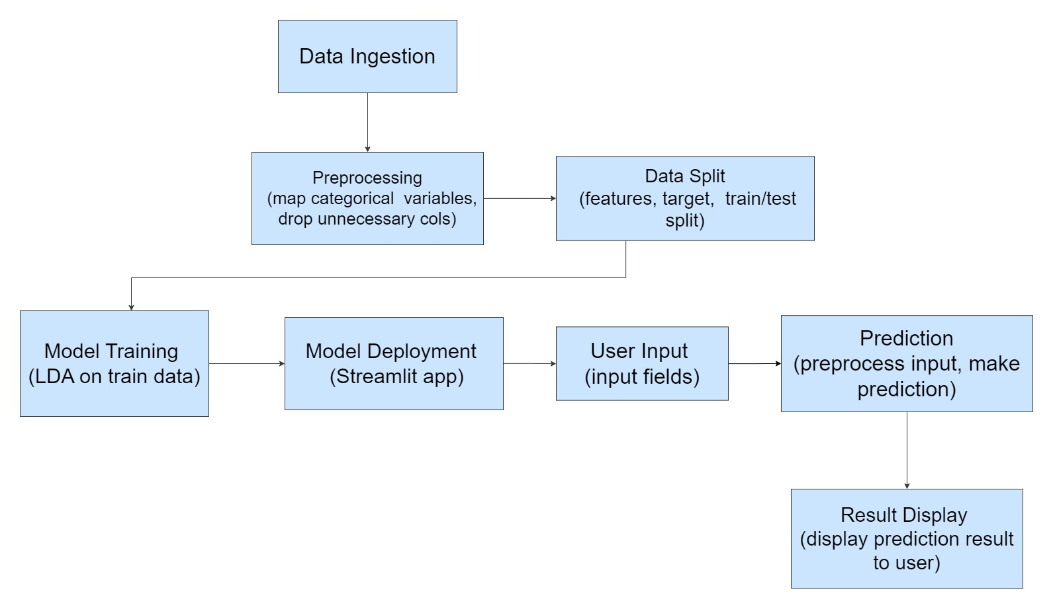

Here is an architecture for the machine learning code:

**Data Ingestion**

* Load dataset from CSV file (**sample_dataset.csv**)
* Preprocess data:
  + Map categorical variables to numerical values
  + Drop unnecessary columns (**salary**, **sl_no**, **gender**)

**Data Split**

* Split preprocessed data into:
  + Features (**x**)
  + Target variable (**y**)
* Split data into training and testing sets (**xtrain**, **xtest**, **ytrain**, **ytest**)

**Model Training**

* Train a Linear Discriminant Analysis (LDA) model on the training data (**xtrain**, **ytrain**)

**Model Deployment**

* Create a Streamlit app to deploy the trained model
* Define input fields for the user to enter their details
* Preprocess user input data
* Make a prediction using the trained model
* Display the prediction result to the user