San Diego City Budget Analysis


Rana Hamad Algayeb
DAB 16

Introduction
Between 2013 and 2024, the City of San Diego allocated over grew from approximately 2.62 billion to nearly $4.47 billion in operating and capital budgets across multiple departments and infrastructure projects. However, there is limited transparency in how accurately these budgets were followed, which departments consistently overspend or underspend, and how these variances impact the city’s ability to deliver public services and infrastructure on time.
This project aims to measure Budget vs Actual performance, identify inefficiencies across funds, departments, and CIP projects, and highlight the financial gaps that may affect future planning and community outcomes.
Problem statement

From 2013 to 2024, San Diego’s operating and capital budgets showed inconsistent spending patterns, making it difficult to see which departments and projects stayed within budget and which exceeded their allocations.
This analysis measures how effectively San Diego translated its approved budgets into actual outcomes, pinpoints inefficiencies in spending, and evaluates the financial impact of major capital projects.
Approach

- Analyzed Budget vs Actual spending from 2013–2024 to identify long-term financial patterns and variances.
- Examined fund types to determine which funds show the highest spending levels and the largest variances.
- Evaluated departmental performance by identifying recurring overspending and underspending across operating budgets.
- Assessed capital project costs by comparing actual, budgeted, and average spending to highlight high-impact projects.
- Used data insights to interpret spending efficiency and support recommendations for improved financial planning and future budget allocation.

Target Audience
1- City finance officers and Decision Makers of San Deigo
2- Citizens interested in public fund transparency
Dataset Overview

This project analyzes a comprehensive collection of San Diego’s financial datasets, covering the period from Fiscal Year 2013 to Fiscal Year 2024. The data includes both operating and capital financial activities, enabling a multi-dimensional evaluation of how the city allocates and utilizes public funds.
- The datasets contain four main components:
- Operating Budget Data
Includes annual departmental budgets, actual operating expenditures, fund types, department names, and spending categories. This allows us to assess day-to-day government spending and compare Budget vs. Actual performance.
- Actual Operating Expenditures
Provides a detailed summary of all real spending records across departments. These values help identify overspending, underspending, and year-over-year fluctuations in operational performance.
- Capital Budget Allocations
Contains budget amounts for Capital Improvement Projects (CIP), including project names, project IDs, fund types, and fiscal-year budgeted allocations. This data reflects long-term infrastructure planning.
- Actual Capital Expenditures
Captures real spending on each capital project, allowing us to compare planned vs. actual financial performance over time.
After cleaning, standardizing, and combining the datasets, we created a unified analytical model that supports comparative analysis across departments, fund types, fiscal years, and individual capital projects. This integration provides clear visibility into financial efficiency trends over the 12-year period.

Analytical Questions
This analysis is guided by four key questions designed to evaluate San Diego’s financial efficiency and spending behavior:
- How efficiently are departments managing their annual operating budgets?
This examines which departments stay within their allocated budgets and which consistently overspend, providing a basis for performance evaluation.
- Which fund types show the largest variance between Budget and Actual spending?
Different fund types such as General Fund, Enterprise Funds, Special Revenue Funds, and Internal Services play unique roles in city finance. Understanding which ones show high variance can reveal structural inefficiencies.
- Are there specific years or departments that show persistent overspending or underspending trends? Identifying recurrent patterns helps understand whether inefficiencies are temporary or systemic.
- Which capital projects represent the highest financial burden, and how do their actual costs compare to planned budgets? This helps evaluate capital spending discipline and long-term project management effectiveness.
These questions shaped the structure of the dashboards, the KPIs chosen, and the comparative visualizations created for the technical report.
Analysis
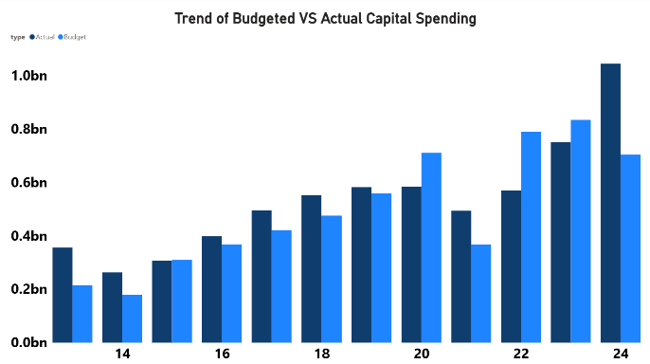
This visual shows the annual comparison between the budgeted capital spending and the actual capital spending from fiscal years 2013 to 2024. It highlights how planned long-term investments in infrastructure differ from the actual expenditures each year, revealing the city’s accuracy in forecasting and managing capital project costs over time.

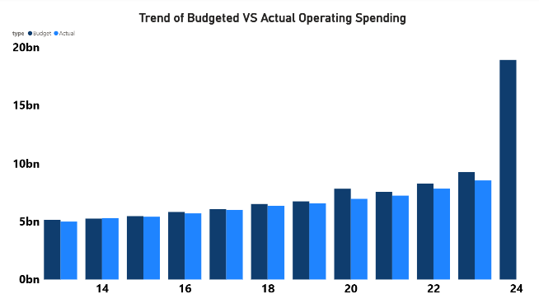
This visualization compares budgeted versus actual operating spending across fiscal years 2013 to 2024. It illustrates how closely departments adhered to their annual operational budgets, showing the city’s ability to manage day-to-day service costs relative to what was originally planned.

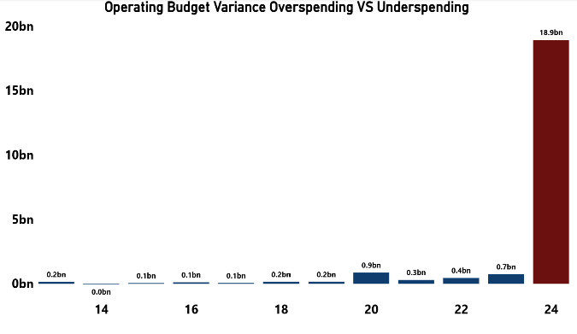
The chart shows that San Diego’s operating budget stayed mostly stable from 2013–2023 with small variances. But in 2024, there is a sudden 18.9bn overspending spike, which is a major anomaly and requires further investigation.

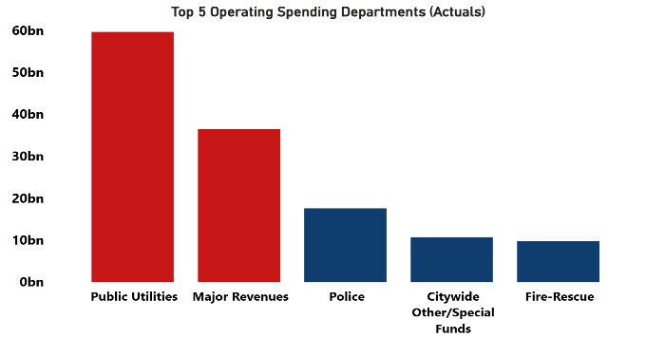
This chart displays total operating spending categorized by fund type. It highlights how different funding sources are utilized across city operations and shows which funds carry the highest operational financial burden.

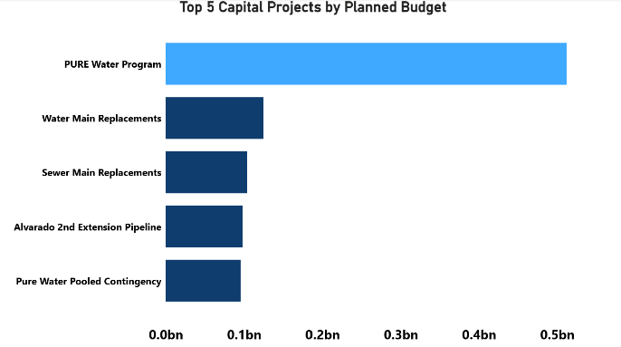
This visual shows the capital projects with the largest planned budgets. It reflects the city’s strategic priorities and the major infrastructure initiatives that require the greatest financial commitment.

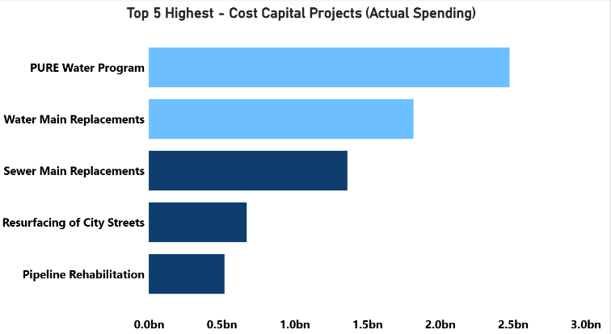
This visualization lists the capital projects with the highest actual spending. It highlights major long-term infrastructure investments that have the greatest financial impact on the city’s capital program and it show the pure water have the most investment.

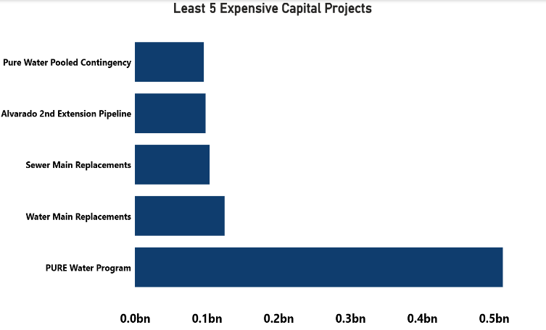
This visualization highlights the capital projects with the lowest overall spending. It provides insight into smaller-scale projects that require minimal investment compared to other city initiatives.

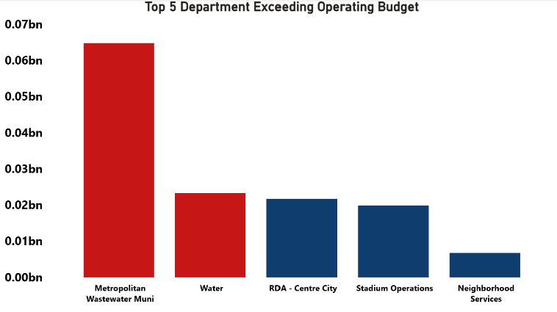
This chart identifies the departments whose actual operating spending exceeded their approved budgets. It highlights areas where spending control was less effective and where budget overruns occurred.

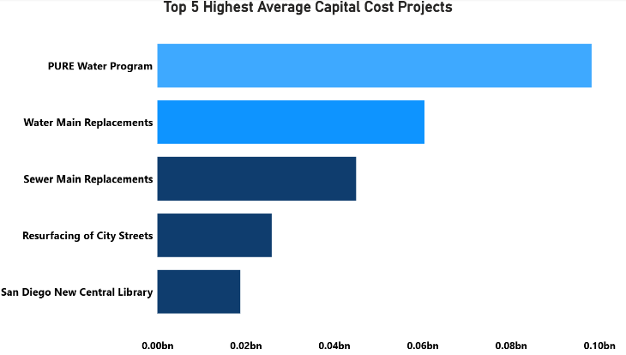
This chart shows the top five projects with the highest average capital cost in San Diego. The PURE Water Program ranks first, followed by major water and sewer replacement projects, indicating that water-related infrastructure is the city’s largest long-term capital expense

Key Findings

The analysis revealed several important trends in San Diego’s financial performance:
1. Steady Growth in Operating Spending (2013–2024)
Actual operating expenditures increased consistently across the 12-year period, with notable spikes around 2022–2024, indicating expanded municipal services, rising operational costs, or economic-driven spending adjustments.
2. Significant Overspending in Key Departments
Departments such as Metropolitan Wastewater, Water, and Stadium Operations showed the highest positive variances (overspending). This may reflect infrastructure strain, rising utility demands, or unexpected project costs.

3. General Fund and Enterprise Funds Dominate Spending
These two fund types showed the highest total spending, indicating their central role in supporting essential city operations and utility-related projects.
4. High-Cost Capital Projects (CIP)
The PURE Water Program emerged as the most financially demanding project, far exceeding other capital initiatives in both budget and actual spending. Other high-cost projects include Water Main Replacements and Sewer Main Replacements.
5. Variance Patterns Suggest Planning Challenges
Several projects showed a significant gap between budgeted amounts and actual spending, indicating potential issues with forecasting, project timeline delays, or changing project scopes.
6. A Small Number of Projects Heavily Influence Total Costs
A small set of mega-projects contributes to a disproportionately large share of San Diego’s capital spending, highlighting potential risk concentration.

Comparison Summary
San Diego benefits from a mature open-data ecosystem that supports detailed public analysis, while Bahrain is progressing but still developing similar transparency and data accessibility mechanisms.
Limitations & Future Opportunities

- Limitations
- Missing or unlabeled project names in the capital dataset reduce accuracy in ranking and comparison.
- Not all fiscal years include fully aligned Budget vs. Actual data for every fund type.
- No contextual information available about emergency spending, cost escalations, inflation, or policy changes.
- Limited metadata regarding department-level financial policies or cost drivers.
- The datasets do not include revenue data, making it difficult to link expenditure variances with financial sustainability.

- Future Opportunities
- Integrate revenue datasets to understand the full financial picture.
- Expand analysis to include cost-per-citizen, population growth, and service delivery KPIs.
- Add predictive modeling (forecasting next-year spending based on historical trends).
- Use geographic analysis for CIP projects to highlight regional investment patterns.
- Encourage the release of expanded open datasets in Bahrain for cross-country benchmarking.

Recommendations

- Improve Budget Forecasting Accuracy
Large differences between budgeted and actual amounts, especially in capital projects, indicate forecasting issues. The City should adopt multi-year forecasting models and review budgets quarterly to reduce variance.
- Strengthening Oversight for High-Variance Departments
Some departments consistently exceed their operating budgets. Implementing monthly variance monitoring and requiring corrective action plans would help improve financial discipline.
- Reassess Fund Allocation Based on Actual Utilization
General Fund and Enterprise Funds show the highest spending levels. Reallocating resources based on actual usage patterns would ensure more efficient fund distribution and reduce imbalances.
- Enhance Cost Control on Major Capital Projects
A small number of capital projects drive a large portion of total spending. Increasing oversight, conducting internal audits, and improving contract management would help minimize cost overruns.
- Address Recurring Underspending Trends
Years with consistent underspending suggest administrative delays or project-execution challenges. Reviewing internal processes and reducing approval delays can improve spending efficiency.
- Use Historical Trends to Guide Future Planning
Clear patterns across fiscal years highlight consistent spending pressures in key areas. Incorporating these trends into future budgets and CIP planning would support more accurate resource allocation.
- Standardize Budgeting Practices Across Departments
Differences in budgeting accuracy suggest inconsistent practices. Establishing city-wide budgeting guidelines and training departments on unified financial planning methods would improve overall reliability.
Data Dictionary

- Actuals Capital Dataset
Original Column Name | Data Type | Action Taken | New Name (If Renamed)
amount | Decimal Number | Kept | amount
project_number_parent | Text | Removed | —
project_number_child | Text | Removed | —
report_fy | Whole Number | Renamed | fiscal_year
fund_type | Text | Kept | fund_type
fund_number | Text | Kept | fund_number
asset_owning_dept | Text | Removed | —
project_name | Text | Kept | project_name
account | Text | Removed | —
account_number | Text | Removed | —
category (added) | Text | Added | category = "CIP"
type (added) | Text | Added | type = "Actual"

- Actual Operation Dataset
Original Column Name | Original Data Type | Action Taken | New Name (If Renamed)
amount | Decimal Number | Kept | amount
report_fy | Whole Number | Renamed | fiscal_year
budget_cycle | Text | Removed | —
fund_type | Text | Kept | fund_type
fund_number | Text | Kept | fund_number
dept_name | Text | Kept + Renamed | department_name
account | Text | Removed | —
account_number | Text | Kept | account_number
category (added) | Text | Added | category = "Operating"
type (added) | Text | Added | type = "Actual"

- Budget Capital
Original Column Name | Original Data Type | Action Taken | New Name (If Renamed)
amount | Decimal Number | Kept | amount
report_fy | Whole Number | Converted + Renamed | fiscal_year
budget_cycle | Text | Removed | —
fund_type | Text | Kept | fund_type
fund_number | Text | Kept | fund_number
dept_name | Text | Kept + Renamed | department_name
account | Text | Removed | —
account_number | Text | Kept | account_number
category (added) | Text | Added | category = "Operating"
type (added) | Text | Added | type = "Actual"

- Budget operation
Original Column Name | Original Data Type | Action Taken | New Name (If Renamed)
amount | Decimal Number | Kept | amount
report_fy | Whole Number | Converted + Renamed | fiscal_year
budget_cycle | Text | Kept (Optional) | budget_cycle
fund_type | Text | Kept | fund_type
fund_number | Text | Kept | fund_number
dept_name | Text | Renamed | department_name
funds_center_number | Text | Removed | —
account | Text | Removed | —
account_number | Text | Kept | account_number
category (added) | Text | Added | category = "Operating"
type (added) | Text | Added | type = "Budget"

Reference

- https://www.sandiego.gov/sites/default/files/2025-02/citizens-budget-review-townhalls.pdf
- https://www.sandiegocounty.gov/content/sdc/openbudget/en/budget-summary.html

Appendix
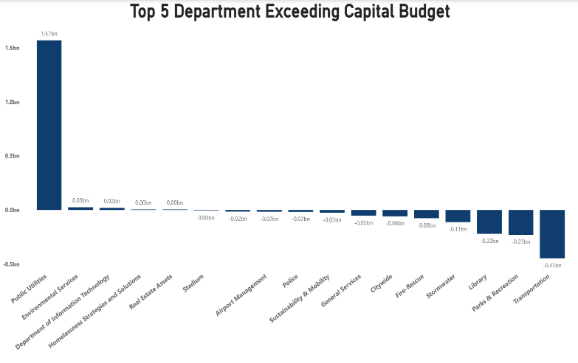
This chart shows which San Diego departments exceeded their capital budget the most. One department shows a major overrun of 1.57bn, far higher than all others, while the remaining departments exceeded their budgets by much smaller amounts. This indicates that overspending is concentrated in one major department, suggesting possible planning issues or unexpected project costs.

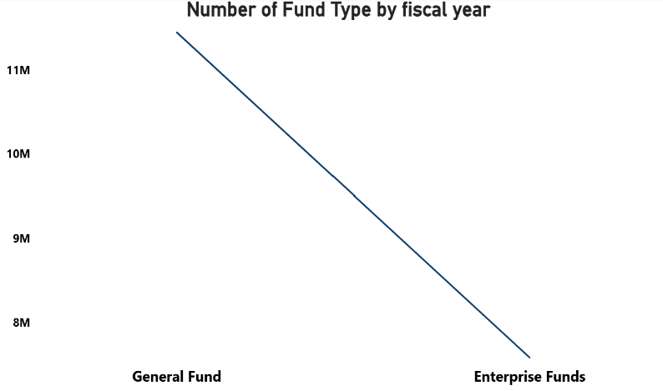
This visualization compares the number of funds between General Fund and Enterprise Funds. It shows a decrease from around 11M to 8M, indicating shifting financial allocations or reduced reliance on certain fund categories over time.

