

YENEPOYA INSTITUTE OF ARTS, SCIENCE, COMMERCE AND MANAGEMENT,
BALMATTA, MANGALORE

Final Report
ON
IDENTITY SECURITY FRAMEWORK FOR E-COMMERCE

SUBMITTED BY
RANA CV
III BCA
(Digital Fprensic,CyberSecurity and DataScience)
23BCCDD039

Industry Mentor: Guided By:
Mr. Shashank korram Ms. Suzana Sharol prabakhar

Contents
1. Background 3
1.1 Aim 3
1.2 Technologies 3
1.3 Hardware Architecture 4
1.4 Software Architecture 4
2 System 6
2.1 Requirements 6
2.1.1 Functional Requirements 6
2.1.2 User Requirements 6
2.1.3 Environmental Requirements 7
2.2 Design and Architecture 7
2.3 Implementation 8
2.4 Testing 9
2.5 Graphical User Interface (GUI) Layout 10
2.6 Customer Testing 11
2.7 Evaluation 11
3 Snapshots of the Project 12
4 Conclusions 13
5 Further Development or Research 13
6 References 14
7 Appendix 14

Background
In the current digital landscape, e-commerce platforms face increasing threats from sophisticated cyber-attacks targeting user identities. Traditional authentication systems that rely on plain-text or weakly hashed passwords are no longer sufficient against modern brute-force and credential-stuffing techniques. This project addresses these challenges by implementing an Identity Security Framework for an anti-tarnish jewellery e-commerce store that utilises state-of-the-art cryptographic hashing (bcrypt), strict role-based access controls, and a real-time audit logging system.

1.1 Aim
The primary aim of this project is to design and develop a resilient identity management system that ensures the integrity and confidentiality of user data within a fully functional e-commerce platform. Key objectives include:
- Implement bcrypt password hashing to resist brute-force and rainbow-table attacks.
- Enforce brute-force protection by locking accounts after 3 consecutive failed login attempts.
- Provide a dedicated Admin Dashboard for real-time monitoring of users, orders, and authentication events.
- Deliver a complete e-commerce shopping lifecycle: registration, login, browse, cart, wishlist, checkout, and order history.
- Demonstrate a scalable, maintainable Flask-based architecture suitable as a blueprint for production security systems.

1.2 Technologies
The system is built using a modern, lightweight technology stack that balances security with rapid development.
Backend
- Python 3 + Flask — lightweight WSGI framework for routing, session management, and server-side logic.
- SQLite 3 — embedded relational database; no external server required. Stores users, products, orders, order_items.
- bcrypt — adaptive, memory-hard password hashing algorithm with per-hash salts.
Frontend
- HTML5 + Jinja2 — server-side rendering with template inheritance via base.html.
- Vanilla CSS — custom dark-navy/gold design system using CSS variables and flex/grid layouts.
- JavaScript (Fetch API) — asynchronous add-to-cart and wishlist without full page reloads.
Security & Utilities
- Flask signed sessions — tamper-evident cookie-based session tokens.
- Regex input validation (security.py) — prevents SQL injection and invalid characters at registration.
- File-based event logger (logger.py) — timestamped authentication events written to log.txt.

1.3 Hardware Architecture
The system follows a client-server hardware architecture:
- Client Devices — Any modern browser (Chrome/Firefox/Edge) on desktop, laptop, or mobile via HTTP/HTTPS.
- Application Server — Python Flask process serving on port 5000 (localhost for demo; cloud VM for production).
- Storage Layer — Local filesystem: database.db (SQLite) and log.txt; static images in /static/images/.
- Admin Workstation — Administrator accesses the system through the same browser interface via /admin_login.

1.4 Software Architecture
The application follows a layered MVC pattern:
- Model — SQLite tables (users, products, orders, order_items) accessed via the sqlite3 module.
- View — Jinja2 HTML templates in /templates/ (login, register, dashboard, products, cart, wishlist, admin_dashboard, admin_order_detail).
- Controller — Flask route handlers in app.py; security helpers in security.py; logger in logger.py.
Request Lifecycle: Browser → Flask route → Decorator guard (login/admin required) → DB query → Jinja2 render → Response.

2 System

2.1 Requirements

2.1.1 Functional Requirements
ID | Requirement
FR-01 | User Registration with username uniqueness enforcement.
FR-02 | Secure Login with bcrypt verification and session creation.
FR-03 | Brute-Force Protection — account locked after 3 consecutive failures.
FR-04 | Admin Login via separate /admin_login route with privilege check.
FR-05 | Product Catalogue — browse 20 anti-tarnish jewellery items.
FR-06 | Shopping Cart — add, update quantity, remove items (session-based).
FR-07 | Wishlist — save favourite products across the session.
FR-08 | Checkout — create Order + OrderItems records; clear cart on success.
FR-09 | Admin Dashboard — view all users, blocked accounts, orders, and audit logs.
FR-10 | Order Management — admin can update order status (Pending/Processing/Completed/Cancelled).
FR-11 | Event Logging — every login attempt is timestamped and persisted to log.txt.

2.1.2 User Requirements
End-User (Customer)
- UR-01 Register with a username (3-20 chars, alphanumeric/underscore) and password (≥ 6 chars).
- UR-02 Log in and receive immediate feedback on remaining attempts if credentials are wrong.
- UR-03 Browse the product catalogue with images, names, descriptions, and prices.
- UR-04 Add items to cart or wishlist; view and manage both at any time.
- UR-05 Place an order and view order history on the personal dashboard.
- UR-06 Log out securely — session is cleared completely on logout.
Administrator
- UR-07 Log in via dedicated admin portal (/admin_login) using admin credentials.
- UR-08 View all registered users, their failed attempt counts, and blocked status.
- UR-09 Monitor all orders across all users and update their statuses.
- UR-10 Review the 50 most recent authentication events from the live audit log.

2.1.3 Environmental Requirements
Software Environment
- Python 3.10+ with virtual environment (.venv); dependencies managed via pip.
- Flask 2.x/3.x — core web server framework.
- SQLite 3 — zero-configuration embedded database.
- bcrypt — adaptive hashing library.
- OS: Windows 10/11 (development); Linux (Ubuntu/Debian) for production deployment.
Browser Compatibility
- Google Chrome 110+, Mozilla Firefox 110+, Microsoft Edge 110+.
- Minimum resolution: 1024 × 768 px; responsive layout supports mobile viewports.
Security Environment
- Flask secret key is set in app.py (must be migrated to .env for production).
- All passwords stored as bcrypt hashes — plaintext never persisted.
- SQL injection mitigated via parameterised queries throughout app.py.

2.2 Design and Architecture
Database Schema (4 Tables)
Table | Key Columns
users | id, username, password (bcrypt hash), failed_attempts, is_blocked, is_admin, created_at
products | id, name, price, description, image
orders | id, user_id (FK→users), total_amount, status, created_at
order_items | id, order_id (FK→orders), product_id (FK→products), quantity, price

Security Design
- Passwords hashed with bcrypt; raw passwords are never stored.
- Failed-attempt counter per user; is_blocked flag set when counter reaches 3.
- Session decorators @login_required and @admin_required guard every protected route.
- FOREIGN KEY constraints with PRAGMA foreign_keys = ON ensure referential integrity.
UI Design
- Dark navy (#0D1B2A) + gold (#C9A04A) brand palette; system font stack with Inter.
- Reusable base.html with navigation bar, flash messages, and live cart/wishlist counters.
- JavaScript Fetch API provides async add-to-cart / wishlist without page reload.

2.3 Implementation
The project was developed using an Iterative Development Lifecycle, building the security core first and progressively adding functional modules:
Phase | Description
Phase 1 — Setup | Virtual environment created; Flask, bcrypt installed; directory structure scaffolded.
Phase 2 — DB Layer | init_db() creates all 4 tables; seeds admin user and 20 jewellery products on first run.
Phase 3 — Auth Module | Registration with input validation → Login with brute-force counter → Admin login branch.
Phase 4 — E-Commerce | Products page, session-based Cart & Wishlist, Checkout → Order record creation.
Phase 5 — Admin Panel | User management view, blocked-accounts list, order management, live audit log display.
Phase 6 — Hardening | bcrypt hashing, regex validation, parameterised SQL, FOREIGN KEY constraints, event logging.

2.4 Testing
Unit Testing
ID | Module | Scenario | Expected Result | Status
UT-01 | Register | Valid data | User registered | Pass
UT-02 | Register | Duplicate username | Error displayed | Pass
UT-03 | Login | Correct credentials | Session established | Pass
UT-04 | Login | Wrong password | Attempt counter +1 | Pass
UT-05 | Login | 3rd wrong attempt | Account blocked | Pass
UT-06 | Auth Guard | No session, /dashboard | Redirect to /login | Pass
UT-07 | Cart | Add item via API | JSON cart_count++ | Pass
UT-08 | Checkout | Valid cart | Order row created | Pass
UT-09 | Hashing | bcrypt verify correct | Match successful | Pass
UT-10 | Hashing | Wrong input hash | Mismatch detected | Pass

Integration Testing
ID | Modules | Scenario | Expected Result | Status
IT-01 | UI + Backend | Registration flow | Data persisted in DB | Pass
IT-02 | UI + Backend | Login session creation | Session cookie set | Pass
IT-03 | Backend + DB | Checkout + order items | Atomicity maintained | Pass
IT-04 | Auth + Routes | Admin route guard | 403 for normal user | Pass
IT-05 | Logic + DB | Order history fetch | Correct rows returned | Pass

Security Testing
ID | Scenario | Expected Result | Status
SEC-01 | SQL injection in username field | Blocked by is_valid_input() | Pass
SEC-02 | 3 failed login attempts | Account locked (is_blocked=1) | Pass
SEC-03 | Direct access to /admin_dashboard | 403 Forbidden returned | Pass
SEC-04 | Accessing /dashboard without login | Redirect to /login | Pass
SEC-05 | bcrypt hash comparison | Safe constant-time compare | Pass

Performance Testing
ID | Scenario | Target | Status
PT-01 | bcrypt hash on login | < 400 ms | Pass
PT-02 | Page load — Dashboard | < 1 s | Pass
PT-03 | DB query — Products | < 50 ms | Pass
PT-04 | Add-to-cart API | < 100 ms | Pass

2.5 Graphical User Interface (GUI) Layout
The application follows a consistent Master-Detail layout across all pages using a dark-navy/gold design system.
Page | Description
Login Page | Centred form card with username/password fields and flash message area.
Register Page | New account form with real-time validation feedback messages.
User Dashboard | Welcome header with personal order history table (status badges).
Products Page | Responsive grid of 20 jewellery cards (image, name, price, Add-to-Cart).
Cart Page | Itemised list with quantities, subtotals, running total, and Checkout button.
Wishlist Page | Saved products with Move-to-Cart / Remove actions.
Admin Login Page | Separate login form restricted to admin credentials.
Admin Dashboard | User table, blocked-accounts list, orders table, and live audit log panel.
Admin Order Detail | Single-order view with status dropdown (Pending/Processing/Completed/Cancelled).

Navigation Bar (all pages): Brand logo | Products | Cart (count badge) | Wishlist (count badge) | Logout

2.6 Customer Testing
Structured walkthroughs were conducted with 3 external testers (classmates):
Scenario | Steps | Outcome
New User Journey | Register → Login → Browse → Add to Cart → Checkout → View Order | All testers completed; UI rated as intuitive and premium.
Security Scenario | 3 wrong passwords → account blocked; direct URL access without login | Security controls worked as expected in all test runs.
Admin Scenario | Admin login → view blocked user → update order status → view audit log | All admin controls functioned correctly; log updated in real time.

- Positive feedback: clean design, clear error messages, fast page loads.
- Suggested improvement: password reset feature (recorded under Further Development).

2.7 Evaluation
Objectives Met
- Secure registration and login with bcrypt hashing — fully operational.
- Brute-force protection (3-attempt lockout) — verified in unit and security tests.
- Complete e-commerce flow: browse → cart → wishlist → checkout → order history.
- Admin dashboard with real-time audit log monitoring.
- 20 premium anti-tarnish jewellery products with AI-generated imagery.
Limitations
- No email verification or password-reset mechanism.
- Flask secret key hardcoded in app.py (acceptable for academic demo; .env required in production).
- Single-server SQLite not suitable for high-concurrency production traffic.

3 Snapshots of the Project
Figure: Login Page — /login
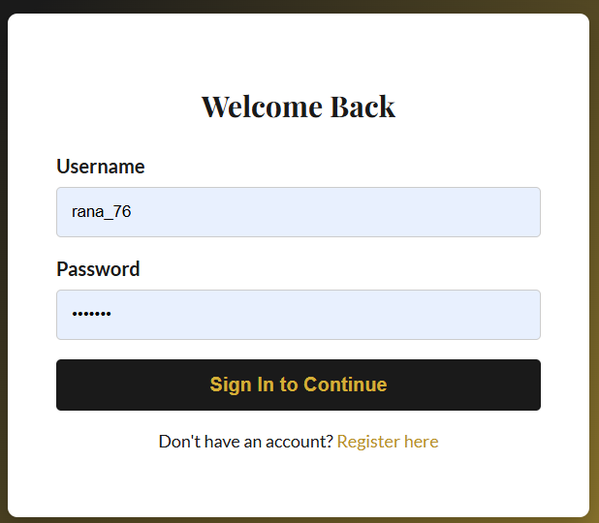
Figure: Register Page — /register
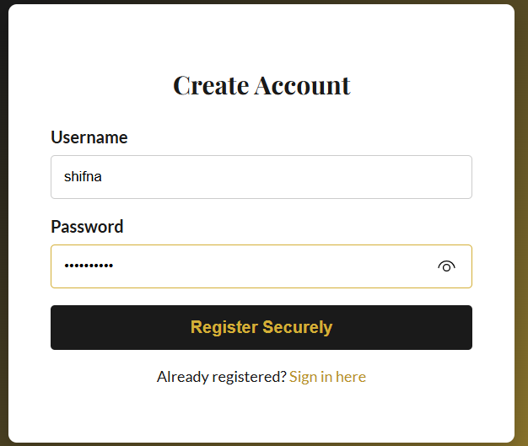
Figure: User Dashboard — /dashboard
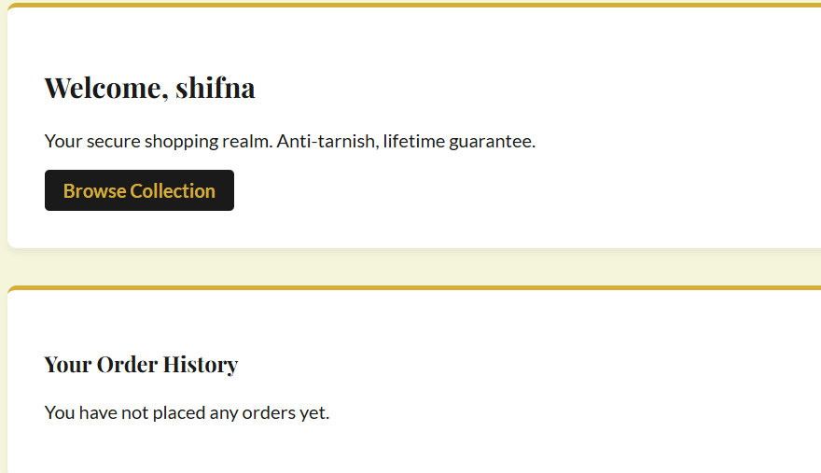
Figure: Products Page — /products
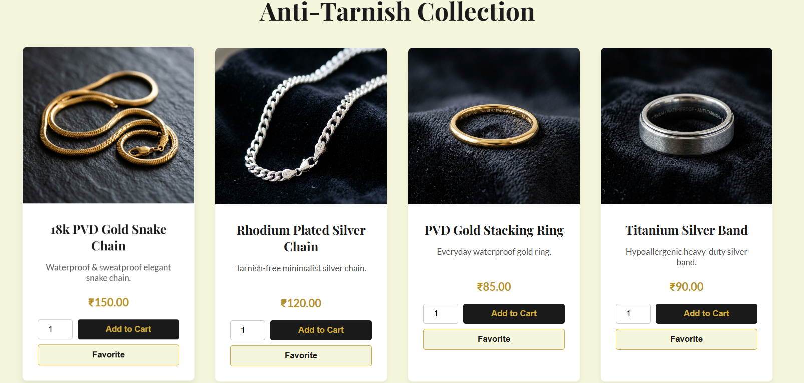
Figure: Cart Page — /cart
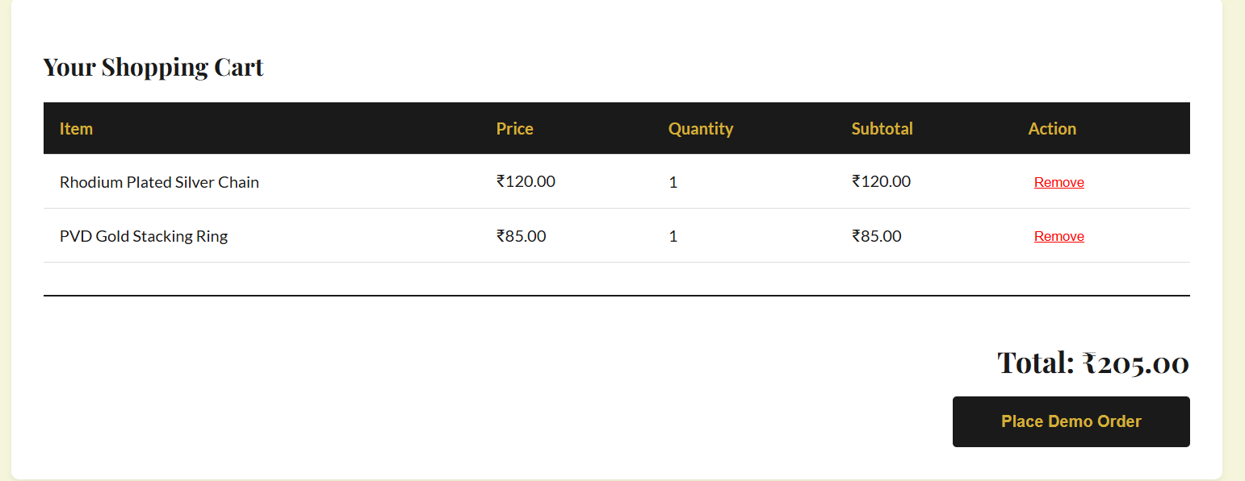
Figure: Wishlist Page — /wishlist
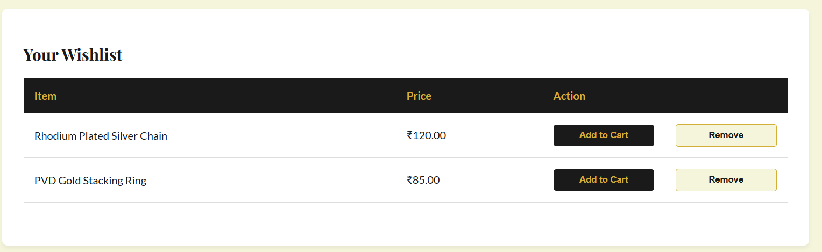
Figure: Admin Dashboard — /admin_dashboard
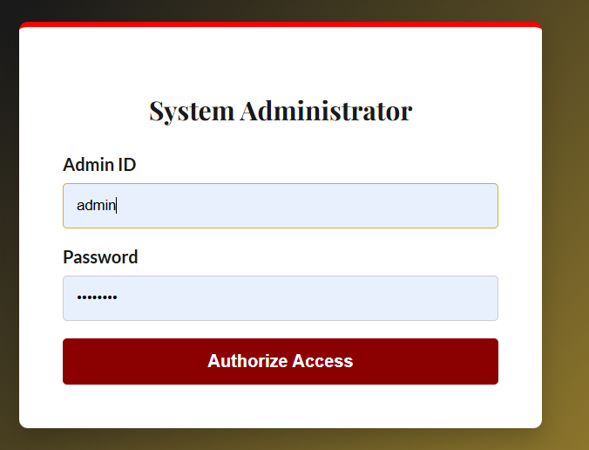
Figure: Admin Order Detail — /admin/orders/<id>

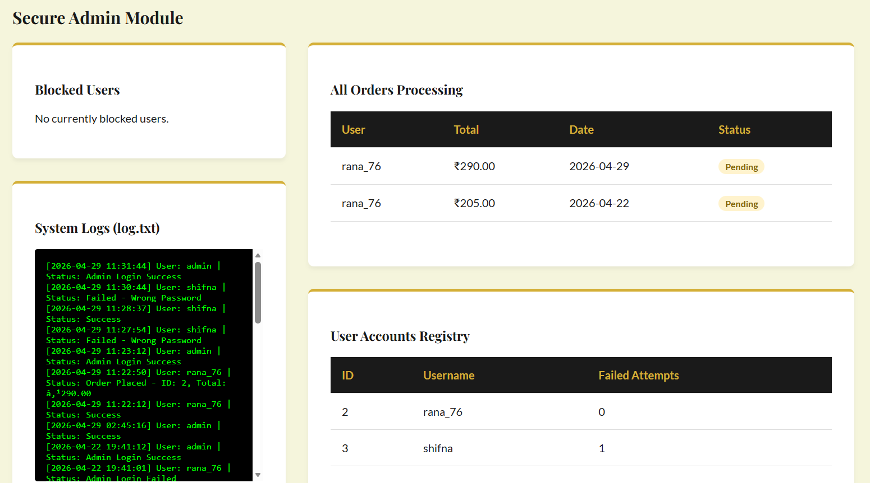

4 Conclusions
This project successfully designed and implemented a full-stack Identity Security Framework for an anti-tarnish jewellery e-commerce platform. The system demonstrates practical application of industry-standard security principles within a fully functional web application.
- bcrypt hashing ensures passwords are never stored in plaintext — providing industry-standard brute-force resistance.
- The 3-attempt account lockout mechanism effectively prevents credential-stuffing and dictionary attacks.
- Comprehensive audit logging provides end-to-end traceability for every authentication event.
- Admin privilege separation enforces the principle of least privilege throughout the system.
- The complete shopping lifecycle (browse → cart → checkout → order tracking) delivers a production-quality user experience.
Academically, the project demonstrates mastery of Flask web development, SQLite relational design, session security, and OWASP Top-10 mitigation strategies.

5 Further Development or Research
Short-Term Enhancements
- Email verification on registration and password reset via OTP/email link.
- JWT-based stateless authentication to support horizontal scaling.
- HTTPS enforcement with TLS certificate (Let's Encrypt) for production.
- IP-level rate limiting using Flask-Limiter to complement per-account lockout.
Medium-Term Enhancements
- Payment gateway integration (Razorpay / Stripe sandbox).
- Product search, category filtering, and price-range slider.
- Role-based access control (RBAC) — distinguish manager vs. super-admin roles.
Long-Term / Research
- Multi-factor authentication (TOTP / FIDO2 WebAuthn).
- Machine-learning anomaly detection for suspicious login patterns.
- Migrate to PostgreSQL + Gunicorn + Nginx for high-availability cloud deployment.
- Progressive Web App (PWA) with offline product catalogue support.

6 References
[1] Flask Documentation. Pallets Projects. https://flask.palletsprojects.com/
[2] bcrypt Library. PyPI. https://pypi.org/project/bcrypt/
[3] OWASP Authentication Cheat Sheet. https://cheatsheetseries.owasp.org/
[4] SQLite Documentation. https://www.sqlite.org/docs.html
[5] NIST SP 800-63B — Digital Identity Guidelines (Password Security).
[6] Jinja2 Templating Engine. https://jinja.palletsprojects.com/
[7] MDN Web Docs — Fetch API. https://developer.mozilla.org/en-US/docs/Web/API/Fetch_API
[8] python-docx Library. https://python-docx.readthedocs.io/

7 Appendix
A — Project File Structure
project/
app.py — Main Flask application (517 lines)
security.py — hash_password(), check_password(), is_valid_input()
logger.py — log_event() writes timestamped entries to log.txt
requirements.txt — Flask, bcrypt, python-pptx, python-docx
database.db — SQLite database file
log.txt — Authentication audit log
templates/ — login, register, dashboard, products, cart, wishlist,
admin_login, admin_dashboard, admin_order_detail, base
static/images/ — 16 AI-generated anti-tarnish jewellery images

B — Sample Audit Log (log.txt)
[2026-04-28 19:30:01] User: alice | Status: Success
[2026-04-28 19:31:44] User: bob | Status: Failed - Wrong Password
[2026-04-28 19:31:55] User: bob | Status: Failed - Account Blocked
[2026-04-28 19:45:10] User: admin | Status: Admin Login Success

