**Design Overview**

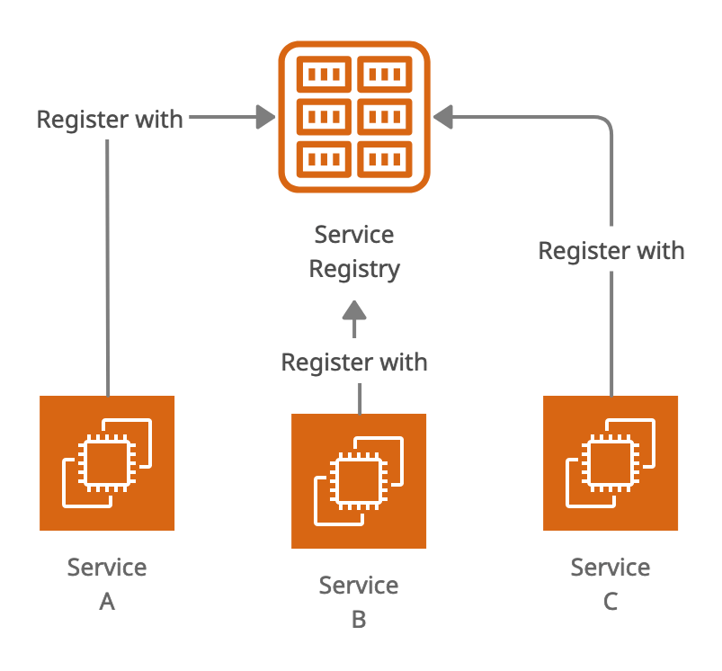

**Service Registry in Microservices Architecture**

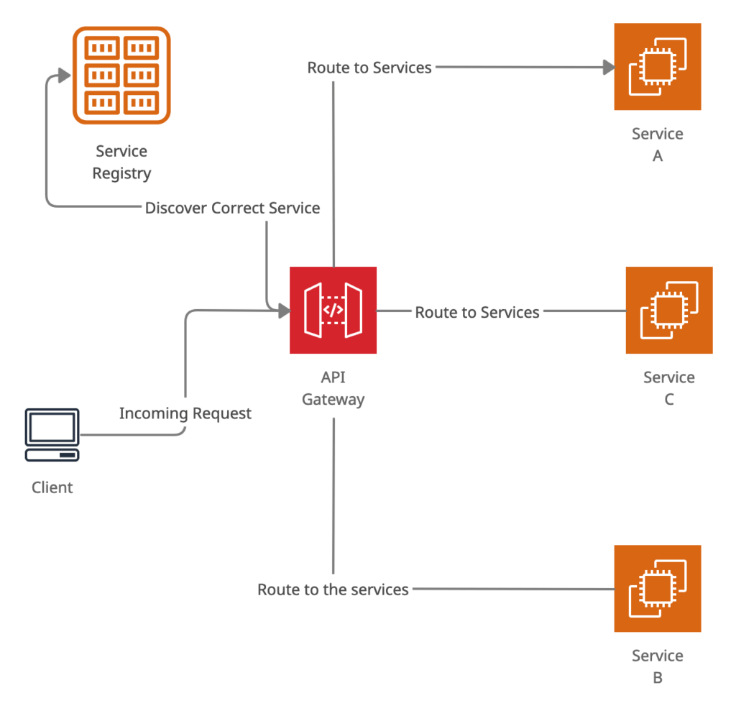**API Gateway use service discovery to route client requests to correct API endpoint using service registry**

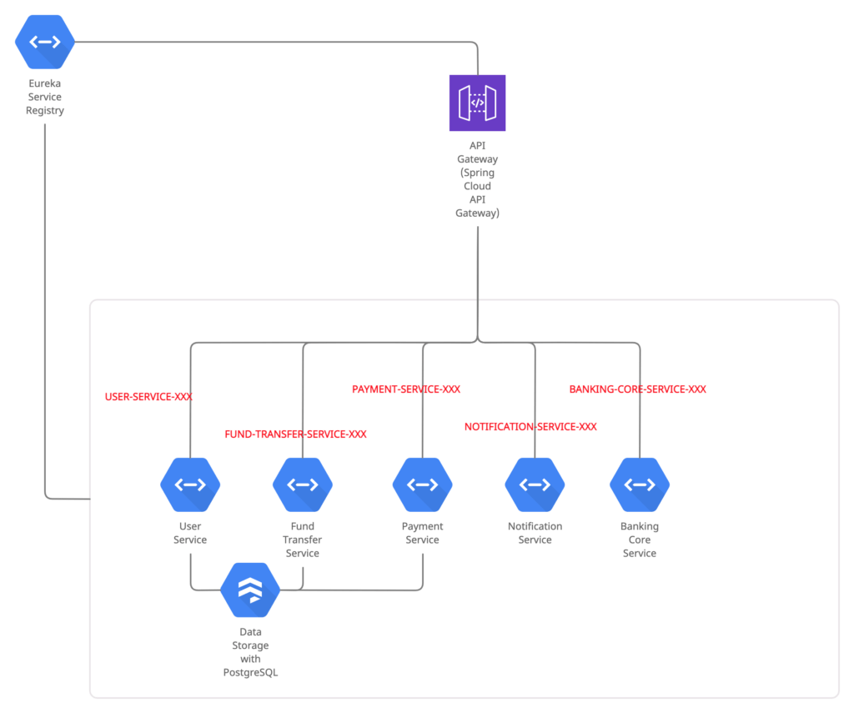**Exception Handling in Microservices in Spring Boot**

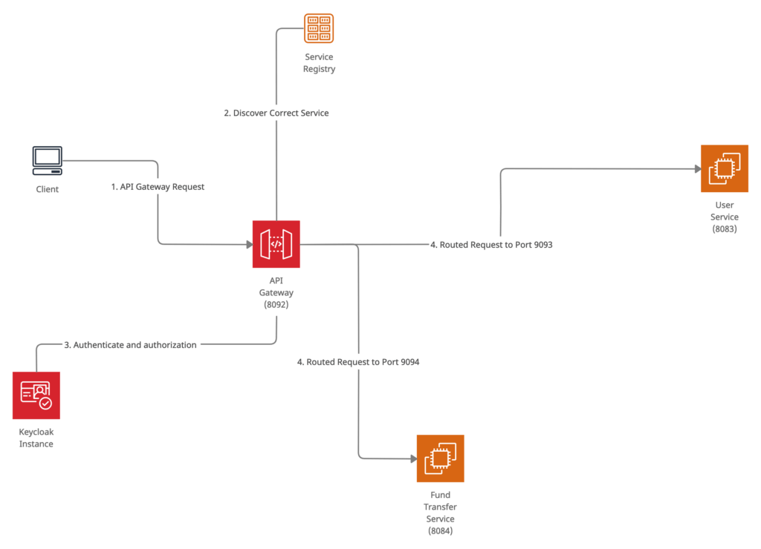**Authentication and authorization in microservice using keycloak**

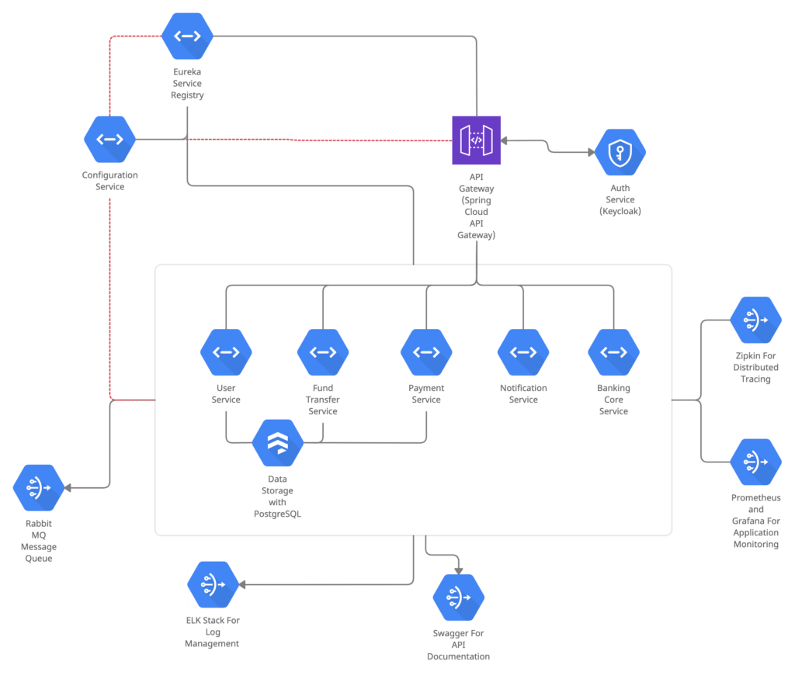**Microservices Architecture for Internet Banking Concept**

The CBD Account to Account transaction microservice includes the below microservices:

1. Setup API Gateway Using Spring Cloud Gateway
2. Authentication, and Authorization with Keycloak
3. CBD core Banking Service Implementation
4. User Service Implementation
5. Fund Transfer Service Implementation
6. Communication with Spring Cloud Open Feign
7. Exception Handling
8. Centralized Configurations with Spring Cloud Config