**(2023F) COMP-51112-FA – Research Methodology**

**Akash Rana & Spandan Thakor**

**Group -36(Skin Cancer Prediction and Detection)**

**Steps for Running our Project:**

1. Set up the Environment:

Install Python: Install Python in your PC. If it is not there than you can download it from Microsoft store or <https://www.python.org/> .

Install Visual Studio Code: You can install it from <https://code.visualstudio.com/>

Install Required Libraries: Run pip install numpy, Keras, pandas, matplotlib, seaborn, tensorflo, MatplotLib, pillow, flask, Gunicorn.

1. Download the Dataset:

Download dataset from given link: <https://www.kaggle.com/datasets/kmader/skin-cancer-mnist-ham10000>

1. Run the Code:

There are two file.

1) HTML file for Model Code:

* Install all the necessary libraries.
* Download the dataset.
* Set a path like this: ‘../foldername/ hmnist_28_28_RGB.csv’
* Note: you will get csv image from dataset zip when you download it from google.
* Run each code step by step
* And check the all libraries version to prevent the errors.
* For the image from google as well just set path according to it and name image as ‘test.jpg’.

2) Zip file name as ‘Skin_Cancer_Detection_byAR(Akash)ST(Spandan)zip’ for Web Page view.

* Unzip the folder given into zip file name as ‘Skin_Cancer_Detection_byAR(Akash)ST(Spandan)zip’
* Put that dataset in archive folder and give path like below.
* path='../Skin_Cancer_Detection_byAR(Akash)ST(Spandan)/archive/hmnist_28_28_RGB.csv'
* Open whole folder in visual code.
* Open terminal: Terminal -> New Terminal
* Note: make sure you successfully installed flask.
* Then write ‘flask run’ in your cmd.
* It will take some time and after that it shows image like below:

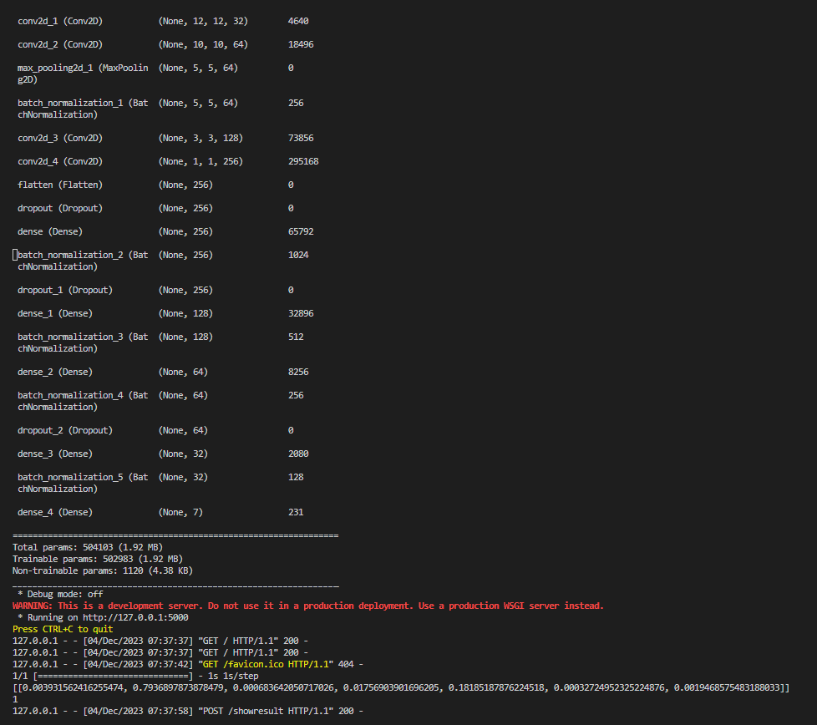

* The response contain localhost link or http server which gives you link. Copy and paste the link in any browser and you are ready to use web page.
* It looks like below image:

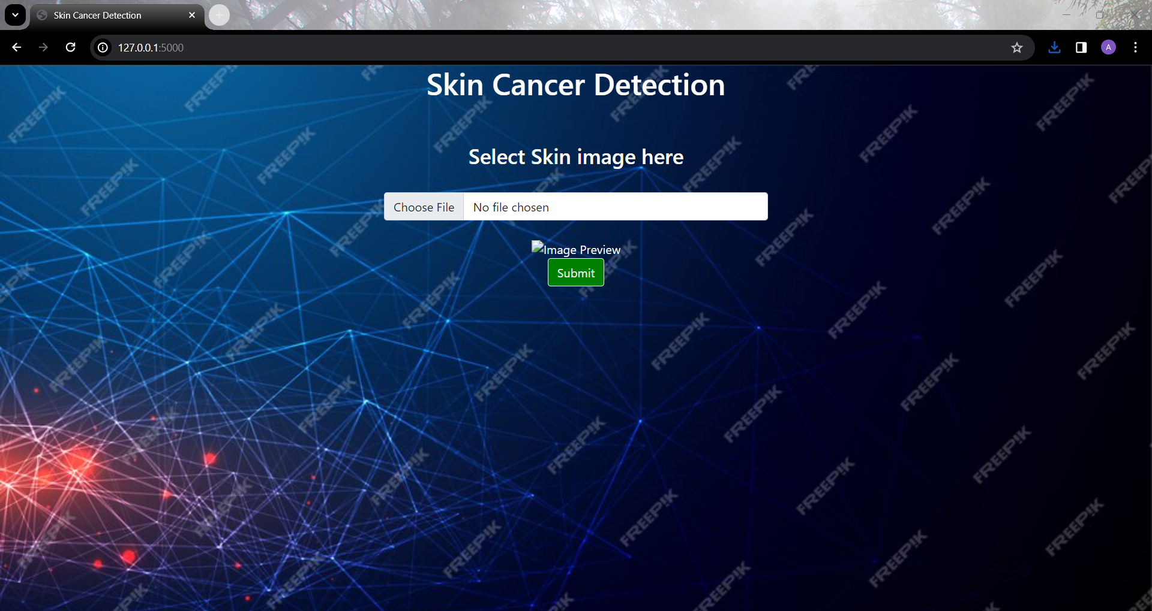

In the same zip folder there will be one folder name as ‘Photos for Testing’. You can open it and browse image from it.

1. Observe Results:

After choosing an image you can observe the result given by model.

Important Notes:

Some of the libraries shows error because of version issue, you have to adjust the version for different libraries.