|  |
| --- |
| rana |
| LAB_4 |
| **Submitted to : Sir.Mukhtar Azeem** |
|  |
| Rana Ali Uzair |
| Sp20-BSE-080 |

|  |
| --- |
| COMSATS University Islamabad |

**Lab4_Activity1:**

package lab4;

public class Lab4_Activity1_Runner {

public static void main(String[] args){

Circle c1;

c1 = new Circle();

c1.setRadius(10);

c1.CalCercum();

int r = c1.getradius();

Circle c2;

c2 = new Circle();

c2.setRadius(r);

c2.CalCercum();

}

}

Encapsulated class:

package lab4;

public class Circle {

private int radius;

public Circle(){

radius = 7;

}

public Circle(int r){

radius = r;

}

public void setRadius(int r){

radius = r;

}

public int getradius(){

return radius;

}

public void display(){

System.out.println("radius = " + radius);

}

public void CalCercum(){

double c = 3.14*radius*radius;

System.out.println("Cercumferance = " + c);

}

}

Output:

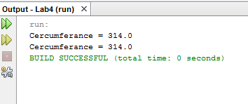

**Lab4_Activity2:**

package lab4;

public class Lab4_Activity2_Runner {

public static void main (String[] args){

Rectangle rect ;

rect = new Rectangle();

rect.setlenght(10);

rect.setwidht(5);

System.out.println("Area = " + rect.Area());

System.out.println("Cuurent lenght = " + rect.getLenght());

}

}

Encapsulated class:

package lab4;

public class Rectangle {

private int lenght , width;

public Rectangle(){

lenght = 5 ;

width = 2;

}

public Rectangle(int a , int b){

lenght = a ;

width = b ;

}

public void setlenght(int l){

lenght = l ;

}

public void setwidht(int w){

width = w;

}

public int getLenght(){

return lenght;

}

public int getwidht(){

return width ;

}

public int Area(){

return(lenght*width);

}

}

Output :

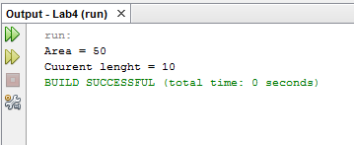

Lab4_Activity3:

package lab4;

public class Lab4_Activity3_Runner {

public static void main(String[] args){

Point p1;

p1 = new Point();

p1.setX(10);

p1.setY(7);

p1.display();

Point p2;

p2 = new Point();

p2.move(2, 4);

p2.display();

}

}

Encapsulated class:

package lab4;

public class Point {

private int x ;

private int y ;

public Point(){

x = 0 ;

y = 0 ;

}

public Point(int a ,int b){

x = a ;

y = b ;

}

public void setX(int e){

x = e ;

}

public void setY(int f){

y = f ;

}

public int getX(){

return x ;

}

public int getY(){

return y ;

}

public void display(){

System.out.println("X cordinate = " + x + "Y cordinate = " + y);

}

public void move(int x1 , int y1){

x = x+x1;

y = y+y1;

System.out.println("X after moving =" + x + "Y after moving = " + y);

}

}

Output:

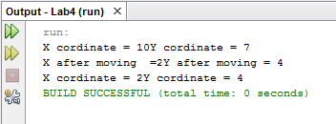

Lab4_HomeActivity1:

package lab4;

public class Lab4_HomeActivity1_Runner {

public static void main(String[] args){

Marks m0;

m0 = new Marks();

m0.set(12, 10, 5);

m0.get();

}

}

Encapsulated class:

package lab4;

public class Marks {

private int num1 ;

private int num2 ;

private int num3 ;

public Marks(){

num1 = 33;

num2 = 33;

num3 = 33;

}

public Marks(int a ,int b , int c){

num1 = a;

num2 = b;

num3 = c;

}

public void set(int d , int e , int f){

num1 = d ;

num2 = e ;

num3 = f ;

}

public void get(){

System.out.println("Numbers Are ...." + num1 + "," + num2 + "," + num3 + ".");

}

}

Output:

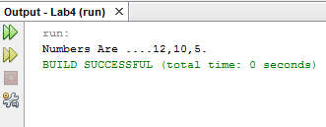

Lab4_HomeActivity2:

package lab4;

public class Lab4_HomeActivity2_Runner {

public static void main(String[] args){

Account a1,a2;

a1 = new Account();

System.out.println("Current balance = " +a1.grtBalance());

a1.Deposit(5000);

a1.withdraw(6000);

int b = a1.grtBalance();

System.out.println(b);

a2 = new Account(b);

System.out.println("Current balance = " +a2.grtBalance());

a2.Deposit(500);

a2.withdraw(1000);

}

}

Encapsulated class:

package lab4;

public class Account {

private int balance ;

public Account(){

balance = 500 ;

}

public Account(int a){

balance = a ;

}

public void Deposit(int d){

balance = balance + d ;

System.out.println("Your Curennt Balance = " + balance);

}

public void withdraw(int w){

if (w <= 0){

int a = balance - w;

System.out.println("You withdraw = " + w + "your current balance = " + a);

}

else

System.out.println("Incifiiant balance.......");

}

public int grtBalance(){

return balance;

}

}

Output:

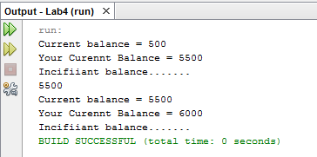

Lab4_HomeActivity3:

package lab4;

public class Lab4_HomeActivity3_Runner {

public static void main(String[] args) {

Student s1;

s1 = new Student("Rana",new int[] {85,45,88,95,84});

System.out.println(s1.avg());

}

}

Encapsulated class:

package lab4;

public class Student {

private String name;

private int[] Result_Array = new int[5];

public Student(String n, int[] Result_arr){

name = n;

Result_Array = Result_arr;

}

public int avg(){

int total = 0;

System.out.println("Average of Student: " + name);

for(int i = 0; i<5;i++){

total = total + Result_Array[i];

}

return(total/5);

}

}

Output:

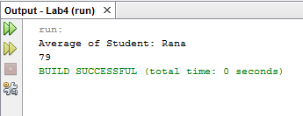

Assignment:

package lab4;

public class Lab4_Assignemnt_runner {

public static void main(String[] args ){

HotDogStand st1 , st2 , st3;

st1 = new HotDogStand(1,88);

st2 = new HotDogStand(2,554);

st3 = new HotDogStand(3,358);

st1.display();

st2.display();

st3.display();

st1.justSold();

st2.justSold();

st3.justSold();

st1.display();

st2.display();

st3.display();

}

}

Encapsulated class:

package lab4;

public class HotDogStand {

private int ID;

private int numOfHotDogSale;

public HotDogStand(){

ID = 0;

numOfHotDogSale = 0;

}

public HotDogStand(int a , int b ){

ID = a;

numOfHotDogSale = b;

}

public void justSold(){

numOfHotDogSale++;

System.out.println("Another HotDog is sailed at " + ID);

}

public void display(){

System.out.println("Store ID :" + ID + " Has Sale : " + numOfHotDogSale + " HotDogs");

}

}

Output:

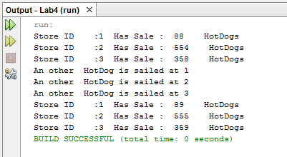

Github Link:

https://github.com/RanaAliUzair080/Lab_4/tree/main/lab4