|  |
| --- |
| Object Oriented Programming |
| Lab_5 Assignment |
| Sir Mukhtar Azeem |

|  |
| --- |
| Rana Ali Uzair  SP20_BSE_080 |

GitHub Link:

https://github.com/RanaAliUzair080/Lab_5

Activity # 1

package lab5;

public class Lab5_Activity1_runner {

public static void main(String[] args){

ObjectPass p;

p = new ObjectPass();

p.value = 10 ;

System.out.println("Before calling : " + p.value);

ObjectPass.increment(p);

System.out.println("Before calling : " + p.value);

}

}

package lab5;

public class ObjectPass {

public int value;

public static void increment(ObjectPass a){

a.value++;

}

}

Output :

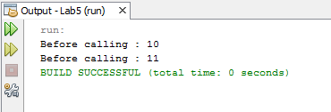

Activity # 2

package lab5;

public class Lab5_Activity2_runner {

public static void main(String[] args){

Complax c1 = new Complax(12,2.5);

Complax c2 = new Complax(24,3.2);

Complax c3 = new Complax();

c3 = c2.Add(c1);

c3.display();

}

}

package lab5;

public class Complax {

private double real;

private double imag;

public Complax(){

real = 0 ;

imag = 0;

}

public Complax(double r , double im){

real = r ;

imag = im;

}

public Complax Add (Complax b){

Complax c_new = new Complax(real + b.real , imag + b.imag);

return c_new ;

}

public void display(){

System.out.println(real + imag );

}

}

Output:

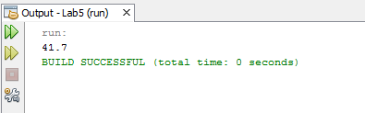

Activity # 3

package lab5;

public class La5_Activity3_runner {

public static void main(String[] args){

Point p1 = new Point(10,20);

Point p2 = new Point(30,40);

Point p3 = new Point ();

Point p4 = p1.Add(p2,p3);

p4.display();

}

}

package lab5;

public class Point {

private int x;

private int y;

public Point(){

x = 0 ;

y = 0 ;

}

public Point(int a , int b){

x = a ;

y = b ;

}

public void setX (int a){

x = a;

}

public void setY (int c){

x= c;

}

public int getX(){

return x;

}

public int getY(){

return y;

}

public Point Add(Point Pa, Point Pb ){

Point p_new = new Point(x+ Pa.x + Pb.x, y+ Pa.y + Pb.y);

return p_new;

}

public void display(){

System.out.println(x);

System.out.println(y);

}

}

Output:

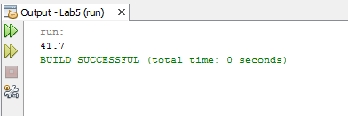

Home Activity # 1:

package lab5;

public class Lab5_HomeActivity1_runner {

public static void main (String[] args){

Distance d1 = new Distance(10 , 12 );

Distance d2 = new Distance (15 , 15);

Distance d3 =d1.ADD(d1, d2);

d3.display();

}

}

package lab5;

public class Distance {

private int feet ;

private int inches ;

public Distance(){

feet = 0 ;

inches = 0 ;

}

public Distance (int a , int b){

feet = a ;

inches = b;

}

public void setFeet(int f){

feet = f ;

}

public void setInches(int in){

inches = in ;

}

public void getFeet(){

System.out.println("feet : " + feet);

}

public void getinches(){

System.out.println("Inches : " + inches);

}

public Distance ADD (Distance a , Distance b){

Distance ad = new Distance(a.feet+b.feet , a.inches + b.inches);

return ad;

}

public void display(){

System.out.println(feet);

System.out.println(inches);

}

}

Output:

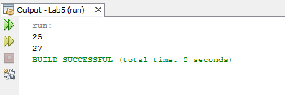

Home Acticity # 2:

package lab5;

public class Lab5_HomeAcivity2_runner {

public static void main(String[] args){

Book b1,b2;

b1 = new Book("ali" , new String[]{"c1","c2","c3"});

b2 = new Book("ali" , new String[]{"c1","c2","c3","c1"});

b2.compareBooks(b1);

b1.compareChapterNames(b2);

}

}

package lab5;

public class Book {

private String Author;

private String[] chapterNames = new String[100];

public Book(){

Author = "No value yet";

chapterNames = new String[] {"not vlaue yet"};

}

public Book(String a , String[] Array){

Author = a ;

chapterNames = Array ;

}

public void compareBooks(Book a){

if(Author == a.Author)

System.out.println("Same Author");

else

System.out.println("Diffrent Author");

}

public void compareChapterNames(Book a){

if(chapterNames.length == a.chapterNames.length){

System.out.println("Same Number of chapters");

}

else if(chapterNames.length <= a.chapterNames.length){

System.out.println("book you enter has more chapter ");

}

else

System.out.println("book you enter has less chapter ");

}

}

Output:

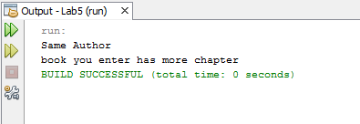

Assignment:

package lab5;

/**

*

* @author Rana Alie

*/

public class Lab5_Assignment1_Runner {

public static void main(String[] args){

Fraction f1 , f2 ;

f1 = new Fraction(13,4);

f1.display();

f1.equals(2.5);

f1.setNumber1(45);

f1.setNumber2(13);

f1.display();

}

}

package lab5;

public class Fraction {

private int num1;

private int num2;

public Fraction(){

num1 = 1 ;

num2 = 1 ;

}

public Fraction(int a , int b ){

num1 = a ; num2 = b ;

}

public void setNumber1(int a){

num1 = a ;

}

public void setNumber2(int a){

num2 = a ;

}

public double get(){

return (num1/num2);

}

public void display(){

double fraction = (double)num1/(double)num2 ;

System.out.println("Fraction of both Number is : " + fraction);

}

public void equals(double a){

double fraction = num1/num2 ;

if(fraction == a){

System.out.println("Fraction is Same...");

}

else

System.out.println("Fraction is not Same...");

}

}

Output:

