**Lab 6**

**Github link:**

https://github.com/RanaAliUzair080/Lab_6/tree/main/lab6

**Activity1:**

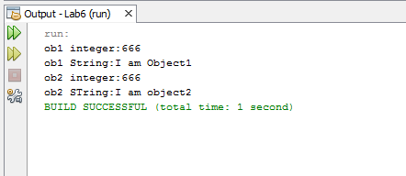

**Activity2:**

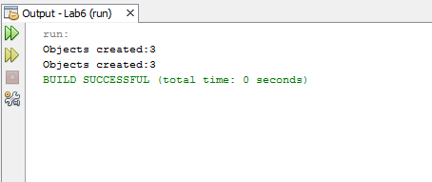

**Activity3:**

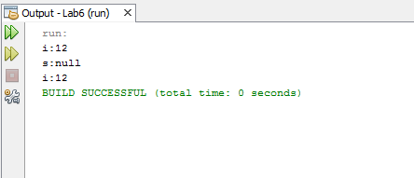

**Home_Activity1:**

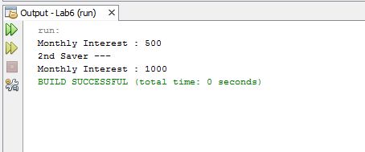

**Home_Activity2:**

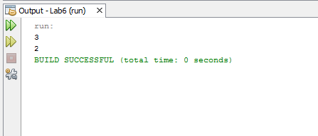

**Assignment:**

