Magnetic Correlations and Superconducting Pairing in an Interaction-Driven Altermagnetic Hubbard Model

Summary. Our group has three published works on altermagnetism (AM) in which the spin splitting is imposed by a spin-dependent hopping. This project studies the complementary, and to our knowledge unexplored, problem: a fully spin-independent Hubbard model on the anisotropic checkerboard lattice, in which altermagnetism can only be generated spontaneously by the interaction. Two results anchor the plan. (i) A symmetry analysis shows the altermagnetic form factor of this lattice is dxy, orthogonal to the dx2-y2 channel of the square-lattice model in our pairing paper [11]; this predicts a different dominant pairing symmetry. (ii) Preliminary L=14 CPQMC data show Néel (π,π) is the only long-range order and it survives only near half-filling, while the doped region is magnetically short-range — precisely the regime where [11]'s mechanism predicts pairing to be enhanced. The honest verdict below is “worth continuing, but the innovation must be narrowed to the pairing / symmetry-selection question.”

Stage 1 — Research Context and Motivation

1.1 Research background
Altermagnets are a third class of collinear magnet, distinct from ferromagnets and conventional antiferromagnets (AFM). The two spin sublattices are related not by translation or inversion but by a rotation, which forbids a net moment yet produces an even-parity, momentum-dependent spin splitting of the bands with a definite d-, g- or i-wave symmetry [1–5]. This unites the zero stray field and THz dynamics of an antiferromagnet with the spin-split, spin-polarized transport of a ferromagnet, without spin–orbit coupling [9,10].
Two physically distinct routes to altermagnetism must be separated:
- Imposed (single-particle) AM: a spin-dependent hopping is written into the Hamiltonian, so the spin splitting exists already at U = 0. This is the route of our group's three published works, including the pairing study [11], where the anisotropy t_A acts oppositely on the two spins.
- Interaction-driven (emergent) AM: the Hamiltonian is fully spin-symmetric; the altermagnetic splitting appears only after a magnetic moment forms spontaneously through the interaction. Proposed from itinerant magnetism [12], orbital order [13], and on modified Lieb [14] and Shastry–Sutherland [15] lattices; correlations can also generate an altermagnetic anomalous Hall response [16].
The essential gap: nearly every interaction-driven study to date is mean-field or slave-boson. Unbiased many-body treatments are rare, and the superconducting pairing problem has never been addressed in a spontaneous altermagnet by an unbiased method. This project targets exactly that intersection.

1.2 Core scientific problem (one sentence)
Does altermagnetism that is generated by the interaction — rather than imposed at the single-particle level — reorganize the magnetic correlations and the superconducting pairing of a single-band Hubbard model, and does the symmetry of the emergent order (here dxy) select a pairing channel different from the imposed square-lattice case (dx2-y2)?

1.3 Why it is worth studying — concretely
- Basic mechanism: tests whether the RVB-like “pairing where AFM is suppressed” mechanism of [11] is a property of altermagnetism itself, or an artifact of imposing the spin splitting. These give opposite conceptual pictures.
- Theory link: supplies the first numerically-unbiased benchmark for the many mean-field predictions of interaction-driven AM [12–15], where correlations are exactly what mean field cannot capture.
- Materials / experiment link: checkerboard / planar-pyrochlore motifs occur in real compounds; a symmetry-selected pairing channel is experimentally falsifiable (spin-split ARPES, phase-sensitive Josephson probes).
- New knowledge if solved: a design principle — lattice geometry fixes the altermagnetic symmetry channel, and the pairing follows it — rather than a single-model result.
- Missing link if not studied: we would still not know whether “altermagnetic superconductivity” requires the splitting to be imposed, or emerges from pure repulsion plus geometry.

1.4 Known vs. unknown
Already resolved | Still open (long-standing)
Symmetry classification of AM and its d/g/i-wave order [1,4,5]. | Whether emergent AM survives strong correlations in an unbiased ground-state calculation.
Experimental existence of AM (MnTe, RuO2) via Kramers-lifting and imaging [6–8]. | Whether emergent AM enhances, suppresses, or reshapes superconducting pairing.
Imposed-AM square lattice: anisotropy suppresses AFM and enhances dx2-y2 pairing [11]. | Whether the pairing symmetry is selected by the lattice AM form factor (dxy vs dx2-y2).
Doping evolution of magnetic order in imposed-AM Hubbard (Papers 1, 2). | Whether that doping evolution changes qualitatively when the anisotropy is geometric, not spin-dependent.

1.5 Where this project plugs in
The project sits at the junction of two established group lines: (a) the magnetic-correlation program (Papers 1, 2) and (b) the AM-pairing program [11]. It replaces the imposed spin-dependent hopping with a geometric anisotropy δ on the checkerboard lattice, making the AM emergent, and asks the magnetic and pairing questions together. It is the natural ‘third leg’ closing the imposed-vs-emergent gap.

Stage 2 — Development Timeline of the Field
Key conceptual nodes rather than a flat citation list. ‘Limit left’ is what each node did NOT settle, which motivates the next.
Period | Node / Ref. | System & method | Core finding | Limit left
2020–22 | Symmetry birth of AM [1,3–5] | Spin-group / symmetry theory | AM defined as a distinct phase; d/g/i-wave spin splitting classified | Pure symmetry; no correlation dynamics
2022–24 | Experimental confirmation [6–8] | MnTe, RuO2; ARPES, imaging | Kramers-degeneracy lifting and real-space AM order observed | Weakly correlated materials, not the Hubbard regime
2024–25 | Interaction-driven AM proposals [12–16] | Itinerant / orbital / Lieb / Shastry–Sutherland; mostly mean-field | AM can emerge spontaneously from interactions or geometry | Mean-field / slave-boson — correlations not captured
2024 | Exact AM benchmark [16] | Kane–Mele–Hubbard; AFQMC | First unbiased AM treatment; correlation-driven Hall response | Different lattice; pairing not addressed
Group | Magnetic correlations, Papers 1–2 | Square Hubbard, spin-dependent hopping; CPQMC | Competing Néel / stripe / diagonal / spiral; doping evolution | AM imposed; pairing not the focus
2026 | AM pairing [11] | Square Hubbard, imposed AM; CPQMC 16×16 | Anisotropy suppresses AFM and enhances dx2-y2 pairing (doping-free RVB analogue) | Leaves open whether the splitting must be imposed
Now | This project | Checkerboard Hubbard, emergent AM; 4-method QMC | (to be determined) | (the gap we address)

2.1 Literature, classified
- Classical / foundational: Šmejkal–Sinova–Jungwirth PRX 12, 040501 (2022) [1]; Mazin (ed.) PRX 12, 040002 (2022) [2]; symmetry [4,5].
- Methodological: Scalapino–White–Zhang pair susceptibility PRB 47, 7995 (1993) [19]; determinant / constrained-path QMC PRB 40, 506 (1989) [20]; the vertex-pairing construction of [11].
- Closest to this project: our AM-pairing paper [11]; group Papers 1 & 2 [17,18].
- Recent frontier: interaction-driven AM [12–15]; exact AM benchmark [16]; experiments [6–8].
- Contrary / cautionary: [11] itself notes the enhancement is strongest where the AFM structure factor is diminished — a warning that a single-band emergent model, which suppresses AFM geometrically rather than by orbital exchange, may behave differently and must be checked, not assumed.

Stage 3 — Positioning of the Current Project
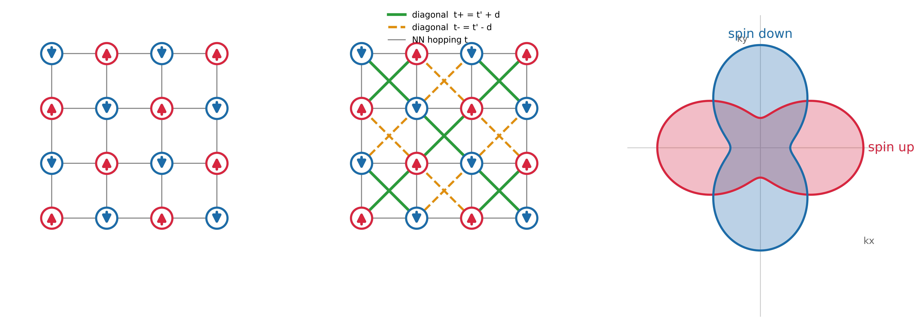
Fig. 1. From imposed to emergent AM. (a) Plain square + U: sublattices related by translation → spin-degenerate Néel (not AM). (b) Checkerboard: every plaquette crossed, half by t+ = t′+δ, half by t− = t′−δ; the two sublattices are related by a rotation → the AM condition. (c) Resulting d-wave spin splitting with zero net moment.
Dimension | Existing work [11,17,18] | This project | Real difference | Gap?
Lattice | Square | Checkerboard (planar-pyrochlore) | New geometry, C4v→C2v | Partly
Hamiltonian | Spin-dependent hopping | Spin-independent; t± = t′±δ | AM imposed → emergent | Yes — core
AM origin | U=0 splitting present | ∝ M·δ, needs a spontaneous moment | Conceptually different | Yes — core
AM symmetry | dx2-y2 | dxy | Orthogonal irreps | Yes — core
Parameter axes | (t_A, t′, n) | (δ, n) at U=4; U=0–4 | Geometric knob δ | Partly
Method | CPQMC | CPQMC + DQMC + CP-DQMC + ED | Adds susceptibilities + exact check | Incremental
Observables | S(q), Δn(k), vertex pairing | + symmetry-resolved AM weight, χ_s, pair susceptibility | New AM-symmetry probe | Yes
Objective | Show imposed AM enhances d-wave | Test if emergent AM does, and which channel | Mechanism, not phenomenon | Yes
Focus | Phenomenon + mechanism | Mechanism + design principle | Symmetry selection | Yes
Done before? | No unbiased emergent-AM pairing study exists | — | — | Open

The AM-symmetry row is the single most consequential difference: dx2-y2 versus dxy are orthogonal irreducible representations, and the spin-fluctuation glue that mediates pairing inherits this symmetry.
Positioning answers:
- Where in the arc? The ‘third leg’ unifying the group's magnetic-correlation and AM-pairing programs under emergent AM.
- Extension, cross-over, or new? A cross-cutting direction: it crosses the imposed-AM pairing method [11] with a geometric emergent-AM model.
- Closest papers: [11] (method & question), [17,18] (magnetic toolkit), [12,15] (emergent-AM concept).
- What we really add: (i) emergent vs imposed AM under unbiased QMC; (ii) symmetry-selection of the pairing channel; (iii) a reusable symmetry-resolved AM order parameter.
- Already done by others: imposed-AM pairing [11]; mean-field emergent AM [12–15]. NOT done: emergent-AM pairing, unbiased.
- Nature of the gap: primarily a mechanism / method gap (no unbiased treatment), secondarily an observable gap (symmetry-resolved AM weight). Not merely ‘one more parameter.’

Stage 4 — Value and Feasibility Judgment
Two independent voices, then a verdict. This section is deliberately critical: the preliminary L=14 data have already falsified one of our earlier claims (below), and the plan is stronger for admitting it.
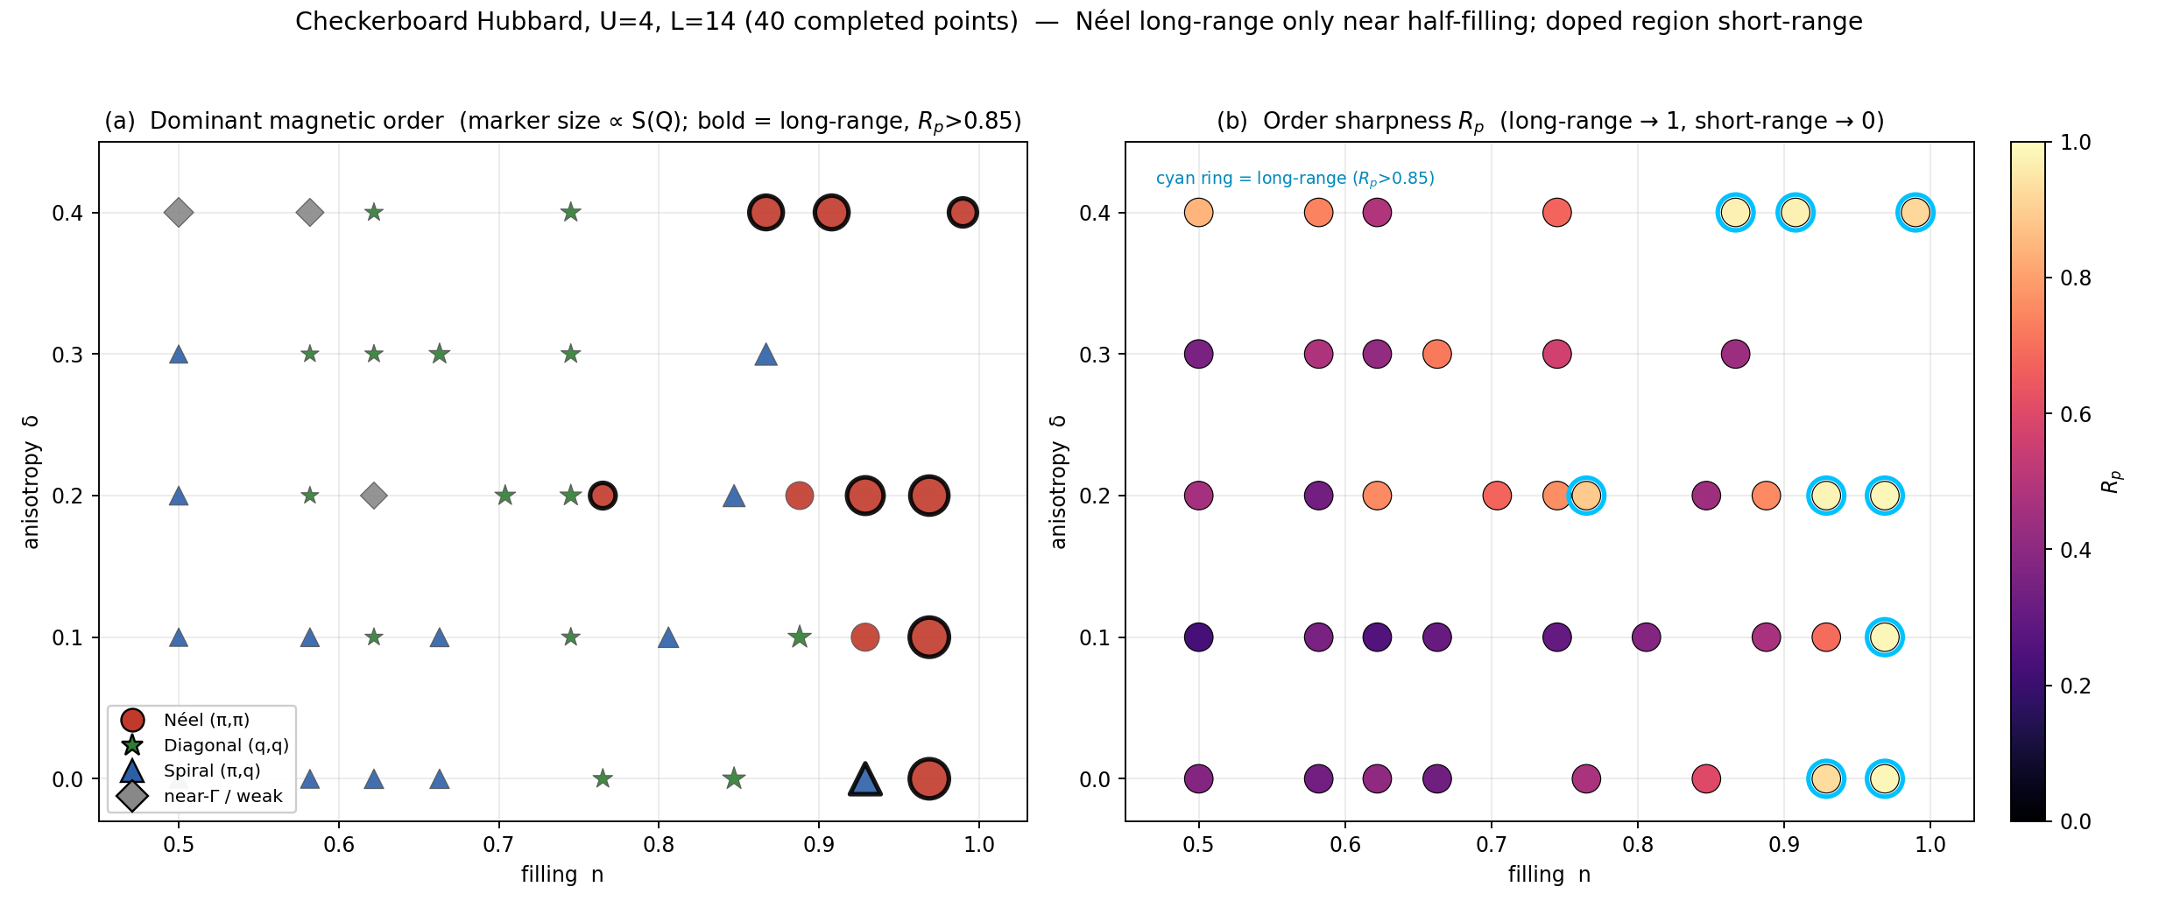
Fig. 2. Honest preliminary L=14 result (U=4). (a) Dominant order (marker size ∝ S(Q); bold = long-range). (b) Sharpness R_p. Only 9/40 points reach R_p>0.85 and 8 are Néel near half-filling; the doped interior is short-range. The earlier L=10 claim of ‘δ drives sharp diagonal order (R_p up to 0.94)’ does NOT survive at L=14 — the tidy L=10 regions were an artifact of coarse k-resolution plus forced classification.

4.1 Judgment
- The symmetry argument (dxy vs dx2-y2) is the crown jewel: model-independent, follows from the Hamiltonian, and yields a concrete falsifiable prediction. It elevates the project from ‘same study, new lattice’ to a design principle.
- The magnetic side is solid but modest: Néel-only-near-half-filling with a short-range doped sea is a clean, defensible result, and it is exactly the substrate [11]'s pairing mechanism needs.
- Four-method control (CPQMC / DQMC / CP-DQMC / ED) is a genuine asset: ED already showed CPQMC over-orders near half-filling, so cross-checks are the credibility of the whole story.

4.2 Strict reviewer judgment
- Magnetism alone is not novel enough: ‘doped Hubbard is short-range, Néel near half-filling’ is expected; published on its own it reads as incremental.
- ‘Altermagnet’ must be earned, not asserted: away from special points the emergent order may be an ordinary Néel AFM. The referee will demand Δ_tot(δ) and the symmetry-resolved weight as proof, not the band cartoon.
- Pairing-signal risk: vertex pairing in a single-band repulsive model at U=4 is small; the constrained-path bias that inflates S(π,π) can also bias the pairing vertex. Without ED / CP-DQMC corroboration the pairing claim is fragile.
- Doped S(Q) is small (0.2–0.9): error bars matter; no doped-region claim without statistics.

4.3 Verdict
▶ [Worth continuing, but the innovation must be narrowed]. The magnetic phase diagram is supporting material, not the headline. The project's real value is the emergent-AM + symmetry-selected pairing question. Re-centre the paper there.
Question | Answer
Strongest research thread | The dxy symmetry prediction — model-independent and falsifiable — that emergent AM selects a pairing channel different from the imposed square-lattice case.
Biggest novelty risk | Emergent order is just ordinary Néel AFM away from special δ, so the ‘altermagnet’ label is unearned.
Biggest technical risk | CP bias inflates S(π,π) and possibly the pairing vertex near half-filling; small doped signals.
Cheapest, most informative test | Measure Δ_tot(δ) and the symmetry-resolved dxy/dx2-y2 weight at half-filling across δ — CPQMC already in hand; directly proves or kills emergent AM and its symmetry.
Continue if… | Δ_tot = 0 at δ=0 and grows ∝ M·δ with dxy dominant; and a pairing-vertex dome appears where AFM is suppressed.
Adjust / stop if… | dxy and dx2-y2 weights are comparable (no clean selection), or the pairing vertex shows no δ-trend beyond error bars.

Stage 5 — Key Observable Design
Observables chosen by the questions and graded by role: core (answer the main question), diagnostic (separate rival explanations), auxiliary (aid understanding), control (exclude finite-size / boundary / numerical artifacts).

5.1 Core observables
- Spin structure factor S_z(q) = (1/N) Σ_ij e^{iq·r} ⟨S_z(i) S_z(j)⟩; dominant order from Q = argmax. Answers ‘which order.’ Confound: CP over-ordering inflates the amplitude near half-filling → trust Q, not S(Q). From CPQMC (dir-kVals/sdwz.dat).
- Sharpness R_p = [S(Q) − ⟨S⟩_shell]/S(Q); an amplitude-insensitive peak-shape measure → robust where CP fails. R_p→1 long-range, →0 short-range. This is the observable that exposed the L=10 artifact.
- Symmetry-resolved AM weight Δ_Γ = Σ_k Δn(k) f_Γ(k), with f_dxy = sin kx sin ky, f_dx2-y2 = cos kx − cos ky, Δn = n↑(k) − n↓(k). The decisive test of the symmetry claim; expected dxy-dominant here, dx2-y2 in [11]. From CPQMC momentum occupations.
- Vertex (connected) pairing function N_Vertex,ζ(k) [connected part of ⟨Δ_ζ Δ†_ζ⟩, Eq. 3 of [11]], ζ = dxy, dx2-y2, ext-s, p↑↓, with checkerboard bond form factors. Positive vertex = genuine interaction-driven pairing.

5.2 Diagnostic observables
- AM order parameter Δ_tot = Σ_k |n↑(k) − n↓(k)| with Σ_k Δn = 0: proves compensated AM; must vanish at δ=0.
- Spin susceptibility χ_s(q) = ∫₀^β dτ ⟨S_z(q,τ) S_z(−q,0)⟩: finite-T instability; separates true ordering from a broad equal-time peak. From DQMC / CP-DQMC.
- Pair-field susceptibility P_ζ vs its bare bubble P̄_ζ: P_ζ > P̄_ζ is the standard attractive-channel criterion; the τ-integration weights low-energy pairs the equal-time vertex misses.

5.3 Auxiliary and control
- Auxiliary: real-space C_SDW(r) (decay = long/short range); non-interacting Fermi surface / DOS / van Hove vs δ (single-particle ‘why’); double occupancy and energy (thermodynamic consistency).
- Control: finite-size scaling L = 10, 14, 16; closed-shell fillings only (unique trial WF); ED cross-check on small clusters; CPQMC vs CP-DQMC to bound the constrained-path bias.

5.4 Scientific-question ↔ observable map
Scientific question | Core observable | Physical meaning | Expected signal | Confounds
Is the AM emergent? | Δ_tot(δ), χ_s | compensated spin split from U | = 0 at δ=0, grows ∝ M·δ | ordinary Néel mimics a finite moment
Which symmetry channel? | Δ_dxy vs Δ_dx2-y2 | irrep of the spin split | dxy ≫ dx2-y2 | mixed if C4 weakly broken
Where is order long-range? | Q, R_p, C_SDW(r) | order vs fluctuation | Néel R_p→1 near n=1; doped →0 | CP inflates S(Q) near n=1
Is pairing enhanced? | N_Vertex,ζ, P_ζ | connected pair correlation | dome vs δ in the dxy channel | ext-s background; CP bias
Which pairing symmetry? | ratio N_d / N_s | competition of channels | dxy leads, rising with δ and U | ext-s background; finite size

Stage 6 — Why the Observables Change (causal chains)
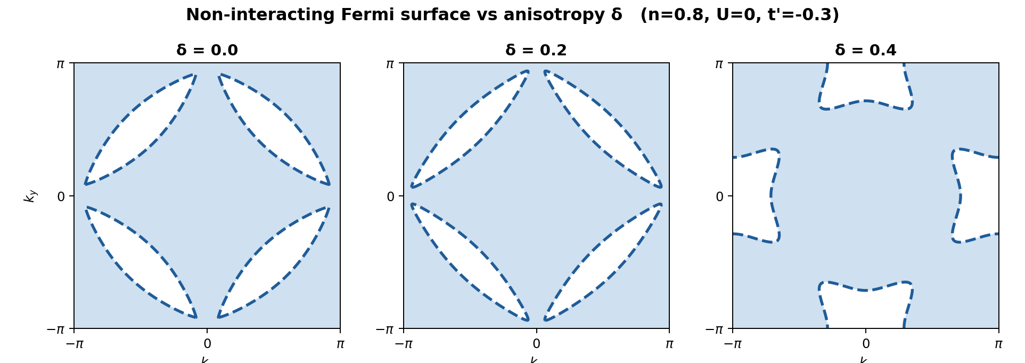
Fig. 3. Non-interacting Fermi surface vs δ. Increasing δ drives a Lifshitz reconstruction that destroys (π,π) nesting.

Master causal chain:
δ ↑ → the diagonal term m(k) = 4δ sin kx sin ky grows in H → C4v→C2v, and the U=0 Fermi surface undergoes a Lifshitz reconstruction (Fig. 3), destroying (π,π) nesting → the AFM instability weakens while a dxy-symmetric particle–hole channel opens → the spin background reorganizes from Néel toward short-range / diagonal fluctuations → S_z(q), R_p, Δn(k) and the pairing vertex all change.
Change-by-change reading:
- Weaken (AFM): N_Sz(π,π) and its R_p fall as δ breaks nesting — symmetry-allowed, robust.
- Peak move (incommensuration): Q drifts off (π,π) on doping; filling-dependent — model/parameter-dependent, not universal.
- Non-monotonic (pairing): the vertex may rise then fall with δ (a dome): too little δ keeps AFM dominant, too much destroys coherence — direction set by competing energies, so we do NOT pre-commit to a sign.
- Symmetry change (AM onset): Δ_tot turns on from 0 as M·δ — fixed by symmetry (must vanish at δ=0).
For each: the direct explanation (nesting loss → AFM suppression) is symmetry-backed; alternatives (e.g. finite-size peak wandering) are separated by R_p, by χ_s(q), and by L = 10/14/16 scaling.

Stage 7 — The New Physical Condition (δ) and Its Effects
- Hamiltonian term: δ enters only through the diagonal hopping t± = t′±δ on the crossed plaquettes; in the 2-sublattice Bloch form it is m(k) = 4δ sin kx sin ky.
- Directly coupled to: the inter-sublattice (A/B) kinetic channel — spin-independently.
- Symmetry / selection rules: lowers C4v→C2v; makes Néel order altermagnetic with a dxy form factor; the spin split is forbidden at first order in δ alone (needs M): ΔE ∝ M·δ.
- Energy scales / competition: δ tunes diagonal kinetic energy against U-driven superexchange and against NN kinetic energy — the knob balancing AFM nesting vs diagonal correlation vs pairing.
- Preferential effect: first on Fermi-surface topology (Lifshitz, Fig. 3) and Δn(k); then on S_z(q) and the pairing vertex.
- Order in perturbation: the AM splitting is second order (∝ M·δ, needs a moment); the FS distortion is first order in δ; a net moment is symmetry-forbidden.
- Strong-δ regime: crossings likely — δ = |t′| = 0.3 switches t+ off (connectivity change); δ > |t′| flips the sign of t+ (maximal AM contrast). State reconstruction expected across this window.
- Artifacts to watch: open-shell fillings (use closed shells); CP over-ordering near n=1; k-resolution at fixed L (the L=10→L=14 lesson); boundary effects → finite-size scaling.

7.1 Predicted effect on each key observable
Observable | Possible change | Direct mechanism | Alternative | Supporting / excluding signal
Δ_tot | 0 → finite as δ ↑ | emergent AM, ∝ M·δ | ordinary Néel (also finite moment) | symmetry-resolved dxy weight distinguishes
Δ_dxy | dominant, grows with δ | dxy form factor of lattice | dx2-y2 leakage if C4 weakly broken | compare Δ_dx2-y2; must be much smaller
N_Sz(π,π) | suppressed with δ | Lifshitz loss of nesting | CP bias masking | cross-check χ_s, CP-DQMC, ED
Q (doped) | drifts off (π,π) | incommensurate response | finite-size peak wander | R_p, L-scaling
N_Vertex (d) | dome vs δ (non-monotonic) | AFM suppression → RVB pairing | ext-s background; CP bias | P_ζ > P̄_ζ; channel ratio; ED

Direction-of-change honesty:
- Model-independent (symmetry): Δ_tot = 0 at δ=0; the AM form factor is dxy; a net moment is forbidden.
- Parameter-dependent: the doped ordering wavevector Q; the exact δ of any crossover; absolute pairing magnitudes.
- Likely non-monotonic: the pairing vertex vs δ (dome). We do not force a sign.
- Key competing energy: diagonal kinetic energy (∝ δ) vs superexchange (∝ t²/U) vs NN kinetic energy — their balance sets every direction of change.

Stage 8 — Synthesis and Priorities
1. Scientific background. Altermagnetism as a third collinear-magnet class; the imposed-vs-emergent divide; pairing in a spontaneous AM is untouched by unbiased methods.
2. Why worth studying. Tests whether [11]'s AFM-suppression→d-wave mechanism is intrinsic to AM or an artifact of imposing the splitting; first unbiased benchmark for emergent-AM theory.
3. Timeline. Symmetry birth (2020–22) → experiments (2022–24) → emergent-AM proposals, mostly mean-field (2024–25) → exact AM benchmark [16] → group imposed-AM pairing [11] → this emergent-AM project.
4. Closest work. [11] (method + question), Papers 1–2 (magnetic toolkit), [12,15] (emergent-AM concept).
5. Positioning. Cross-cutting: imposed-AM pairing method × geometric emergent-AM model; the ‘third leg’ closing the imposed-vs-emergent gap.
6. Real innovation. (i) emergent vs imposed AM under unbiased QMC; (ii) symmetry-selected pairing channel (dxy vs dx2-y2); (iii) a reusable symmetry-resolved AM order parameter.
7. Main novelty risk. Emergent order may be ordinary Néel away from special δ — ‘altermagnet’ must be proven by Δ_tot(δ) plus the symmetry weight.
8. Is it really useful?. Yes, if narrowed to the pairing / symmetry question. A negative result (emergent AM does NOT enhance pairing) is itself publishable: it would show [11]'s effect needs the imposed splitting.
9. Core observables. Δ_tot(δ), Δ_dxy/Δ_dx2-y2, Q and R_p, vertex pairing N_ζ and pair susceptibility P_ζ, χ_s(q); with ED / CP-DQMC controls.
10. Observable → physics. δ → Lifshitz loss of nesting → AFM suppression + dxy channel opening → changes in S(q), R_p, Δn(k), pairing vertex.
11. Effect of δ. First-order FS distortion; second-order (∝ M·δ) AM splitting; crossover / state reconstruction expected near δ = |t′| = 0.3 and δ > |t′|.
12. Most likely mechanism. Geometric anisotropy suppresses (π,π) nesting; where Néel weakens, a dxy pairing channel is favoured — an emergent-AM analogue of the doping-free RVB route of [11].
13. Undetermined now. Whether the pairing vertex forms a δ-dome; the true doped-region order beyond error bars; the magnitude of CP bias on the pairing vertex.
14. Highest-priority next step. At half-filling (the 5 δ points now archived), sweep δ and measure Δ_tot and Δ_dxy/Δ_dx2-y2 — the single cheapest test that proves emergent AM and its symmetry; then the vertex-pairing dome vs δ, cross-checked by CP-DQMC / ED.

Bottom line. Re-centre the project on emergent altermagnetism and symmetry-selected pairing. The magnetic phase diagram (Néel near half-filling, short-range when doped) is honest supporting material, not the headline. The decisive, cheap first experiment is Δ_tot(δ) with the dxy/dx2-y2 decomposition at half-filling; the headline experiment is the vertex-pairing dome vs δ in the dxy channel, controlled against ED and CP-DQMC.

References
[1] L. Šmejkal, J. Sinova, T. Jungwirth, Phys. Rev. X 12, 040501 (2022).
[2] I. Mazin (ed.), Phys. Rev. X 12, 040002 (2022).
[3] L. Šmejkal, A. B. Hellenes, R. González-Hernández, J. Sinova, T. Jungwirth, Phys. Rev. X 12, 011028 (2022).
[4] Y. Jiang et al., Phys. Rev. X 14, 031039 (2024).
[5] P. A. McClarty, J. G. Rau, Phys. Rev. Lett. 132, 176702 (2024).
[6] J. Krempaský et al., Nature 626, 517 (2024).
[7] O. Fedchenko et al., Sci. Adv. 10, eadj4883 (2024).
[8] O. J. Amin et al., Nature 636, 348 (2024).
[9] B. H. Rimmler, B. Pal, S. S. P. Parkin, Nat. Rev. Mater. 10, 109 (2025).
[10] T. Jungwirth et al., Newton 1, 100162 (2025).
[11] J. Li, J. Liu, X. Yang, H.-K. Tang, “Enhancement of d-wave pairing in strongly correlated altermagnet” (our group, 2026).
[12] S. Giuli, C. Mejuto-Zaera, M. Capone, Phys. Rev. B 111, L020401 (2025).
[13] V. Leeb, A. Mook, L. Šmejkal, J. Knolle, Phys. Rev. Lett. 132, 236701 (2024).
[14] N. Kaushal, M. Franz, Phys. Rev. Lett. 135, 156502 (2025).
[15] F. Ferrari, R. Valentí, Phys. Rev. B 110, 205140 (2024).
[16] T. Sato, S. Haddad, I. C. Fulga, F. F. Assaad, J. van den Brink, Phys. Rev. Lett. 133, 086503 (2024).
[17] Our group, “Competing magnetic correlations in the square-lattice Hubbard model with spin-dependent NN and NNN hopping” (Paper 1).
[18] Our group, “Evolution of magnetic correlation in the doped Hubbard model with altermagnetic spin splitting,” Phys. Rev. B 113, 134443 (2026) (Paper 2).
[19] D. J. Scalapino, S. R. White, S. C. Zhang, Phys. Rev. B 47, 7995 (1993).
[20] S. R. White et al., Phys. Rev. B 40, 506 (1989).

