Descriptive Statistics
for Machine Learning — Concepts Explained Simply
Part 1 of the Statistics for ML series • Companion notebook: Descriptive_Statistics_Concepts_and_Code.ipynb

Introduction
Before you can build a Machine Learning model, you need to understand your data. Statistics is the branch of mathematics that gives you the tools to describe, summarize, and draw conclusions from data. It splits into two big branches:
- Descriptive Statistics — summarizing and describing the data you already have (this document).
- Inferential Statistics — using a sample of data to draw conclusions about a larger population (covered in the companion document).
This document focuses entirely on Descriptive Statistics: the everyday tools you'll use to understand a dataset before you clean it, visualize it, or feed it into a model — things like averages, spread, shapes of distributions, and relationships between variables.

What You Will Learn
- Types of data: qualitative vs quantitative, and four measurement scales.
- Measures of central tendency: mean, median, and mode.
- Measures of dispersion (spread): range, variance, standard deviation, and IQR.
- Percentiles, quartiles, and boxplots.
- Skewness: what it means when a distribution isn't symmetric.
- Covariance and correlation: how two variables move together.
- Standardization (z-scores): putting different variables on the same scale.

1. Types of Data
Before you can summarize data, you need to know what kind of data you're dealing with. This affects which statistics and which charts even make sense to use.

1.1 Qualitative (Categorical) vs Quantitative (Numeric) Data
Qualitative data describes categories or labels — things you cannot meaningfully do arithmetic on. Examples: city name, gender, product category, pass/fail.
Quantitative data describes measurable quantities — things you can add, average, or compare numerically. Examples: age, temperature, salary, height.

1.2 Four Measurement Scales
Data is often further classified into one of four scales. Each scale allows different kinds of operations.
Scale | Description | Example | Allowed Operations
Nominal | Categories with no natural order | Blood type, city, gender | Count, mode, equality (=, ≠)
Ordinal | Categories with a meaningful order, but unequal gaps | Movie rating (1-5 stars), education level | Order comparisons (<, >), median
Interval | Numeric, equal gaps, but no true zero | Temperature in °C, calendar year | Addition, subtraction, mean
Ratio | Numeric, equal gaps, and a true zero (zero means 'none') | Height, weight, salary, age | All arithmetic, including ratios (e.g. 'twice as much')

2. Measures of Central Tendency
A measure of central tendency is a single number that tries to represent the "center" or typical value of a dataset. The three most common are the mean, median, and mode.

2.1 Mean (Average)
The mean is the sum of all values divided by the number of values. It's the most commonly used measure of center, but it is sensitive to extreme values (outliers).
Formula: mean = (sum of all values) ÷ (number of values)
Example: marks = [78, 85, 91, 67, 88]. Sum = 409. Count = 5. Mean = 409 ÷ 5 = 81.8.

2.2 Median
The median is the middle value when the data is sorted in order. If there's an even number of values, it's the average of the two middle values. The median is not affected by extreme outliers — it only cares about the middle position.
Example: sorted marks = [67, 78, 85, 88, 91]. The middle value (3rd of 5) is 85, so the median is 85.

2.3 Mode
The mode is the value (or values) that appears most frequently in the dataset. A dataset can have one mode (unimodal), two modes (bimodal), or more. The mode is the only measure of central tendency that works for purely categorical data.
Example: grades = ["B", "A", "A", "C", "B", "A"]. "A" appears 3 times — more than any other grade — so the mode is "A".

2.4 When Mean, Median, and Mode Disagree
In a perfectly symmetric distribution, the mean, median, and mode are all equal. But in a skewed (lopsided) distribution, they pull apart from each other — and this tells you something important about your data's shape.
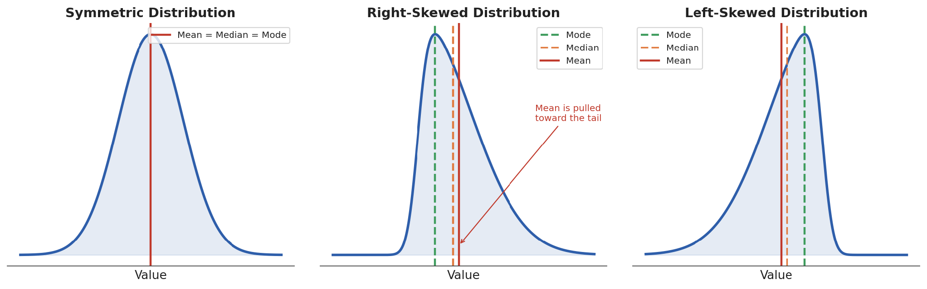
Figure 1: In a symmetric distribution, mean = median = mode. In a skewed distribution, the mean is pulled toward the longer tail.

3. Measures of Dispersion (Spread)
Central tendency tells you where the "middle" of your data is, but not how spread out the values are. Two datasets can have the exact same mean but look completely different — one tightly clustered, one widely scattered.
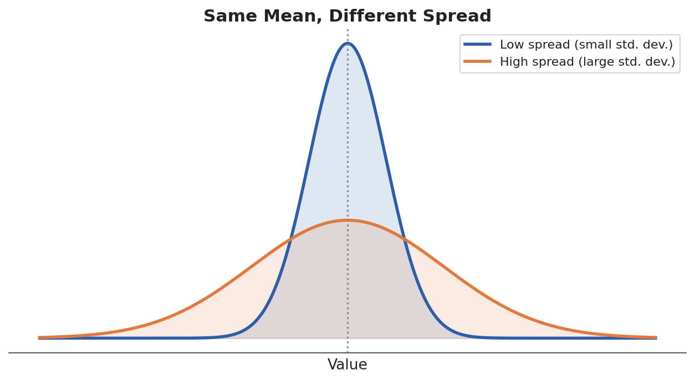
Figure 2: Two distributions with the same mean but very different spread.

3.1 Range
The simplest measure of spread: the difference between the maximum and minimum values. Range = max − min. It's easy to compute but very sensitive to a single extreme outlier.

3.2 Variance
Variance measures the average squared distance of each value from the mean. Squaring makes every distance positive (so distances above and below the mean don't cancel out), and it also emphasizes larger deviations.
Formula (population variance): variance = average of (each value − mean)²
Note: when working with a sample instead of the whole population, we divide by (n − 1) instead of n. This is called Bessel's correction, and it produces a better estimate of the true population variance from a limited sample.

3.3 Standard Deviation
Standard deviation is simply the square root of the variance. It's extremely useful because, unlike variance, it's back in the same units as the original data (e.g. dollars, not squared dollars) — making it much easier to interpret.
Example: for marks = [78, 85, 91, 67, 88], the mean is 81.8. The variance and standard deviation measure how far, on average, each mark is from that mean of 81.8. A small standard deviation means the marks are clustered close to 81.8; a large one means they're spread out widely.

3.4 Interquartile Range (IQR)
The IQR measures the spread of the "middle 50%" of the data. It's calculated as IQR = Q3 − Q1 (the 75th percentile minus the 25th percentile — see Section 4 for more on percentiles). Because it ignores the most extreme values entirely, the IQR is much more robust to outliers than the range or even the standard deviation.

It measures the spread of the middle 50% of the data.

⭐ This is the most important sentence to remember.

4. Percentiles, Quartiles, and Boxplots
A percentile tells you the value below which a given percentage of the data falls. For example, if you scored in the 90th percentile on a test, 90% of test-takers scored lower than you.
Quartiles are specific percentiles that divide the data into four equal parts:
- Q1 (25th percentile) — 25% of the data falls below this value.
- Q2 (50th percentile) — this is the same as the median.
- Q3 (75th percentile) — 75% of the data falls below this value.

4.1 The Boxplot
A boxplot (or "box-and-whisker plot") is a visual summary built directly from quartiles. It shows the median, the "box" spanning Q1 to Q3 (the IQR), "whiskers" extending to the smallest/largest values within 1.5×IQR of the box, and any remaining points plotted individually as outliers.
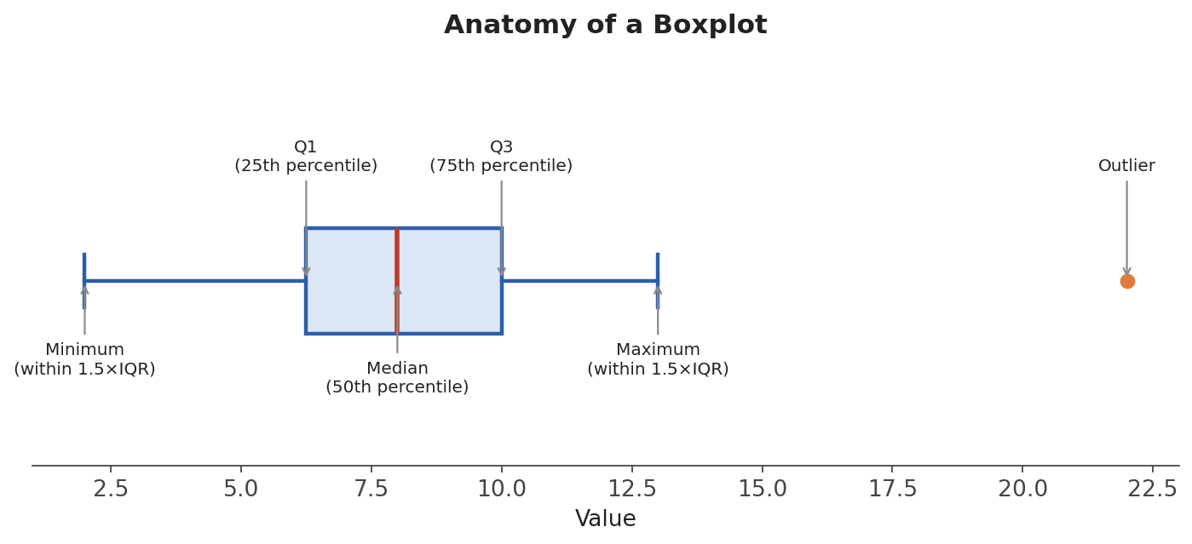
Figure 3: The anatomy of a boxplot, built entirely from percentiles.

6. Covariance and Correlation
So far, every measure we've discussed describes a single variable. Covariance and correlation describe the relationship between two variables — do they tend to increase together, move in opposite directions, or show no clear pattern at all?

6.1 Covariance
Covariance measures the direction of the linear relationship between two variables: positive covariance means they tend to increase together; negative covariance means as one increases, the other tends to decrease. However, the raw number is hard to interpret on its own because its scale depends on the units of the two variables.

6.2 Correlation
Correlation (specifically, the Pearson correlation coefficient) standardizes covariance into a value always between −1 and +1, making it much easier to interpret:
- +1 — perfect positive correlation (as X increases, Y always increases proportionally).
- 0 — no linear correlation.
- −1 — perfect negative correlation (as X increases, Y always decreases proportionally).
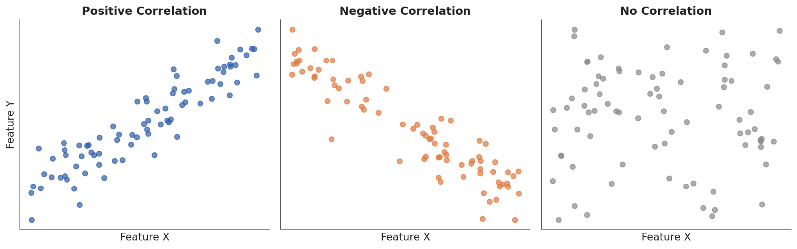
Figure 4: Scatter plots showing positive, negative, and no correlation between two variables.

7. Standardization (Z-Scores)
Real datasets often have features on very different scales — for example, "age" (0-100) and "income" (0-500,000). Many ML algorithms are sensitive to scale, so we often convert features into z-scores: a standardized measure of how many standard deviations a value is above or below the mean.
Formula: z = (value − mean) ÷ standard deviation
A z-score of 0 means the value is exactly at the mean. A z-score of +2 means the value is two standard deviations above the mean. After standardizing, every feature has a mean of 0 and a standard deviation of 1 — putting completely different features on the same, comparable scale.

Summary
Concept | What it Tells You
Mean, Median, Mode | The 'typical' or central value of the data
Range, Variance, Std. Dev., IQR | How spread out the data is
Percentiles / Quartiles / Boxplot | Where a value ranks, and where outliers lie
Skewness | Whether the data is symmetric or lopsided
Covariance / Correlation | How two variables relate to each other
Standardization (z-scores) | How to put different-scale features on equal footing

This is the essential descriptive-statistics toolkit you'll reach for constantly during exploratory data analysis. Next, open the companion notebook, Descriptive_Statistics_Concepts_and_Code.ipynb, to see every one of these concepts computed directly in Python. After that, continue to the second document in this series, Inferential Statistics, which covers how to go beyond describing a sample and start drawing conclusions about a wider population.

