Inferential Statistics
for Machine Learning — Concepts Explained Simply
Part 2 of the Statistics for ML series • Companion notebook: Inferential_Statistics_Concepts_and_Code.ipynb

Introduction
In the first document, Descriptive Statistics, you learned how to summarize data you already have in hand — its center, its spread, its shape. This document tackles a bigger question: how can you draw reliable conclusions about a much larger group, using only a small sample of data from it?
This is the core idea of Inferential Statistics: using probability theory to go from a limited sample to a confident (if never 100% certain) statement about the whole population.

What You Will Learn
- Population vs sample, and why we sample at all.
- Sampling distributions and the Central Limit Theorem — arguably the most important idea in all of statistics.
- Standard error, and how it differs from standard deviation.
- The normal distribution and the empirical rule.
- Confidence intervals: expressing uncertainty around an estimate.
- Hypothesis testing: null/alternative hypotheses, p-values, significance levels, and Type I/II errors.
- Z-tests and t-tests, and when to use each.
- Chi-square tests and ANOVA, at a conceptual level.
- Correlation vs causation — a critical distinction for responsible data analysis.

1. Population vs Sample
A population is the entire group you're interested in studying — every customer, every possible measurement, every voter in a country.
A sample is a smaller subset of the population that you actually collect data from, because studying the entire population is usually impossible, too expensive, or too slow.
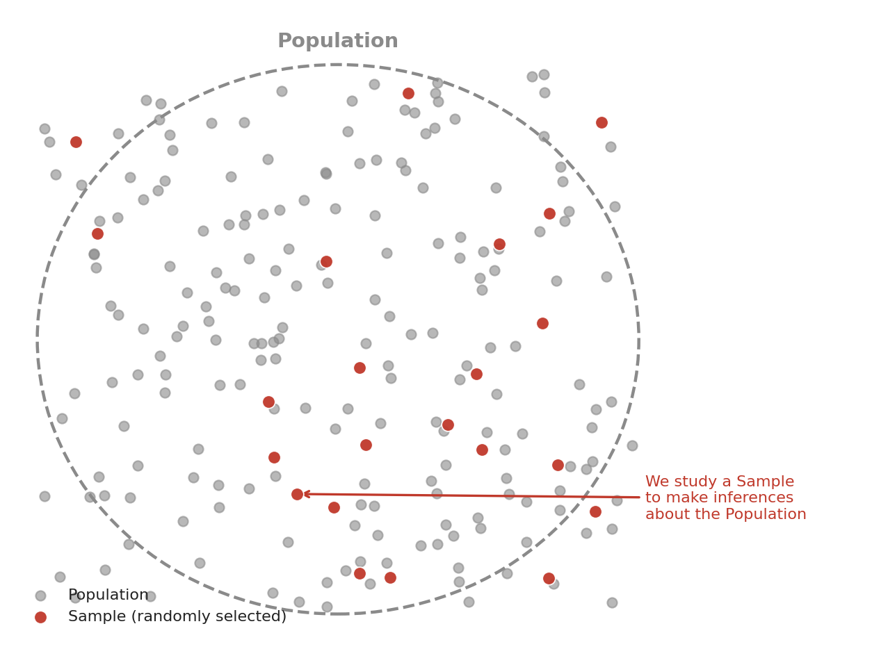
Figure 1: We study a randomly selected sample in order to draw conclusions about the entire population.

1.1 Why Random Sampling Matters
For a sample to reliably represent the population, it generally needs to be selected randomly — meaning every member of the population has a known, non-zero chance of being included. If a sample is biased (e.g. only surveying people who answer their phone during business hours), conclusions drawn from it may not generalize to the true population at all, no matter how sophisticated the statistics applied to it are.
2. Sampling Distributions and the Central Limit Theorem
Imagine repeatedly drawing many different random samples from the same population, and calculating the mean of each sample. If you plotted all of those sample means on a histogram, you'd get what's called the sampling distribution of the mean.

2.1 The Central Limit Theorem (CLT)
The Central Limit Theorem is one of the most powerful and surprising results in all of statistics. It states: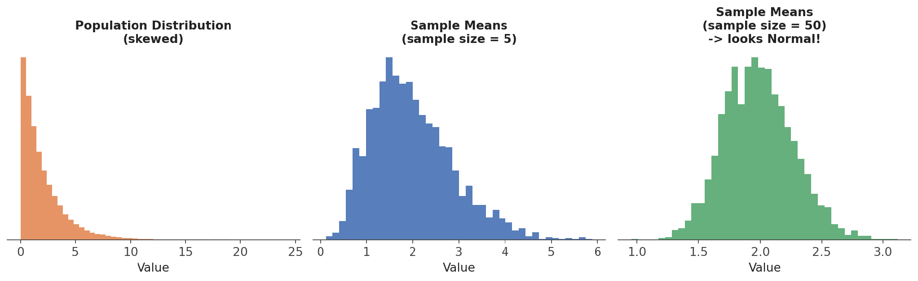
Figure 2: Even though the population is skewed, the distribution of sample means becomes approximately Normal as sample size increases.
This is enormously useful, because it means we can use the well-understood mathematics of the Normal distribution to make confident statements about sample means and population parameters — even when we know almost nothing about the shape of the original population.

Xˉsample​±1.96(SE)

SEXˉ​=σpopulation​ / sqrt(n)

3. Standard Error
The standard error (SE) measures how much sample means would be expected to vary from sample to sample. It's easy to confuse with standard deviation, but they answer different questions:
- Standard deviation: how spread out individual data points are within one sample or population.
- Standard error: how spread out the sample MEAN itself would be, if you repeated the sampling process many times.
Formula: standard error = (sample standard deviation) ÷ √(sample size)
Notice that as sample size (n) grows larger, the standard error shrinks — larger samples give you a more precise (less variable) estimate of the true population mean. This single formula is the mathematical foundation behind confidence intervals and hypothesis tests, both covered next.

4. The Normal Distribution and the Empirical Rule
The Normal distribution (also called the Gaussian distribution, or the "bell curve") is symmetric, single-peaked, and defined entirely by two numbers: its mean (μ, the center) and its standard deviation (σ, the spread). It appears constantly throughout statistics, partly because of the Central Limit Theorem discussed above.

4.1 The Empirical Rule (68-95-99.7 Rule)
For any Normal distribution, a simple, memorable rule tells you roughly what proportion of values fall within a certain number of standard deviations of the mean:
- About 68% of values fall within 1 standard deviation of the mean.
- About 95% of values fall within 2 standard deviations of the mean.
- About 99.7% of values fall within 3 standard deviations of the mean.
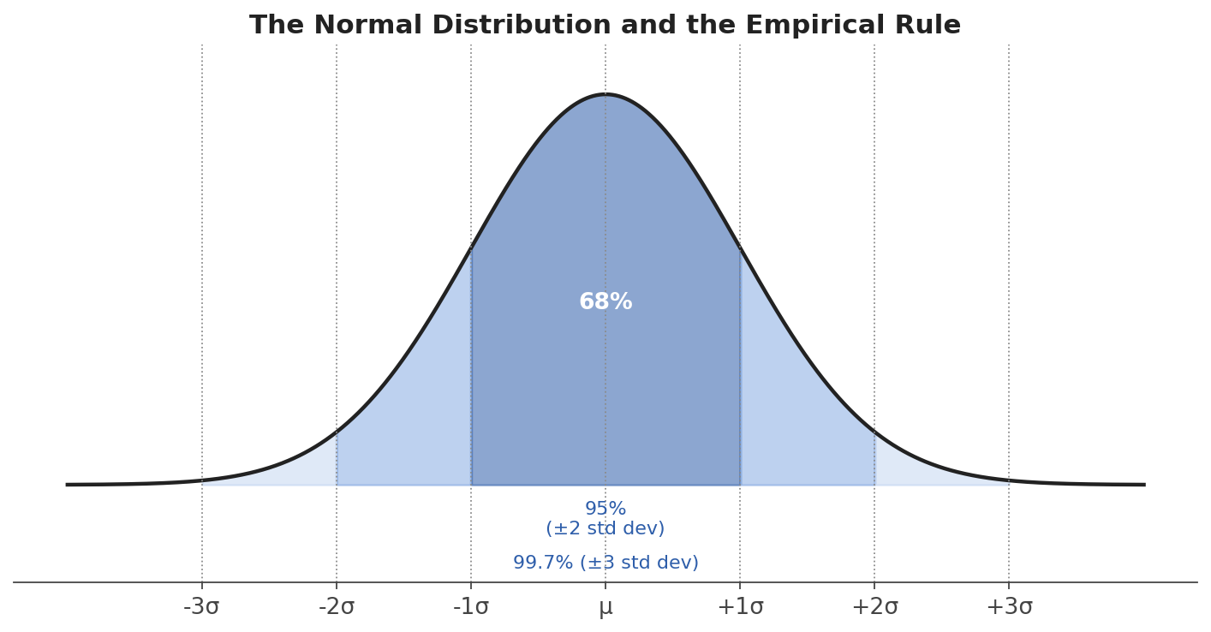
Figure 3: The empirical rule for the Normal distribution.

Special Case:
Standard Normal Variate (Z) : When meu = 0 and sigma = 1
We can write it Z ~ N(0, 1)

5. Confidence Intervals
A sample mean is just a single number — a "point estimate" — but it's very unlikely to be exactly equal to the true population mean. A confidence interval expresses our uncertainty by giving a range of plausible values instead of just one number.
A 95% confidence interval means: if we repeated this entire sampling and interval-building process many times, about 95% of the intervals we'd construct would contain the true population mean.
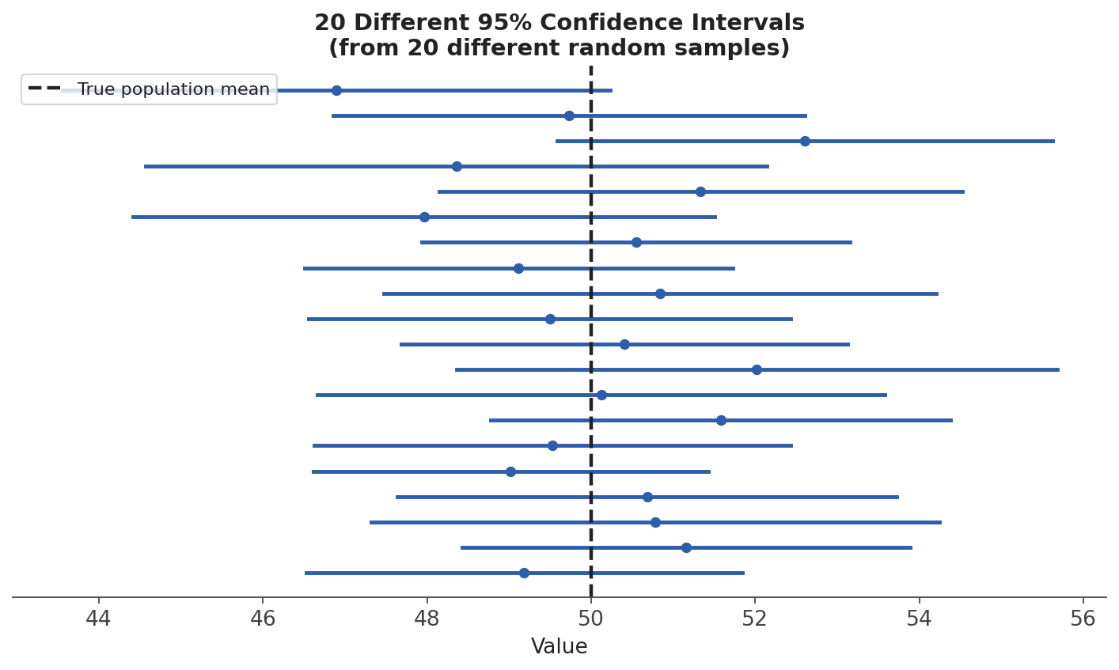
Figure 4: Twenty different 95% confidence intervals, built from twenty different random samples of the same population. Most — but not necessarily all — capture the true mean.

1. Kurtosis
Think of a dataset as having a distribution shape.
For example:
- Where are most observations?
- How heavy are the tails?
- Are there many extreme values?
Kurtosis mainly tells us about the heaviness of the tails / presence of extreme values.

Simple example
Suppose we have two datasets:
Dataset A
48, 49, 50, 50, 51, 52
Most values are close to 50.
Dataset B
20, 49, 50, 50, 51, 80
Dataset B has extreme observations: 20 and 80.
So Dataset B has heavier tails and potentially higher kurtosis.

Three terms you should know

1. Mesokurtic
Approximately normal-like tail behavior.
For a normal distribution:
Kurtosis=3\text{Kurtosis}=3
But many Python libraries report excess kurtosis, where normal distribution = 0.
So:
Excess Kurtosis=0\text{Excess Kurtosis}=0

2. Leptokurtic
Higher kurtosis / heavier tails.
Excess Kurtosis>0\text{Excess Kurtosis}>0
This indicates more tendency toward extreme observations.

3. Platykurtic
Lower kurtosis / lighter tails.
Excess Kurtosis<0\text{Excess Kurtosis}<0

Very important
Don't teach students:
"Kurtosis tells us how peaked the distribution is."
That's an oversimplification and can be misleading.
A better statement is:
Kurtosis is primarily associated with tail heaviness and the frequency/severity of extreme observations.

2. Quantile-Quantile Plot (Q-Q Plot)
Now let's move to Q-Q plots.
The name sounds difficult, but the idea is actually simple.
Q-Q = Quantile-Quantile.
A Q-Q plot compares:
Quantiles of our actual data
versus
Quantiles of a theoretical distribution
Most commonly, we compare our data against a normal distribution.

First: What is a quantile?
Suppose we have:
10, 20, 30, 40, 50
The:
- 50th percentile is around 30
- 25th percentile is around 20
- 75th percentile is around 40
These percentile positions are quantiles.
So a Q-Q plot asks:
"At different percentile positions, how do my data values compare with what a normal distribution would give?"

6. Hypothesis Testing
Hypothesis testing is a formal procedure for deciding whether a pattern you observe in a sample is likely to reflect a real effect in the population, or whether it could plausibly have arisen just from random chance.

6.1 Null and Alternative Hypotheses
- Null hypothesis (H0): the "nothing interesting is happening" baseline assumption — e.g. "this new website design has no effect on purchase rate."
- Alternative hypothesis (H1 or Ha): the claim you're actually trying to find evidence for — e.g. "this new website design DOES change the purchase rate."
A hypothesis test never directly "proves" H1. Instead, it asks: if H0 were actually true, how surprising would our observed sample data be? If it would be very surprising, we reject H0 in favor of H1.

6.2 The p-value
The p-value is the probability of observing a result at least as extreme as the one in your sample, assuming the null hypothesis is true. A small p-value means your observed result would be quite surprising under H0 — giving you evidence against it.

6.3 Significance Level (α) and the Decision Rule
Before running a test, we choose a significance level (α, commonly 0.05) — our threshold for how surprising a result needs to be before we reject H0. The decision rule is simple:
- If p-value ≤ α: reject H0 (the result is "statistically significant").
- If p-value > α: fail to reject H0 (not enough evidence to conclude an effect exists).
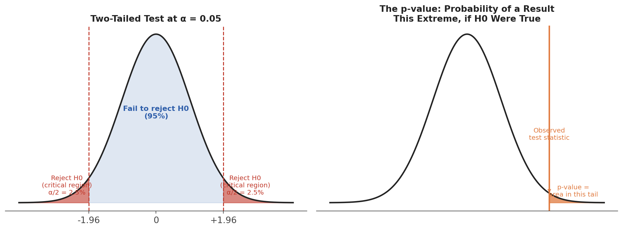
Figure 5: Left — the critical (rejection) region for a two-tailed test at α = 0.05. Right — the p-value is the probability of a result this extreme or more, assuming H0 is true.

6.4 Type I and Type II Errors
Because we're making a decision under uncertainty, two kinds of mistakes are possible:
 | H0 is actually True | H0 is actually False
We reject H0 | Type I Error (false positive) — probability = α | Correct decision
We fail to reject H0 | Correct decision | Type II Error (false negative) — probability = β

There's usually a trade-off: making it harder to commit a Type I error (e.g. lowering α) generally makes Type II errors more likely, and vice versa. The right balance depends on which mistake is more costly in your specific situation — e.g. in medical testing, missing a real disease (Type II) is often considered far worse than a false alarm (Type I).

7. Z-Tests and T-Tests
Both tests check whether a sample mean is significantly different from some reference value (or whether two sample means differ from each other). The choice between them comes down to what you know about the population.
 | Z-Test | T-Test
When to use | Population standard deviation is known, or the sample is very large (n > 30) | Population standard deviation is unknown (the common case), especially with smaller samples
Distribution used | Standard Normal distribution | Student's t-distribution (has heavier tails, to account for extra uncertainty)
Typical use case | Large-scale surveys, quality control with known process variability | Comparing two small groups, e.g. an A/B test with limited data

In practice, since the true population standard deviation is rarely known, the t-test is used far more often than the z-test in real-world data analysis. As the sample size grows large, the t-distribution becomes nearly identical to the Normal distribution anyway, so the two tests tend to agree.

8. Chi-Square Tests and ANOVA (A Conceptual Introduction)

8.1 Chi-Square Test
The chi-square (χ²) test is used with categorical data, to check whether two categorical variables are related to each other (a "test of independence"), or whether an observed distribution of categories matches an expected one (a "goodness-of-fit" test).
Example: does a customer's preferred product category depend on which city they live in? A chi-square test compares the actual counts in each city/category combination against the counts you'd expect if city and category were completely unrelated.

8.2 ANOVA (Analysis of Variance)
A t-test compares the means of exactly two groups. ANOVA extends this idea to three or more groups at once, testing whether at least one group's mean is significantly different from the others.
Example: comparing average test scores across students taught by four different teachers. ANOVA tests whether teacher assignment is associated with a real difference in average scores, without needing to run a separate t-test for every possible pair of teachers (which would inflate the chance of a false positive).

9. Correlation vs Causation
This is one of the most important — and most often violated — principles in all of statistics and data science:Classic example: ice cream sales and drowning incidents are strongly correlated — but ice cream doesn't cause drowning. Both increase in summer, driven by the confounding variable of hot weather (more swimming AND more ice cream purchases).
Establishing genuine causation typically requires a controlled experiment (like a randomized A/B test), where you actively change one variable and observe the effect, rather than simply observing two variables that happen to move together.

Summary
Concept | What it Tells You
Population vs Sample | The whole group of interest, vs. the smaller subset we actually study
Central Limit Theorem | Why sample means tend toward a Normal distribution as sample size grows
Standard Error | How much a sample mean would vary across repeated sampling
Confidence Interval | A range of plausible values for an unknown population parameter
Hypothesis Test / p-value | Whether an observed effect is likely real, or just random chance
Z-test / T-test | Comparing means when population std. dev. is known / unknown
Chi-square / ANOVA | Testing relationships in categorical data / comparing 3+ group means
Correlation vs Causation | A reminder that association alone doesn't prove one thing causes another

Together, Descriptive and Inferential Statistics form the foundation for everything that follows in this course: understanding your data (NumPy, Pandas), visualizing it, and ultimately building, evaluating, and trusting Machine Learning models built on top of it. Next, open the companion notebook, Inferential_Statistics_Concepts_and_Code.ipynb, to see every one of these concepts computed directly in Python.

