Quantitative and Functional Imaging

BME 4420/7450

**Project #2: Cardiac ejection fraction**

In this project, you will measure cardiac ejection fraction using MRI images. As in earlier projects, you are free to get your results in some other way—these procedures are just one (not necessarily optimal) method. Again, Matlab commands are given in *italics* for easy reference. Use *help <command>* (for example, *help squeeze*) or the Matlab Help pages for more details on any Matlab function. Create a Matlab program that carries out the following steps:

1. Load the data file proj2Data.mat into your workspace with

*load(‘proj2Data’)*

There are an array and two scalars in the .mat file:

image_3d A 3D array of image intensity values (256 x 256 x 30) acquired at 30 equally spaced times during the cardiac cycle. The indices of the array are (row, col, time).

dx Pixel size (in cm) in the x direction (i.e., along a row).

dy Pixel size (in cm) in the y direction (i.e., along a column).

The images were acquired in a plane that cuts through the middle of the left ventricle from the base to the apex (this is called a *long axis* view of the ventricle). The 30 time points in the cardiac cycle are called *cardiac phases* (*phase* in this context means ‘time point in the cycle’).

Our goal is to measure the volume of the left ventricle as a function of time during the cardiac cycle. We will assume that the left ventricle is ellipsoidal in shape and its volume can be calculated from measurements on the long axis image. If the lengths of an ellipsoid along its principal axes are *a*, *b*, and *c*, then its volume is

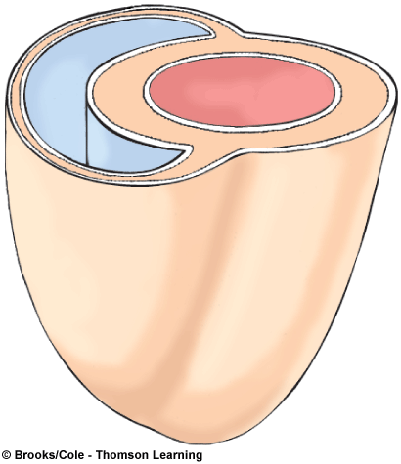

**Right ventricular wall**

**Left ventricular**

**wall**

 [1]

We will assume that the two minor axes have the same length, i.e., that .

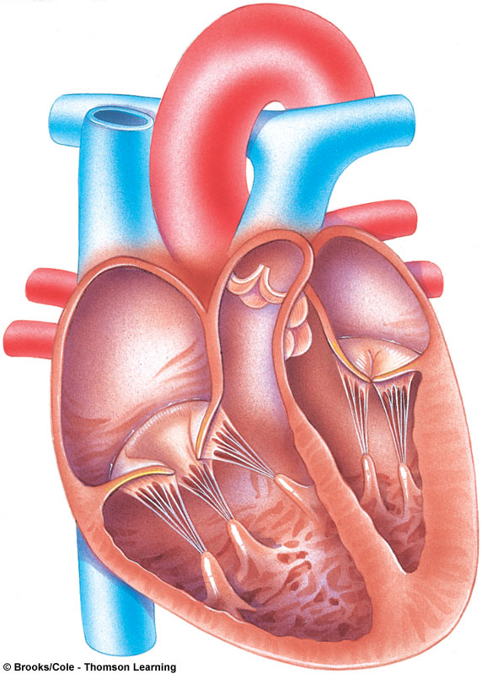

**Aorta**

**Right atrium**

**Right AV valve**

**Right ventricle**

**Left atrium**

**Left AV valve**

**Chordae tendineae**

**Papillary muscle**

**Left ventricle**

**Interventricular septum**

1. Make a movie of the beating heart. Display each image and use the *getframe* command to capture it in a movie frame. Use the same intensity scaling in each image:

*% Make a movie:*

*Figure*

*nFrames = 30;*

*for index = 1:nFrames*

*imagesc(squeeze(image_3d(:, :, index)))*

*% Set the intensity scale based on the first image:*

*if (index == 1)*

*cLim_v = get(gca, 'CLim');*

*else*

*set(gca, 'CLim', cLim_v)*

*end*

*axis image*

*axis off*

*colormap(gray)*

*title(['Cardiac phase: ', num2str(index)])*

*drawnow*

*mov(index) = getframe;*

*end*

*fps = 8; % frames per second.*

*nReps = 4; % number of repetitions.*

*movie(mov, nReps, fps)*

Identify the following anatomical structures in the movie: intraventricular septum, left ventricle (LV), apex (bottom tip) of the heart, papillary muscle, and the approximate location of the atrioventricular (AV) valve (you can identify this from the bright flow artifact as the AV valve opens and blood shoots from the atrium to the ventricle at high velocity).

1. Estimate the LV volume as a function of time during the cardiac cycle. Use the *ginput* command to define the major axis of the ventricle (i.e., the distance from the AV valve to the end of the ventricle near the apex). Use *ginput* again to define the minor axis (the maximum width of the ventricle). Use Eqn. [1] to calculate the LV volume:

*% Define the major and minor axes of the ellipse in each frame:*

*skip = 5; % Number of phases to skip.*

*nVols = length(1:skip:nFrames);*

*volume_v = zeros(1, nVols);*

*for index = 1:skip:nFrames*

*imagesc(squeeze(image_3d(:, :, index)))*

*set(gca, 'CLim', cLim_v)*

*axis image*

*axis off*

*colormap(gray)*

*% Get axes:*

*title(['Cardiac phase ', num2str(index), ' define major axis'])*

*% Insert your code here to measure the major axis:*

*…*

*title(['Cardiac phase ', num2str(index), ' define minor axis'])*

*% Insert your code here to measure the minor axis:*

*…*

*volIndex = (index-1)/skip + 1;*

*% Enter your code here to calculate the LV volume:*

*volume_v(volIndex) = …*

*end*

1. Plot the LV volume as a function of cardiac phase and calculate the ejection fraction (i.e., the volume of blood pumped out of the LV during each cycle).

# Questions

1. What is the diastolic (i.e., maximum) volume of the LV? (Don’t forget the units!)
2. What is the systolic (i.e., minimum) volume?
3. What is the ejection fraction (i.e., the fraction of the maximum volume that is pumped out of the heart each cycle)?
4. Could you use the same approach to estimate the volume of blood ejected from the right ventricle? If not, explain why. Do you expect the right and left ventricular ejection volumes to be equal?
5. We assumed that the two minor axes, *b* and *c*, are equal, but this is only approximately true. Let *b* be the measured minor axis and *c* be the unmeasured minor axis (i.e., the minor axis in the direction perpendicular to the image plane). Suppose that in a group of patients *c*=*b* on average, but there is a 20% variation in the ratio, i.e., the standard deviation of *c*/*b* in this group is

$$σ\left(\frac{c}{b}\right)=\frac{σ\left(c\right)}{b}=\frac{σ\left(c\right)}{c}=0.2$$

Assuming this is the most important source of errors, use a ‘propagation of errors’ approach to predict the errors in ventricular volume estimates for this population. Express your answer as the fractional error in ventricular volume, .

1. Besides the possibility that , what are the most important limitations to the accuracy of your measurement of ejection fraction? What changes to the experiment might improve the accuracy?
2. What medical conditions (i.e., diseases or cardiac abnormalities) do you think this technique could be used to diagnose or assess?

# Assignment

Create a Word document that includes

1. The image for the first cardiac phase with the major and minor axes shown.
2. Your plot of LV volume versus cardiac phase.
3. Your answers to the questions above.
4. Your Matlab code.

Please save your report in **PDF format** with the name “**Project2_<your name(s)>**”. Submit your report on Brightspace by Thursday, October 20.