

**Computer Science Department**

**Software Engineering Comp 433**

**First Semester 2024/2025**

**Group Number: G1**

**jewelry shop**

**Software Requirement Specifications and Design-SRSD**

**Prepared By:**



Leyan burait Rana Musa Jenin Mansour Sireen Beerat Rahaf Naser

1211439 1210007 1200540 1210712 1201319

Manager Secretary Technical architect Programmer Tester

**Instructor’s Name: Adel Tawil**

**Section: 4**

**January 2025**

**Chapter 1: Project Planning and Management**

**1.1     Names of Editors/writers of the Report (those who have put the report together)**

# **1.2. Business Title: Jewelry online shop**

# **1.3. Group Number: G1**

# **1.4. Students names, numbers**

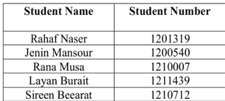

# **1.5. rule for each member:**

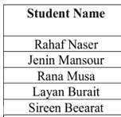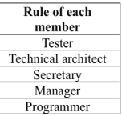

# **1.6.  Project management strategy.**

The team meets twice a week for status updates, problem-solving, and planning. Decisions are made collaboratively, with the project manager having the final say if needed. Following a waterfall software process model, the team uses sprint planning, daily stand-ups, and retrospectives to ensure flexibility and continuous improvement.

# **1.7. Project manager report: a project manager must write, maximum, one page stating:**

1. Leyan Buirat (1211439) - Manager: I’m played a crucial role in coordinating the team, ensuring that deadlines were met, and facilitating communication between team members and the instructor. I were responsible for overseeing the overall progress of the project and ensuring that all tasks were aligned with the project goals. also contributed to the design and implementation of the "Display Discounts and Sales Items" feature, ensuring that it met the user requirements.

2. Rana Musa (1210007) - Secretary: Rana was responsible for documenting meetings, tracking progress, and ensuring that all team members were on the same page. She also led the development of the "Feedback and Recommendation System," which allowed users to provide feedback on purchased items. Rana's organizational skills were instrumental in keeping the project on track.

3. Sireen Bearat (1210712) - Programmer: Sireen was responsible for implementing the "Payment by Credit Card" feature, ensuring that it was secure and met all system requirements. She also contributed to the design goals and reviewed the overall architecture of the system. Sireen's coding skills were essential in bringing the project to life.

4. Jenin Mansour (1200540) - Technical Architect: Jenin was responsible for the technical design and architecture of the system. She led the development of the "Add to Cart" feature, ensuring that it was user-friendly and met all system requirements. Jenin also contributed to the creation of class diagrams and sequence diagrams, which were critical for the system's design.

5. Rahaf Naser (1201319) - Tester: Rahaf was responsible for testing the system to ensure that it met all functional and non-functional requirements. She led the development of the "Sign-Up" feature and ensured that it was secure and user-friendly. Rahaf also contributed to the effort/time estimation and reviewed various diagrams to ensure accuracy.

**Barriers or Challenges Faced in Managing the Project:**

Managing the project presented several challenges, including ensuring effective communication among team members, particularly while working remotely, which was addressed through regular meetings and status updates. Technical difficulties, such as software compatibility issues and integration challenges, occasionally slowed progress, requiring collaborative troubleshooting to stay on track. Balancing the project with other academic responsibilities was another hurdle, necessitating efficient time management and task prioritization to meet deadlines. Additionally, occasional requirement changes based on instructor feedback demanded flexibility and quick adaptation from the team to ensure the project remained aligned with expectations.

**Evaluation of the Project's Success:**

The project was a success due to strong team collaboration, with each member contributing their skills and expertise, enabling us to overcome challenges and deliver a high-quality product. The final system met all specified user and system requirements, with features implemented as planned and thoroughly tested for functionality and security. The project provided valuable hands-on learning experiences in software engineering, from requirement elicitation to system design and implementation. Positive feedback from the instructor highlighted the project's strengths and offered constructive suggestions, reinforcing our belief in its success. Overall, I am proud of the team's accomplishments, as we delivered a well-designed, functional online jewelry shop that met user needs while enhancing our technical skills, teamwork, and ability to manage complex tasks effectively.

The creative leaders of the website design were Layan Buirat and Rana Musa, who collaborated to create an engaging and visually appealing online jewelry shop. Their efforts resulted in a user-friendly and aesthetically pleasing website that reflects the elegance and luxury of the jewelry being offered. The website, hosted at (https://layanbuirat.github.io/JewelleryShop/), features a welcoming message: Welcome to our online Jewelry Shop.

This creative direction, led by Layan and Rana, successfully captures the essence of the brand and provides an inviting experience for users. Their work demonstrates a strong understanding of design principles and user experience, contributing significantly to the overall success of the project.

Project Manager: Leyan Buirat

Date: January 2025

# **1.8. Group members report: in one paragraph, each group member must write**

**Jenin Mansour :** This project, in my opinion, was a valuable learning opportunity that enabled me to actively engage in teamwork. Working closely with team members, I was able to help with many parts of the project and get valuable experience in listening to constructive feedback and suggestions to make our work better. Since we got along well as a team and everyone performed their jobs well, I consider the project a success. As for my contribution in the project, I was the **technical architect** and I led the user and system requirements for the shopping cart in Phase 2. I also led the "Add to Cart" scenario, including the use case description, the activity diagram, and the reviewed of effort/time calculation in Phase 3. Furthermore, I contributed to the discussion of actor analysis, reviewed the use case diagram, led the design of the activity diagram. In Phase 3, I led the system analysis class diagram, the detailed class model, and the "Add to Cart" sequence analysis. As for Phase 4, I lead the design of deployment diagram, the discussion of the Design Goals , and reviewed the component and architecture diagrams.

**Rahaf Naser:** In my opinion, this project was a enjoyable experience that allowed me to actively participate in collaborative work. Working closely with team members. I extend my sincere gratitude to Dr. Adel for making the course enjoyable despite the challenging circumstances. His guidance played a pivotal role in our learning journey, and I am thankful for the support that enhanced our overall experience. I was the tester in the project.My tasks are: Lead in user requirements task, Lead system requirements for sign up to jewelry online shop and system requirements for search methodology, write a scenario for my use case which was Sign-Up to Jewelry Online Shop, Lead time/cost estimate calculation, Discuss ACTORS analysis and their description, Discuss USE-CASE diagram, Write description for my use case which was signed up to jewelry online shop, Review in the activity diagram, make an activity diagram for my use case which was Sign-Up to Jewelry Online Shop, Discuss class diagram, make sequence diagram for my use case which was signed up to jewelry online shop, Discuss the goals of design, lead component diagram and architecture diagram. Review the deployment diagram., Communicate with the doctor and upload projects.

**Sireen Bearat :**

This project has been a truly rewarding experience, providing me with the opportunity to engage in collaborative teamwork. Through close collaboration with my teammates, I was able to contribute meaningfully to different areas of the project. I would like to express my heartfelt gratitude to Dr. Adel for making the course both engaging and insightful, even in the face of challenging circumstances. His invaluable guidance greatly contributed to our learning journey, and I deeply appreciate the support that enriched our overall experience.

**My tasks**:

* Write SCENARIO for my use case which was Ordering by Credit Card .
* Detailed Use-Case Specification for ordering by Credit card.
* Activity Modelling for ordering by Credit card .
* System requirement Credit card
* SEQUENCE Diagram for ordering by Credit card.
* Reviewing in user requirement and lead in Effort/Time estimation calculation
* Reviewing in ACTORS analysis , USE-CASE diagram and lead in ACTIVITY diagram , disussion in class diagrams, lead in Description of Design Goals , discussion in Component Diagram, reviewing in Overall architecture diagram and Deployment diagram

**Rana Musa 1210007**

From my point of view, our project was successful because we worked well together as a team and communicated effectively. We faced some challenges, but by sharing our ideas and helping each other, we were able to overcome them and create a good final product. Our teacher's feedback was very positive, pointing out the strong parts of our project and giving us suggestions for improvement. This encouragement, along with our hard work, makes me feel confident that we introduced a final product that is well-designed online jewelry shop. I really enjoyed working on this project, and as the secretary, I was responsible for keeping track of our meetings and making sure everyone’s ideas were heard. This role helped me develop my organizational skills while contributing to our team's success. I discussed user and system requirements, and I led the user and system requirements for the Feedback and recommendation system in Phase 2, discussed effort and time estimation, led use case diagram, reviewed activity diagram, reviewed Description of Design Goals, and discussion of the component diagram , architecture diagrams and deployment diagram, also led my own scenario “user gives feedback” , including the use case description, reviewed the activity diagram, discussion of the system analysis class diagram, the detailed class model, and I led the user and system requirements for the Feedback and recommendation system in Phase 2, also I led the final presentation of the project and also contributed in the website demo [https://layanbuirat.github.io/JewelleryShop/].

**Leyan Buirat (1211439) - Manager:**

As the project manager, I was responsible for coordinating the team, ensuring deadlines were met, and facilitating communication between team members and the instructor. I also contributed to the design and implementation of the "Display Discounts and Sales Items" feature, ensuring it met user requirements. Additionally, I led the final presentation of the project, showcasing our work and highlighting the key features and achievements of the online jewelry shop. My role involved overseeing the overall progress, ensuring alignment with project goals, and presenting our efforts effectively to stakeholders.

In this project, In this project, I played a key role in several critical tasks. I led the ACTORS analysis and their description (2.5), I also participated in the Effort/Time estimation calculation (2.4), where I contributed to discussions alongside Rana. For the USE-CASE diagram (2.6), I was involved in discussions . In the class diagrams (3.1), I reviewed the work . Additionally, I contributed to the Description of Design Goals (4.1), reviewing the work. For the Component Diagram (4.2), I reviewed the work this final phase 4 all group draw all diagrams together. Finally, I was actively involved in the Overall architecture diagram (4.3), participating in discussion Overall architecture diagram. My contributions ensured the project's technical and design aspects were well-coordinated and aligned with the team's goals.

As one of the creative leaders of the website design, I collaborated to create an engaging and visually appealing online jewelry shop. Our efforts resulted in a user-friendly and aesthetically pleasing website that reflects the elegance and luxury of the jewelry being offered. The website, hosted at [https://layanbuirat.github.io/JewelleryShop/], showcases our dedication to delivering a high-quality product that meets user needs and expectations.

**Chapter 2: Requirement Elicitation, Analysis and Modelling**

**2.1.     Requirement statement/Business description.**

# **2.2. USER and SYSTEM requirements.**

# **USER REQUIREMENTS:**

(Lead: Rahaf, Reviewing: Jenin & Sireen, qDiscussion: Layan & Rana).

**UR1.0:** The users shall be able to sign up to a jewelry online shop.

**UR3.0:** The system shall feature a search methodology, enabling users to search for types of jewelry, including rings, necklaces, and bracelets, earrings.

**UR4.0:** The system shall provide a shopping cart for users to add items for purchase.

**UR5.0:** The online jewelry shop shall support a range of secure payment options, including credit cards and online gateways.

**UR6.0:** The system shall provide an efficient delivery management feature to guarantee the reliable delivery of items to the users.

**UR7.0:** The system shall provide the jewelry shop information, to enable users to communicate with the jewelry shop.

**UR8.0:** The user shall be able to evaluate items and give feedback about the items, such quality of jewelry.

**UR9.0:** The system shall provide personalized recommendations based on user preferences and browsing history.

**UR10.0:** The system shall provide a feature to display discounts and sales items for the users.

# **SYSTEM REQUIREMENTS**

**UR1.0: The users shall be able to sign up and generate a personal account that includes**

**their personal information. (By: Rahaf)**

SR1.1: The system shall allow users to create a personal account by entering their full name,

email address, phone number (optional), and a password.

SR1.2: The system shall enable the user to specify a password that is at least 8 characters long

and contains at least one uppercase letter and one number.

SR1.3: The system shall enable users to sign up via social media to simplify the registration process.

SR1.4: The system shall send an email verification link to new users to confirm their email

address before activating the account.

SR1.5: The system shall display error messages if required fields are missing or do not meet

specified validation criteria, providing guidance for users to correct their inputs.

**UR3.0: The system shall feature a search methodology, enabling users to search for types of**

**jewelry, including rings, necklaces, and bracelets, earrings. (By: Rahaf)**

SR.3.1: The system shall display a search bar on the menu feature, allowing users to search for

specific types of jewelry (rings, necklaces, bracelets, earrings).

SR3.2: The system shall allow users to search by item id, description of the item and the types of

jewelry.

SR3.3: The system shall display search results in a list view, showing the item image, price, item

id, item description and ratings.

SR3.4: The system shall recommend alternative or related items if the search results do not

match the user’s query exactly.

**UR4.0:The system shall provide a shopping cart for users to add items for purchase.**

**(By: Jenin)**

SR4.1: The users shall be able to add items to their shopping cart.

SR4.2: The system shall display items in a vertical layout with each item’s image, item id, price, rating, quantity.

SR4.3: The shopping cart shall allow the modification of item quantities.

SR4.4: The shopping cart shall display the total sum of the items in the cart.

SR4.5: The total sum of the items in the cart shall remain visible even when the user scrolls down.

SR4.6: The system shall allow users to initiate the purchase process directly from the shopping cart for the items added to it.

**UR5.0: The online jewelry shop shall support a range of secure payment options, including**

**credit cards and online gateways. (By: sireen)**

SR5.1: The system shall support multiple payment methods, including credit/debit cards, bank

transfers, PayPal, Apple Pay, Google Pay, to offer flexibility for users.

SR5.2: The system shall display a payment confirmation page after successful transactions,

showing order details and payment status, with options for printing or saving.

SR5.3: The system shall offer an option for users to securely save payment details for future use ,

to protect stored information.

SR5.4: In case of payment failure, the system shall provide clear error messages and suggest

alternative payment methods to assist users in completing their purchase.

**UR6.0: The system shall provide an efficient delivery management feature to guarantee**

**reliable delivery of items to the users. (By: sireen)**

SR6.1: The system shall store user delivery details, including full name, phone number, email,

precise delivery address.

SR6.2: The system shall display error messages if required fields are missing, providing

guidance for users to correct their inputs.

SR6.3: The system shall send real-time order status updates via email/SMS, such as Order

Confirmed, and Delivered.

SR6.4: The system should integrate with mapping services to calculate optimal delivery routes

and provide estimated delivery times based on factors like traffic and location.

SR6.5: The system shall maintain a database of delivery personnel details, including names,

contact information, vehicle details, and current availability status.

SR6.6: The system shall allow users to rate and provide feedback on the delivery experience for

each order.

SR6.7: After selecting an item and payment method, the user shall receive a confirmation

message with details about delivery time, delivery method, and the final price.

**UR7.0: The system shall provide the jewelry shop information, to enable users to**

**communicate with the jewelry shop. (By: Layan)**

SR7.1: The system shall display the jewelry shop’s contact details including the phone number,

email, and physical address in a dedicated "Contact Us" section on the system.

SR7.2: The system shall ensure that contact details are easy to find through clickable icon and

should be accessible from the menu feature.

SR7.3: The system shall allow users to send inquiries via a contact form that includes fields for

name, email, subject, and message, and an automated confirmation email should be sent after

submission.

SR7.4: The system shall integrate live chat functionality to provide real-time communication

with user support during business hours.

SR7.5: The system shall display social media links (Facebook, Instagram, Twitter) for easy user

access to the jewelry shop’s profiles and updates.

**UR8.0: The user shall be able to evaluate and give feedback about the items, such quality of**

**jewelry. (By: Rana)**

SR8.1: The system shall allow users to leave comments on items only if they have previously

purchased them.

UR8.2: The system shall allow users to provide ratings for item from 1-to-5-star rating scale only

if they have previously purchased them.

SR8.3: The system shall allow users to report inappropriate or irrelevant comments, which will

be flagged for moderator review. A “Report” button shall be displayed alongside each comment,

enabling users to flag content as inappropriate or irrelevant. Reported comments shall be

automatically routed to a moderation queue, where moderators can review and take appropriate

action (e.g., delete, approve).

SR8.4: The system shall calculate and display an average rating of each item based on all user

reviews. Ratings shall update in real-time as new reviews are submitted.

SR8.5: The system shall send a reminder notification to users after a purchase, encouraging them

to leave a rating and comment on the item. An automated reminder message shall be sent to users

via email or push notification within a set period (e.g., 7 days) after purchase. The reminder shall

include a direct link to the item’s review section to simplify the review process. The system

should send only one reminder per purchase to avoid annoying users.

SR8.6: The system shall reward users with a $5 discount if their feedback gets 50 likes, with a

visible "like" counter for each comment.

**UR9.0: The system shall provide personalized recommendations based on user preferences**

**and browsing history. (By: Rana)**

SR9.1: The system shall track and securely store user interactions, including viewed items,

search queries, and cart additions, to build a profile of user preferences.

SR9.2: The system shall analyze stored data to determine user preferences based on key

attributes such as jewelry type, metal, gemstone, and style, updating these preferences as users

interact with the platform.

SR9.3: The system shall use a recommendation algorithm to generate item suggestions that align

with recent browsing history, prioritizing items similar to those previously viewed or purchased.

SR9.4: The system shall display updated recommendations on the user’s homepage and item

pages, adjusting these suggestions based on the user’s latest activity to maintain relevance.

SR9.5: The system should display personalized recommendations within 2 seconds of the user’s

interaction with the system (e.g., item view) to ensure a seamless user experience.

**UR10.0: The system shall provide a feature to display discounts and sales items for the**

**users. (By: Layan)**

SR10.1: The system shall display a dedicated “ Sales” section that provides information on

available promotions, sales events, and any ongoing offers.

SR10.2: The system shall include a detailed explanation of sales policies, including return and

refund policies, and shipping information, in an easily accessible format in the item description.

SR10.3: The system shall send an automatic notification (email or app notification) to users

about upcoming sales events or special offers based on their preferences or past purchase

behavior.

SR10.4: The system shall ensure that discounted items are clearly marked with the discount

percentage or price reduction on the item details.

SR10.5: The system shall allow users to check the current sale price of the item before and after

adding it to the shopping cart to clearly inform users of the savings.

SR10.6: The system shall allow the administrators to add, remove, or modify the discount on the

items.

# **2.3. SCENARIOs:**

# **(Jenin Mansour 1200540)**

**Scenario Analysis for Adding Items to the Shopping Cart for purchase.**

**Initial Assumption:**

The customer is logged into his account on the online jewelry shop's website. The customer browses the shop and select specific item he intends to purchase.

**Normal:**

**1.Adding an Item to the Cart**

1.1 The customer login to his account

1.2 The customer select specific item to buy .

1.3 The customer clicks on the "Add to Cart" button for the selected item.

1.4 The system confirms the product availability and updates the shopping cart with:

-Product details (image, ID, price, rating, and quantity).

-The total cost of all items in the cart.

1.5 The customer navigates to the shopping cart section using shopping cart “icon”and reviews the item displayed in the cart.

1.6 The item details, including the image, ID, price, rating, and quantity, are clearly displayed.

1.7 The total price of all items in the cart is shown at the bottom of the screen, and the total cost remains visible even when scroll down the page.

1.9 The customer confirms the item quantity and price.

1.8 The customer decides to purchase the item.

**What Can Go Wrong?**

**Alternatives** (Successful outcome)

**1. Adding the Same Item Twice**

The customer browsed the shopping cart and decided to add the same product again. The customer **clicks on the “+” button** appearing next to the item to increase the quantity of the item, instead of browsing for the product again and adding it. The system then successfully updates the quantity and recalculates the total price accordingly.

**Errors** (Unsuccessful outcome)

**1. System Fails to Update Cart**

The customer clicks on the "Add to Cart" button for a specific item. The customer navigates to the cart but does not find the item displayed. The system fails to retrieval the item from the database and add it to the cart. The customer cannot proceed with the purchase.The system should notify the customer about the error and offer options to retry the action.The system logs the issue for technical support to resolve, and the customer can contact customer support via life chat to solve the issue.

**2.Item Out of Stock**

The customer clicks on the **"Add to Cart"** button for an item. The system detects that the item is out of stock. The system notifies the user that the item is unavailable, and suggests similar items for the customer. The customer can either choose a recommended item or continue browsing.

**3.Incorrect Price Displayed**

The customer clicks on the "**Add to Cart**" button for a specific item. The customer finds the item in the cart but notices that the displayed price is incorrect. The system shows an incorrect price Due to a system failure in updating product prices and calculating discounts, potentially confusing the customer and preventing them from making the purchase. The system should notify technical support for resolution, and the customer can contact customer support via life chat to solve the issue.

**4. Payment Gateway Failure**

The customer clicks **"Proceed to Payment"**, but the payment fails due to a server crash. The system notifies the customer of the failure and prompts them to try again. The system logs the issue for technical support to solve.

**Other Activities:**

**Abandoned Cart Reminders**

* If customers leave items in their cart without completing a purchase, the system sends an email reminder encouraging them to return.

**View Item Details**

* The customer can view detailed information about each item in the cart, including images, descriptions, and ratings.

**Sale Prices**

* The system displays both the original price and the sale price so that customers can see how much they are saving.

**Life chat with Customer support team.**

* Customers can contact “customer support” via life chat to solve any issue .

**System State on Completion:**

The items are successfully added to the cart, and the customer proceeds to the payment process, And if the customer abandons the cart, the system sends an email reminder to encourage them to complete the purchase.

# **(Rahaf Naser 1201319)**

**Scenario : Sign-Up to Jewelry Online Shop**

**Initial Assumption:** The customer has connected to the internet, visited the jewelry online shop, and

decided to create an account to access personalized features such as wish lists, exclusive discounts, and

order tracking.

**Normal:**

The customer visits the system and clicks on the "Sign Up" button. The system displays a secure

registration form requiring the customer's full name, valid email address, password, valid phone number,

and jewelry preferences. The password field includes security guidelines, it requires at least 8 characters,

one uppercase letter, one lowercase letter, and one number. The customer completes the form and submits

it, after which the system validates the inputs to ensure the email address is in a valid format and not

already registered, the password meets the security requirements, and all required fields are completed

correctly. If all inputs are valid, the system displays a confirmation message stating that a verification

email has been sent to the customer's provided email address, encrypts and securely stores the password

using hashing algorithms, and flags the account as "inactive" until email verification is completed. The

system sends a verification email containing a unique, time-limited verification link (valid for 24 hours)

to ensure security. If the link expires, the customer is prompted to request a new verification email. The

customer clicks the verification link in the email, and the system validates the link to ensure it is not

expired or tampered with. Once validated, the system activates the account, and redirects the customer to

a "Welcome" page confirming that their account has been successfully activated and is ready for use.

Then the customer can access the personal account and take advantage of the various services offered.

**What can go wrong?**

**Alternative:** The customer enters an invalid password that does not meet the security requirements (at

least 8 characters, one uppercase letter, one lowercase letter, and one number). The system should notify

the customer that their password does not meet the security criteria and provide guidelines for creating a

stronger password.

**Alternative:** The customer does not receive the verification email due to spam filtering, or server issues.

The system should provide an option to resend the verification email, allowing the customer to request it

again.

**Error:** The customer will not provide his email when prompted. The system should print the standard

exclusion form stating that the lack of important registration requirement leads to inability to create the

desired account.

**Other activities:**

1. After signing up, the system prompts the customer to set preferences for jewelry type, price range, and

materials.

2. The customer can take a guided tour of system features like creating wish lists, applying discounts, and

tracking orders.

**System state on completion:**

Upon the successful completion of the sign-up process and email verification, the system created a new

user record in the database. The user’s information (username, email, password, phone number, jewelry

preferences) was securely stored in the database. The system automatically sent a "Welcome" email to

the customer’s provided email address, confirming that the account had been successfully activated. The

account was marked as "active," allowing the customer to access all features of the jewelry shop.

# **(Rana Musa)**

**Feedback**

**Initial Assumption:**

The feedback and rating service will be accessible only after the user has completed the purchase of a jewelry item, and the purchase has been confirmed as complete in the system.

**Normal:**

After Yazeed receives his newly purchased ring from the online jewelry shop, he is promptly presented with a feedback notification on his device. He has three options: provide feedback now, set a reminder for later, or exit the prompt. Choosing to give feedback, Yazeed rates the quality of the ring, and rate it 3 stars.

His feedback is quickly submitted and becomes visible to other customers, offering them genuine insights about their shopping experience. Inspired by Yazeed’s positive review, the jewelry shop team is now considering implementing similar efficient delivery practices and enhancing their customer service even further.

**Alternative:**

After receiving the necklace she ordered from the website, Hala was preoccupied and didn’t have the chance to evaluate the product right away. she selected the “Remind me later” option. Later on, when she opened the app again, a friendly reminder prompted her to submit her feedback. she then provided a review detailing her thoughts on the quality of the necklace.

**Error:**

Mia received her new bracelet from the jewelry shop and wanted to provide feedback on the product. However, when she attempted to leave her feedback, she couldn't find the feedback option because her order had not yet been confirmed as completed. She had to wait until the shop confirmed the delivery before she was able to submit her feedback.

# (Leyan Buirat)

**Display Discounts and Sales Items**

**Initial Assumption:**

The customer is logged into their account on the online jewelry shop's website. The customer navigates to the "Sales" or "Discounts" section to browse discounted items and promotions.

**Normal Flow: Displaying Discounts and Sales Items**

1. **Customer Navigates to the Sales Section:**
   * The customer logs into their account and clicks on the "Sales" or "Discounts" section from the main menu.
2. **System Displays Discounted Items:**
   * The system retrieves and displays all items currently on sale, including:
     + Product details (image, ID, original price, discounted price, rating, and availability).
     + Clear labels indicating the discount percentage or amount (e.g., "50% off" or "$20 off").
     + A countdown timer for time-limited offers (if applicable).
3. **Customer Views Discount Details:**
   * The customer clicks on a discounted item to view more details, including:
     + A clear comparison of the original price and the discounted price.
     + Any terms and conditions associated with the discount (e.g., "Valid until 2/31/2025" or "Minimum purchase of $50 required").
     + Availability (e.g., "Only 3 left in stock").
4. **Customer Adds Discounted Item to Cart:**
   * The customer clicks the "Add to Cart" button for a discounted item.
   * The system confirms the item is in stock and updates the cart with:
     + The discounted price.
     + The total cost of all items in the cart.
5. **Customer Proceeds to Checkout:**
   * The customer reviews the cart, confirms the discounted price, and proceeds to checkout.
   * The system applies the discount correctly and displays the final total.

**What Can Go Wrong?**

**Alternatives (Successful Outcomes)**

**1.Customer Adds the Same Item Twice:**

The customer clicks the "+" button next to an item in the cart to increase the quantity.

The system updates the quantity and recalculates the total price.

**2.Customer Adds Multiple Discounted Items:**

The customer adds several discounted items to the cart. The system successfully updates the cart with the correct prices and recalculates the total cost.

**3.Customer Uses a Coupon Code:**

The customer applies a valid coupon code to a discounted item. The system applies both the discount and the coupon correctly, displaying the final price.

**4. Customer Views Similar Discounted Items:**

The customer clicks on a "View Similar Items" button for a discounted product. The system displays a list of similar items that are also on sale, helping the customer find alternatives.

**5.Customer Receives a Discount Notification:**

The customer receives a notification (e.g., email or push notification) about a new discount or sale. They click the link and are directed to the discounted item, which they successfully add to their cart.

**Errors (Unsuccessful Outcomes)**

1. **Incorrect Discount Displayed:**
   * The system displays an incorrect discount percentage or amount. For example, a product is labeled as "50% off," but the discount is not applied at checkout.
   * **Resolution:** The system should notify the customer of the error and offer to honor the displayed discount. The issue is logged for technical support to resolve.
2. **Expired Discounts Shown:**
   * The system displays discounts that have already expired. Customers try to add the item to their cart, but the discount is not applied.
   * **Resolution:** The system should automatically remove expired discounts and notify the customer that the promotion has ended. It can suggest similar active discounts.
3. **Out-of-Stock Discounted Items Displayed:**
   * The system displays discounted items that are out of stock. Customers try to add the item to their cart but receive an "Out of Stock" message.
   * **Resolution:** The system should automatically remove out-of-stock items from the sales section or clearly mark them as "Sold Out." It can suggest similar available items.
4. **Discounts Not Applied at Checkout:**
   * The customer adds a discounted item to the cart, but the discount is not applied during checkout.
   * **Resolution:** The system should notify the customer of the error and offer to retry the action. The issue is logged for technical support to resolve.
5. **Misleading Discount Labels:**
   * The system displays misleading labels such as "Up to 70% off," but only a few items are discounted at the maximum rate.
   * **Resolution:** The system should clearly indicate which items are discounted at the maximum rate and which are not. It can also provide filters to sort items by discount percentage.
6. **Poor Mobile Display of Discounts:**
   * Discount banners or labels are not properly displayed on mobile devices, making it difficult for customers to view discounted items.
   * **Resolution:** The system should ensure that discounts are clearly visible and properly formatted on all devices, including mobile.

**Other Activities**

1. **Abandoned Cart Reminders for Discounted Items:**
   * If a customer adds a discounted item to their cart but does not complete the purchase, the system sends an email reminder with the discounted price to encourage them to return.
2. **View Discounted Item Details:**
   * Customers can view detailed information about discounted items, including images, descriptions, ratings, and availability.
3. **Display Original and Discounted Prices:**
   * The system clearly displays both the original price and the discounted price so customers can see how much they are saving.
4. **Live Chat with Customer Support:**
   * Customers can contact customer support via live chat to resolve any issues related to discounts or sales items.

**System State on Completion**

* Discounted items are successfully displayed, and customers can easily browse and add them to their cart.
* Discounts are correctly applied at checkout, and customers can proceed with their purchase.
* If customers abandon their cart, the system sends a reminder email with the discounted price to encourage them to complete the purchase.
* Any errors or issues are logged for technical support, and customers are provided with clear notifications and options to resolve problems (e.g., retry, contact support).

# **(Sireen Bearat 1210712)**

### Scenario: **Pay for Order by Credit Card in Jewelry Online Shop**

#### **Initial State**

* The user logs into the online jewelry shop.
* The user selects jewelry items, adds them to the shopping cart, and reviews the cart before proceeding to checkout.

#### **Normal Flow**

1. **Checkout Process Initiation**: The system guides the user to the payment page after confirming the items in the cart.
2. **Payment Method Selection**: The system displays available payment methods, and the user selects "Credit Card."
3. **Data Entry**: The user securely enters credit card details (e.g, card number, expiration date)
4. **Data Validation**: The system validates the entered details, checking for formatting errors and card validity.
5. **Authorization Request**: The system contacts the payment gateway or bank for payment authorization.
6. **Successful Authorization**: If authorization is successful, the payment amount is deducted from the user’s account.
7. **Payment Confirmation Page**: The system displays a confirmation page with order details and payment status.
8. **Email Confirmation**: The user receives an email with the order summary, payment confirmation, and shipping details.

#### **Alternative Flow 1: Payment Failure**

1. **Authorization Failure**: If the payment authorization fails (e.g., insufficient funds, invalid card, or network issue), the system displays an error message specifying the issue.
2. **Alternative Payment Options**: The system presents alternative payment methods (e.g., PayPal, Google Pay, or bank transfer).
3. **Retry Payment**: The user selects one of the alternative methods and enters the required details.
4. **Completion**: If the alternative method is successful, the system proceeds to the payment confirmation step.

#### **Alternative Flow 2: Save Payment Information**

1. **Save Option Prompt**: After completing the payment, the system prompts the user to save their credit card details for future transactions.
2. **Consent Request**: The user gives explicit consent to store the card details.
3. **Secure Storage**: The system encrypts and securely stores the credit card information according to PCI-DSS standards.
4. **Acknowledgment**: The system displays a confirmation message indicating that the card details have been saved successfully.

#### **Error Flow: Invalid Credit Card Details**

1. **Data Entry Error**: If the user enters invalid credit card details (e.g., expired card, incorrect number), the system displays an error message indicating the issue.
2. **Retry Data Entry**: The system prompts the user to correct the details or choose another payment method.
3. **Alternative Selection**: If the user fails to enter valid details after multiple attempts, they can select an alternative payment method to complete the transaction.

# **2.4.Effort/Time estimation calculation.**

**(Lead: Rahaf, Sireen, reviewing: Jenin , discussion: Layan & Rana).**

pw= person week; pm= person month; w= week; m= month

effort= the effort required for a person employed all month/week long

Schedule time = time needed to complete including based on working days only (including holidays etc.)

|  |  |  |  |
| --- | --- | --- | --- |
| **UR** | **Estimated No of Developers (can work concurrently on UR)** | **Estimated Effort (average/developers)** | **Total Effort (for One Developer)** |
| **UR1** | 2Dev | 2pw | =2*2=4pw |
| **UR2** | 3Dev | 2pw | =3*2=6pw |
| **UR3** | 3Dev | 3pw | =3*3=9pw |
| **UR4** | 2Dev | 3pw | =2*3=6pw |
| **UR5** | 2Dev | 2pw | =2*2=4pw |
| **UR6** | 2Dev | 2pw | =2*2=4pw |
| **UR7** | 2Dev | 1pw | =2*1=2pw |
| **UR8** | 2Dev | 2pw | =2*2=4pw |
| **UR9** | 3Dev | 2pw | =3*2=6pw |
| **UR10** | 2Dev | 3pw | =2*3=6pw |
| **Total effort/avg** | (2+3+3+2+2+2+2+2+3+2)/10=2.3 dev on avg needed | 22pw | 51 pw |
| **Schedule time 30%** |  | 22*1.30=29 w (min time to complete) | 51*1.30= 66(max time to complete) |
| **Cost** |  | Avg salary /w = $250 | 250 * 66w=$16500 |
| **Profit margin**  **(min=10%; max=30%)** |  | Min cost->  Max cost-> | 16500*1.10=18150  16500*1.30=21450 |

**The agreed-upon price for this project is $20,000.**

# **2.5.****ACTORS analysis and their description.**

**(Lead: Layan , Discussion: Jenin, Rahaf, Reviewing: Rana, Sireen)**

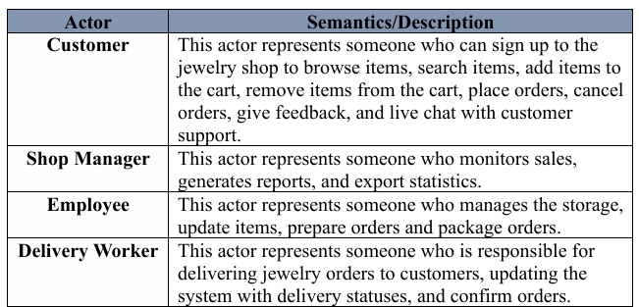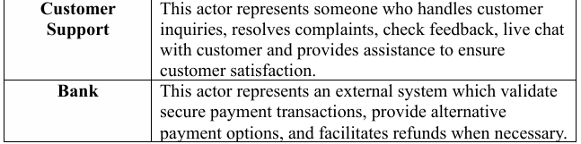

# **2.6. USE-CASE diagram**

**(Lead: Rana, Discussion: Rahaf, Layan, Reviewing: Seren, Jenin)**

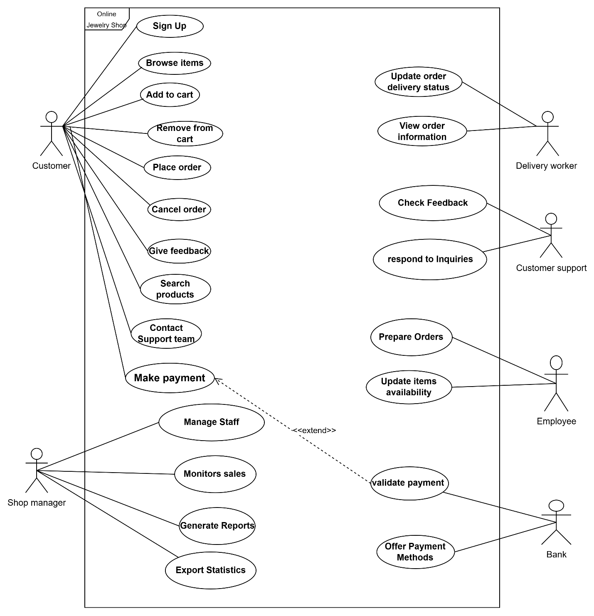

# **2.7. Description of key USE-CASES**

# **( Jenin Mansour 1200540)**

Use-Case Specification (**Adding an Items to the Shopping Cart for Purchase**):

|  |  |
| --- | --- |
| **System Name** | online jewelry shop system |
| **Use case title** | Add to cart (Add item to the shopping cart for purchase) |
| **Description** | The customer browse the online shop, and select item to add to the cart, the customer reviews the cart to confirm or modify item quantities and confirm total price, then decides whether to proceed with the purchase or continue browsing. |
| **Actors** | Customer , Customer support team |
| **Data** | Customer information.  Item information (ID, image, price, quantity, and rating).  Shopping cart status and summary (total cost, selected items). |
| **Pre-condition** | 1-The customer is successfully logged into the system.  2- The item exists in the online shop and available for purchase. |
| **Workflow/Sequence of Events** | 1. The customer logs into his account 2. The customer selects an item and clicks the “Add to Cart” button 3. The customer accesses the shopping cart by clicking the cart icon displayed on any page.   3.1-The system displays the item in the shopping cart with its details (image, ID, price, and quantity).   1. The customer reviews the cart to confirm or modify item quantities.   4.1- If the customer decide to add the same item  4.1.1- The customer clicks "+" to increase the item quantity.  4.1.2- if the process succeed the system updates the item quantity and total cost based on the new quantity.  4.1.3- If the process not succeed System informs customer to retrying. The system logs the issue for technical support to resolve,   1. The system displays the total cost at the bottom of the shopping cart. 2. The customer reviews the total price to confirm it.   6.1 If the price is not correct The system should notify the user about the error and offer options to retry the action.The system logs the issue for technical support to resolve, and the customer can contact customer support via life chat to solve the issue.  6.2 If the price is correct the customer decide whether to proceed with the purchase or continue browsing.  6.2.1 If the customer decide to proceed with purchase the system redirects the customer to the secure payment page.  6.2.2 If the customer decide to continue browing the system sends an email reminder encouraging them to return. |
| **Post- conditions/Response** | 1. The item added to the shopping cart 2. The system calculates and displays the total cost accurately. |
| **Comments** | The system must have permissions to send Email/Notification to the customer |

# **(Rahaf Naser 1201319)**

**Use-Case Specification (Sign-Up to Jewelry Online Shop):**

|  |  |
| --- | --- |
| **Use Case Title** | Sign-Up to Jewelry Online Shop |
| **Description** | A customer can create an account to access personalized features such as wish lists, exclusive discounts, and order tracking. The process involves filling out a registration form, submitting the details, verifying the provided email address, and activating the account. The system must ensure secure data handling and provide necessary feedback during the process. |
| **Actors** | Customer |
| **Data** | Full name, Email address, Password, Phone number,Jewelry preferences, Verification email. |
| **Stimulus/Trigger** | The customer initiates the process by clicking the "Sign Up" button on the Jewelry Online Shop system. |
| **Pre-conditions** | 1. The customer does not already have an existing account. 2. The system has sufficient database capacity to store new account information. 3. Password requirements are clearly outlined to the customer (at least 8 characters, one uppercase letter, one lowercase letter, and one number.). 4. The customer has a stable internet connection. |
| **Workflow OR Sequence/Flow of Events** | 1. The customer clicks the "Sign Up" button.  2. The system displays a registration form requiring details such as name, email, password, phone number, and jewelry preferences.  3. The customer fills in the required fields and submits the form.  4. The system validates the input to ensure all fields are completed and correctly formatted.  **- If the validation succeeds:** 4.1. The system checks if the password meets security requirements (at least 8 characters, one uppercase letter, one lowercase letter, one number).  **-If the password meets security requirements:** 4.2. The system stores the password securely and proceeds to the next step.  **-Else, if the password does not meet the security requirements:** 4.3. The system notifies the customer that their password does not meet the security criteria and provides guidelines for creating a stronger password. 4.4. The customer revises the password and resubmits the form.  5. If the form is valid and all fields are correct, the system sends a verification email to the customer.  **- If the customer does not receive the verification email (due to spam filtering or server issues):** 5.1. The system provides an option to resend the verification email. 5.2. The customer requests the email to be resent.  6. The customer opens the verification email and clicks the verification link.  **- If the customer does not provide an email address (an essential field):** 6.1. The system displays an error message stating that the email address is required for account creation. 6.2. The customer provides the missing email and resubmits the form.  7. The system validates the verification link to ensure it is not expired or tampered with.  **- If the verification link has expired:** 7.1. The system prompts the customer to request a new verification email. 7.2. The customer requests the new verification email and repeats the process.  8. Once the verification link is validated, the system activates the account and redirects the customer to a confirmation page.  9. The system marks the account as "active," and the customer can access all personalized features, such as wish lists, exclusive discounts, and order tracking. |
| **Post-conditions/Response** | 1. A new customer account is created, and the customer receives a "Welcome" email, If successful. 2. The customer can now access personalized features like wish lists and discounts, If successful. |
| **Comments** | 1. Verification links must expire within a specific time frame (24 hours) to ensure security. 2. Users should be allowed to resend the verification email if not received. 3. The password requirements must be clearly displayed to reduce user errors during registration. |

# **(Rana Musa)**

Customer gives Feedback.

|  |  |
| --- | --- |
| **Actors** | Customer, Customer Support, Employee |
| **Description** | Once customers purchase a jewelry item the feedback and rating service becomes accessible. Customers can rate the product and share their experience. Positive feedback is displayed publicly to motivate other buyers, while critical feedback triggers customer support actions to resolve issues and improve service. In cases of delay or delivery issues, compensation, such as discounts, may be offered to dissatisfied customers. |
| **Pre-condition** | 1. The customer is logged into their account.   1. The jewelry order has been delivered to the customer. |
| **Sequence/flow of event** | 1. The customer places an order for a jewelry item. 2. Once the order is confirmed as complete, the system sends a notification to the customer, inviting them to leave feedback. 3. If customers choose to provide feedback immediately, they write and submit it 4. If the customer chooses “Remind me later, " the system reminds them to provide feedback when they revisit the website. 5. The system will classify the feedback as positive/negative. 6. In case the feedback is critical or indicates issues, the support team contacts the customer, and the support team promptly investigates the raised issues and works towards resolving. 7. The support team may use positive feedback to highlight successful services and features. 8. The system will make positive feedback visible to other customers |
| **Data** | Customer account details, Jewelry purchase history, Feedback and ratings, System logs and support tickets |
| **Stimulus/Trigger** | Customer submission of feedback after an order is marked as completed. |
| **Post- condition/response** | Feedback is recorded, categorized, and displayed publicly for other customers. |
| **Comments** | 1. The system should have a user-friendly feedback interface that allows customers to easily rate and comment on jewelry items.  2. Automated reminders (via email or notifications) should encourage customers to leave feedback after delivery.  3. A clear process for handling flagged or critical feedback must be in place to ensure customer satisfaction. |

# (Leyan Buirat 1211439)

**Use case title: Display Discounts and Sales Items**

|  |  |
| --- | --- |
| **Use case title** | Display Discounts and Sales Items |
| **Actors** | 1. **Customer:** The user browsing the online jewelry shop and viewing discounted items. 2. **Customer Support:** Provides assistance if issues arise (e.g., respond to inquiries, incorrect discounts, out-of-stock items). |
| **Description** | This use case describes how the system displays discounts and sales items to customers, allowing them to browse, view details, and add discounted items to their cart. The system ensures that discounts are accurately displayed, applied, and updated in real-time. |
| **Pre-condition** | 1. The customer is logged into their account on the online jewelry shop's website. 2. The system has active discounts and sales items available. 3. The customer navigates to the "Sales" or "Discounts" section. |
| **Sequence/flow of event** | 1. **Customer Navigates to the Sales Section:**    * The customer clicks on the "Sales" or "Discounts" link from the main menu.    * The system retrieves and displays all active discounts and sales items. 2. **System Displays Discounted Items:**    * The system shows a list of discounted items, including:      + Product details (image, ID, original price, discounted price, rating, and availability).      + Clear labels indicating the discount percentage or amount (e.g., "50% off" or "$20 off").      + A countdown timer for time-limited offers (if applicable). 3. **Customer Views Discount Details:**    * The customer clicks on a discounted item to view more details.    * The system displays:      + A clear comparison of the original price and the discounted price.      + Any terms and conditions associated with the discount (e.g., "Valid until 12/31/2023").      + Availability (e.g., "Only 3 left in stock").   **4.Customer Adds Discounted Item to Cart:**  4.1The customer selects an item and clicks the “Add to Cart” button  4.2-The customer accesses the shopping cart by clicking the cart icon displayed on any page.  4.3-The system displays the item in the shopping cart with its details (image, ID, price, and quantity).  4.4-The customer reviews the cart to confirm or modify item quantities.  4.5- If the customer decide to add the same item  4.5.1- The customer clicks "+" to increase the item quantity.  4.5.2- if the process succeed the system updates the item quantity and total cost based on the new quantity.  4.5.3- If the process not succeed System informs customer to retrying. The system logs the issue for technical support to resolve,  **5.The system displays the total cost at the bottom of the shopping cart.**  **6.The customer reviews the total price to confirm it.**  6.1 If the price is not correct The system should notify the user about the error and offer options to retry the action. The system logs the issue for technical support to resolve, and the customer can contact customer support via life chat to solve the issue.  6.2 If the price is correct the customer decide whether to proceed with the purchase or continue browsing.  6.2.1 If the customer decide to proceed with purchase the system redirects the customer to the secure payment page.  6.2.2 If the customer decide to continue browing the system sends an email reminder encouraging them to return. |
| **Data** | * **item Data:** Includes product ID, name, image, original price, discounted price, rating, and availability. * **Discount Data:** Includes discount percentage/amount, terms and conditions, and expiration date. * **Cart Data:** Includes items added to the cart, their quantities, and the total cost. |
| **Stimulus/Trigger** | 1. The customer clicks on the "Sales" or "Discounts" section to view discounted items. 2. The customer clicks on a specific discounted item to view details. 3. The customer clicks the "Add to Cart" button for a discounted item. |
| **Post- condition/response** | 1. The item added to the shopping cart 2. The system calculates and displays the total cost accurately. |
| **Comments** | 1. The system should ensure that discounts are accurately displayed and applied in real-time to avoid customer frustration. 2. Clear communication of terms and conditions (e.g., expiration dates, minimum purchase requirements) is essential to build trust with customers. 3. Mobile optimization is critical, as many customers may browse and shop using mobile devices. 4. Regular audits should be conducted to ensure that discounts are up-to-date and that out-of-stock items are removed from the sales section. |

# **(Sireen Bearat 1210712)**

**Use Case : Pay for Order by Credit Card in Jewelry Online Shop**

|  |  |
| --- | --- |
| **Title** | Pay for Order by Credit Card |
| **Purpose** | Facilitate secure payment for jewelry orders using a credit card. |
| **Description** | |  | | --- | | the customer selects jewelry items and proceeds to pay using a credit card. This use case outlines the steps for completing a secure payment transaction. | |
| **Actors** | Customer, Bank |
| **Pre-conditions** | 1. The customer is logged into the online jewelry shop. 2. The customer has added items to the cart, reviewed them, and confirmed the selection for purchase. 3. The payment interface is operational and ready to process transactions. |
| **Sequence/Flow of Events** | **1. Customer Initiates Payment:** 1.1 The customer navigates to the checkout page after confirming the selected jewelry items. 1.2 The system displays available payment options. 1.3 The customer selects "Credit Card" as the payment method.  **2. Entering Credit Card Details:** 2.1 The system prompts the customer to enter credit card details securely (card number, expiration date, and CVV). 2.2 The customer enters the required information and submits the details.  **3. Validation and Authorization:** 3.1 The system validates the entered credit card details to ensure accuracy and compliance (e.g., format, expiration, and validity). 3.2 Upon successful validation, the system communicates with the bank/payment gateway to initiate authorization. 3.3 The payment gateway processes the transaction and returns the authorization status.  **4. Successful Payment Transaction:** 4.1 If the authorization is successful, the system deducts the specified amount from the customer’s account. 4.2 The order status is updated to "Paid." 4.3 The system displays a confirmation page summarizing the order details and payment status.  **5. Email Confirmation:** 5.1 The system automatically sends an email to the customer containing:   * Order summary * Payment receipt * Delivery details  1. **Logging Transaction Details:** 6.1 The system logs the transaction details (e.g., payment reference number, order ID) for future reference by the shop manager. 2. **Logging Transaction Details:** 6.1 The system logs the transaction details (e.g., payment reference number, order ID) for future reference by the shop manager.  **Alternative Flow 1: Payment Failure**  1. **Failed Authorization:** 1.1 If the payment fails (e.g., insufficient funds, expired card), the system displays an error message indicating the issue. 2. **Presenting Alternatives:** 2.1 The system displays alternative payment options (e.g., PayPal, bank transfer). 2.2 The customer selects one of the alternative options and proceeds with payment. 3. **Retry Payment:** 3.1 If the retry is successful, the system redirects to the payment confirmation flow.  **Alternative Flow 2: Invalid Credit Card Details**  1. **Data Validation Error:** 1.1 If invalid details are entered (e.g., incorrect number or expired card), the system displays a validation error. 2. **Retry or Alternative:** 2.1 The system allows the customer to re-enter valid details or select an alternative payment method.  **Alternative Flow 3: Save Payment Information**  1. **Prompt Save Option:** 1.1 After completing the payment, the system prompts the customer to save their card details for future transactions. 2. **Customer Consent:** 2.1 If the customer agrees, the system encrypts the data and stores it securely, ensuring compliance with PCI-DSS standards. 3. **Confirmation:** 3.1 The system displays a confirmation message indicating successful storage of the details. |
| **Data** | Customer login credentials,Selected jewelry items,Credit card details (number, expiration date, Payment reference ID. |
| **Stimulus/Trigger** | The customer interacts with the payment interface after reviewing the jewelry order |
| **Comments** | 1. The system ensures the security and confidentiality of credit card information using encryption.  2. Clear error messages are shown if the payment fails or the card details are incorrect. 3. Customers have the option to save their payment details securely for future purchases. |

# **2.8. ACTIVITY diagram**

**(Lead: Jenin, Sireen, Reviewing: Rahaf, Rana , Discussion: Layan)**

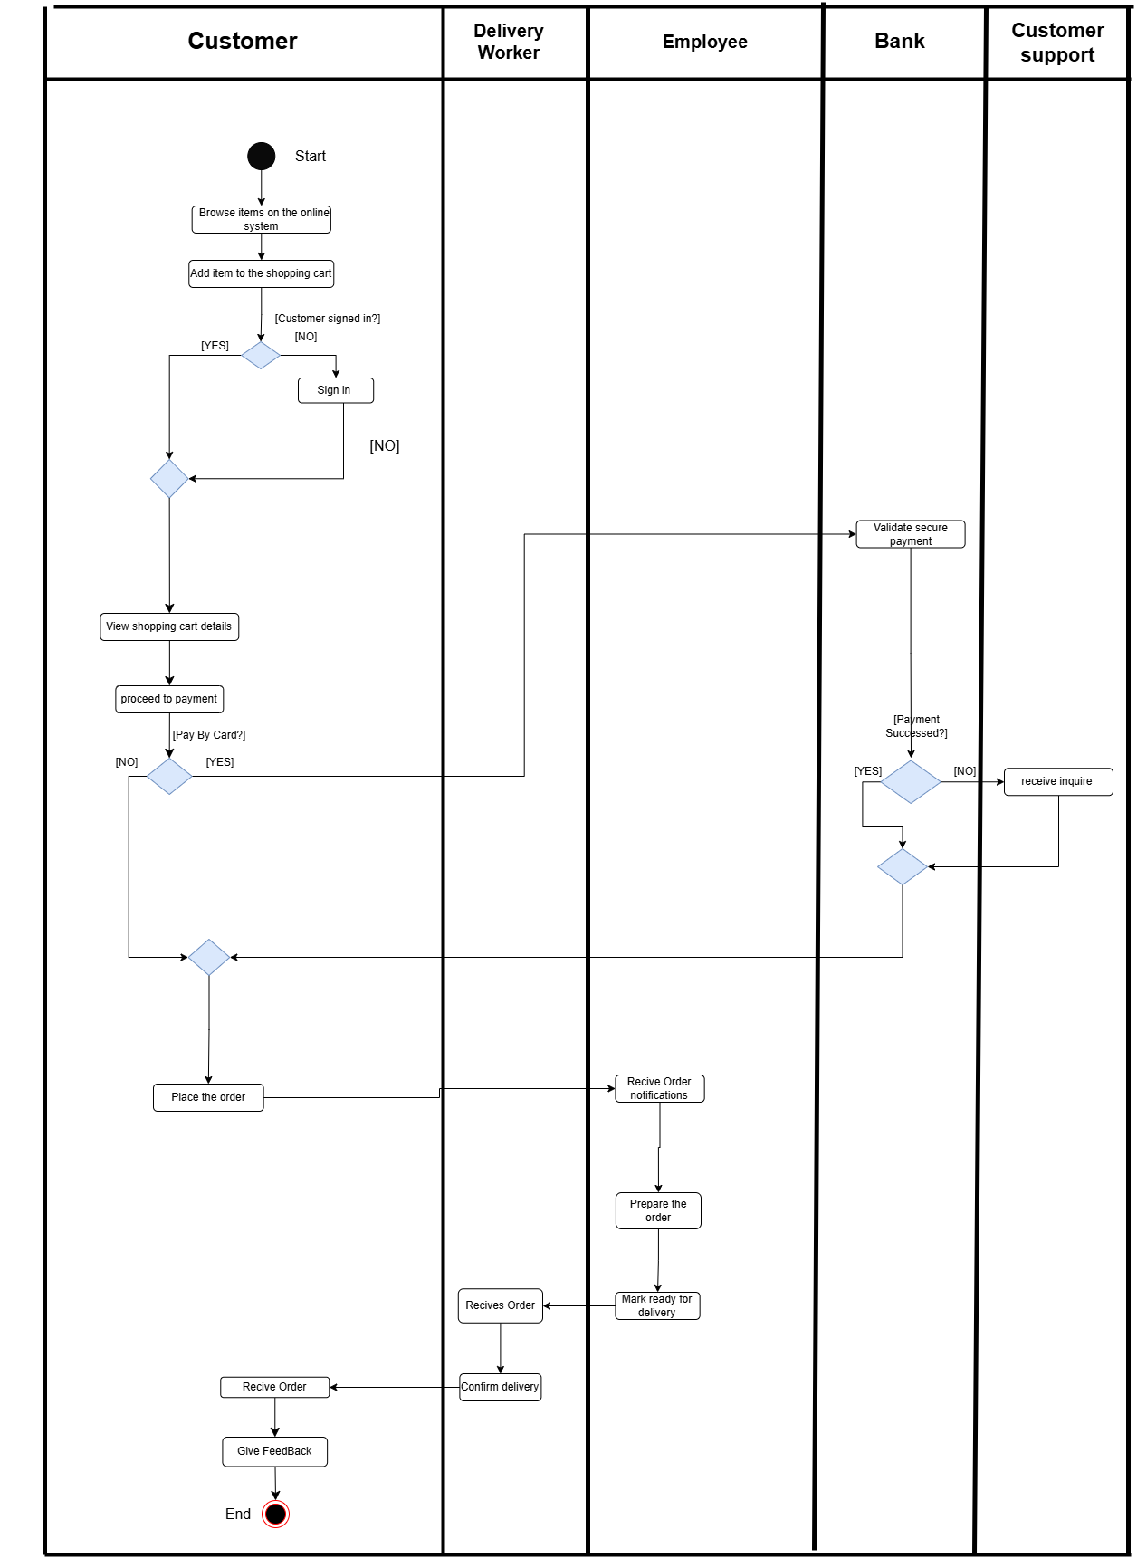

# **2.9. Instance Activity diagrams**

# **( Jenin Mansour 1200540)**

**Use-Case activity model (Adding an Items to the Shopping Cart for Purchase)**

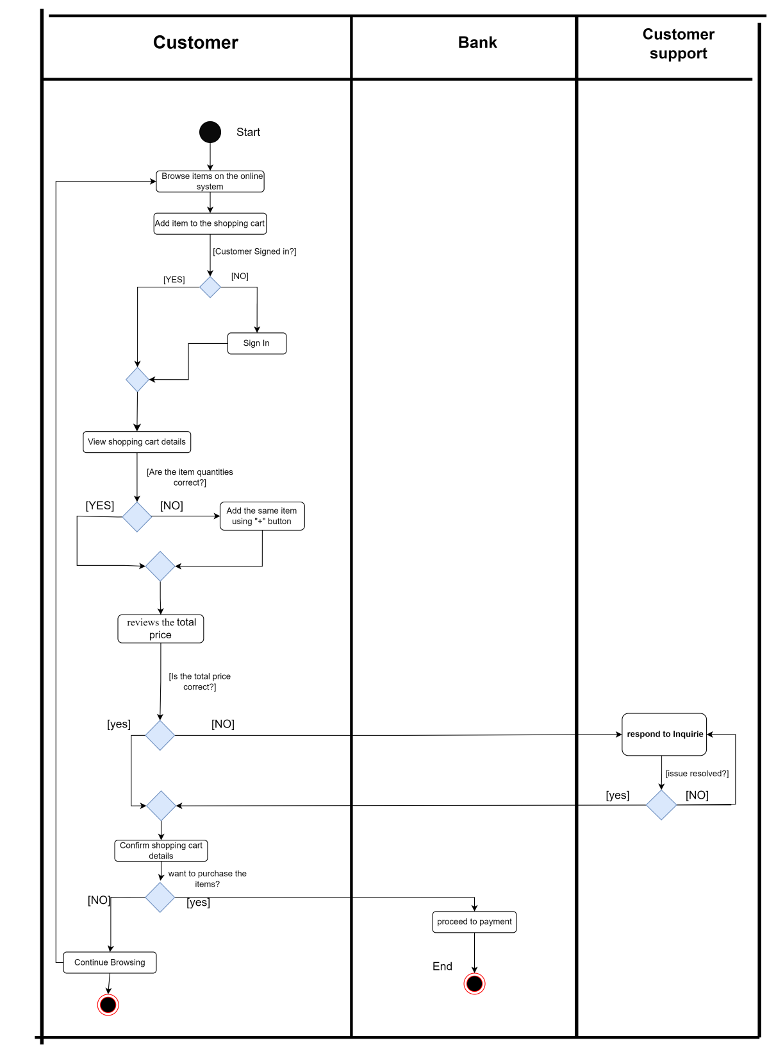

# **(Rahaf Naser 1201319)**

**Use-Case Activity Modelling (Sign-Up to Jewelry Online Shop)**

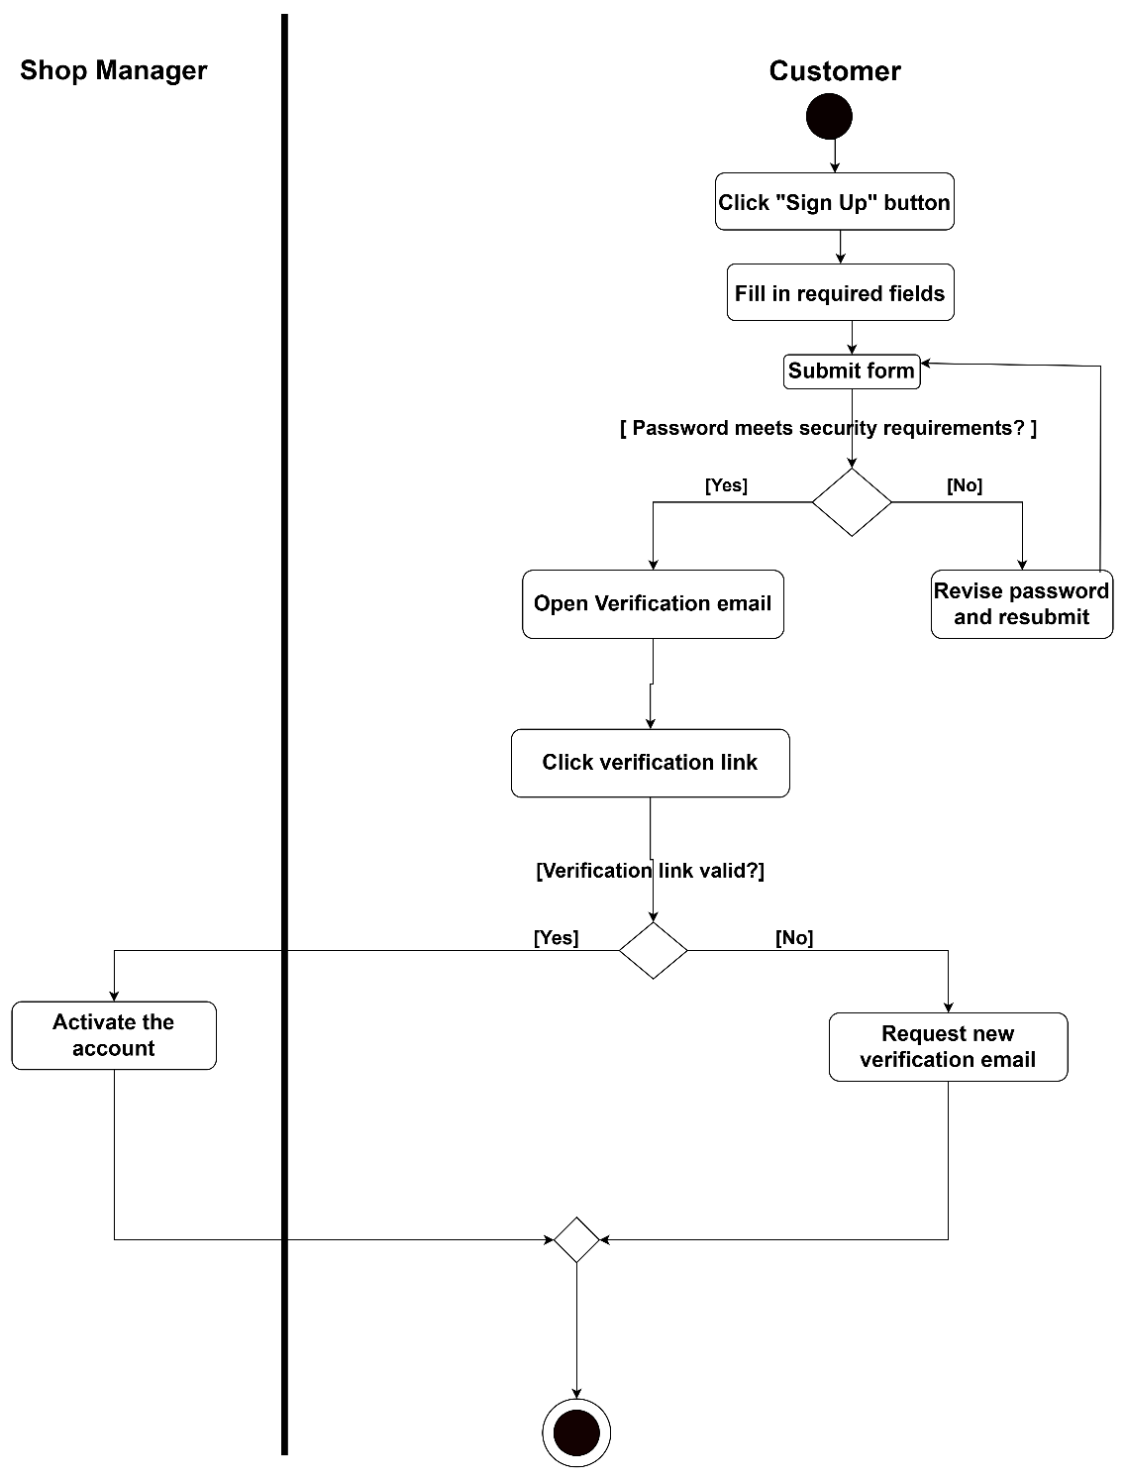

# **(Rana Musa)**

**Use-Case Activity Modelling(Feedbacks )**

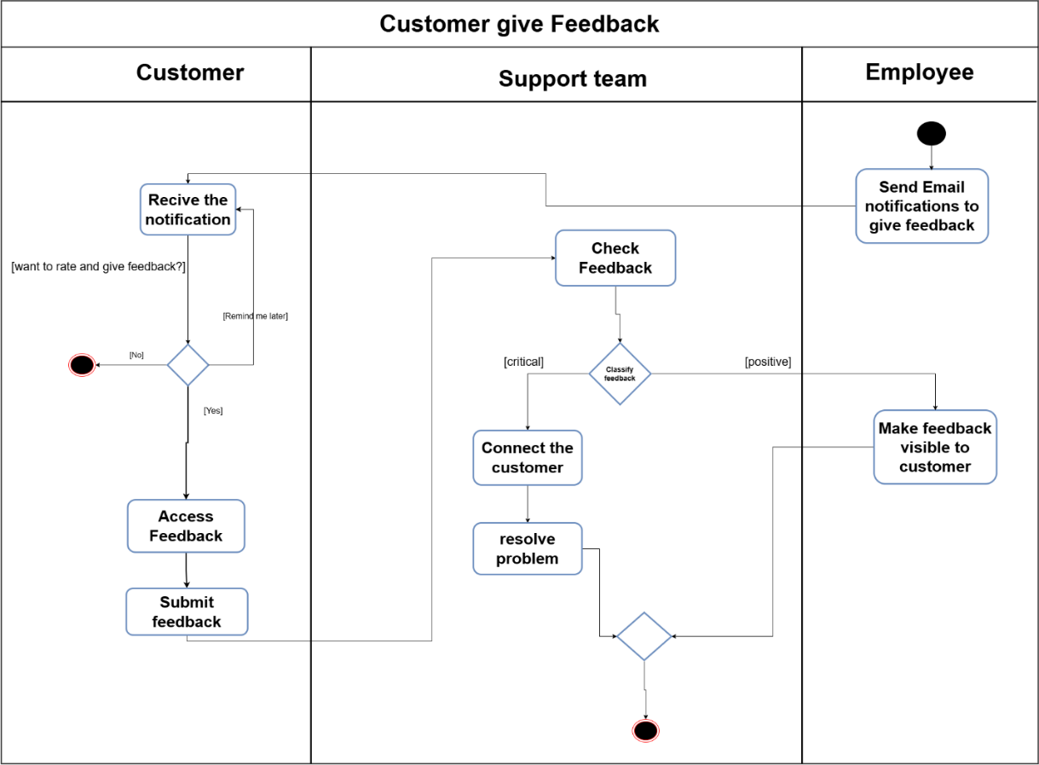

**(Leyan Burait)**

**Use-Case Activity Modelling(Display Discounts and Sales Items)**

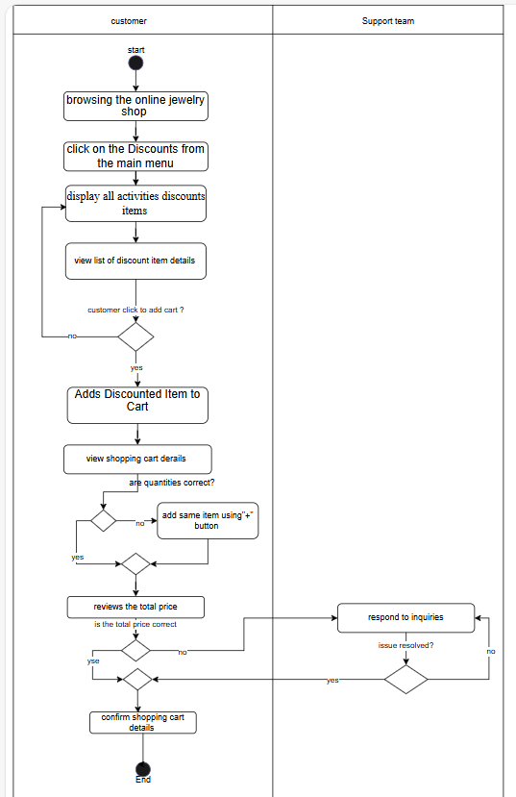

**Link:** **first.drawio.svg**

# **(Sireen Bearat 1210712)**

**Use Case model : Pay for Order by Credit Card in Jewelry Online Shop**

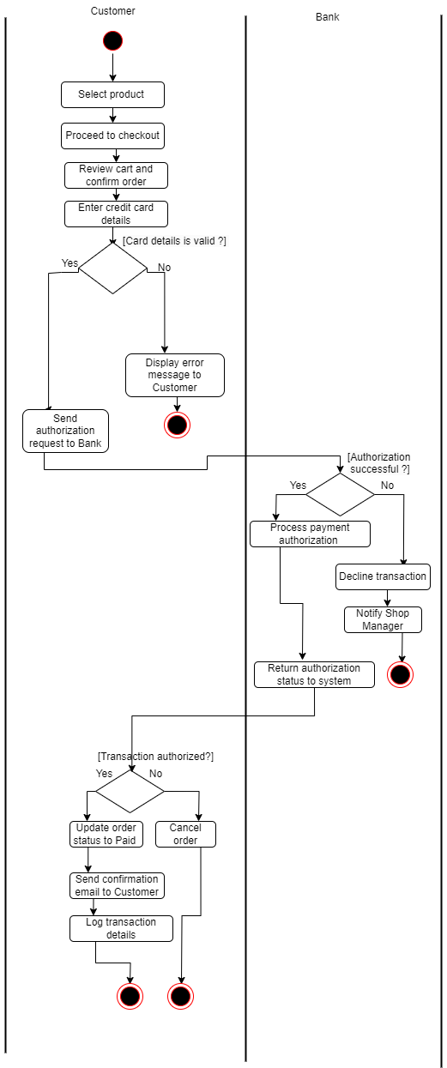

**Chapter 3: System Analysis and Modelling**

**3.1. class diagrams**

**(Lead: Jenin ,Discussion: Sireen: Rahaf ,Reviewing: Rana, leyan)**

**System analysis class diagrams:**

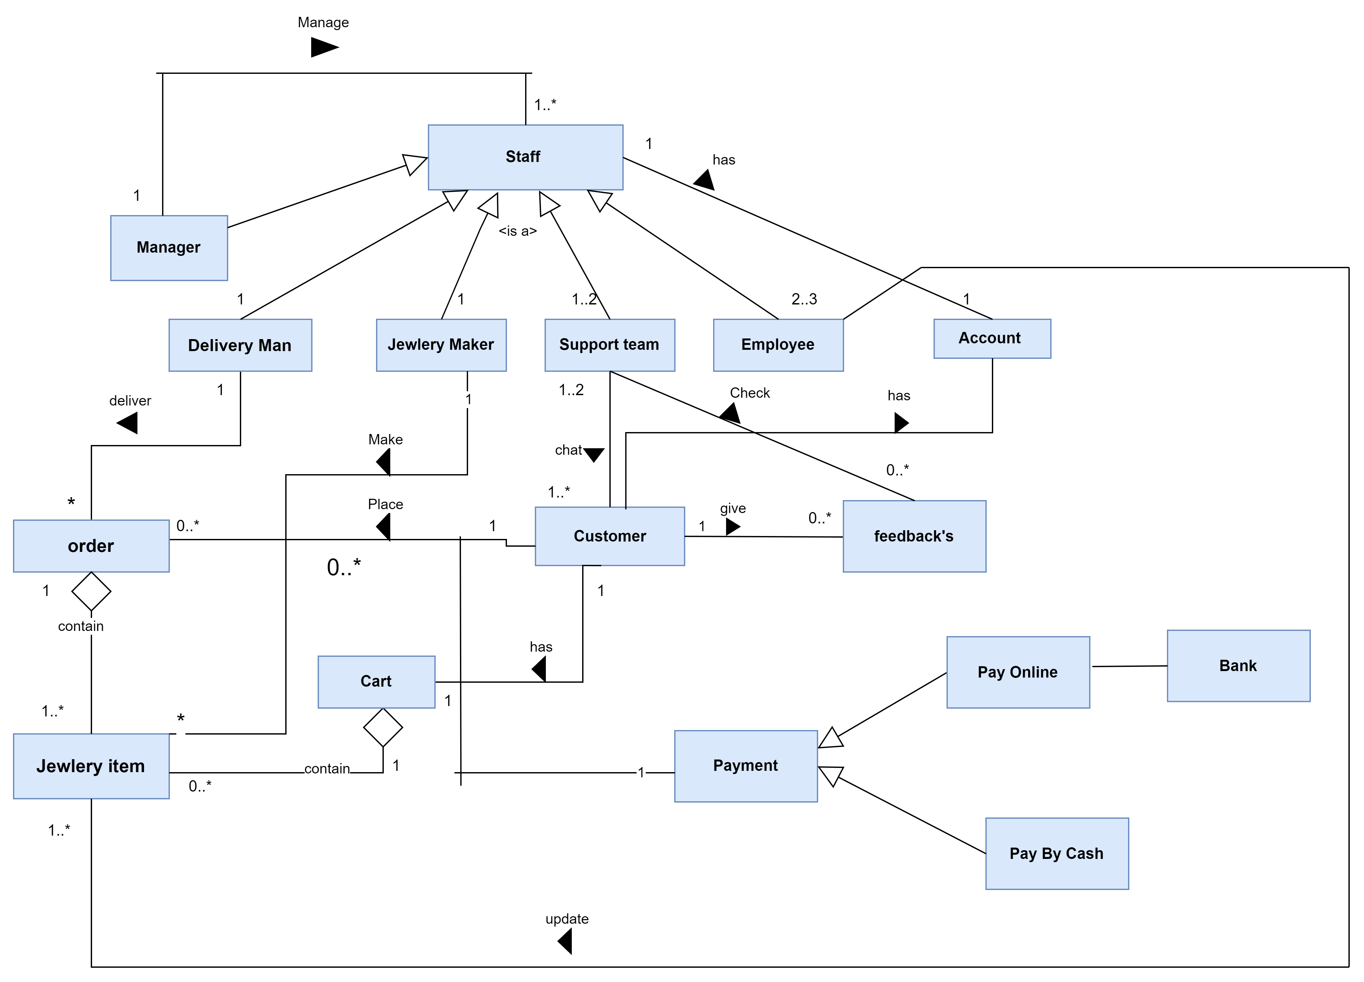

**Detailed class model:**

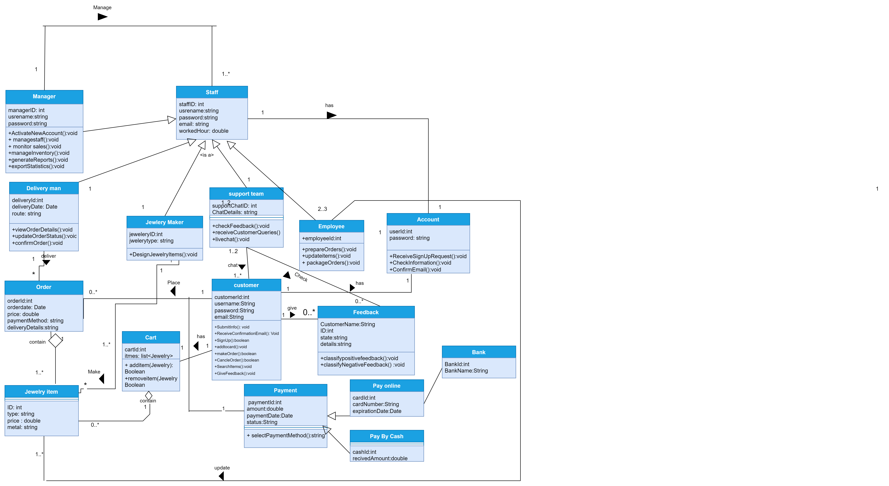

**a**

# **3.2. SEQUENCE Diagrams**

# **(Rahaf Naser 1201319)**

**System Sequence modelling and Analysis: Sign up to jewelry online shop.**

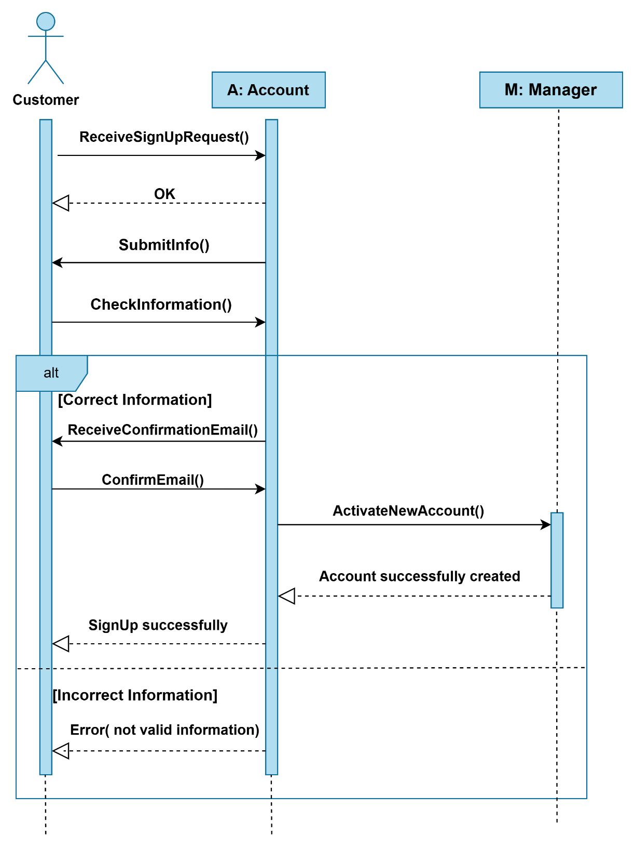

# **(Jenin Mansour 1200540)**

**System Sequence modelling and Analysis: Add item to the shopping cart.**

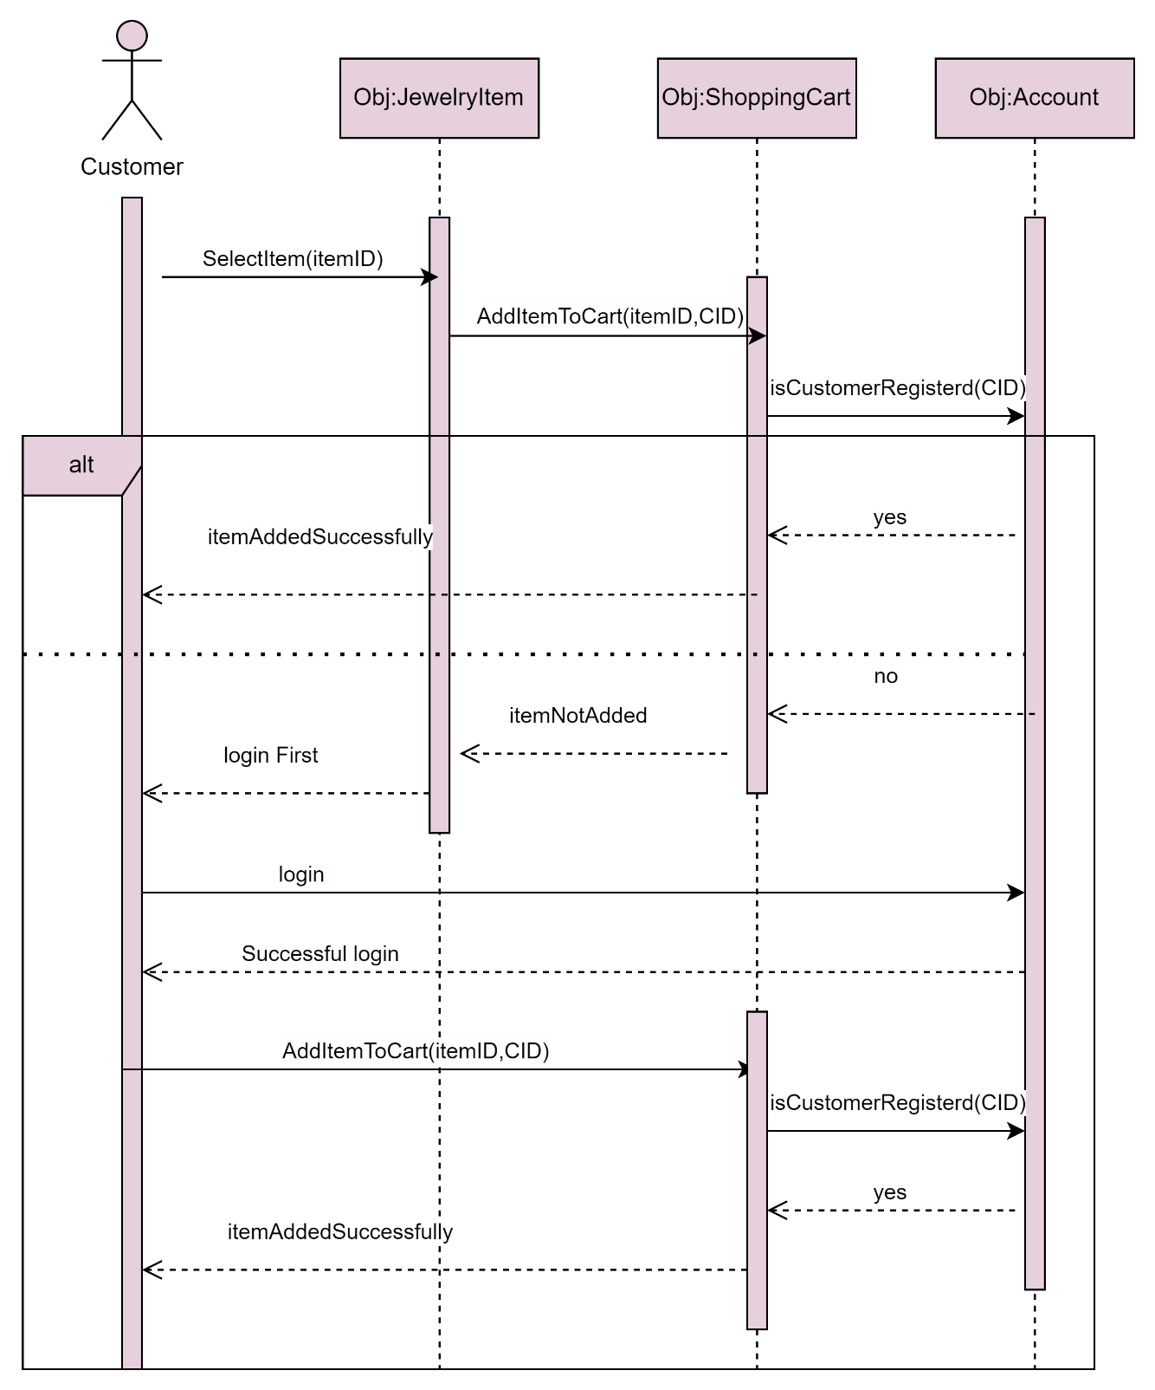

# **(Rana Musa 1210007)**

**System Sequence modelling and Analysis: Customer give feedback**

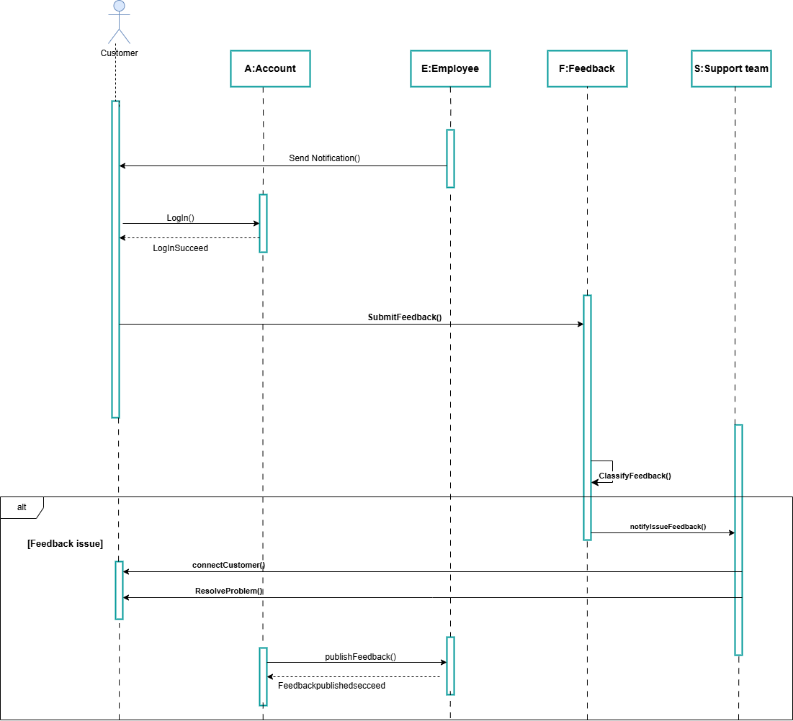

# (Leyan Buirat 1211439)

**System Sequence modelling and Analysis: Display Discounts and Sales Items**

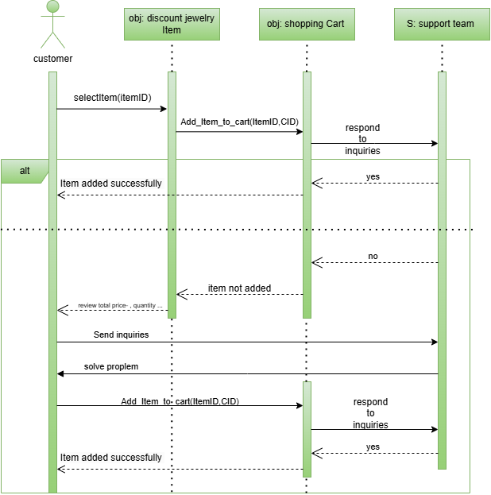

# (Sireen Bearat 1210712)

**System Sequence modelling and Analysis:** **Pay for Order by Credit Card in Jewelry Online Shop**

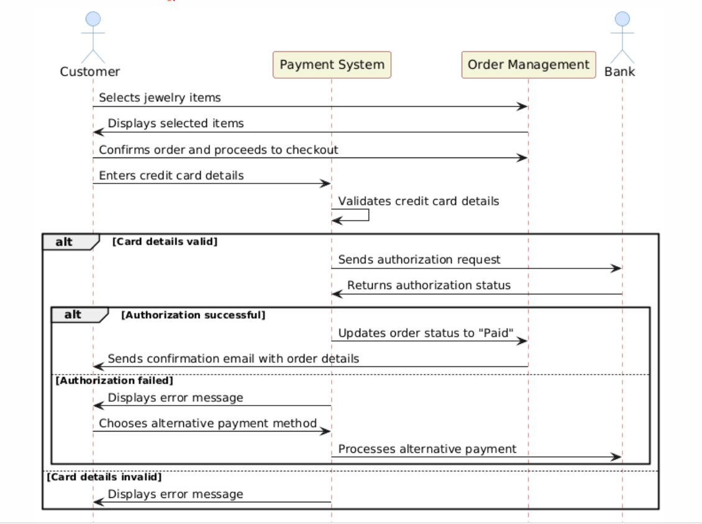

**Chapter 4: System Design and Modelling**

# **4.1. Description of Design Goals**

**(Lead: Sireen ,Discussion: Jenin, Rahaf , Reviewing: Rana, Leyan )**

**-General System Designs Goals:**

**1. High cohesion**

High Cohesion refers to grouping related functionality within the same layer or component. In this way, components and modules are well-defined and have a clear purpose, making a system more organized and maintainable. As an example, in a web server for a business application, entities such as Manager, Customer, Employee, Product, and Feedback are grouped together since they relate to the business's operations. It's important to place these entities in the same layer so they can interact and collaborate easily. When each component within a system has a specific set of responsibilities, it promotes modularity and well-structured architecture, which will result in high cohesion. Debugging and future development are also simplified as a result, which enhances readability and maintainability.

**2.Low coupling**

In a system with low coupling, dependencies between components or layers are minimized. Using well-defined interfaces, each component interacts with others, reducing the need to rely directly on implementation details of other components. Low coupling can be achieved by implementing a multi-layer architecture.

**-Specific System Designs Goals:**

**1. User-Friendly Interface**

Our system will be designed to be intuitive and easy to use, ensuring that customers of all backgrounds and technical skill levels can navigate and interact with it effectively on their first try.

**2. High Security**

Our system must ensure high security; so that if the system is exposed to a specific problem or hack, we must ensure that system data and customers personal information are not accessed. To achieve high security, the Database and security servers in the infrastructure layers were separated into two servers, this design guarantees the security and the safety because if an external problem occurs that affects one server, the other server will not be affected and will continue to serve.

# **4.2. Component Diagram**

**(Lead: Rahaf ,Discussion: Sireen ,Rana ,Reviewing: leyan , Jenin )**

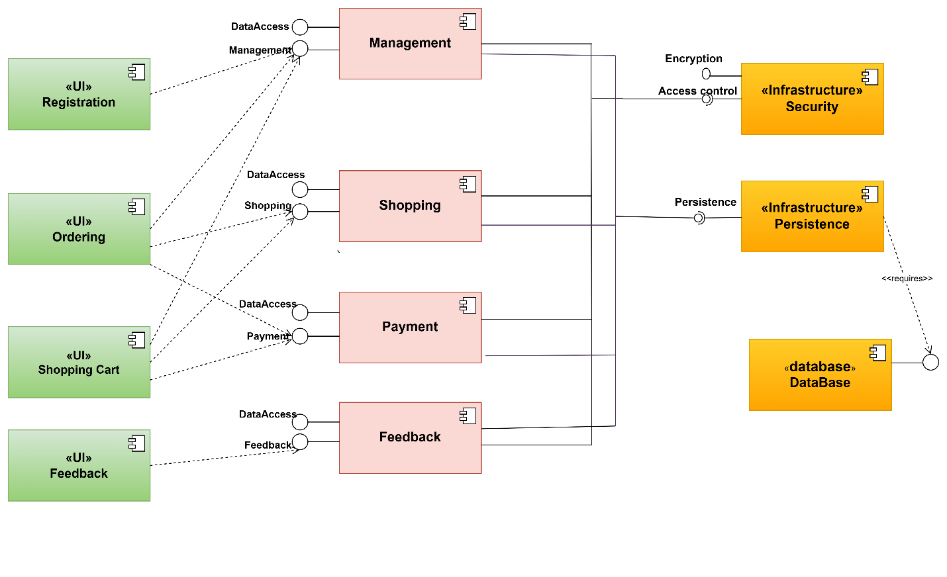

# **4.3. Overall architecture diagram**

**(Lead: Rahaf ,Discussion: layan, Rana, ,Reviewing: Jenin,sireen )**

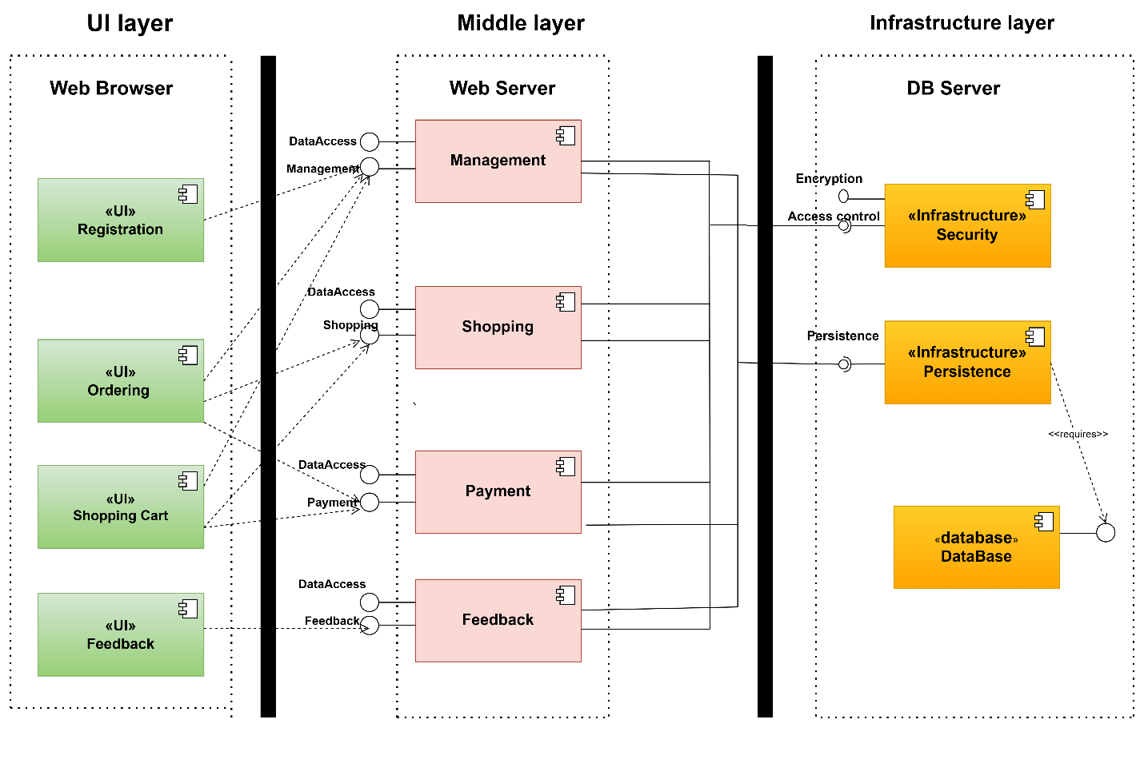

The Web Browser Layer is responsible for handling the user interface and user interactions, ensuring a seamless experience. Web Server Layer manages the logic and requests, acting as the application's brain. System security is ensured by the Security Server Layer, which handles authentication, authorization, and other security-related functions. Database Layer: Maintains data persistence by storing and retrieving data.

# **4.4.Deployment diagram**

**(Lead: Jenin, Discussion: Rana, Leyan ,Reviewing: Rahaf ,Sireen)**

|  |
| --- |
|  |

