# **Practical One**

**Objective: To create the college time table using HTML Tables**

**timeTable.html**

<!DOCTYPE html>

<html lang="en">

<head>

<meta charset="UTF-8">

<meta http-equiv="X-UA-Compatible" content="IE=edge">

<meta name="viewport" content="width=device-width, initial-scale=1.0">

<link rel="stylesheet" href="styles.css">

<title>Time Table - Section A</title>

</head>

<body>

<h1>GRAPHIC ERA DEEMED TO BE UNIVERSITY Rev. 3.0 <br>

TIME TABLE OF B. TECH. VIth SEMESTER – COMPUTER SCIENCE & ENGG. -A<br>

ACADEMIC YEAR 2021-22

</h1>

<br>

<h2>Room No: LT-9<span id="date">W.E.F: 21<sup>st</sup> February</span><br>

2022</h2>

<table>

<tr>

<th></th>

<th>9:00-9:55</th>

<th>9:55-10:50</th>

<th>11:10-12:05</th>

<th>12:05-1:00</th>

<th>1:00-1:55</th>

<th>1:55-2:50</th>

<th>3:10-4:05</th>

<th>4:05-5:00</th>

</tr>

<tr>

<td>Mon</td>

<td colspan="2">Web Development Lab<br />DIGITAL LAB-1</td>

<td>XCS-601<br />(Quant.)<br />LT-7</td>

<td>XCS-601<br />(Verbal)<br />LT-7</td>

<td>Lunch</td>

<td>TCS693</td>

<td colspan="2">Career Excellence Classes(CEC)<br />LT-1</td>

</tr>

<tr>

<td>Tue</td>

<td colspan="2">Software Engineering Lab<br />DIGITAL LAB-1</td>

<td>TCS-691(LT-9)/<br>TCS-651(LT-8)/<br />TCS-619(LAB-2)</td>

<td>XCS-601 <br>(SOFT SKILLS) <br> LT-5</td>

<td>Lunch</td>

<td>TCS-601</td>

<td colspan="2">Career Excellence Classes(CEC)<br />LT-1</td>

</tr>

<tr>

<td>Wed</td>

<td colspan="2">Compiler Design Lab <br> DIGITAL LAB-1</td>

<td>TCS-601</td>

<td>TCS-602</td>

<td>Lunch</td>

<td>TCS-604</td>

<td colspan="2">Career Excellence Classes(CEC)<br />LT-1</td>

</tr>

<tr>

<td>Thu</td>

<td>TCS-604</td>

<td>TCS-693</td>

<td>TCS-601</td>

<td>LIB</td>

<td>Lunch</td>

<td>LIB</td>

<td colspan="2">Career Excellence Classes(CEC)<br />LT-1</td>

</tr>

<tr>

<td>Fri</td>

<td colspan="2">TCS-691(LT-9)/<br>TCS-651(LAB-1)/<br>TCS-619 <br>(G1 LAB-2 & G2 LT-8)</td>

<td>TCS-604</td>

<td>TCS-693</td>

<td>Lunch</td>

<td>LIB</td>

<td colspan="2">Career Excellence Classes(CEC)<br />LT-1</td>

</tr>

</table>

</body>

</html>

**Styles.css:**

h1{

text-align: center;

}

table{

border-collapse: collapse;

}

th,td{

border:2px solid black;

padding:20px;

}

#date{

position: relative;

left:685px;

}

**Output:**

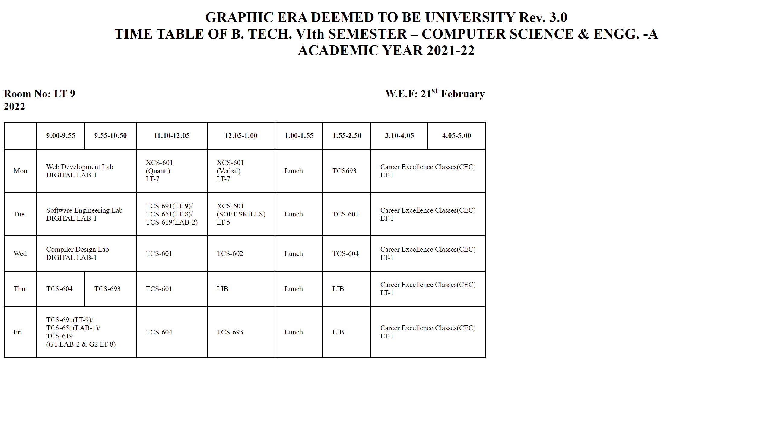

# **Practical Two**

**Objective: To Demonstrate the use of selectors**

**cssSelectors.html**

<!DOCTYPE html>

<html lang="en">

<head>

<meta charset="UTF-8">

<meta http-equiv="X-UA-Compatible" content="IE=edge">

<meta name="viewport" content="width=device-width, initial-scale=1.0">

<title>CSS Selectors</title>

<style>

/*** Element selector**/

h1 {

color: purple;

}

h2 {

color: red;

}

p {

color: blue;

}

/** Id selector**/

p#id {

color: green;

}

/**Class Selector**/

p.class {

color: orange;

}

/** Group Selector*/

h1.one,

h2.two,

h3.three {

color: brown;

}

/** Universal Selector **/

* {

text-align: center;

}

</style>

</head

<body>

<h1>This is an h1 in purple color</h1>

<h2> This is an h2 in red color</h2>

<p>This is Paragraph tag in blue color</p>

<p id="id">This is a paragraph with id ="id" and color="green".</p>

<p class="class">This is a paragraph with class="class" and color="orange"</p>

<h1 class="one">h1 with class one</h1>

<h2 class="two">h2 with class two</h2>

<h3 class="three">h3 ith class three</h3>

</body>

</html>

**Output:**

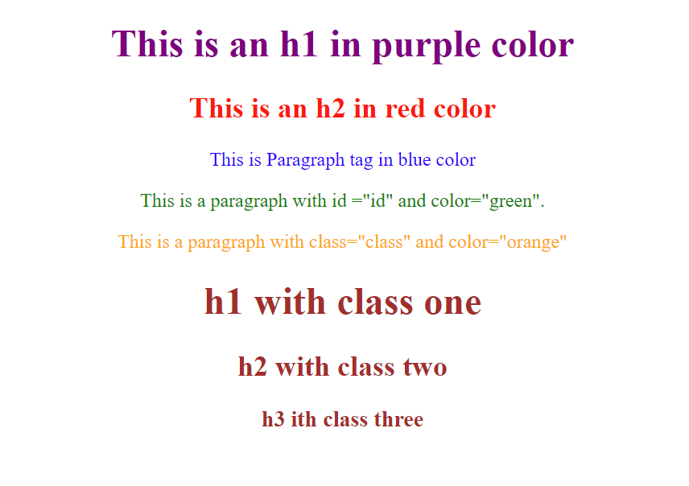

# **Practical Three**

**Objective: To demonstrate use of clickable maps**

**map.html**

<!DOCTYPE html>

<html lang="en">

<head>

<meta charset="UTF-8">

<meta http-equiv="X-UA-Compatible" content="IE=edge">

<meta name="viewport" content="width=device-width, initial-scale=1.0">

<title>Clickable Map</title>

</head>

<body>

<img src="img.png" alt="" usemap="#img-map" style="height: 500px; width: 500px" />

<map name="img-map">

<area shape="rect" coords="0,0, 250,250" alt="" href="https://www.google.co.in" target="_blank" />

<area shape="rect" coords="250,0, 500,250" alt="" href="https://youtube.com" target="_blank" />

<area shape="rect" coords="0,250, 250,500" alt="" href="https://github.com" target="_blank" />

<area shape="rect" coords="250,250, 500,500" alt="" href="https://duckduckgo.com" target="_blank" />

</map>

</body>

</html>

**Output:**

