**Week 1: Introduction to Web Development Tools and Basic HTML/CSS**

Lab 1: Setting up the Development Environment

Objective: Install and configure VS Code, Git, and GitHub.

Steps:

1. Install VS Code and Git.

2. Set up VS Code settings for development (e.g., Prettier for formatting).

3. Initialize a git repository and connect to GitHub.

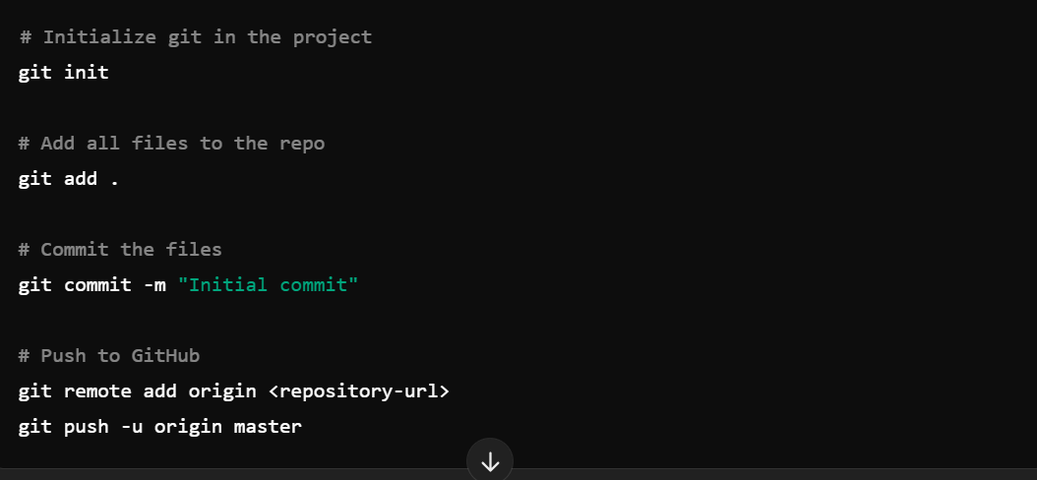

Lab 2: Creating Your First HTML Page

Objective: Build a basic HTML page and style it with CSS.

Steps:

1. Create an `index.html` file and structure it with basic HTML elements (e.g., `<html>`, `<head>`, `<body>`).

2. Add CSS to style elements such as paragraphs, headers, and images.

