**Week 2: HTML Forms, Bootstrap Integration, JavaScript Integration**

Lab 1: Creating an HTML Form

Objective: Build a basic form using various input types.

Steps:

1. Create a form with input elements like text fields, dropdowns, and a submit button.

Code Snapshot:

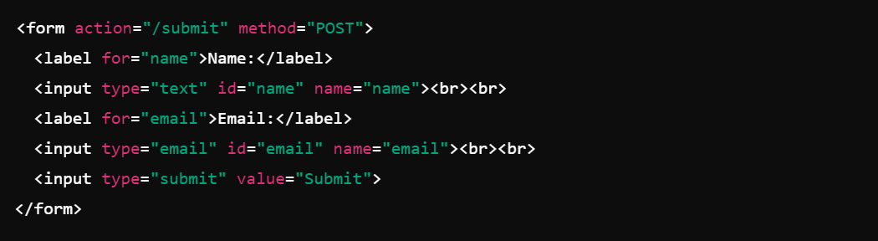

Lab 2: Adding Bootstrap for Styling

Objective: Use Bootstrap to style the form and make it responsive.

Steps:

1. Include Bootstrap CDN in the HTML file.

2. Apply Bootstrap classes to make the form more attractive.

