Week 3: JavaScript Fundamentals

Lab 1: Variables and Data Types

Objective: Learn about JavaScript variables, data types, and basic operations.

Steps:

1. Declare variables using `let`, `const`, and `var`.

2. Perform basic operations with strings and numbers.

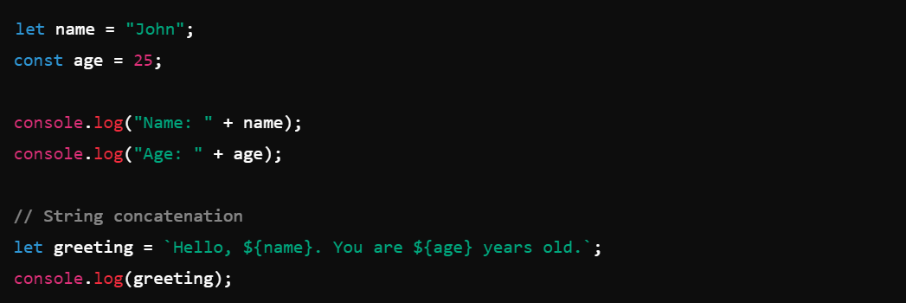

**Lab 2: Loops and Conditionals**

- Objective: Practice using `for` and `while` loops, as well as `if-else` conditions.

- Steps:

1. Write a loop that prints numbers from 1 to 10.

2. Use an `if-else` condition to check if a number is even or odd.

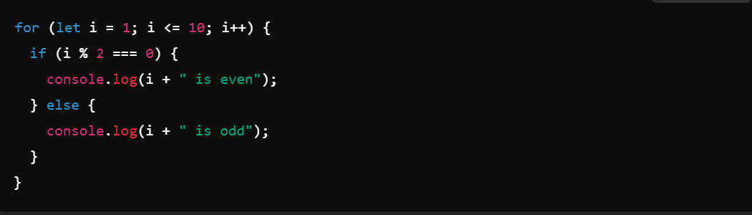

Let me know if you want to continue with the next weeks, or if you want any specific adjustments to the labs or code samples!