Week 4: JavaScript Fundamentals

Lab 1: Arrays in JavaScript

Objective: Learn how to manipulate arrays using methods like `push`, `pop`, `shift`, `unshift`.

Steps:

1. Create an array and perform various operations.

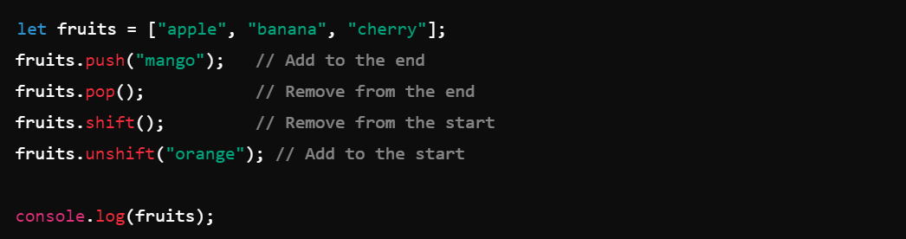

Lab 2: Objects and Arrays of Objects

Objective: Create and manipulate objects and arrays of objects.

Steps:

1. Create an object and access its properties.

2. Create an array of objects.

