Week 5: Functions in JavaScript

Lab 1: Function Declaration and Arrow Functions

Objective: Practice creating normal and arrow functions.

Steps:

1. Create a function to add two numbers.

2. Rewrite the function using arrow function syntax.

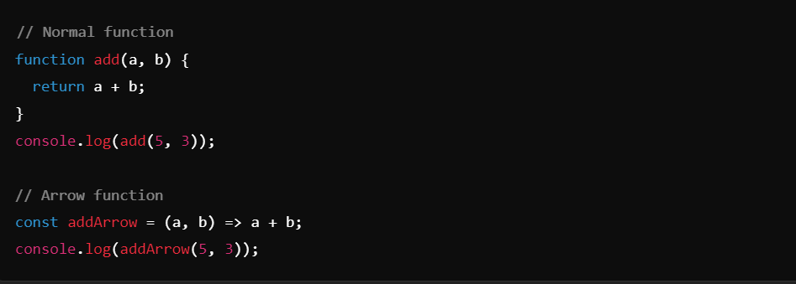

Lab 2: Functions as Methods

Objective: Create functions as methods within objects.

Steps:

1. Create an object with a method that returns a greeting message.

