Week 6: DOM Manipulation in JavaScript

Lab 1: DOM Selection and Manipulation

Objective: Practice selecting and manipulating DOM elements.

Steps:

1. Select an element by `id` and change its content.

2. Change the style of an element.

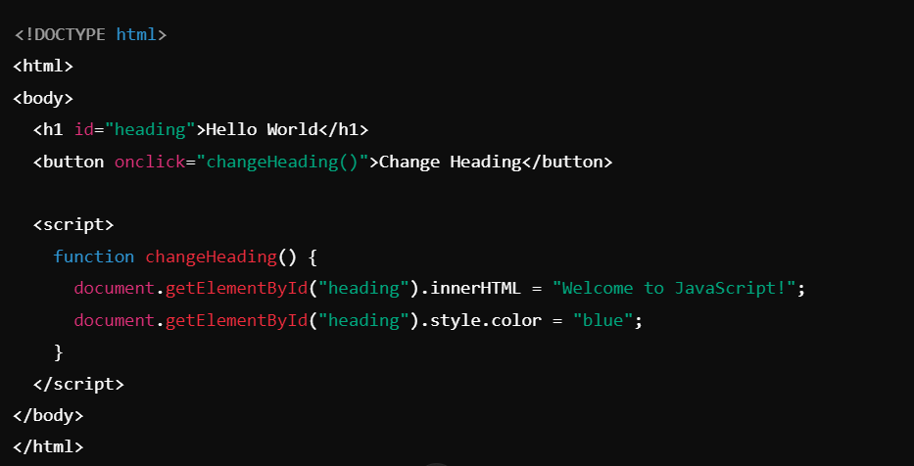

Lab 2: Event Handling

Objective: Handle form submission and display submitted values.

Steps:

1. Capture form data and display it using DOM manipulation.

