Week 7: Asynchronous JavaScript

Lab 1: Working with Promises

Objective: Learn how to handle asynchronous tasks using Promises.

Steps:

1. Create a Promise to simulate a network request.

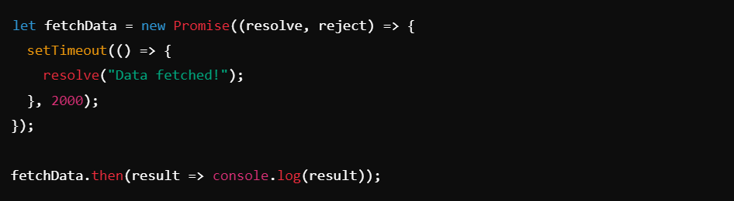

Lab 2: Using `fetch` API

Objective: Fetch data from a remote server and display it.

Steps:

1. Fetch data from a public API and log the result.

