Week 9: PHP and MySQL Integration

Lab 1: Connecting PHP to MySQL

Objective: Connect to a MySQL database using PHP.

Steps:

1. Set Up a MySQL Database: Install MySQL and create a database (e.g., `lab_db`) and a table (e.g., `users`) with fields like `id`, `name`, and `email`.

2. Connect to MySQL with PHP: Write a PHP script to connect to the MySQL database using `mysqli`.

3. Display Connection Status: Print a message if the connection is successful or display an error if it fails.

Code Example:

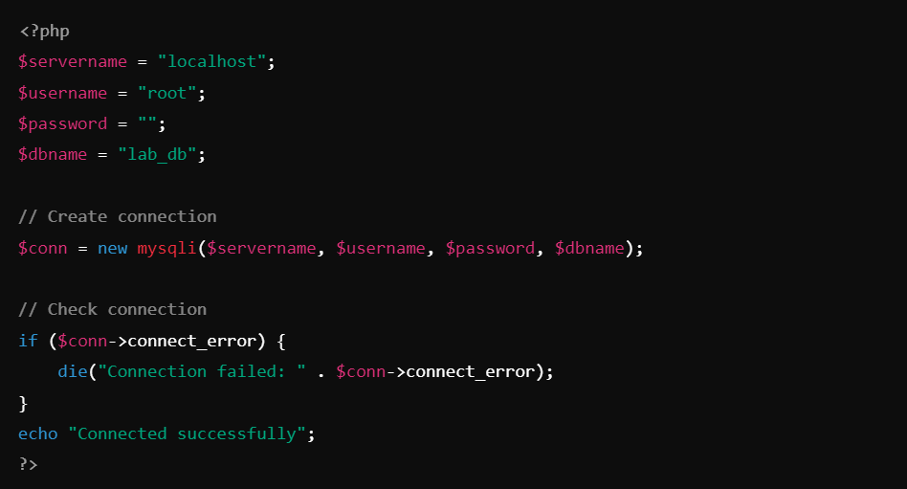

Lab 2: Handling MySQL Connection Errors

Objective: Learn to handle connection errors and troubleshoot common database connection issues.

Steps:

1. Introduce Error-Handling Mechanisms: Modify the connection script to implement better error handling using `try-catch` or detailed error messages.

2. Simulate Connection Failures: Change the database name or password to an incorrect value and observe the error messages.

3. Log Connection Errors: Create a log file to save connection errors for future reference.

Code Example:

