Week 10: PHP and MySQL CRUD Operations

Lab 1: Basic CRUD Operations

Objective: Perform basic CRUD (Create, Read, Update, Delete) operations using PHP and MySQL.

Steps:

1. Create Record: Write a PHP form to insert new records into the `users` table.

2. Read Records: Write a PHP script to retrieve and display records from the database.

3. Update Record: Create a form to update existing records in the `users` table.

4. Delete Record: Write a PHP script to delete a record from the `users` table.

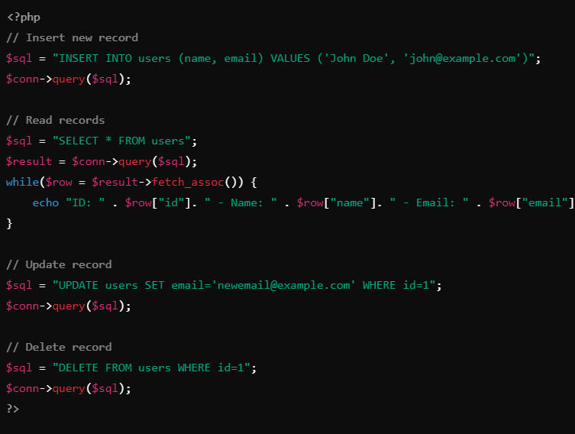

Lab 2: Form Handling with PHP

Objective: Learn how to handle HTML forms in PHP, process user input, and store the data in a MySQL database.

Steps:

1. Create an HTML Form: Build a simple HTML form that collects `name` and `email` inputs from the user.

2. Process the Form with PHP: Write PHP code to handle form submission and validate the input.

3. Insert Form Data into MySQL: Store the user input from the form into the `users` table in MySQL.

4. Display Confirmation: Show a success message after the form is successfully submitted.

Code Example:

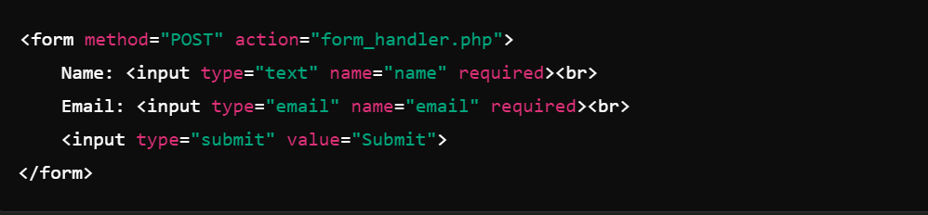

form_handler.php: 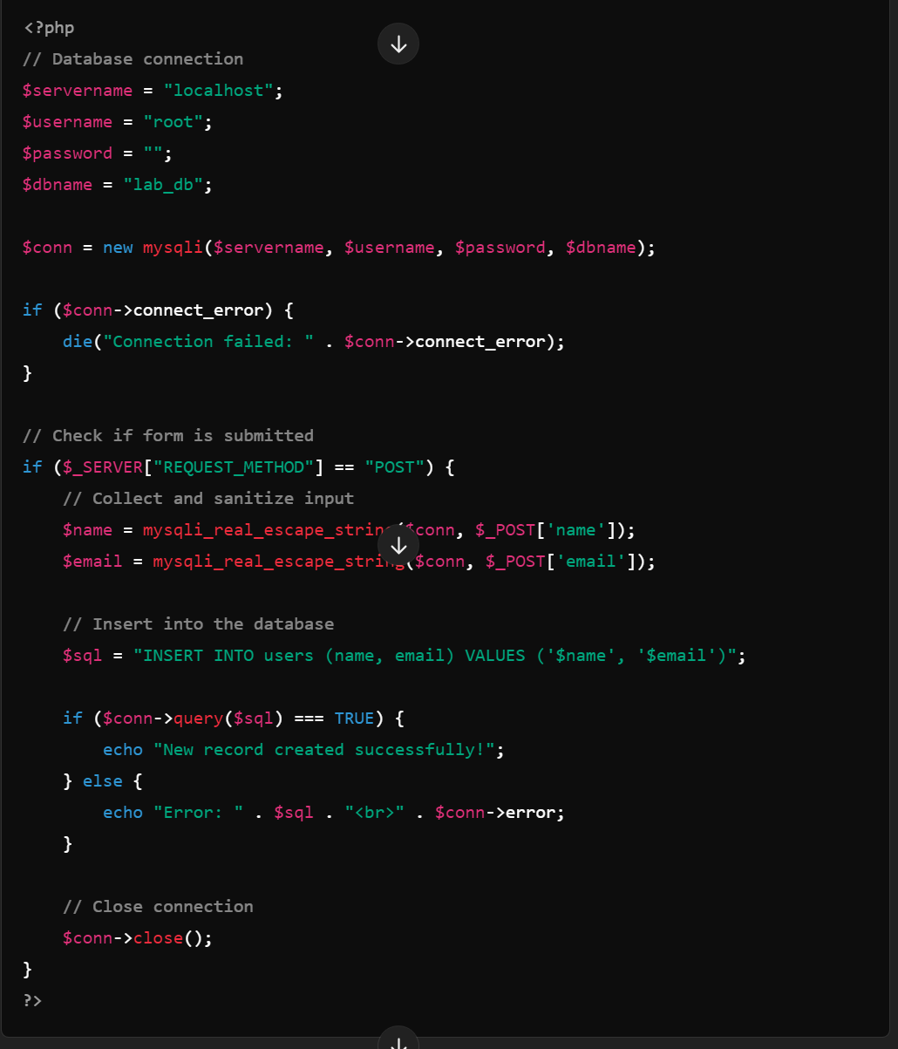

Explanation of Form Handling Lab

Step 1: Create an HTML Form:

You create a simple form that uses the POST method to send user data to the `form_handler.php` script.

Step 2: Process the Form in PHP:

PHP captures the form data via the `$_POST` superglobal and sanitizes the inputs before inserting them into the MySQL database to avoid security issues.

Step 3: Insert Data:

After validation, the data is inserted into the database using a simple `INSERT` query.

Step 4: Display Confirmation:

A success message is displayed when the record is inserted correctly.