Week 11: Introduction to Laravel

Lab 1: Setting up Laravel

Objective: Install Laravel and create a basic project.

Steps:

1. Install Laravel using Composer.

2. Create a simple controller and route.

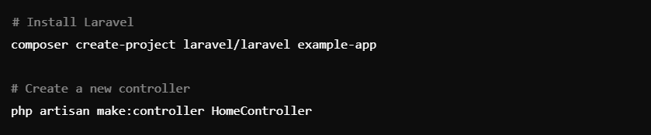

Lab 2: MVC Architecture

Objective: Understand and implement the MVC pattern.

Steps:

1. Create a route, controller, and view.

