Week 12: Introduction to Tailwind CSS

Lab 1: Tailwind CSS Installation

Objective: Install and use Tailwind CSS for styling.

Steps:

1. Install Tailwind CSS using npm.

2. Style a basic webpage using Tailwind CSS.

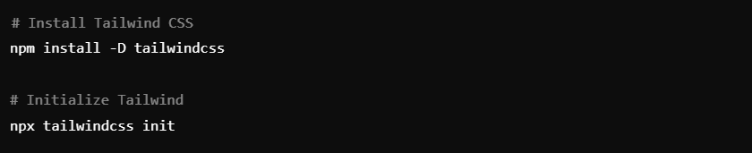

Lab 2: Styling with Tailwind

Objective: Apply Tailwind CSS classes to create a responsive design.

Steps:

1. Use Tailwind classes to style buttons and layout.

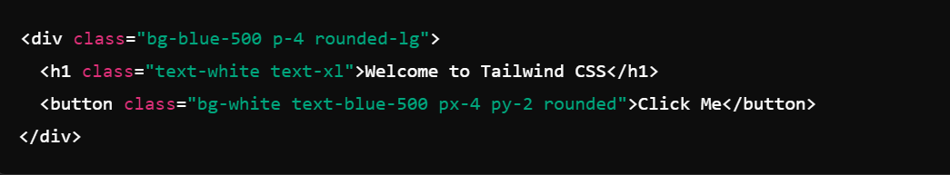

This plan covers all weeks from 1 to 12. Let me know if you need any further adjustments!