Week 1: Introduction to Web Development Tools and Basic HTML/CSS
Lab 1: Setting up the Development Environment
Objective: Install and configure VS Code, Git, and GitHub.
- Steps:
1. Install VS Code and Git.
2. Set up VS Code settings for development (e.g., Prettier for formatting).
3. Initialize a git repository and connect to GitHub.

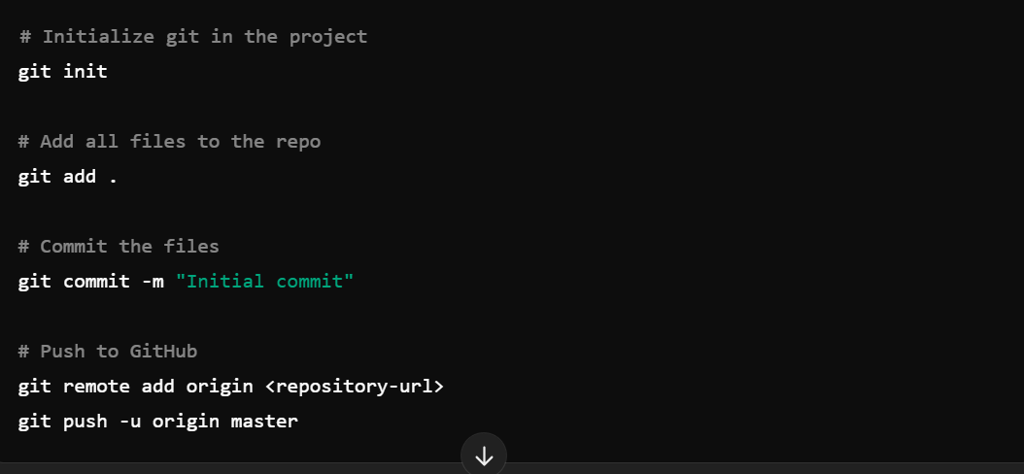

Lab 2: Creating Your First HTML Page
Objective: Build a basic HTML page and style it with CSS.
Steps:
1. Create an `index.html` file and structure it with basic HTML elements (e.g., `<html>`, `<head>`, `<body>`).
2. Add CSS to style elements such as paragraphs, headers, and images.

