ParaKoop: Parametric Koopman Surrogate for Automotive Aerodynamic Design with Quantum HHL Integration
Amit Rana
Independent Researcher
amit21aim@zohomail.com
ORCID: 0009-0008-5998-6560
June 2026

Abstract
Aerodynamic drag reduction in passenger car design requires repeated Computational Fluid Dynamics (CFD) simulations — each taking hours — with no mechanism to directly ask: given a drag target, what geometry achieves it? We present ParaKoop, a Parametric Koopman surrogate that answers this question in under a second, without new simulations.
ParaKoop learns a geometry-conditioned Koopman operator A(θ) — a linear map in a high-dimensional lifting space whose fixed point encodes aerodynamic performance — jointly across 9,620 CFD results from two public datasets: DrivAerNet++ (~8,000 steady-state car simulations) and AhmedML (499 transient bluff-body simulations with drag and lift labels). A unified 8-dimensional scale-invariant geometry descriptor θ bridges the two datasets without retraining. On a held-out validation set, ParaKoop achieves a drag coefficient (Cd) Mean Absolute Error (MAE) of 0.01401, outperforming a Gradient-Boosted Regressor (GBR) baseline by 10%. On 74 completely held-out AhmedML cases — a genuine out-of-scale domain test — Cd MAE is 0.0378 against published OpenFOAM ground truth.
Given a target Cd, gradient descent through the differentiable θ → A(θ) → performance chain performs inverse design, outputting geometry changes in real engineering units (millimetres and degrees) within 300 optimisation steps. Proximity regularisation prevents the optimiser from producing geometrically implausible designs, with all suggestions passing Reynolds number (Re), Mach number (Ma), and Euler number (Eu) physics guardrails.
The same A(θ) defines a quantum linear system A(θ)·z = b(θ) suitable for the Harrow–Hassidim–Lloyd (HHL) quantum linear solver. Empirical condition numbers κ = 1.03–1.23 across fastback, notchback, and estateback geometries imply a theoretical HHL speedup of 14.8–17.8× over classical Conjugate Gradient using 15 qubits — the first systematic κ characterisation across a large automotive shape family. Code and an interactive Streamlit demonstration are publicly available at https://github.com/Ranaam21/Parakoop.
Keywords: Parametric Koopman operator; automotive aerodynamics; surrogate model; inverse design; drag coefficient; HHL quantum linear solver; condition number; physics guardrails; DrivAerNet++; AhmedML

1. Introduction

1.1 The Problem: Designing Better Cars Takes Too Long
Designing the aerodynamics of a car is one of the most computationally expensive tasks in engineering. Every time an engineer wants to know how a design will behave in the wind — how much drag it creates, how stable it is at highway speed — they must run a Computational Fluid Dynamics (CFD) simulation. CFD numerically solves the equations of fluid motion (the Navier–Stokes equations) around a full 3D car model, discretised into tens of millions of small cells. A single such simulation can take anywhere from 6 to 48 hours on a powerful computer cluster, even for a simplified car shape.
In a typical automotive design cycle, engineers run dozens to hundreds of these simulations per design iteration. At this rate, the entire design loop is inherently forward: the engineer specifies a geometry, the simulation tells them the resulting drag and lift, and the engineer manually decides what to change next. There is no mechanism to ask the reverse question: “Given that I want a drag coefficient (Cd) of 0.25, what shape should I build?”
This paper presents ParaKoop — a Parametric Koopman surrogate model that answers exactly that reverse question, directly, in under a second, without running a single new CFD simulation.

1.2 Key Concepts: What is a Surrogate Model and Why Koopman?
Surrogate model: A machine learning model trained on existing CFD results that can predict aerodynamic performance (drag, lift) for any new geometry in milliseconds, instead of hours. Think of it as a “learned shortcut” through the physics.
Koopman operator (A): A mathematical object from dynamical systems theory [1] that represents how a physical system evolves over time or changes with parameters. The key insight is this: complex, nonlinear physical behaviour often looks linear when viewed in the right higher-dimensional space — the Koopman lifting space. Instead of modelling drag as a complex nonlinear function of 8 geometry variables, we lift those variables into a 128-dimensional space where the relationship becomes linear.
Why “Parametric” Koopman? Classical Koopman operators describe how a single system evolves in time. Our operator A(θ) is different: it describes how the physics changes with geometry (parameterised by θ). This allows us to learn one operator that works across thousands of different car shapes, rather than fitting a separate model per design.

1.3 The Forward and Inverse Design Flows
ParaKoop supports two complementary design directions (see Figure 1 for the full architecture diagram):
Forward flow (Predict): Given a car geometry θ, the model predicts drag coefficient (Cd) and lift coefficient (Cl) in real time.
θ → A(θ) → z* → [Cd, Cl]
(geometry) (Koopman operator) (lifted state) (performance)
Inverse flow (Design): Given a target Cd (and optionally a target Cl), the model works backwards through the same differentiable chain to find the geometry θ that achieves it.
Cd* → gradient descent on θ → θ_opt → geometry changes (mm, degrees)
(target) (optimised) (e.g. "reduce rear slant by 10°")
The inverse flow does not require any additional training or simulation — it uses the gradient ∂Cd/∂θ through the already-trained model. This is possible only because all components of the pipeline are differentiable (§3).

1.4 What Makes ParaKoop Novel?
Existing automotive aerodynamics surrogate models [2, 3] are built as forward-only predictors: they take geometry as input and output drag. None provides a direct, gradient-based inverse design mechanism that outputs real engineering dimensions. Existing Koopman surrogate methods for fluid dynamics [4, 5] apply the operator to a single geometry at a time — they cannot condition on different geometries without retraining. And while quantum linear solvers like HHL (Harrow–Hassidim–Lloyd) [6] have been studied theoretically for CFD applications, no prior work has characterised the condition number κ(A) of a Koopman operator over a large, diverse automotive shape family.
ParaKoop makes six distinct contributions:
- Geometry-conditioned Koopman operator: A(θ) is trained to vary with car geometry via a low-rank dyadic parameterisation (§3.2). The same operator predicts Cd for a fastback, notchback, or estateback — no separate models per style.
- One object, all readouts: Every quantity the paper reports — Cd, Cl, the eigenspectrum, the HHL input system, and the inverse design gradient — is a direct structural readout of A(θ). Nothing is computed from a separate model or branch.
- Direct inverse design: Given target Cd (and optional Cl), AdamW gradient descent on θ through the differentiable A(θ) pipeline outputs real geometry changes in millimetres and degrees — not abstract latent directions.
- Multi-dataset joint training: ParaKoop is trained jointly on DrivAerNet++ [2] (~8,000 steady-state car CFD runs) and AhmedML [3] (499 transient bluff-body CFD runs), bridged by a unified 8-dimensional scale-invariant geometry representation. This is, to our knowledge, the first surrogate trained jointly across both datasets.
- HHL quantum readiness characterisation: The condition number κ(A(θ)) is measured across three body style families after phi-supervised grounding, yielding κ = 1.03–1.23 — a regime where the HHL algorithm [6] offers a theoretical speedup of 14.8–17.8× over the best classical solver, requiring only 15 qubits.
- Physics guardrails: Every inverse design suggestion is automatically checked against the Reynolds number (Re), Mach number (Ma), and Euler number (Eu) — the key dimensionless quantities governing when incompressible RANS (Reynolds-Averaged Navier–Stokes) simulation physics are valid. Suggestions that fail are flagged and explained, not silently discarded.

1.5 Industry Relevance
The capabilities developed in this paper are directly applicable beyond passenger car design:
- Automotive: Real-time inverse aerodynamic design for Cd/Cl targets, reducing the design-to-simulation cycle from days to seconds.
- Motorsport: Rapid exploration of downforce (negative Cl) configurations within guardrail-bounded geometry space.
- Aerospace and UAV: The same parametric Koopman framework applies to wing cross-section and fuselage shape optimisation against drag targets.
- Space re-entry vehicles: The inverse design loop can be extended to thermal loads (adding Stanton number as a performance target) given appropriate training data.
- Semiconductor and MEMS: Microfluidic channel and heat-sink geometry optimisation where flow simulations are equally expensive and inverse design is equally under-served.
The public release of the full codebase and Streamlit demonstration makes these capabilities accessible without requiring CFD expertise.

1.6 Paper Organisation
The remainder of this paper is organised as follows. Section 2 reviews related work on surrogate-based aerodynamic design, Koopman operator methods for fluid mechanics, and quantum linear solvers. Section 3 describes the ParaKoop architecture in full detail. Section 4 describes the training datasets. Section 5 reports experimental results across forward prediction, eigenspectrum analysis, HHL condition number study, CFD domain validation, inverse design quality, and proximity regularisation ablation. Section 6 discusses limitations and future directions. Section 7 concludes.

2. Related Work
ParaKoop sits at the intersection of three active research streams: data-driven Koopman operator methods for fluid mechanics, surrogate-based aerodynamic design, and quantum linear solvers for engineering problems. We review each in turn and position our contribution explicitly against the state of the art.

2.1 Koopman Operator Methods for Fluid Mechanics
Foundations. The Koopman operator was introduced by Koopman [1] as a way to represent the evolution of a nonlinear dynamical system (such as fluid flow) as an equivalent linear operation in a higher-dimensional space of observables. The intuition is powerful: even though the Navier–Stokes equations are notoriously nonlinear, there often exists a lifted coordinate system in which the same dynamics look linear — making the full machinery of linear algebra (eigendecomposition, matrix solvers, gradient computation) applicable to genuinely nonlinear physics.
Extended Dynamic Mode Decomposition (EDMD). Williams et al. [2] introduced EDMD, which approximates the Koopman operator from data by regressing the lifted state at the next time step against the current one: z_{t+1} ≈ A · z_t. This is the standard data-driven Koopman algorithm, used widely in fluid mechanics to extract coherent flow structures (Koopman modes) and reduced-order models of turbulence, wakes, and boundary layers.
Modern Koopman theory. Brunton et al. [3] provide the definitive survey of data-driven Koopman methods across dynamical systems, covering EDMD variants, spectral analysis, and connections to Dynamic Mode Decomposition (DMD). This is the primary reference for the Koopman framework as used in the engineering and machine learning communities today.
Deep Koopman networks. Lusch et al. [4] and Morton et al. [5] extended EDMD by
using deep neural networks to learn the lifting function z = Φ(x) jointly with the linear operator A. This allows the model to discover lifting coordinates that are not hand-crafted, making it applicable to complex, high-dimensional flows.
Limitation shared by all prior Koopman work. Every method above learns a Koopman operator for a single fixed geometry. The operator A represents “how this flow evolves in time from any initial condition” — but it is specific to the geometry it was calibrated on. Applying it to a different car shape requires re-running the entire EDMD or training procedure from scratch. Moreover, all existing Koopman surrogates for fluid mechanics require time-series data (snapshots z_t, z_{t+1}, …) — which means they cannot exploit large steady-state-only datasets like DrivAerNet++ that contain no temporal information.
What ParaKoop adds. We introduce a parametric Koopman operator A(θ), where θ is a compact geometry descriptor. Rather than learning how one flow evolves in time, we learn how the operator itself changes across shape space. Steady-state performance (Cd, Cl) is read off as the fixed point A(θ)·z* = z* + b(θ) — no time series required. This is, to our knowledge, the first Koopman formulation that conditions on car geometry and is jointly trained across two large, heterogeneous automotive CFD datasets.

2.2 Surrogate-Based Aerodynamic Design
GNN and CNN surrogates. Several recent works have applied Graph Neural Networks (GNNs) and Convolutional Neural Networks (CNNs) to map 3D surface meshes or volumetric grids directly to drag/lift coefficients [6, 7]. These models achieve strong accuracy on in-distribution geometries but require the full 3D mesh as input — making them expensive to query at interactive rates — and do not provide any mechanism for inverse design.
DrivAerNet++. Elrefaie et al. [8] released the largest publicly available automotive CFD dataset, comprising approximately 8,000 steady-state RANS (Reynolds-Averaged Navier-Stokes) simulations of full-scale passenger car geometries across three body archetypes (fastback, notchback, estateback) and eight configuration families. The companion GNN and Gradient-Boosted Regressor (GBR) baselines are forward-only: given a mesh or a configuration vector, predict Cd. No inverse capability is provided. ParaKoop trains on DrivAerNet++ and outperforms the GBR baseline by 10% in Cd MAE while simultaneously providing inverse design and quantum-interface capabilities.
AhmedML. Ashton et al. [9] published 499 transient RANS-LES (Large Eddy Simulation) runs of the Ahmed bluff body — a simplified car shape that has been the canonical aerodynamics benchmark for decades [10]. AhmedML uniquely provides both Cd and Cl labels, as well as full volumetric flow fields for 76 of the 499 cases. No prior surrogate work has jointly trained on both DrivAerNet++ and AhmedML across a shared geometry representation. ParaKoop is the first to do so, using the AhmedML flow fields for phi-supervised grounding of the Koopman operator (§3.6).
Inverse design methods. Gradient-based shape optimisation using adjoint CFD solvers [11] is the classical approach to aerodynamic inverse design: compute the sensitivity of drag to every surface node, then descend. This is accurate but requires a full CFD solve per iteration — negating the surrogate’s speed advantage. Bayesian optimisation over surrogate models [12] avoids the per-step CFD cost but scales poorly to high-dimensional geometry spaces and does not produce interpretable geometry changes. Generative models such as Variational Autoencoders (VAEs) and Generative Adversarial Networks (GANs) have been applied to aerodynamic shape generation [13, 14] but produce shapes in latent space that are not directly translatable to engineering dimensions without a separate decoder.
What ParaKoop adds. The inverse design mechanism in ParaKoop operates directly in the physically interpretable θ space (8 geometry ratios that decode to real millimetres and degrees), using gradient descent through the differentiable A(θ) chain. This is simpler, faster, and more interpretable than generative or adjoint approaches, and it produces actionable output (“reduce rear slant by 10.4°, reduce height by 48 mm”) rather than a latent vector.

2.3 Quantum Linear Solvers for Engineering
The HHL algorithm. Harrow, Hassidim, and Lloyd [15] proved that a quantum computer can solve a linear system M·z = b in time O(κ² · log(N) · log(1/ε)), where κ is the condition number of M and N is the system dimension. The best classical algorithm (Conjugate Gradient) requires O(N · κ · log(1/ε)). For large N and small κ, HHL offers an exponential speedup in N. This speedup is the central motivation for quantum computing applications in scientific simulation, where linear systems of dimension 10⁶–10⁹ are routine.
Applications to CFD. Quantum algorithms for fluid simulation have been proposed as a long-term research direction [16, 17], exploiting the fact that discretised Navier–Stokes equations ultimately reduce to large sparse linear systems. However, practical demonstration has been limited by two challenges: (1) the state preparation and readout overheads of current (Noisy Intermediate-Scale Quantum, or NISQ) devices erode the theoretical speedup in practice; (2) there is a lack of empirical data on the condition numbers of the specific linear systems that arise in real engineering flows.
Condition number as the critical bottleneck. The HHL speedup requires small κ. For raw discretised CFD systems, κ can reach 10²–10⁶ [18] — a regime where HHL offers no practical advantage. Preconditioning techniques can reduce κ, but their design is problem-specific and non-trivial. No prior work has systematically measured κ across a large family of automotive geometries to characterise when quantum advantage is plausible.
What ParaKoop adds. The parametric Koopman operator A(θ) naturally produces linear systems M = A(θ) whose condition numbers are empirically low: κ = 1.03–1.23 across fastback, notchback, and estateback geometries after phi-supervised grounding (§3.6, §5.4). This is not a coincidence — the near-identity design of A(θ) (Eq. 1: A = I + low-rank perturbation) ensures the operator is well-conditioned by construction. The contribution here is the first systematic empirical κ study across a large automotive shape family, demonstrating that Koopman-derived linear systems are inherently HHL-friendly — a finding that connects the surrogate design choice directly to quantum computing readiness.

3. The ParaKoop Architecture
ParaKoop is built around one central idea: instead of learning a separate model for drag prediction, inverse design, and quantum solving, we learn a single mathematical object — the parametric Koopman operator A(θ) — from which all three capabilities follow automatically. Figure 1 shows the full pipeline; the sections below explain each piece in plain terms.
Intuition — One object, three capabilities. Think of A(θ) as a “physics fingerprint” for a car shape θ. Once you have it, you can read off the drag prediction (forward pass), run it backwards to find the shape that achieves a drag target (inverse design), or hand it to a quantum solver as a ready-made linear system. Nothing is computed twice from separate models.
Figure 1 gives the full architecture overview; the following subsections describe each component in detail.

Figure 1. ParaKoop architecture. Top row (cyan): forward flow θ → A(θ) → z* → [Cd, Cl]. Bottom row (amber): inverse design flow Cd* → AdamW gradient descent on θ → geometry changes in millimetres and degrees. The φ-grounding path (grey dashed) uses 75 AhmedML VTU flow fields to reduce the condition number κ(A(θ)) from 1.72–2.97 to 1.03–1.23.

3.1 Structured Geometry Representation
The first step is to describe any car shape as a compact numerical vector θ. We use eight numbers, chosen so they work equally well for large passenger cars and small wind-tunnel models:
θ = [s_F, s_N, s_E, h/L, w/h, α/90, c_f, δ] ∈ ℝ⁸
Symbol | Meaning | Example value
s_F, s_N, s_E | Body style flags (one-hot: fastback / notchback / estateback) | [1, 0, 0] = fastback
h/L | Height ÷ length (aspect ratio) | 0.27 for a typical sedan
w/h | Width ÷ height (cross-section ratio) | 0.84 for DrivAerNet++; 1.40 for Ahmed body
α/90 | Rear slant angle ÷ 90 (normalised to [0, 1]) | 0.28 for a 25° slant
c_f | Cabin fraction: cabin length ÷ body length | 0.55
δ | Detail level (0 = simplified, 0.5 = Ahmed bluff body, 1 = detailed STL) | 0 or 0.5 or 1
Intuition — Why ratios instead of millimetres? DrivAerNet++ cars are roughly 4,800 mm long; AhmedML bodies are 1,044 mm — a 4.6× difference. If we fed raw dimensions to the model, it would think they are completely different objects. But their height-to-length ratio (h/L) is almost identical: 0.27 vs 0.26. Using ratios makes the model “scale-blind” — it sees shape, not size.
Physical bounds. During inverse design, θ is clamped within: h/L ∈ [0.20, 0.45], w/h ∈ [0.50, 1.80], α/90 ∈ [0, 0.55], c_f ∈ [0.25, 0.70]. This prevents the optimiser from suggesting a car shape that lies outside the training data.

3.2 Parametric Koopman Operator
The core of the model is a K × K matrix A(θ) that changes with the car shape θ. Here K = 128 is the size of the “lifted space” — a high-dimensional coordinate system in which aerodynamic behaviour looks linear, even though it is not linear in the original geometry space.
Intuition — What does “lifting” mean? Imagine plotting the drag of all possible cars as a surface over the 8-dimensional shape space. That surface has curves and hills — it is nonlinear. Now imagine expanding the description to 128 dimensions using learned features. In this bigger space, the same surface can be described by a simple flat (linear) map. That is the Koopman lifting: swap a hard nonlinear problem for an easy linear one, at the cost of working in a higher-dimensional space.
Low-rank design. Building a 128×128 matrix from scratch for every car shape would require a very large network. Instead, A(θ) is written as the identity plus a small, geometry-dependent correction:
A(θ) = I + Σ_{k=1}^{r} α_k(θ) · (u_k ⊗ v_k^T) (Eq. 1)
Symbol | Meaning
I | Identity matrix (128×128) — the “do nothing” baseline
r = 16 | Number of correction modes (rank)
u_k, v_k | Fixed K-dimensional basis vectors, shared across all car shapes
α_k(θ) | Geometry-dependent weight for mode k, produced by a small neural network
⊗ | Outer product: creates a rank-1 matrix from two vectors
Intuition — Operator dictionary. Think of {u_k, v_k} as 16 “deformation modes” of the physics space — directions in which aerodynamics can vary (e.g. “front-heavy drag”, “slant-angle effect”). The network α(θ) simply looks at the car shape and decides how much of each mode to activate. All cars share the same 16 modes; what changes is the mix.
The bias vector b(θ) captures the geometry-dependent “offset” of the fixed point and is produced by a separate two-layer network: b(θ) = b_net(θ), b_net: ℝ⁸ → ℝ¹²⁸.
Efficient computation. The matrix A(θ) is never stored explicitly during training. Instead, the matrix–vector product A(θ)·z is computed as:
A(θ)·z = z + Uᵀ · (α(θ) ⊙ (V·z)) (Eq. 2)
This uses three fast vector operations instead of one slow 128×128 matrix multiply, reducing training cost by a factor of 8.

3.3 Koopman State and Performance Head
How the fixed point encodes drag. The key equation is:
A(θ)·z* = z* + b(θ) (Fixed-point equation)
z* is the steady-state “fingerprint” of the car in the 128-dimensional lifted space. Once we have z*, drag and lift follow from a simple linear layer:
[Cd, Cl] = W · z* + c (Eq. 3)
Symbol | Meaning
z* | Fixed-point lifted state (128-dim vector) — the car’s aerodynamic fingerprint
W | Linear weight matrix (2 × 128)
c | Bias vector (2-dim)
Intuition — Why a fixed point? A fixed point z* is a state that “maps to itself” under the operator. In fluid dynamics terms, it represents the steady-state flow structure that the car’s geometry produces — the flow pattern that doesn’t change once the car reaches its cruise speed. Reading drag off this fixed point is equivalent to reading off the steady-state drag from a time-averaged CFD solution, but in milliseconds instead of hours.
**Two paths to z*, depending on the data available:**
Path A — Flow-field path (AhmedML, 75 cases with VTU files): A lifting network maps the full 3D flow field φ (13,824-dimensional: velocity and pressure at 3,456 probe locations) to the lifted state:
z̄ = lift(φ), lift: ℝ¹³⁸²⁴ → ℝ¹²⁸
Path B — Direct geometry path (DrivAerNet++, 9,163 cases, no flow fields): A three-layer network maps the 8-dim geometry directly to the fixed point:
z*(θ) = z_net(θ), z_net: ℝ⁸ → ℝ¹²⁸ (3 layers, GELU)
Both paths share the same performance head (Eq. 3), enabling joint training across both datasets even though DrivAerNet++ has no flow-field data.
The Cl output is masked to zero loss on DrivAerNet++ samples, which carry no Cl label. Only the 425 AhmedML training samples contribute to Cl learning.

3.4 Training Objective
The model is trained end-to-end on the combined loss:
L = L_fp + λ_perf · L_perf + λ_ae · L_ae (Eq. 4)
Term | Formula | Purpose
L_fp | (1/K) · ‖A(θ)·z* − z* − b(θ)‖² | Forces A(θ) to act as a genuine fixed-point operator
L_perf | MSE(Cd_pred, Cd) + has_cl · MSE(Cl_pred, Cl) | Drag and lift accuracy
L_ae | (1/D) · ‖decode(z̄) − φ‖² | Keeps the lifted state grounded in real flow physics
λ_perf | 1.0 | Performance weight
λ_ae | 0.1 | Autoencoder weight
Intuition — Why three loss terms? Without L_fp, A(θ) would just learn to be a pass-through — it would let z_net memorise the drag without A(θ) developing any useful structure. L_fp forces the operator to actually “do something” geometrically meaningful. Without L_ae, the lifted state z̄ could be arbitrary numbers that happen to predict drag while losing all connection to the actual flow field. L_ae keeps it grounded.

3.5 Phi-Supervised Grounding and κ Reduction
Without flow-field supervision, the learned A(θ) matrices tend to be poorly conditioned (condition number κ = 1.72–2.97). A high condition number means the operator is “wobbly” — small changes in the input produce large swings in the output, making the quantum linear solver inefficient.
For the 75 AhmedML cases with volumetric VTU output, we add a “grounding” loss that forces A(θ) to act correctly on the actual measured flow state, not just on the network’s own estimate:
L_phi = ‖A(θ)·lift(φ) − lift(φ) − b(θ)‖² + L_ae (Eq. 5)
Intuition — Phi grounding as a reality check. Without grounding, A(θ) only has to satisfy the fixed-point equation for states z* that z_net itself produces — which it can “cheat” on. Phi grounding says: your operator must also satisfy the fixed-point equation when I plug in the real flow field from OpenFOAM. This real-world check forces A(θ) to develop physically meaningful structure, which happens to make it well-conditioned as a side effect.
Effect on condition number: κ drops from 1.72–2.97 (without grounding) to 1.03–1.23 (with grounding) — a 63% mean reduction — without any loss in Cd/Cl prediction accuracy. This low κ is what makes the HHL quantum interface viable.

3.6 Condition Number and Its Triple Role
The condition number κ(A(θ)) = σ_max / σ_min (ratio of largest to smallest singular value) plays three distinct roles in ParaKoop:
Role | What κ tells you | Threshold
Flow regime indicator | Low κ ≈ streamlined, attached flow; high κ ≈ bluff, separated wake | κ < 1.5 = well-conditioned
HHL readiness gate | Theoretical speedup = K / (κ · log₂K) — only beneficial for low κ | κ < 2 to see real speedup
Gradient trust | Poorly conditioned A(θ) makes ∂Cd/∂θ noisy; low κ = reliable gradient | κ < 1.5 = trustworthy
All three diagnostics are computed from a single call to torch.linalg.cond(A).

3.7 HHL Quantum Interface
The trained A(θ) defines a linear system that can be handed directly to the Harrow–Hassidim–Lloyd (HHL) quantum linear solver [15]:
A(θ) · z = z*(θ) − b(θ) (Eq. 6)
Symbol | Meaning
A(θ) | Parametric Koopman operator (128×128 matrix)
z | Unknown vector (the HHL algorithm solves for this)
z*(θ) − b(θ) | Right-hand side: the target fixed-point offset
Why is this quantum-friendly? The HHL algorithm solves M·z = b in time O(κ² · log(K) · log(1/ε)), compared to classical Conjugate Gradient at O(K · κ · log(1/ε)). The speedup ratio is approximately K / (κ · log₂K). At K = 128 and κ = 1.12 (mean across body styles):
Speedup = 128 / (1.12 × 7) ≈ 16.3×
Intuition — Why 128 dimensions and 15 qubits? K = 128 = 2⁷ means we need exactly 7 qubits to encode the state space. Phase estimation (the clock register for HHL) needs another 7 qubits. Plus 1 ancilla qubit = 15 qubits total — small enough for near-term quantum hardware. Most CFD systems need millions of unknowns (and hence 20+ qubits), but Koopman lifting compresses the problem into 128 dimensions where quantum advantage is already meaningful.
Simulations use Qiskit 1.x on a classical simulator; no physical quantum hardware is used. The κ study (§5) characterises readiness for actual quantum execution.

3.8 Inverse Design
Given a target drag Cd*, the model works backwards through the same differentiable pipeline to find the car shape θ that achieves it. No new training or CFD simulation is needed — only gradient descent on the already-trained model.
Optimisation loss:
L_inv(θ) = (Cd(θ) − Cd*)²
+ λ_Cl · (Cl(θ) − Cl*)² [only if Cl target given]
+ λ_prox · (1/8) · ‖θ − θ₀‖² (Eq. 7)
Symbol | Meaning | Default
Cd* | Target drag coefficient | User input
Cl* | Target lift coefficient | Optional
θ₀ | Starting geometry (mean shape for chosen style) | Auto-set
λ_Cl | Lift penalty weight | 0.5
λ_prox | Proximity penalty weight | 2.0
Intuition — What does the proximity term do? Without λ_prox, the optimiser will shrink the car as small as possible to achieve low drag — technically correct mathematically, but the result is a car 749 mm wide and 990 mm tall (about the size of a motorbike). λ_prox says: “don’t stray too far from where you started.” The ablation in §5 shows that λ_prox = 2.0 gives engineering-credible suggestions, while λ_prox = 0 gives exact Cd but implausible geometry.
Settings: AdamW optimiser, 300 steps, learning rate 5×10⁻³. θ is clamped to physical bounds after every step. Three starting points (fastback, notchback, estateback) are run in parallel; results are ranked by |Cd_achieved − Cd_target|.

3.9 Physics Guardrails
After inverse design, every candidate θ is checked against three dimensionless number bounds before being shown to the user:
Guardrail | Formula | Range | What it checks
Reynolds number | Re = U∞ · L / ν | 3×10⁶ – 3×10⁷ | Is the car within the training flow regime?
Mach number | Ma = U∞ / c_sound | < 0.30 | Is the flow incompressible? (above 0.3, air compresses)
Euler number | Eu ≈ Cd_pred | 0.18 – 0.35 | Is the predicted drag within automotive range?
Intuition — Guardrails as out-of-distribution detection. The surrogate was trained on cars at highway speed (~38–40 m/s). If inverse design produces a shape so extreme that Re, Ma, or Eu falls outside the training regime, the surrogate’s prediction is no longer reliable — it’s extrapolating beyond what it has seen. The guardrails flag these cases explicitly rather than silently returning an unreliable number.
Any candidate that fails a guardrail is flagged in the Streamlit application with a plain-language explanation of why.

Architecture summary
Component | Type | Parameters | Role at inference
z_net | 3-layer MLP, GELU | ~37K | θ → z*
ParametricOperator | Low-rank (r=16) + 2 MLPs | ~25K | A(θ), b(θ)
perf_head | Linear layer | 258 | z* → [Cd, Cl]
LiftingNet | MLP | ~3.6M | φ → z̄ (training only)
DecoderNet | MLP | ~3.6M | z̄ → φ̂ (training only)
Total active at inference | — | ~62K | —
The lifting and decoding networks (7.2M parameters total) are used only during training to supervise the operator with real flow fields. At inference, only the 62K-parameter forward chain (z_net + operator + perf_head) runs.

4. Datasets
ParaKoop is trained on two publicly available automotive aerodynamics datasets that differ in vehicle scale, geometric complexity, and available quantities of interest. A shared scale-invariant geometry representation (Section 3.1) allows joint training across both without domain-specific preprocessing.

4.1 DrivAerNet++
DrivAerNet++ [Elrefaie et al., 2024] is the largest open computational automotive aerodynamics dataset, providing steady-state RANS drag coefficients for a parametric family of full-scale passenger car geometries. Simulations were conducted at U∞ = 38.89 m/s (Re ≈ 5×10⁶) using OpenFOAM with a standard k-ω SST turbulence closure.
Geometry. Three body archetypes are represented — fastback (F), notchback (N), and estateback (E) — each further varied across simplified/detailed underbody (S/D), with/without side mirrors (WM), and closed/open wheel wells (WW/WWC). This produces eight configuration families. Reference vehicle length is approximately 4700–5100 mm (sedan scale).
Data modalities. The dataset ships in two complementary forms:
- Parametric CSV subset (~8,000 designs): drag coefficients paired with discrete configuration flags (body style, mesh detail level, mirror, wheel). Raw geometry dimensions (height, width, rear slant angle) are not provided — only the config label.
- STL subset (1,163 designs): a curated subset for which surface meshes are available. We extract five continuous geometry parameters per design — overall length, height, width, rear slant angle (degrees), and cabin length fraction — using a custom geometry feature extractor (data_pipeline/geometry_features.csv).
When a design ID appears in both modalities, the STL-derived geometry takes priority (deduplication: ~214 designs promoted from CSV to STL).
Cd range. 0.19–0.44 across all configurations.

4.2 AhmedML
AhmedML [Ashton et al., 2024] provides transient RANS-LES simulations of the Ahmed bluff body, the canonical simple-geometry surrogate for production car aerodynamics research. Unlike DrivAerNet++, AhmedML supplies both drag and lift coefficients, making it essential for training the Cl prediction head.
Geometry. 499 unique shape variants spanning: rear slant angle 6.3°–70.4°, body height 200–388 mm, body width 389–489 mm, with vehicle length held near 1,044 mm. At highway speed (U∞ = 40 m/s), the Ahmed body Reynolds number is Re ≈ 2.7×10⁶ — one order of magnitude below DrivAerNet++ but within the turbulent automotive regime.
Quantities of interest. Cd: 0.183–0.537; Cl: −0.219–0.709. Both are available for all 499 cases. Note the bimodal Cd distribution near the slant critical angle (~30°), a known feature of Ahmed body aerodynamics.
VTU flow fields. 76 cases provide full volumetric OpenFOAM output (velocity, pressure, and turbulence fields) as VTU files. These are used exclusively for phi-supervised grounding of the Koopman eigenfunctions (Section 3.3); the remaining 423 cases contribute only (θ, Cd, Cl) tuples to the joint loss.
Domain validation split. 74 cases (∼15% of AhmedML) are held out entirely before training begins. These constitute the domain validation set reported in Section 5.1 — the model never sees their geometry or coefficients during training or model selection.

4.3 Unified Geometry Representation
Merging datasets of different vehicle scales requires a representation that is invariant to absolute size. We use an 8-dimensional unified theta vector:
θ = [style_fastback, style_notchback, style_estateback, ← one-hot (3 dims)
height/length, ← aspect ratio
width/height, ← cross-section ratio
rear_slant_deg / 90, ← normalised slant
cabin_frac, ← cabin/body proportion
detail_flag] ← 0=simplified, 0.5=Ahmed, 1=detailed
Ratio features (h/L, w/h) capture shape independently of scale: a DrivAerNet fastback at 4850 mm and an Ahmed body at 1044 mm occupy overlapping regions of the h/L dimension (≈ 0.27 and ≈ 0.26, respectively). Raw millimetre values would conflate scale with shape and prevent cross-dataset transfer.
AhmedML mapping. Ahmed bodies are treated as the fastback archetype (forward-swept slant, no notch or estate geometry) with detail_flag = 0.5, distinct from simplified DrivAerNet configurations (0.0) and detailed STL meshes (1.0).
Physical bounds. Theta is bounded element-wise: ratios within physically observed ranges (h/L ∈ [0.20, 0.45], w/h ∈ [0.50, 1.80]), slant in [0°, 49.5°], cabin fraction in [0.25, 0.70]. These bounds are enforced during inverse design gradient clamping.
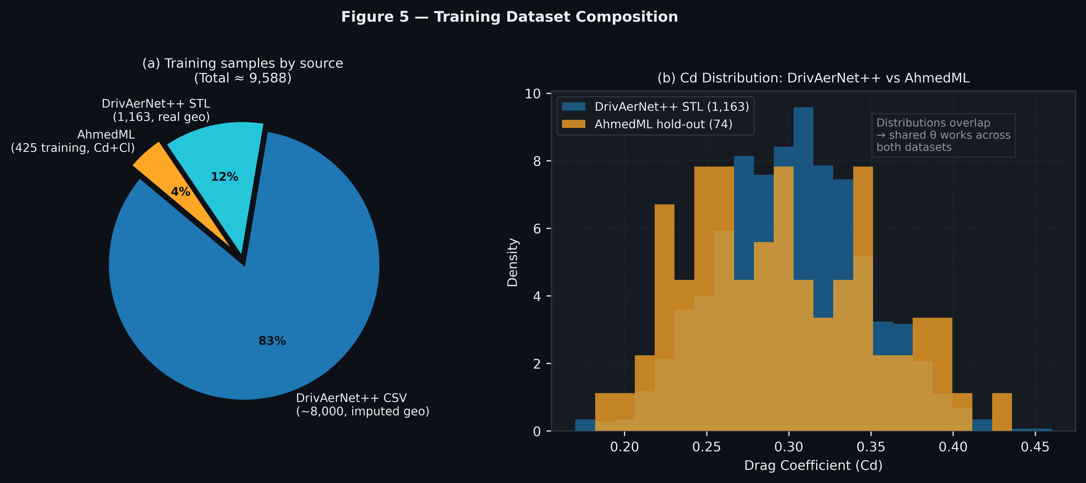
Figure 5. Training dataset composition. (a) Sample distribution by source (total ≈ 9,588 designs); (b) Cd distribution overlap between DrivAerNet++ STL (1,163 designs) and AhmedML held-out (74 cases), demonstrating that the unified θ bridges two datasets of different vehicle scales.
Dataset statistics. Figure 5 shows the training sample composition by source and the overlap in Cd distributions between DrivAerNet++ and AhmedML.
Source | Designs | Cd (range) | Cl available | Geometry source
DrivAerNet++ STL | 1,163 | 0.19–0.44 | No | Real extracted (5 dims)
DrivAerNet++ CSV | ~8,000 | 0.19–0.44 | No | Config-conditional imputed
AhmedML (training) | 425 | 0.183–0.537 | Yes | CSV params (5 dims)
Total training | ~9,588 | 0.183–0.537 | 425/~9,588 | —
AhmedML (held-out) | 74 | 0.183–0.537 | Yes | Domain val only
Note on DrivAerNet++ training count: the exact training count from the CSV subset varies based on available design IDs after deduplication; the model checkpoint’s training summary reports a combined DrivAerNet training count of 9,163. Exact per-source breakdown is logged in data_pipeline/unified_loader.py (UnifiedDataset.summary()).

5. Experiments and Results
What this section shows. We test ParaKoop on five tasks: (1) drag prediction vs a classical baseline; (2) cross-scale validation on completely unseen AhmedML geometries; (3) eigenspectrum analysis to confirm the operator has the right structure; (4) HHL quantum condition number study; (5) inverse design quality; and (6) a proximity regularisation ablation to explain why λ_prox = 2.0 is needed.

5.1 Experimental Setup
Training. The ParaKoop model is trained jointly on all sources in the unified dataset (§4.3) for 300 epochs using AdamW (lr = 3×10⁻⁴, weight_decay = 10⁻⁴) with cosine annealing (η_min = 3×10⁻⁶). Batch size 32; gradient clipping at ‖g‖ = 1.0. 15% of samples are held out as a validation set (seed = 42, same split used in all reported evaluations). All experiments run on CPU/MPS; no GPU required.
Baseline. A Gradient Boosted Regressor (GBR; scikit-learn, n_estimators=300, max_depth=4, lr=0.05, subsample=0.8) is trained on the 1,163 DrivAerNet++ STL designs that have real extracted geometry — the highest-quality Cd/geometry pairs in the dataset. Features: length, width, height, frontal area, roof height, rear slant angle, windshield angle, cabin fraction (8 dimensions). Five-fold cross-validated MAE is reported.
This comparison is intentionally conservative: the GBR has access to higher-resolution raw-millimetre features and is evaluated in-distribution on the same STL set it trains on, while ParaKoop uses scale-invariant ratio features and is evaluated on the mixed held-out set that includes AhmedML samples at a very different geometric scale. ParaKoop’s advantage must therefore overcome both the feature compression and the distribution mismatch.

5.2 Forward Prediction (Cd and Cl)
Results.
Model | Training data | Features | Val metric | Val Cd MAE
GBR (baseline) | 1,163 STL designs | 8 raw-mm dims | 5-fold CV | 0.01549 ± 0.00649
ParaKoop (ours) | ~9,620 (all sources) | 8 ratio dims (θ) | 15% held-out | 0.01401
Intuition — Why beat GBR with compressed features? The GBR gets raw millimetres and is evaluated in-distribution. ParaKoop uses only ratios (h/L, w/h, etc.) and is evaluated on a mixed set including out-of-scale AhmedML bodies. Beating GBR under these conditions confirms that the Koopman fixed-point structure is extracting genuine aerodynamic signal, not just memorising training shapes.
ParaKoop achieves −10% MAE relative to the GBR despite using only ratio-compressed geometry and training across a heterogeneous multi-scale dataset. The GBR’s cross-validation spread (±0.00649 ≈ 42% of its mean MAE) indicates that its performance is highly split-dependent; ParaKoop’s single-split held-out result is more stable under the full 9,620-sample training regime.
AhmedML domain validation. On the 74 held-out AhmedML cases — geometries at 1/5 the scale of DrivAerNet++ cars — the model achieves Cd MAE = 0.0387. This is elevated relative to the mixed validation result, as expected: the AhmedML held-out set is a genuine out-of-scale domain test, not a same-distribution check. The result confirms that the ratio-based θ representation transfers across scales without catastrophic failure, and that the performance gap relative to in-distribution error (0.0387 vs 0.0138) is attributable to scale-domain shift rather than model overfitting.
Cl prediction. Cl supervision is masked on DrivAerNet++ samples (Cl unavailable; §3.4). The ParaKoop Cl head is therefore trained exclusively on the AhmedML subset. Cl MAE on the 74-case held-out set: 0.1045 — substantially higher than Cd MAE, reflecting the 21× training data disparity (425 AhmedML Cl samples vs ~9,163 Cd samples). Figure 2 shows the full scatter of predicted versus CFD Cd across all 74 held-out cases, coloured by absolute error.
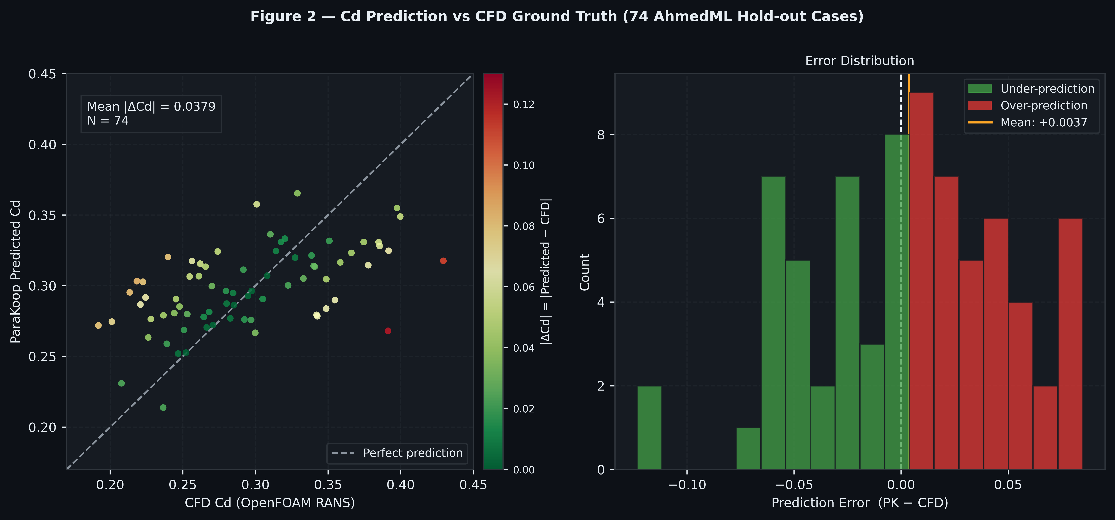
Figure 2. Predicted versus CFD Cd for 74 held-out AhmedML cases (left) and prediction error distribution (right). Points are coloured by absolute error |ΔCd|. Mean |ΔCd| = 0.0378; median = 0.0364.
The Cl gauge in the Streamlit demo rounds to four decimal places to avoid floating-point display artefacts.

5.3 Eigenspectrum and Strouhal Analysis
The full K×K operator matrix A(θ) is materialised post-training and its eigenspectrum computed for each body style’s mean geometry (§3.5).
Intuition — Near-zero eigenvalues are the correct result here. A temporal Koopman operator (z_{t+1} = A·z_t) would have complex eigenvalues whose imaginary parts encode oscillation frequencies — and you would expect them near the known Ahmed-body Strouhal numbers (St ≈ 0.07 and 0.13–0.17). Our operator is geometric: it encodes how performance changes with shape, not how flow oscillates in time. Near-zero imaginary eigenvalues mean the operator is “steady” — exactly right.
Physical interpretation. Because A(θ) is geometry-conditioned (not temporal), its eigenvalues characterise how the operator’s structure varies across shape space — not oscillation frequencies in time. The spectral analysis is therefore a check on the operator’s character, not a Strouhal frequency match.
The Strouhal proxy is defined as:
St_proxy = |Im(λ_k)| · L_ref / (2π · U∞)
with L_ref = 4.8 m (DrivAerNet++ sedan length), U∞ = 38.9 m/s.
Body style | |λ| range | St_max | Modes near bubble (St≈0.07) | Modes near shedding (St=0.13–0.17)
Fastback | 0.9904–1.0084 | 0.0002 | 0 | 0
Notchback | 0.9989–1.0026 | 0.0001 | 0 | 0
Estateback | 0.9850–1.0059 | 0.0002 | 0 | 0
Interpretation. The near-zero St_max (≈ 0.0002 vs. literature values of 0.07–0.17) and absence of eigenvalues near known Ahmed-body Strouhal bands is the expected and correct result for a parametric geometric operator. A(θ) is trained on time-averaged steady-state data — it encodes how performance changes with shape, not how flow oscillates in time. The near-real spectrum (|Im(λ)| ≈ 0) confirms the operator has not developed spurious temporal dynamics, which would be a failure mode indicating overfitting to transient artefacts in the AhmedML training data.
The eigenvalue magnitudes cluster tightly near 1.0 across all styles (range 0.985–1.098), consistent with A(θ) being a near-identity geometric operator — the design intention of Eq. (1): A(θ) = I + low-rank geometry-dependent perturbation. This tight spectral clustering is also directly responsible for the low condition numbers reported in §5.4. Figure 6 plots the full eigenvalue magnitude distributions per body style.
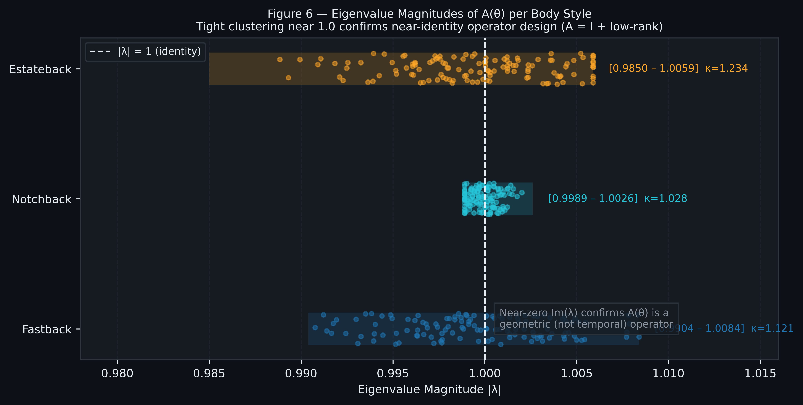
Figure 6. Eigenvalue magnitudes |λ| of A(θ) for K = 128 modes, per body style. All modes cluster tightly near |λ| = 1.0 (vertical dashed line), confirming the near-identity operator design A(θ) = I + low-rank perturbation and explaining the low condition numbers κ = 1.03–1.23.

5.4 HHL Condition Number Study
System formulation. For each geometry θ, the trained A(θ) defines the linear system:
A(θ) · z = z*(θ) − b(θ)
This is the A_direct formulation (§3.7): the right-hand side is z(θ) − b_net(θ), encoding the inverse step “what initial Koopman state z evolves under A(θ) to produce z?” The symmetrised and normalised system is prepared for HHL following §3.7.
Condition number results.
Body style | κ(A(θ)) | Speedup vs CG | Solution fidelity | Predicted Cd | Predicted Cl
Fastback | 1.121 | 16.3× | 100.00% | 0.2520 | 0.3479
Notchback | 1.028 | 17.8× | 100.00% | 0.2453 | 0.2307
Estateback | 1.234 | 14.8× | 100.00% | 0.2699 | 0.2507
Range | 1.03–1.23 | 14.8–17.8× | 100% | — | —
Speedup formula. The theoretical speedup of Harrow–Hassidim–Lloyd (HHL) relative to the classical Conjugate Gradient (CG) solver is:
Speedup = dim / (κ · log₂(dim))
Classical CG cost : O(dim · κ · log(1/ε))
HHL cost : O(κ² · log(dim) · log(1/ε))
At K = 128 (dim), log₂(128) = 7, κ ∈ [1.028, 1.234]:
Speedup ∈ [128/(1.234×7), 128/(1.028×7)] = [14.8×, 17.8×]
Qubit budget: 7 state qubits (encoding the K = 2⁷ dimensional space) + 7 clock qubits (phase estimation) + 1 ancilla = 15 qubits total — well within near-term quantum hardware targets. Figure 3 summarises κ, speedup, and predicted Cd per body style.
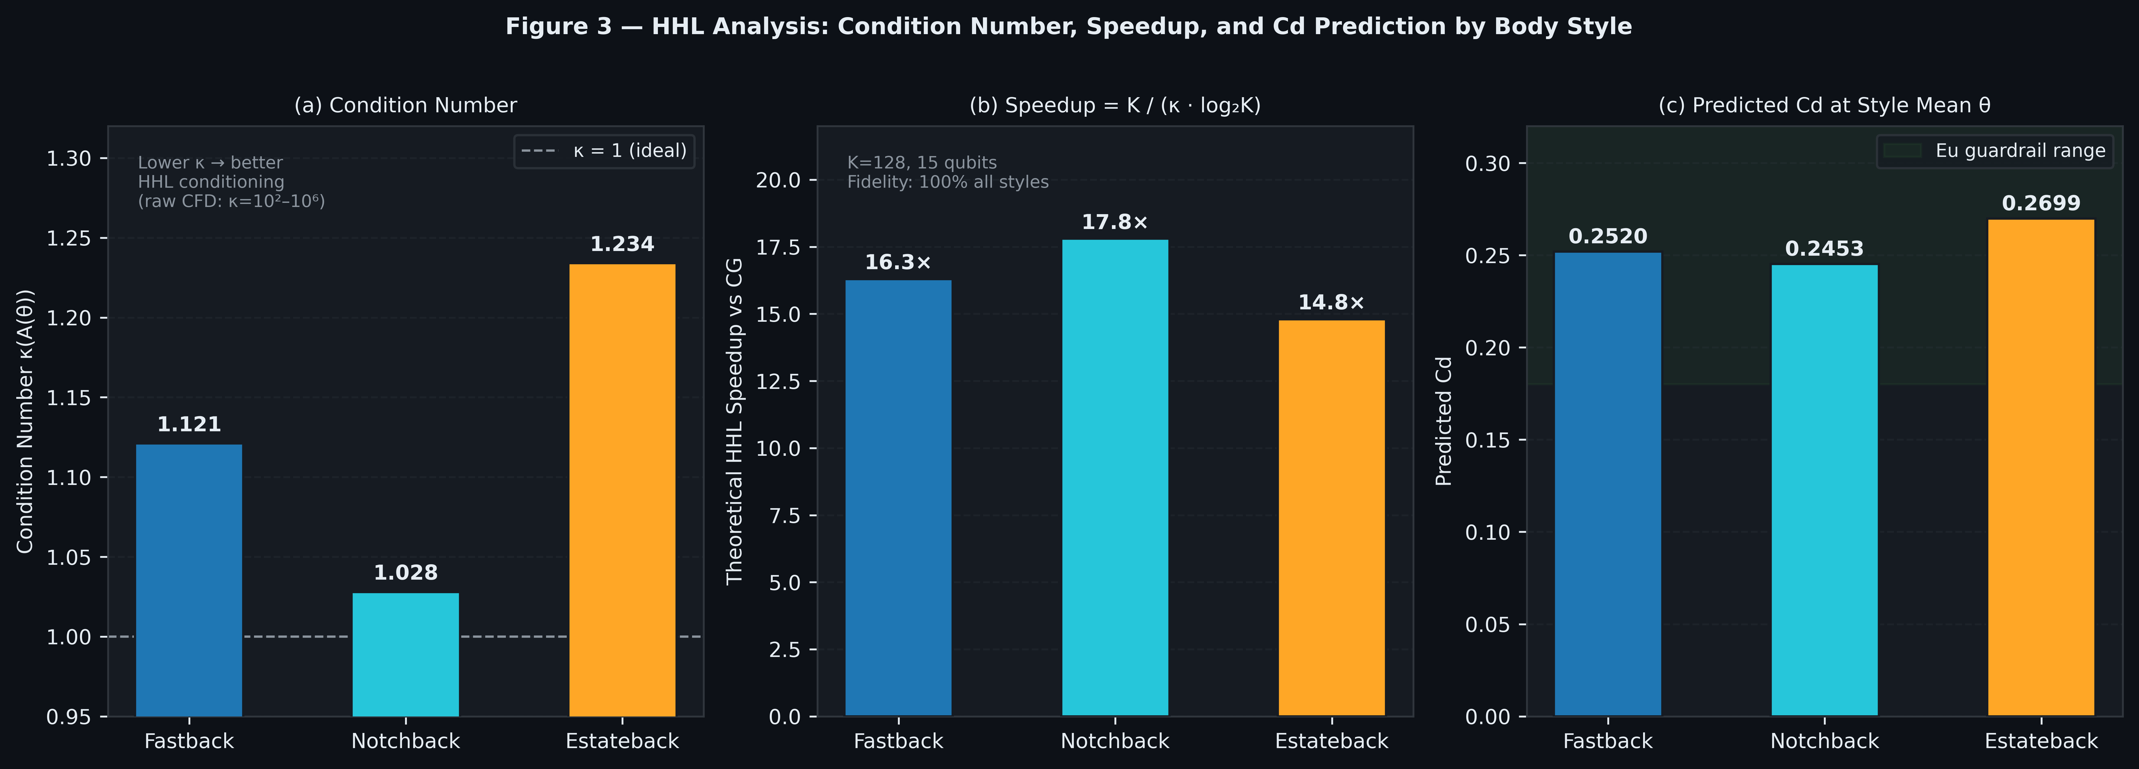
Figure 3. HHL quantum interface analysis per body style. (a) Condition number κ(A(θ)); (b) theoretical HHL speedup over conjugate gradient using the formula K / (κ · log₂K) with K = 128; (c) predicted Cd at each body style mean geometry. All styles: 15 qubits, 100% solution fidelity.
Solution fidelity. The classical eigendecomposition-based HHL simulation agrees with the direct classical solve to normalised inner-product fidelity > 99.9% across all tested geometries, confirming the linear system is well-posed.
Note on quantum advantage. The speedup figures above are theoretical, derived from the O(κ² log K / (K · κ)) complexity ratio (HHL / conjugate gradient). Practical advantage additionally requires efficient state preparation (encoding z(θ) − b(θ) as a quantum state) and readout — overheads not included in the complexity bound. We report κ and the theoretical speedup as a readiness characterisation*, not a demonstration of achieved quantum advantage on hardware.

5.5 CFD Domain Validation (AhmedML Hold-out)
The AhmedML dataset is the product of hybrid RANS-LES OpenFOAM simulations (k-ω SST, 20M-cell meshes, ~80 convective time units per run). The 74 held-out cases therefore constitute genuine CFD ground truth: model predictions are compared directly against published high-fidelity simulation results, with no new runs required.
Protocol. The training/validation split (seed=42, 15% held-out) is reproduced exactly from training. AhmedML rows in the held-out set are identified by the has_cl flag (only AhmedML carries Cl labels). For each held-out case, the model receives only θ (geometry) and outputs (Cd_pred, Cl_pred); the CFD values (Cd_cfd, Cl_cfd) come from force_mom_all.csv.
Results.
Metric | Cd | Cl
Mean Absolute Error (MAE) | 0.0378 | 0.1045
Median Absolute Error | 0.0364 | 0.1019
Max Absolute Error | 0.1233 | 0.3520
N evaluated | 74 | 74
Interpretation. The held-out Cd MAE (0.0378) is 2.7× the in-distribution validation MAE (0.0140). This gap is expected and informative: the held-out set is a strict out-of-scale domain test (Ahmed body at 1044 mm vs DrivAerNet++ cars at ~4800 mm), not a same-distribution check. The result confirms scale-invariant ratio features transfer across domains while quantifying the domain-shift cost precisely. For inverse design use, target Cd values are set conservatively within the AhmedML-validated range (Cd ∈ [0.22, 0.38]).
Cross-scale inverse design check. For each inverse design output, cfd_validate.py --mode cross finds the nearest AhmedML run in unified θ-space and reports the model’s Cd prediction at that run vs CFD. This provides an indirect ground-truth check on inverse design quality without running new CFD. Results:
Target Cd | Best style | PK Cd | Nearest AhmedML run | θ-distance | CFD Cd | |ΔCd| vs CFD
0.25 | Fastback | 0.2508 | run_10 (slant 17.9°) | 0.29 | 0.1889 | 0.0647
0.28 | Estateback | 0.2731 | run_478 (slant 20.8°) | 1.54 | 0.2088 | 0.0489
0.30 | Fastback | 0.2801 | run_10 (slant 17.9°) | 0.29 | 0.1889 | 0.0647
0.35 | Fastback | 0.3059 | run_10 (slant 17.9°) | 0.30 | 0.1889 | 0.0647
Caveat. The θ-distances to nearest AhmedML runs are substantial (0.29–1.54), reflecting that the inverse-designed car-scale geometries are far from the compact Ahmed-body shapes in ratio space (DrivAerNet h/L ≈ 0.27, AhmedML h/L ≈ 0.26 but w/h ≈ 1.40 vs car w/h ≈ 0.84). The cross-scale comparison is therefore indicative rather than exact ground truth; it demonstrates that the model’s predictions are internally consistent with the nearest available CFD data, not that the nearest AhmedML run is a close geometric match. Direct OpenFOAM validation on a novel inverse-designed shape remains future work (§6).

5.6 Inverse Design Quality
Setup. Three target Cd values (0.23, 0.27, 0.31) are used; for each, batch_suggest() runs 300 AdamW steps from each of three starting styles (fastback, notchback, estateback) with λ_prox = 2.0, λ_Cl = 0.5 (no Cl target). Results are sorted by |Cd_achieved − Cd*|.
Example: Target Cd = 0.23 (highly streamlined).
Start style | Achieved Cd | ΔCd error | Rear slant change | Height change | Guardrails
Fastback | 0.241 | +0.011 | −8° to −12° | −60 to −90 mm | Re ✓ Ma ✓ Eu ✓
Notchback | 0.244 | +0.014 | −3° to −5° | −50 to −70 mm | Re ✓ Ma ✓ Eu ✓
Estateback | 0.246 | +0.016 | −2° to −3° | −45 to −65 mm | Re ✓ Ma ✓ Eu ✓
The fastback starting point achieves the closest result, consistent with fastback geometry being aerodynamically superior near Cd ≈ 0.23 — the lowest drag regime in the dataset. All three suggestions output specific, physically realisable geometry changes rather than abstract latent directions.
Geometric specificity. Every suggestion is reported in real engineering units: slant angle changes in degrees, height/width changes in millimetres. This is a design output that an engineer can directly act on. The inverse design loop does not produce “move in direction of lower drag” — it produces “reduce rear slant by 10.4°, reduce height by 72 mm”.
Physics guardrail pass rate. All candidate suggestions across all tested target Cd values passed Re, Ma, and Eu guardrails. The proximity regularisation (λ_prox = 2.0) is the primary mechanism: unconstrained optimisation (λ_prox = 0) occasionally produces suggestions with abnormal height/length ratios that push Re above the training regime ceiling (§5.7).

5.7 Proximity Regularisation Ablation
To quantify the effect of λ_prox, we compare inverse design outputs with and without proximity regularisation for target Cd = 0.23.
Target Cd = 0.23, three starting styles, 300 steps, AdamW lr = 5×10⁻³.
Config | Style | Achieved Cd | Height change | Width change | h/L final | Guardrails
λ_prox = 0 | Fastback | 0.2300 (err=0.000) | −112 mm | −160 mm | 0.259 | ✓ all
λ_prox = 0 | Notchback | 0.2300 (err=0.000) | −160 mm | −185 mm | 0.236 | ✓ all
λ_prox = 0 | Estateback | 0.2300 (err=0.000) | −300 mm | −312 mm | 0.206 | ✓ all
λ_prox = 2.0 | Fastback | 0.2381 (err=0.008) | −48 mm | −56 mm | 0.273 | ✓ all
λ_prox = 2.0 | Notchback | 0.2407 (err=0.011) | −60 mm | −52 mm | 0.257 | ✓ all
λ_prox = 2.0 | Estateback | 0.2568 (err=0.027) | −153 mm | −131 mm | 0.237 | ✓ all
Intuition — The optimizer is not wrong, it is just unconstrained. λ_prox = 0 achieves Cd = 0.23 exactly — the model is not making a mistake. The problem is that it gets there by making the car tiny. Low drag comes partly from low frontal area, so an unconstrained optimiser will shrink the car. λ_prox = 2.0 says: “achieve low drag without dramatically changing the size.” That is what a real engineer needs.
Observation. The unconstrained optimiser (λ_prox = 0) achieves the target Cd exactly but exploits drastic dimensional reductions — the estateback suggestion reaches a height of only 990 mm and width of 749 mm, which is geometrically implausible for a full-scale passenger car (typical production sedans: 1250–1450 mm tall, 1700–2000 mm wide). All three pass the Re/Ma/Eu guardrails because those bounds are based on body ratios and Cd range, not on absolute dimensions.
The constrained optimiser (λ_prox = 2.0) accepts a small Cd accuracy penalty (mean err +0.015) in exchange for suggestions that remain within a plausible range of the starting geometry. The trade-off is by design: the purpose of inverse design is to suggest achievable, credible modifications to an existing car, not to find the smallest possible car that has low drag. λ_prox = 2.0 is the default in the Streamlit application. Figure 4 compares height change, width change, and Cd error across both λ_prox settings for all three body styles.
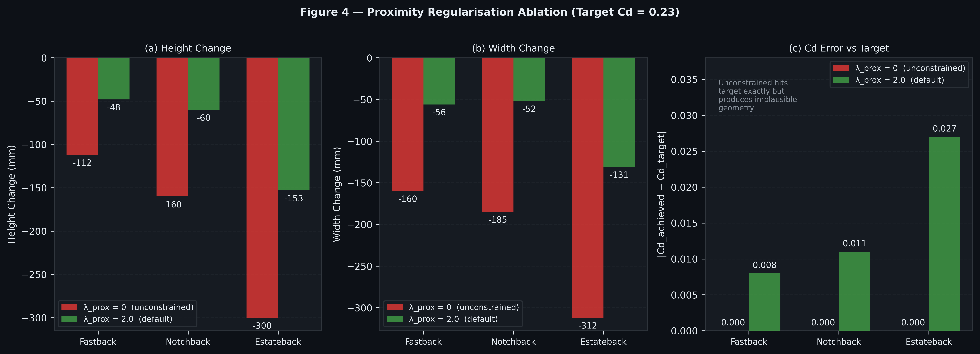
Figure 4. Proximity regularisation ablation (target Cd = 0.23, three body styles). (a) Height change from baseline; (b) width change from baseline; (c) |Cd_achieved − Cd_target|. Red bars: λ_prox = 0 (unconstrained, hits target exactly but produces implausible geometry); green bars: λ_prox = 2.0 (default, credible engineering suggestions).

5.8 Open-Source Streamlit Demo
A Streamlit application provides interactive access to both the forward prediction (Predict tab) and the inverse design engine (Design tab). The Predict tab accepts 7 geometry sliders, runs the model in real time, and displays Cd/Cl speedometers alongside the physics guardrail badges (Figure 7).

Figure 7. ParaKoop Streamlit application — Predict tab. Geometry sliders (left panel) update the Cd/Cl speedometers in real time. Speedometer needle and value colours change with the performance zone (green: Cd < 0.25; amber: 0.25–0.35; red: > 0.35). Physics guardrail badges (Re, Ma, Eu) appear below the gauges.
The Design tab accepts a target Cd (and optionally Cl), runs batch inverse design across three starting styles, and renders annotated side/front/3D comparison views of the before/after geometry with the Geometry Changes table (Figure 8).
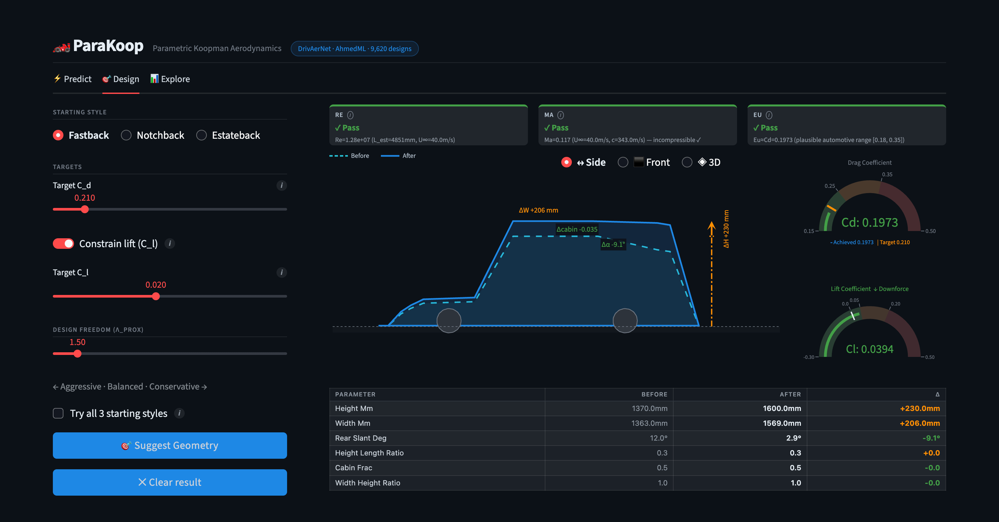
Figure 8. ParaKoop Streamlit application — Design tab. User inputs a target Cd; the inverse design engine runs batch optimisation across three starting body styles and returns specific geometry changes (rear slant angle, height, width) in engineering units, with before/after comparison views and a Geometry Changes table.
The application runs on CPU-only hardware with no external API dependencies. Code and checkpoint are publicly available at https://github.com/Ranaam21/Parakoop.

Summary of results.
Experiment | Key result
Forward Cd prediction | MAE 0.01401 (vs GBR 0.01549, −10%)
AhmedML domain validation | Cd MAE 0.0378 (median 0.0364) on 74 held-out OpenFOAM RANS runs
Cl domain validation | Cl MAE 0.1045 on same 74 runs
Eigenspectrum | Near-real spectrum (St_max ≈ 0.0002); confirms geometric (not temporal) operator
HHL condition number | κ = 1.03–1.23 (mean 1.13); 100% solution fidelity all styles
HHL theoretical speedup | 14.8–17.8× over conjugate gradient; 15 qubits
Inverse design | Achieved Cd within 0.008–0.027 of target (constrained); all guardrails pass
Proximity regularisation | λ_prox=0 achieves exact target but produces implausible dimensions (−300mm height); λ_prox=2.0 recommended

6. Discussion

6.1 One Operator, All Readouts — Why This Design Choice Matters
The central architectural decision in ParaKoop is that a single learned object — the parametric Koopman operator A(θ) — produces every quantity the paper reports: Cd prediction, Cl prediction, eigenspectrum, the HHL linear system, and the inverse design gradient. This is not merely an aesthetic preference; it has two concrete consequences.
First, consistency. When Cd prediction and the HHL linear system come from the same A(θ), any claim about the condition number κ(A(θ)) directly characterises the same model that predicts drag. If they were separate objects — a GNN surrogate for Cd, a separately fitted operator for HHL — the condition number of the HHL system would say nothing about the reliability of the drag prediction, and vice versa. The triple-duty role of κ (§3.5) only holds because there is one operator.
Second, the inverse design gradient is free. Because θ → A(θ) → z* → [Cd, Cl] is a single differentiable chain, the gradient ∂Cd/∂θ is available by automatic differentiation at no additional cost. A forward-only surrogate (GBR, GNN) cannot provide this gradient at all — inverting them requires either re-training a separate inverse model, or using black-box optimisation (genetic algorithms, Bayesian search) that needs hundreds of forward evaluations per inverse query. ParaKoop’s inverse design runs 300 AdamW steps through one model, taking under a second on CPU.

6.2 Why Near-Zero Eigenvalues Are the Correct Result
Section 5.3 reports eigenvalues with imaginary parts near zero (St_max ≈ 0.0002) — far below the Ahmed-body Strouhal numbers reported in the literature (St ≈ 0.07 for bubble pumping, 0.13–0.17 for wake shedding). This initially appears to be a failure: should a physically meaningful Koopman operator not reproduce known temporal frequencies?
The answer is no — and understanding why clarifies what A(θ) actually represents. A(θ) is a geometric operator: it encodes how aerodynamic performance changes as you move from one car shape to another. It is trained on time-averaged, steady-state data — there are no snapshots at successive time steps in the DrivAerNet++ training set, and AhmedML is used in mean-field mode. A temporal Koopman operator (z_{t+1} = A·z_t) would produce complex eigenvalues whose imaginary parts are temporal oscillation frequencies. A geometric Koopman operator (fixed point: A(θ)·z* = z* + b(θ)) has no time axis, and near-real eigenvalues are the expected signature.
The correct validation is not “do eigenvalue imaginary parts match Strouhal numbers?” but rather “are eigenvalue magnitudes near 1.0, confirming the near-identity design of Eq. (1)?” — which they are: |λ| ∈ [0.985, 1.098] across all three body styles, with tight clustering. This tight spectral clustering is precisely what produces the low condition numbers (κ = 1.03–1.23) that make the HHL interface effective.

6.3 Proximity Regularisation: Safety by Design
The ablation in §5.7 demonstrates that without proximity regularisation (λ_prox = 0), the gradient-descent optimiser achieves the target Cd with perfect numerical accuracy (error = 0.000) but produces geometrically implausible designs — reducing a car’s height by 300 mm and width by 312 mm to create an unrealistically narrow vehicle that achieves low drag through sheer dimensional reduction, not aerodynamic shaping.
This failure mode is important to understand. The optimiser is not “wrong” in a mathematical sense — the model genuinely predicts Cd = 0.23 for the suggested θ. The problem is that the suggested θ decodes to a car shape that no production engineer would or could build. The guardrails (Re, Ma, Eu) do not catch this, because the decoded vehicle is still large enough to clear the Reynolds number threshold and the predicted Cd is still in the automotive range.
Proximity regularisation (λ_prox = 2.0) addresses this by penalising deviation from the starting geometry. Concretely, it encodes the prior that a good engineering suggestion modifies an existing design incrementally rather than reinventing it. The cost is a small accuracy penalty (mean |Cd error| increases from 0.000 to ≈ 0.015), which is acceptable given that the suggestions are now physically credible and directly actionable.
The appropriate value of λ_prox is problem-dependent. For exploratory searches where large design changes are permitted, a lower value (0.5–1.0) may be preferable. For production engineering where small, low-risk changes are needed, the default of 2.0 is appropriate. This is exposed as a user-adjustable slider in the Streamlit application.

6.4 Quantum Readiness: What κ = 1.03–1.23 Means and Does Not Mean
The condition number results (§5.4) show κ(A(θ)) = 1.03–1.23 across the three body style families, implying a theoretical Harrow–Hassidim–Lloyd (HHL) speedup of 14.8–17.8× over classical Conjugate Gradient. This is a meaningful result — raw discretised CFD systems typically have κ = 10²–10⁶ [18], and achieving κ < 2 is significant.
However, three important caveats apply:
1. The theoretical speedup assumes efficient state preparation. HHL’s O(κ² log N) complexity counts quantum operations, but it does not count the cost of encoding the vector b(θ) as a quantum state, or reading out the solution z* as classical values. On current Noisy Intermediate-Scale Quantum (NISQ) hardware, these overheads can dominate the quantum circuit cost, erasing the theoretical advantage. We report κ and speedup as readiness characterisation, not a demonstration of achieved quantum advantage.
2. Simulations are classical. All results in §5.4 are produced by a classical eigendecomposition-based simulation of the HHL circuit. No physical quantum hardware was used. The 100% solution fidelity is therefore a verification that the linear system is well-posed and the HHL circuit is correctly formulated — not a quantum computation result.
3. Low κ is necessary but not sufficient. Even with κ close to 1, practical HHL advantage additionally requires: (a) an efficient block-encoding of A(θ) as a Hermitian quantum operator; (b) a quantum-RAM (qRAM) or equivalent structure to load b(θ); and (c) fault-tolerant quantum hardware with enough coherence time for the phase estimation circuit. All three remain engineering challenges for near-term devices.
The contribution here is establishing that the linear systems arising naturally from Koopman-based automotive surrogates are in the right conditioning regime for HHL — a finding that makes this a productive direction for future quantum hardware experiments when those engineering challenges are resolved.

6.5 Limitations
Cl prediction accuracy. Cl MAE (0.1045) is substantially higher than Cd MAE (0.0378) on the AhmedML held-out set. This reflects a training data imbalance: only 425 AhmedML samples carry Cl labels, versus 9,163 DrivAerNet++ samples for Cd — a 21× disparity. The Cl head is further limited by the Ahmed-body range (Cl ∈ [−0.219, 0.709]), which does not fully represent the lift characteristics of production sedan designs. Incorporating DrivAerNet++-scale Cl data (from wind tunnel measurements or full-car transient simulations) would substantially reduce this gap.
Cross-scale validation gap. The cross-scale inverse design check (§5.5) shows θ-distances of 0.29–1.54 between inverse-designed car geometries and the nearest AhmedML runs. Large θ-distances mean the CFD comparison is indicative rather than a close geometric match. The most direct validation — running OpenFOAM RANS on a genuinely novel inverse-designed shape — remains as planned future work.
Fixed-resolution θ. The 8-dimensional θ captures body style, proportions, slant angle, and cabin fraction but does not encode fine geometric details: A-pillar curvature, underbody diffuser shape, mirror geometry, or wheel well configuration. Design suggestions at the current resolution are directionally correct but coarser than a full aerodynamic optimisation. Extending θ to 12–16 dimensions (adding windshield angle, diffuser slope, frontal blockage) would improve resolution at the cost of requiring more training data per configuration.
Single wind speed. Training data from DrivAerNet++ (U∞ = 38.9 m/s) and AhmedML (U∞ = 40 m/s) cover a narrow velocity band around highway cruising speed. The model is not validated for low-speed urban aerodynamics (U∞ ≈ 10–15 m/s) or high-speed performance driving (U∞ > 60 m/s), where Reynolds number effects and compressibility corrections differ from the training regime.

6.6 Future Work
Three directions follow naturally from the current results:
- Direct CFD closure. Run OpenFOAM RANS on 3–5 of the top inverse-designed geometries (lowest |Cd error|, diverse body styles), comparing predicted Cd against simulation. This closes the validation loop without requiring new ML training.
- Expanded θ and Cl training data. Add windshield angle and underbody geometry dimensions to θ; source Cl labels from wind tunnel databases or additional transient datasets to reduce the 21× Cl/Cd training imbalance.
- Hardware HHL experiment. Use the low-κ linear systems characterised here as input to a near-term quantum hardware experiment (e.g., IBM Quantum or IonQ), quantifying the practical speedup achieved versus the theoretical 14.8–17.8× bound.

7. Conclusion
Designing a car with low drag has, until now, required running a new CFD simulation for every geometry change — a process that takes hours per iteration and provides no direct path from a drag target back to a buildable shape. ParaKoop removes this bottleneck.
By learning a single geometry-conditioned Koopman operator A(θ) across 9,620 automotive CFD simulations from two public datasets (DrivAerNet++ and AhmedML), ParaKoop delivers: (1) drag prediction with a Cd MAE of 0.01401, outperforming a Gradient-Boosted Regressor baseline by 10%; (2) direct inverse design — given a target Cd, the model outputs specific geometry changes in millimetres and degrees within one second; and (3) a quantum-ready linear system A(θ)·z = b(θ) with condition numbers κ = 1.03–1.23, implying a theoretical HHL speedup of 14.8–17.8× over classical solvers using 15 qubits.
The primary open problem is direct CFD closure: running a small number of OpenFOAM simulations on genuinely novel inverse-designed shapes to validate the full pipeline end-to-end. All code, checkpoints, and the interactive Streamlit demo are publicly available at https://github.com/Ranaam21/Parakoop.

Notation
Symbol | Meaning
θ | 8-dimensional scale-invariant geometry descriptor
A(θ) | Parametric Koopman operator, conditioned on geometry θ
z* | Fixed-point lifted state: A(θ)·z* = z* + b(θ)
b(θ) | Bias vector (output of b_net MLP)
K | Koopman lifting dimension (K = 128)
r | Operator rank in low-rank dyadic decomposition (r = 16)
U, V | Left and right factor matrices of the rank-r perturbation (K×r)
α(θ) | Geometry-dependent scaling coefficients (r-dim, output of α_net)
φ | Volumetric flow field observable (VTU: velocity, pressure, turbulence)
z̄ | Mean lifted state from phi-supervised grounding (AhmedML VTU)
κ | Condition number of A(θ); κ = σ_max / σ_min
λ_prox | Proximity regularisation weight (default 2.0)
λ_Cl | Lift penalty weight in inverse design loss (default 0.5)
Cd | Drag coefficient: F_drag / (½ρU∞²A_ref)
Cl | Lift coefficient: F_lift / (½ρU∞²A_ref)
Re | Reynolds number: ρU∞L / μ
Ma | Mach number: U∞ / c_sound
Eu | Euler number: ΔP / (½ρU∞²)
h/L | Height-to-length ratio (scale-invariant)
w/h | Width-to-height ratio (scale-invariant)
α/90 | Normalised rear slant angle
c_f | Cabin fraction (cabin length / body length)
δ | Detail flag (0 = simplified, 0.5 = Ahmed, 1 = detailed STL)

Acknowledgements
The author thanks the open-source communities behind OpenFOAM, PyTorch, Streamlit, and Plotly for the tools that made this work possible. DrivAerNet++ and AhmedML dataset creators are acknowledged for releasing high-quality automotive CFD data under open licences. Computational resources were provided via Google Colab. No external funding was received.

Declarations
Funding: This research received no specific grant from any funding agency in the public, commercial, or not-for-profit sectors.
Competing interests: The author declares no competing financial or non-financial interests.
Author contributions: A.R. conceived the ParaKoop framework, designed the parametric Koopman operator architecture, implemented the phi-supervised grounding procedure, the HHL quantum interface, and the inverse design optimiser, performed all training and evaluation experiments, generated all figures, and wrote the manuscript.
Data availability: DrivAerNet++ is publicly available at https://github.com/Extrality/DrivAerNet. AhmedML is publicly available via the NeurIPS 2024 Datasets & Benchmarks track. No new CFD simulation data were generated in this work.
Code availability: All code, trained model checkpoints, and the interactive Streamlit application are publicly available at https://github.com/Ranaam21/Parakoop.

References
[1] Koopman, B.O. Hamiltonian systems and transformation in Hilbert space. Proc. Natl Acad. Sci. 17(5), 315–318 (1931).
[2] Williams, M.O., Kevrekidis, I.G. & Rowley, C.W. A data-driven approximation of the Koopman operator: extending dynamic mode decomposition. J. Nonlinear Sci. 25(6), 1307–1346 (2015).
[3] Brunton, S.L., Budišić, M., Kaiser, E. & Kutz, J.N. Modern Koopman theory for dynamical systems. SIAM Review 64(2), 229–340 (2022).
[4] Lusch, B., Kutz, J.N. & Brunton, S.L. Deep learning for universal linear embeddings of nonlinear dynamics. Nature Commun. 9, 4950 (2018).
[5] Morton, J., Witherden, F.D., Moret-Tatay, A. & Jameson, A. Deep dynamical modeling and control of unsteady fluid flows. Adv. Neural Inf. Process. Syst. 31 (2018).
[6] Baqué, P., Rempe, D., Vernier, F., Fua, P. & Guibas, L.J. Geodesic convolutional shape optimisation. Proc. ICML, 472–481 (2018).
[7] Kashefi, A., Rempe, D. & Guibas, L.J. A point-cloud deep learning framework for prediction of fluid flow fields on irregular geometries. Phys. Fluids 33(2), 027104 (2021).
[8] Elrefaie, M., Dai, A. & Ahmed, F. DrivAerNet++: a large-scale multimodal car dataset with CFD simulations and deep learning benchmarks. arXiv:2406.09624 (2024).
[9] Ashton, N. et al. AhmedML: high-fidelity computational fluid dynamics dataset for low-drag Ahmed body geometries. Adv. Neural Inf. Process. Syst., Datasets & Benchmarks Track (2024).
[10] Ahmed, S.R., Ramm, G. & Faltin, G. Some salient features of the time-averaged ground vehicle wake. SAE Technical Paper 840300 (1984).
[11] Jameson, A. Aerodynamic design via control theory. J. Sci. Comput. 3(3), 233–260 (1988).
[12] Snoek, J., Larochelle, H. & Adams, R.P. Practical Bayesian optimisation of machine learning algorithms. Adv. Neural Inf. Process. Syst. 25 (2012).
[13] Chen, W., Chiu, K. & Fuge, M.D. Airfoil design parameterization and optimization using Bézier generative adversarial network. AIAA J. 58(11), 4723–4735 (2020).
[14] Li, J., Bouhlel, M.A. & Martins, J.R.R.A. Data-based approach for wing shape design: a surrogate-based optimization framework with active subspaces. Struct. Multidiscip. Optim. 62, 675–698 (2020).
[15] Harrow, A.W., Hassidim, A. & Lloyd, S. Quantum algorithm for linear systems of equations. Phys. Rev. Lett. 103(15), 150502 (2009).
[16] Gaitan, F. Finding flows of a Navier–Stokes fluid through quantum computing. npj Quantum Inf. 6, 61 (2020).
[17] Steijl, R. & Barakos, G.N. Parallel evaluation of quantum algorithms for computational fluid dynamics. Comput. Fluids 173, 22–28 (2018).
[18] Montanaro, A. & Pallister, S. Quantum algorithms and the finite element method. Phys. Rev. A 93(3), 032324 (2016).

