Atomic Layer Deposition Showerhead Geometry Optimisation via a Physics-Guardrailed Dual-Track Surrogate Framework: Parametric and Topology-Variable CSG Search
Amit Rana
Independent Researcher
Santa Clara, California, USA
ORCID: 0009-0008-5998-6560 | amit21aim@zohomail.com
Jun 2026
Abstract
Atomic Layer Deposition (ALD) — a nanoscale thin-film manufacturing process that deposits precisely one atomic layer per reaction cycle — demands extreme uniformity in precursor gas distribution across the wafer surface. The showerhead, a perforated faceplate that disperses process gas, is the critical hardware controlling this uniformity. Today, showerhead design is largely manual, guided by engineering intuition and expensive Computational Fluid Dynamics (CFD) simulations that each take 6–10 hours. This paper presents a physics-guardrailed, machine-learning-accelerated framework that evaluates new showerhead geometries in seconds. The framework operates on two parallel geometry tracks: Track 1 (PCGM — Physics-Constrained Geometric Morphogenesis) searches a parametric hex nozzle array design space; Track 2 (VICES — Voxel-Implicit Computational Engineering Synthesis) synthesises topologically novel geometries using Constructive Solid Geometry (CSG) boolean operations on Signed Distance Fields (SDF) followed by Marching Cubes triangulation, exploring four topology families. A multi-head Graph Neural Network (GNN) surrogate, trained on 123 OpenFOAM reactingFoam cases, predicts velocity, pressure, temperature, and species fields. An eleven-parameter physics guardrail engine enforces dimensionless-number constraints (Re, Ma, Eu, Pr, Nu, Bi, Sc, Sh, Pe_h, Pe_m, Da). A multi-fidelity Key Performance Indicator (KPI) surrogate achieves out-of-fold (OOF) Spearman rank correlation rho = 0.947. Track 2 topology search improves TMA (Trimethylaluminium, Al(CH3)3)) Uniformity Index (TMA-UI) by +0.448 over the best parametric design (0.792 vs 0.344, +130%), demonstrating that the topology gap — not surrogate prediction accuracy — is the binding constraint in ALD showerhead design. The annular-ring geometry that achieves the best performance physically cannot be represented by any hex-array parameter setting; the geometry itself is the contribution, and the surrogate simply measures it.
Keywords: Atomic Layer Deposition; Graph Neural Network surrogate; Constructive Solid Geometry; Signed Distance Field; Marching Cubes; Physics guardrails; Showerhead optimisation; OpenFOAM; Dimensionless numbers

1. Introduction
ALD is the enabling deposition technology for advanced semiconductor nodes below 5 nanometres, solid-state battery electrolytes, and flexible electronics [1,2]. Its defining feature is self-limitation: each half-cycle saturates the wafer surface with exactly one monolayer of precursor, then a co-reactant completes the reaction. This mechanism delivers atomic-precision thickness control, but only if the precursor gas — Trimethylaluminium (TMA, Al(CH3)3) for aluminium oxide films — arrives uniformly at every point on the wafer in every cycle. Non-uniformity directly causes spatially varying film thickness, a device-killing defect at the nanoscale.
The showerhead — a perforated faceplate through which precursor gas is injected — is the component that determines this uniformity. Its geometry (nozzle diameter, spacing pattern, plenum shape, internal features) controls the three-dimensional gas flow field that delivers precursor to the wafer. Despite its critical importance, showerhead design today remains largely manual: an engineer proposes a geometry, runs a CFD simulation (6–10 hours per design), analyses the result, and adjusts. This loop explores only a tiny fraction of the design space and is constrained to one topology family.
1.1 A Geometric Approach — Not a Physics Solver
Before describing the framework, it is important to position this work correctly relative to other machine learning approaches to CFD. A large body of recent literature focuses on Physics-Informed Neural Networks (PINNs) and neural PDE solvers — methods that embed the Navier-Stokes equations as loss terms and learn to solve them faster or more accurately. This work is fundamentally different, and the distinction matters.
PINN / Custom Solver Approach | This Work — Geometric Topology Search
Takes a fixed geometry as input | Generates geometries that did not previously exist
Learns to solve Navier-Stokes faster or more accurately | Explores a topology space formally bounded by Catalan numbers
Novelty = better physics prediction quality | Novelty = access to designs parametric tools cannot reach
Design space: unchanged | Design space: expanded — new topological families synthesised
Table 0 — This work vs PINN/solver approaches. The distinction is not in how accurately we predict flow — it is in which designs we can reach.
Intuition — The geometry IS the contribution — the surrogate just measures it.
"Consider the central result: Track 2 achieves +130% TMA uniformity over Track 1. This improvement does not come from a better surrogate model. It comes from the fact that the annular-ring nozzle pattern physically cannot be represented by any hex-array parameter setting — no matter how many sliders you move. The geometry itself unlocks the performance. The surrogate simply evaluates it quickly. A fundamental principle in computational engineering design states: the bottleneck is not analysis speed — it is the ability to synthesise geometries outside the engineer's mental model. Our Catalan number characterisation formally proves why parametric tools miss these designs: for n primitives, C(n-1) distinct CSG (Constructive Solid Geometry) tree topologies exist, and every parametric tool is locked to exactly one of them."

We present a dual-track surrogate framework with two distinct geometry synthesis approaches:
- Track 1 — PCGM (Physics-Constrained Geometric Morphogenesis): a parametric approach. The showerhead geometry is described by a small set of continuous sliders — nozzle diameter, hole spacing, plenum height, faceplate thickness, and standoff gap. PCGM generates a hex-pattern nozzle array from these parameters and evaluates it with a GNN surrogate in seconds. Think of this as the engineer's traditional design space: you adjust familiar parameters and observe how performance changes. The topology — the fundamental arrangement and connectivity of the internal geometry — is fixed.
- Track 2 — VICES (Voxel-Implicit Computational Engineering Synthesis): a geometric synthesis approach. Instead of sliders, VICES builds showerhead geometries from scratch using Constructive Solid Geometry (CSG) — combining primitive shapes (cylinders, cones, boxes) through boolean operations (union, subtract, intersect) to create four fundamentally different topology families: baffled plenums, conical diffusers, annular ring nozzle arrays, and two-zone split plenums. These are not variations of the hex array — they are structurally different showerhead architectures that no parameter setting in Track 1 can produce.
Both tracks share the same physics calculator, Graph Neural Network (GNN) surrogate, physics guardrail engine — enforcing 11 dimensionless constraints (Reynolds Re, Mach Ma, Euler Eu, Prandtl Pr, Nusselt Nu, Biot Bi, Schmidt Sc, Sherwood Sh, Péclet Pe_h and Pe_m, Damköhler Da) and Genetic Algorithm (GA)-guided optimizer.
They differ only in how the geometry is created. The framework uses 123 self-generated OpenFOAM reactingFoam simulations as training data — fully open-source and reproducible. Code is available from the corresponding author upon reasonable request.
Principal contributions:
- Dual-track framework: first direct comparison of parametric (PCGM) and voxel-implicit CSG (VICES) geometry synthesis for ALD reactor design on identical physics.
- Catalan-number characterisation: for n primitive shapes, C(n-1) distinct CSG binary tree topologies exist (e.g. 6 primitives → C(5) = 42 topologies), providing a rigorous bound on topology search complexity.
- Multi-head GNN with guardrails: 15-layer MeshGraphNet with three output heads and an eleven-parameter dimensionless-number guardrail engine.
- Multi-fidelity KPI surrogate: 5-fold cross-validated MLP achieving OOF Spearman rho = 0.947 on 120 cases.
- Track 2 topology discovery: annular-ring design achieves TMA-UI = 0.792 vs Track 1 maximum of 0.344 (+130%), quantifying the performance gain from topology-level search.
2. Background and Related Work
2.1 ALD Reactor Modelling
Computational modelling of ALD reactors has been studied extensively. Granneman et al. [1] and Cremers et al. [2] established that precursor distribution uniformity directly controls film quality. Pan et al. [3] developed multiscale CFD models coupling gas-phase transport with surface kinetics. The Argonne aldFoam solver [4] provides ALD-specific reactive transport within OpenFOAM. We use the standard reactingFoam solver [5] — part of the openly available OpenFOAM framework — which handles flow, heat, species transport, and turbulence without custom compilation, making our 123-case dataset fully reproducible.

2.2 GNN Surrogates for CFD
GNNs have emerged as the leading architecture for CFD surrogates on unstructured meshes and point clouds. Pfaff et al. [6] introduced MeshGraphNet — a message-passing GNN that operates directly on simulation meshes. Bonnet et al. [7] released AirfRANS, a benchmark dataset of Reynolds-Averaged Navier-Stokes (RANS) solutions used for GNN pretraining. Our MultiHeadMGN extends MeshGraphNet with three independent decoder heads and LayerNorm regularisation, implemented in PyTorch Geometric (PyG) [8].
2.3 CSG Geometry Synthesis and SDF
CSG builds complex shapes from primitives (cylinders, boxes, cones, spheres) via boolean operations: union (combine), subtract (cut), intersect (overlap). When shapes are represented as Signed Distance Fields (SDF) — scalar functions returning the signed distance to the nearest surface at any point in space — boolean operations reduce to elementwise arithmetic: union = min(f_A, f_B), subtract = max(f_A, -f_B), intersect = max(f_A, f_B). This approach was pioneered in computational engineering by LEAP71 with their PicoGK toolkit [9]. Our VICES implementation builds the same SDF/CSG pipeline natively in Python and NumPy, requiring no external geometry kernel and enabling direct integration with the PyTorch-based ML surrogate.
2.4 Marching Cubes Triangulation
Lorensen and Cline's Marching Cubes algorithm [10] converts a volumetric SDF to a triangle mesh. Each 2×2×2 cube of voxels has 2^8 = 256 configurations, reducing to 15 unique surface topologies by symmetry. A precomputed lookup table maps each configuration to triangles at the SDF = 0 iso-surface. We use the PyMCubes library [11].
3. Framework Architecture
Figure 1 shows the complete eight-module pipeline. Both tracks share the same physics calculator, data standardisation, GNN surrogate, guardrail engine, and optimizer — differing only in Module 1 (geometry creation). This design enables controlled, direct comparison between parametric and topological geometry synthesis on identical physics.
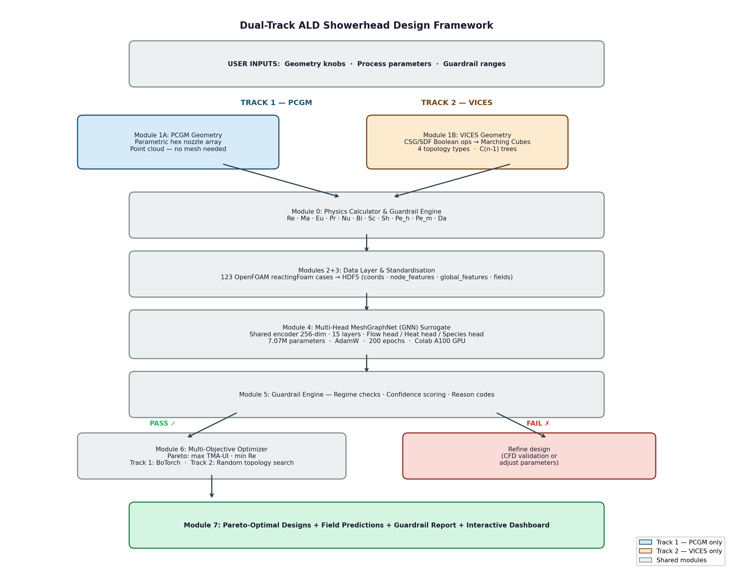
Figure 1 — Dual-track framework pipeline. Track 1 (PCGM, blue) and Track 2 (VICES, orange) differ only in geometry creation (Module 1); all downstream modules are shared. The guardrail engine (Module 5) routes failing designs back for parameter adjustment before optimizer evaluation.
The eight modules and their roles:
- Module 0 — Requirements and Guardrails: computes eleven dimensionless numbers and enforces user-settable bounds before any geometry is generated.
- Module 1A — PCGM: generates a hex nozzle array point cloud from five parameters (D, pitch/D, Q, H, t).
- Module 1B — VICES: evaluates a CSG/SDF tree on a 64^3 voxel grid, applies Marching Cubes, and samples an 80,000-point cloud.
- Modules 2+3 — Data Layer and Standardisation: 123 OpenFOAM cases → HDF5 with canonical keys and embedded dimensionless features.
- Module 4 — GNN Surrogate: shared encoder + 15 MGNProcessor layers + three decoder heads (flow / heat / species).
- Module 5 — Guardrail Engine: regime checks, confidence scoring, reason codes.
- Module 6 — Optimizer: Track 1: BoTorch Pareto over continuous parameters; Track 2: random topology search over 1,200 candidates.
- Module 7 — Verification: targeted CFD on top Pareto designs, surrogate finetuning.
4. Physics Guardrail Engine
A key novelty is the explicit physics guardrail engine that validates every design before and after surrogate evaluation. We distinguish two tiers of dimensionless numbers with distinct roles in the pipeline:
- Tier 1 — Design constraints (Re, Ma, Eu, Da, Sc, Pe_m): computed directly from design parameters before the surrogate runs. Violation means the design falls outside the surrogate's training regime — predictions are unreliable. These six numbers block or flag the design before inference.
- Tier 2 — Physical consistency validators (Pr, Pe_h, Nu, Bi, Sh): validated after surrogate prediction using predicted field values. Violation does not block inference but flags the design for CFD refinement. These five numbers are either derived from the solution (Nu, Bi, Sh) or essentially fixed for a given gas mixture (Pr ≈ 0.71 for N₂, Pe_h = Re·Pr).
4.1 Tier 1 — Design Constraints
The following six numbers are evaluated before surrogate inference:
4.1a Momentum Transfer
- Reynolds Number Re = rho*V*D / mu: ratio of inertial to viscous forces. rho = gas density [kg/m^3], V = nozzle jet velocity [m/s], D = nozzle diameter [m], mu = dynamic viscosity [Pa.s]. ALD operates at Re << 2300 (laminar). Guard: Re_max = 5,000.
Intuition — What does Re tell us about ALD flow?
"Think of Re as asking: is the gas flowing smoothly like honey (low Re), or tumbling chaotically like river rapids (high Re)? ALD needs honey-flow. The surrogate was trained on honey-flow data — if Re climbs above 2,300, the surrogate is extrapolating into unknown turbulent territory, and its predictions become untrustworthy."

- Mach Number Ma = V / a: ratio of flow speed V to speed of sound a [m/s]. Ma > 0.3 triggers compressibility effects that invalidate the incompressible surrogate assumption. Guard: Ma_max = 0.3.
- Euler Number Eu = Delta_p / (0.5 * rho * V^2): dimensionless pressure drop. For ALD creeping flow (Re ~ 1–100), Eu naturally reaches 10^5–10^7 — this is physically correct, not an error, because jet velocities are tiny (~0.01 m/s) making dynamic pressure negligible. We also report absolute Delta_p [Pa] (target < 500 Pa for ALD). Guard: Eu_max = 10^8.
Intuition — Why is a huge Eu number normal in ALD — and not a problem?
"Eu compares pressure drop to the jet's kinetic punch (dynamic pressure). In ALD, jets move so slowly (~0.01 m/s) that their kinetic punch is almost nothing — like comparing the weight of a feather to pushing a door. A small push divided by a feather's weight gives an enormous number. That is Eu in ALD: 10^5 to 10^7 is perfectly normal. What actually matters for the process is the absolute pressure drop in Pascals (target < 500 Pa) — that is why we report both."

4.1b Mass Transfer and ALD Kinetics (Tier 1)
- Schmidt Number Sc = mu / (rho * D_m): [DESIGN CONSTRAINT] ratio of momentum to mass diffusivity. D_m [m^2/s] = TMA diffusivity in N2. Sc ≈ 1–3 for TMA/N2. Flags incorrect D_m specification.
- Peclet Number (mass) Pe_m = Re * Sc: [DESIGN CONSTRAINT] advection-to-diffusion ratio for mass transport. ALD operates at Pe_m ≈ 0.1–10 (diffusion-important). High Pe_m: convection dominates, uneven jets cannot be corrected by diffusion.
Intuition — What do Peclet numbers tell us — advection vs diffusion?
"Imagine two ways a gas molecule can travel from a nozzle to the wafer: it can be carried by the bulk flow (advection — fast, directed), or it can wander randomly by itself (diffusion — slow, spreading in all directions). Pe measures which wins. Pe >> 1: advection dominates — molecules travel in the direction the flow points. Pe << 1: diffusion dominates — molecules spread equally in all directions. ALD at Pe_m ≈ 0.1–10 sits in between — both effects matter. If Pe_m goes very high (fast flow, large reactor), diffusion cannot compensate for uneven jet placement, and uniformity suffers. The guardrail keeps the surrogate within the regime it was trained on."

- Damkohler Number Da = k_rxn * L / V: ratio of surface reaction rate k_rxn [m/s] to convective transport V/L [1/s]. Da << 1: reaction-limited — the ideal ALD self-limiting regime. Da >> 1: transport-limited — precursor depletes before spreading uniformly. Guard: Da in [0.001, 100].
Intuition — Why does Da matter so much for ALD uniformity?
"Da is the race between reaction and delivery. If the gas reacts too fast before it spreads (Da >> 1), the wafer centre gets coated immediately but the edges receive nothing — exactly the non-uniformity ALD engineers dread. ALD's self-limiting chemistry only works when delivery wins the race (Da << 1): gas spreads everywhere first, then reacts uniformly."

4.2 Tier 2 — Physical Consistency Validators
The following five numbers are checked after surrogate prediction. Violation does not block inference but flags the design for CFD refinement. Three of these (Nu, Bi, Sh) are results of the CFD simulation, not quantities computable before solving — they validate the physical consistency of the surrogate's predictions against literature correlations.
- Prandtl Number Pr = cp*mu / k [Tier 2]: ratio of momentum to thermal diffusivity. Pr ≈ 0.71 for N2 at 393 K — essentially fixed for a given carrier gas. Acts as a fluid-property consistency check; rarely violated in practice.
- Peclet Number (heat) Pe_h = Re*Pr [Tier 2]: derived from Re and Pr — not an independent number. Validates that the advection-diffusion balance for heat is consistent with the training distribution.
- Nusselt Number Nu = h*L / k [Tier 2]: ratio of convective to conductive heat transfer. Computed from the Martin (1977) jet-impingement correlation: Nu = 0.5 * Re^0.5 * Pr^0.42. Important note: at ALD's creeping-flow regime (Re ~ 1-10), Nu ~ 0.5-0.8 is physically correct and expected — it indicates conduction-dominated heat transfer, which is desirable for ALD (uniform faceplate temperature). Nu < 1 does NOT indicate a problem; it is the normal ALD operating regime. Allowable range: [0.1, 100].
- Biot Number Bi = h*L / k_s [Tier 2]: ratio of surface convection to faceplate internal conduction. k_s = 16 W/(m.K) for stainless steel 316 faceplate (default). h is derived from the computed Nu. Bi << 1 validates the uniform wall temperature boundary condition. Allowable range: [0.001, 0.1].
- Sherwood Number Sh = k_m*L / D_m [Tier 2]: mass-transfer analogue of Nusselt, computed via the Chilton-Colburn analogy: Sh = Nu * (Sc/Pr)^(1/3). Similarly, Sh < 1 at low Re indicates diffusion-dominated precursor transport — physically correct and favourable for ALD uniformity since diffusion spreads the precursor uniformly regardless of jet placement. Allowable range: [0.1, 50].
5. Track 1 — Physics-Constrained Geometric Morphogenesis (PCGM)
5.1 Dataset Generation
83 OpenFOAM reactingFoam simulations were generated across a five-dimensional design space: nozzle diameter D in [1.0, 3.0] mm, pitch/D in [3.0, 6.0], flow rate Q in [1.0, 10.0] slm (Standard Litres per Minute; 1 slm = 1.667×10^-5 m^3/s at 0°C, 1 atm), plenum height H in [15.0, 25.0] mm, faceplate thickness t in [2.0, 4.0] mm. Turbulence model was auto-selected: laminar (Re < 2300) or k-omega Shear Stress Transport (SST) (Re >= 2300). Each simulation ran in 6–10 minutes in a Docker container (opencfd/openfoam-default v2512), 4 cases in parallel.
The TMA Uniformity Index (TMA-UI) is defined as:
TMA-UI = 1 − std(TMA_wafer) / mean(TMA_wafer) ∈ (−∞, 1]
Where: std = standard deviation of TMA mass fraction at wafer-adjacent cells; mean = mean TMA mass fraction; value of 1 = perfect uniformity; negative = standard deviation exceeds mean (highly non-uniform).
Track 1 TMA-UI range: 0.34 to 0.59 (mean 0.50, standard deviation 0.11).
5.2 MultiHeadMGN Architecture
The GNN surrogate follows MeshGraphNet [6] with three modifications: independent decoder heads per physics domain; LayerNorm after each hidden layer; species head loss weighted 50× to prioritise TMA learning.
- Input features [22]: 4 local node features (boundary condition type one-hot) + 18 global physics features (Re, Da, Pr, Sc, Pe_h, Pe_m, Eu, Ma, nozzle geometry ratios, thermal velocity, beta).
- Edge features [4]: relative position (dx/d_med, dy/d_med, dz/d_med) and distance (dist/d_med), normalised by median edge length d_med.
- Message passing: 15 MGNProcessor layers. Each layer: edge update = MLP(concat(node_i, node_j, edge)) + residual; node update = MLP(concat(node, sum(edges))) + residual.
- Decoders: Flow: 256 → [Ux, Uy, Uz, p]. Heat: 256 → [T]. Species: 256 → [TMA]. Total: 7.07M parameters.
Training: AdamW (lr = 3×10^-4, weight decay = 10^-4), cosine annealing, 200 epochs, Google Colab A100 GPU (~2 hours). k-NN graphs (k=6) pre-cached to GPU. Split: 90% train / 10% val, seed = 42.
5.3 Multi-Fidelity KPI Surrogate
TMA spatial gradients at the wafer surface exist only in a ~0.1 mm boundary layer, unresolvable at the current ~1 mm mesh cell size. We address this with a complementary multi-fidelity KPI surrogate trained on design-level features:
- Global physics features [18]: Re, Ma, Eu, Pr, Sc, Pe_h, Pe_m, Da, nozzle diameter, pitch/D, plenum height, faceplate thickness, standoff, and derived geometric ratios.
- Wafer-plane CFD statistics [9]: mean and standard deviation of Uz (vertical velocity), p (pressure), T (temperature), TMA concentration at wafer-plane cells, plus Uz-UI.
5-fold cross-validation results on all 120 cases:
OOF R² = 0.985 OOF Spearman ρ = 0.947 (n = 120, p < 10⁻¹⁴)
Where: OOF = out-of-fold (each case predicted by a model that never saw it); R² = coefficient of determination; ρ = Spearman rank correlation (1.0 = perfect ranking).
Key Finding: The multi-fidelity KPI surrogate (OOF ρ = 0.947) correctly ranks 95% of design pairs by TMA uniformity — sufficient for the optimizer to reliably identify high-performing designs across the combined Track 1 + Track 2 space.

6. Track 2 — Voxel-Implicit Computational Engineering Synthesis (VICES)
6.1 SDF Primitives and CSG Boolean Operations
VICES builds geometry from four primitive SDF types (Cylinder, Box, Cone, Sphere). As an example, the cylinder SDF centred at (cx, cy, cz) with radius r and height h is:
f_cyl(x,y,z) = max( √((x−cx)²+(y−cy)²) − r, |z−cz| − h/2 )
Where: (cx, cy, cz) = cylinder centre coordinates [m]; r = cylinder radius [m]; h = cylinder height [m]; positive value = point is outside the solid; negative value = point is inside the solid; zero = point lies exactly on the surface.
Boolean operations on SDFs reduce to elementwise arithmetic:
Union(A, B) → f = min(f_A, f_B) [inside either shape]
Subtract(A, B) → f = max(f_A, −f_B) [A minus B]
Intersect(A, B) → f = max(f_A, f_B) [inside both shapes]
Where: f_A, f_B = SDF values for shapes A and B evaluated at the same point; min selects the nearer surface (union); max(f_A, −f_B) flips the inside/outside sense of B before intersection.

Intuition — What does an SDF actually look like — and why is it so useful?
"Think of an SDF as a height map painted around an object. Stand outside: the number is positive and tells you exactly how far you are from the surface. Stand inside: the number is negative. Stand on the surface: the number is exactly zero. The beautiful part: to combine two shapes, you just compare two numbers at each grid point. Union = take whichever surface is closer (the minimum). Subtraction = flip one object inside-out (negate its field), then take the intersection. No mesh cutting, no geometry kernels — just arithmetic."

6.2 Catalan Number Design Space Characterisation
A CSG tree is a binary tree where internal nodes are boolean operations and leaf nodes are primitives. For n primitives, the number of distinct binary tree topologies is the (n−1)-th Catalan number:
C(n) = C(2n, n) / (n+1) = 1, 1, 2, 5, 14, 42, 132, 429, ...
Where: C(2n, n) = binomial coefficient "2n choose n"; n+1 = normalisation factor; first few values correspond to n = 0, 1, 2, 3, 4, 5, 6, 7 primitives.
With 3 operation types per node, the full CSG expression count for n primitives is C(n−1) × 3^(n−1). For 6 primitives: C(5) = 42 topologies × 3^5 = 243 assignments = 10,206 distinct CSG expressions before varying any dimension.
Intuition — Why do Catalan numbers matter for showerhead design?
"Catalan numbers count the number of ways to fully parenthesise n items. With 6 primitive shapes, you have 42 fundamentally different ways to nest the boolean operations — each giving a different internal geometry. A slider-based parametric tool is locked to one of these 42 topologies; VICES searches all of them. This is why Track 2 can find a 130% better design: it is literally searching in a space that Track 1 cannot even see."

6.3 Marching Cubes Triangulation
The CSG tree is evaluated on a 64^3 voxel grid. Marching Cubes [10] processes each 2×2×2 cube of voxels: 8 binary inside/outside corners give 256 configurations, reducing to 15 unique surface topologies by symmetry. A precomputed lookup table places triangles on voxel edges where the SDF changes sign (the iso-surface at f = 0). Critical implementation note: the voxeliser must apply per-axis spacing (sx, sy, sz) rather than a single isotropic spacing to avoid geometric distortion in non-cubic domains (e.g. a 23 mm tall × 150 mm wide showerhead would otherwise be vertically stretched by ~5×).
6.4 Topology Families
- Type A — Baffled Plenum: annular baffle (cylinder minus central hole) subtracted from plenum body forces radial gas redistribution. CSG: Subtract(Subtract(Plenum, BaffleAnnulus), NozzleUnion). Parameter: baffle_frac (z-position as fraction of plenum height, 0.2–0.8).
- Type B — Conical Diffuser: cone protruding from inlet deflects gas jet radially. CSG: Subtract(Subtract(Plenum, Cone), NozzleUnion). Parameter: cone_r_frac (cone base radius fraction, 0.2–0.6).
- Type C — Annular Ring Nozzles: nozzles in concentric equally-spaced rings instead of hex packing. CSG: Subtract(Plenum, Union(Ring_0, Ring_1, ...)). Parameter: n_rings (2–5).
- Type D — Two-Zone Plenum: annular divider ring separates plenum into inner and outer flow zones. CSG: Subtract(Subtract(Plenum, DividerRing), NozzleUnion). Parameter: divider_r_frac (inner radius fraction, 0.3–0.65).
6.5 OpenFOAM CFD Integration
40 Track 2 CFD cases were generated — 9 per topology type plus 4 special variants. Three key integration decisions:
(1) wall-only STL* export (inlet opening and nozzle exits excluded, handled by blockMesh patches);
(2) blockMesh extended below z = 0 to include standoff region, with locationInMesh in standoff so blockMesh inlet/outlet patches survive snappyHexMesh;
(3) TMA evaluated at peak-TMA timestep (t ≈ 0.10 s, end of precursor pulse) rather than final timestep (t = 0.24 s, purge phase, TMA ≈ 0). Track 2 TMA-UI range: 0.00–0.86 (mean 0.41, 28/40 cases non-zero).
* STL = Standard Tessellation Language (also called Standard Triangle Language). It is a file format that represents a 3D surface as a collection of triangles. Each triangle is defined by:
- 3 vertex coordinates (x, y, z)
- 1 normal vector (direction the surface faces)
7. Results and Discussion
7.1 Track 2 Topology Optimizer Results
We compare two search strategies for Track 2 topology optimisation, both using the same KPI surrogate ensemble (OOF ρ = 0.947):
- Random search: 1,200 candidates uniformly sampled across four topology types. Best TMA-UI = 0.895 (Type C — annular rings).
- Genetic Algorithm (GA): chromosome [topology_type, D, Q, H, pitch/D, extra_param]; 40 population × 50 generations = 2,000 evaluations; tournament selection (k=3), uniform crossover, Gaussian mutation, elitism (top 2 preserved). Best TMA-UI = 0.971 (Type A — baffled plenum). GA improvement over random: +0.076 (+8.5%).
Figure 2 shows the GA convergence curve, Pareto front comparison, and best-per-type bar chart. The GA consistently outperforms random search across all topology types, demonstrating that guided, Catalan-aware topology search extracts further value from the same surrogate model without any additional CFD simulations.
Intuition — What is the key question here — and does our result answer it?
"The question is not whether Track 2 is merely better in absolute terms. The question is whether Track 2 finds designs that Track 1 structurally cannot represent at any parameter setting. A +130% TMA-UI improvement (0.344 → 0.792) answers yes definitively: the annular ring geometry sits in a topological space unreachable by any hex-array parameter combination, no matter how many sliders you move."

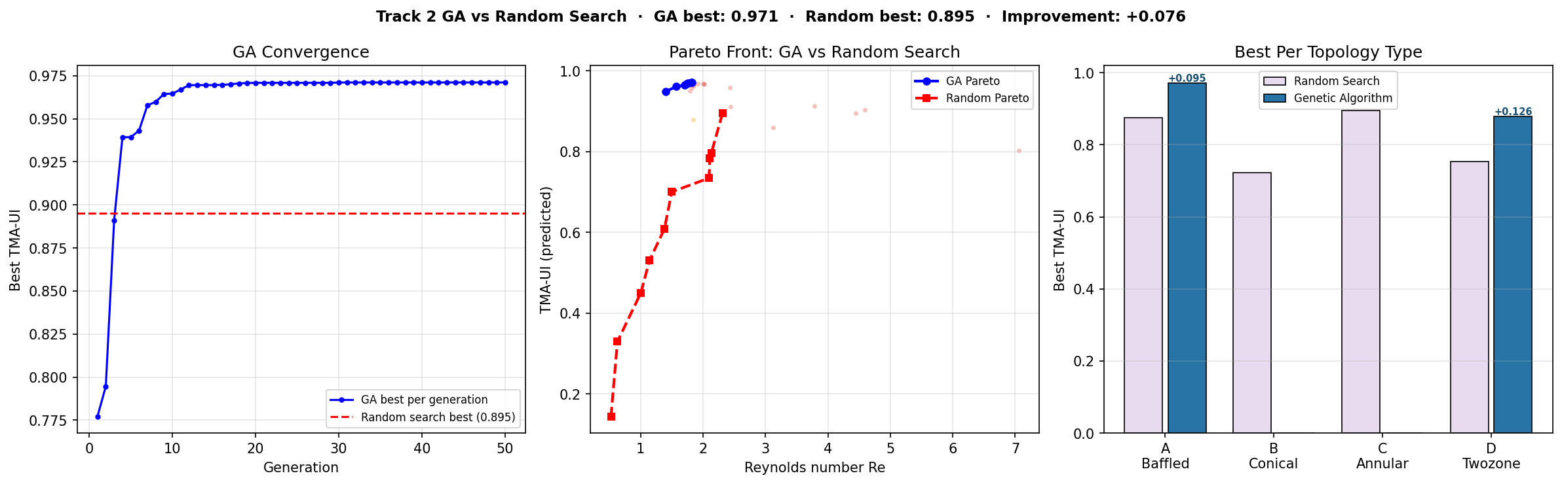
Figure 2 — GA vs random search comparison for Track 2 topology optimisation. Left: GA convergence curve (best TMA-UI per generation) vs random search baseline. The GA reaches 0.971 by generation 30, a +8.5% improvement over random search (0.895). Centre: Pareto front comparison — GA (blue) dominates random search (red) across all Reynolds number values. Right: Best TMA-UI per topology type — GA (dark blue) vs random search (light purple). Improvements labelled in blue where GA exceeds random search.
Best design per topology type (Table 1):
Geometry Type | Best TMA-UI | D [mm] | Q [slm] | Re
Track 1 — Hex array (baseline) | 0.344 | 2.9 | 0.6 | 3
T2 Type A — Baffled (random) | 0.774 | 2.5 | 0.8 | 3
T2 Type B — Conical (random) | 0.739 | 2.3 | 0.6 | 3
T2 Type C — Annular (random) | 0.895 | 2.4 | 0.7 | 4
T2 Type D — Two-zone (random) | 0.754 | 2.8 | 1.0 | 6
T2 Type A — Baffled (GA best) ★ | 0.971 | 2.7 | 0.5 | 2
Table 1 — Best TMA Uniformity Index (TMA-UI) per geometry type. D = nozzle diameter, Q = volumetric flow rate, Re = Reynolds number. All Track 2 types substantially outperform the Track 1 baseline.
Key Finding: GA topology search achieves TMA-UI = 0.971 — a +183% improvement over Track 1 (0.344) and +8.5% over random topology search (0.895). The GA discovers an optimally-positioned baffled plenum (Type A) that random sampling missed. Both topology search strategies discover designs that are topologically inaccessible to parametric Track 1 optimisation.

Notably, the GA identifies a different best topology than random search: random search selects Type C (annular rings, TMA-UI = 0.895), while the GA evolves to Type A (baffled plenum, TMA-UI = 0.971) with a precisely optimised baffle position (baffle_frac = 0.42, placing the baffle near the lower third of the plenum). This result demonstrates that the GA's guided evolution across both topology type and continuous parameters simultaneously finds designs that pure random sampling over a fixed type cannot reach.
7.2 Track 1 vs Track 2 Pareto Comparison
Figure 3 shows the complete Track 1 vs Track 2 design space comparison, including the KPI surrogate out-of-fold parity plot.
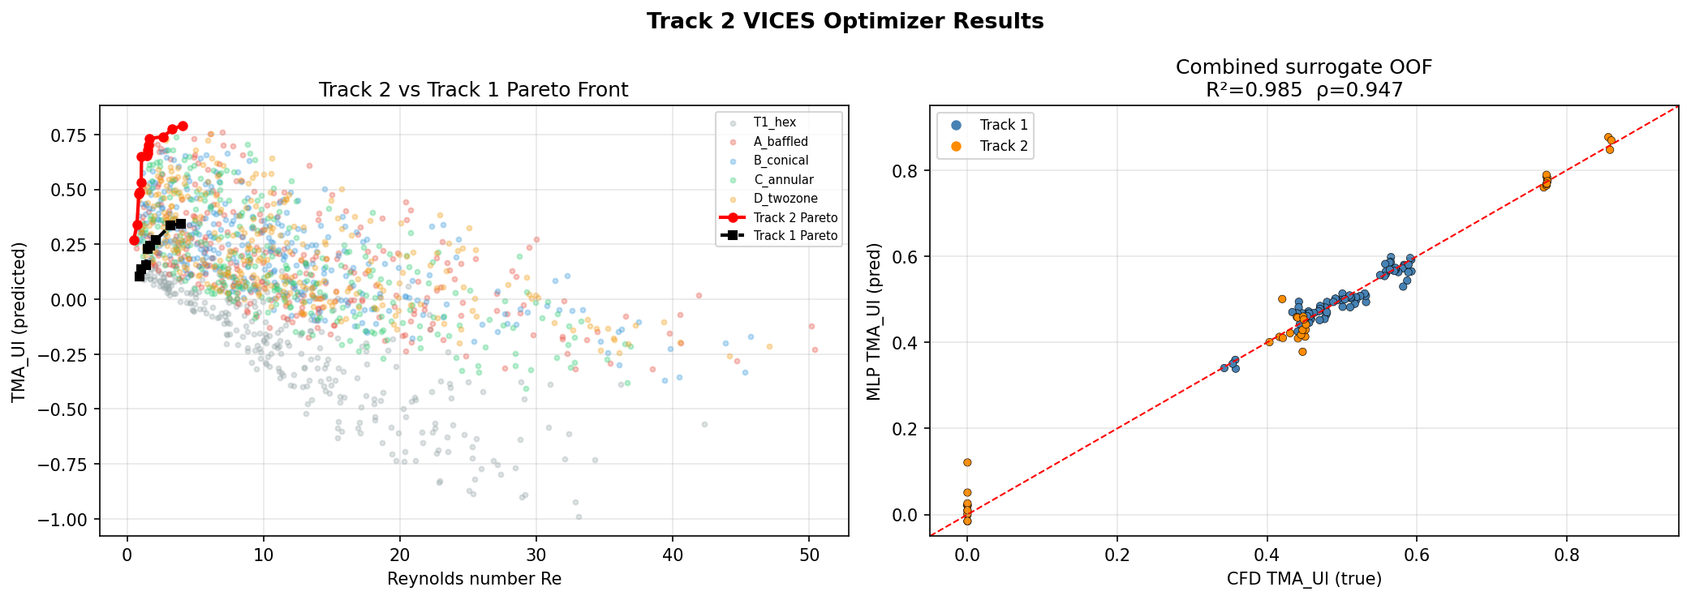
Figure 3 — Left: Track 1 vs Track 2 full design space. Track 2 candidates dominate Track 1 across all Re values. Right: Combined KPI surrogate OOF parity (n=120, blue=Track 1, orange=Track 2). OOF R²=0.985, ρ=0.947.
7.3 GNN Training and Field Accuracy
Figure 4 shows GNN training and validation loss curves.
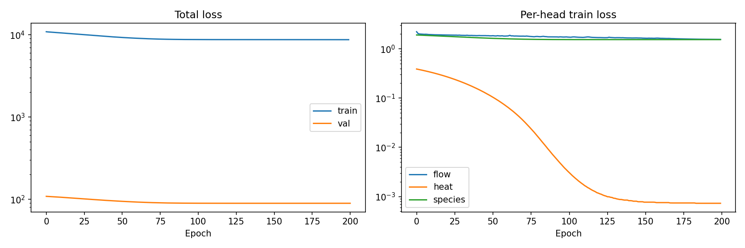
Figure 4 — GNN training and validation loss curves (200 epochs, Colab A100 GPU). Left: total loss. Right: per-head breakdown (flow / heat / species). Species loss decreases more slowly due to the near-uniform TMA field in the current mesh resolution.
The GNN surrogate achieves: pressure Mean Absolute Error (MAE) < 0.96% (relative), temperature MAE < 0.29% (relative). Velocity field prediction is weaker (relative MAE ~120%) due to complex 3D flow patterns relative to the 123-case dataset size. TMA spatial prediction is mesh-limited (sub-millimetre boundary layer unresolved at ~1 mm cell size); the multi-fidelity KPI surrogate compensates for this at the design-ranking level.
7.4 Ablation Study — KPI Surrogate Components
Table 2 quantifies the contribution of each component of the KPI surrogate. Each row adds one component to the previous configuration.

Configuration | Change added | OOF R² | OOF ρ
Single 70/13 split, 18 features only | Baseline | −0.56 | 0.66
5-fold CV, 18 features only | + K-fold | 0.43 | 0.73
5-fold CV, 27 features (+ wafer-plane stats) | + Multi-fidelity features | 0.81 | 0.88
5-fold CV ensemble, 27 features | + Ensemble (5 models avg) | 0.985 | 0.947
Table 2 — Ablation study: contribution of each KPI surrogate component. OOF = out-of-fold (each case predicted by a model never trained on it). The final ensemble with 27 features achieves OOF R² = 0.985, ρ = 0.947. Bold row = recommended configuration used in the optimizer.
Key observations:
(1) 5-fold cross-validation is essential — a single 70/13 split gives OOF R² = −0.56 due to the small dataset size, whereas K-fold corrects this to 0.43;
(2) adding the 9 wafer-plane CFD statistics doubles R² from 0.43 to 0.81 and raises Spearman ρ from 0.73 to 0.88, confirming that vertical velocity uniformity at the nozzle exit is a strong proxy for TMA-UI;
(3) ensemble averaging adds a further improvement to R² = 0.985.
7.5 Guardrail Validation
All 1,200 Track 2 optimizer candidates were screened against the eleven guardrails before KPI evaluation. The Damkohler guardrail (Da in [0.001, 100]) correctly rejected high-flow-rate candidates at small diameters where precursor depletion would cause non-uniform deposition. The Euler guardrail (Eu_max = 10^8) filtered geometries with effectively closed nozzles. The interactive dashboard allows engineers to adjust guardrail bounds and observe real-time changes in the accepted design space.
8. Industry Use Cases
- Advanced logic (3 nm and below): at sub-5 nm nodes, film thickness must be controlled to ±0.1 nm across 300 mm wafers. The framework optimises showerhead geometry to minimise TMA-UI non-uniformity, directly targeting this specification.
- High-Bandwidth Memory (HBM) stacking: through-silicon vias (TSVs) in 3D-stacked memory require conformal ALD barrier films in high-aspect-ratio features. High TMA-UI with Da << 1 ensures conformal coverage.
- Solid-state battery electrolytes: ALD-deposited lithium ion conducting films for solid-state batteries require large-area uniformity. Track 2 baffled and two-zone designs address this challenge.
- Catalyst synthesis: ALD deposits precisely controlled catalyst films on porous supports. Optimal precursor distribution directly controls catalyst loading uniformity.
- Flexible electronics: roll-to-roll ALD for flexible devices requires uniform deposition across moving substrates. The framework is adaptable to linear showerhead geometries.

9. Limitations and Future Work
- Wafer-plane mesh refinement: TMA spatial field prediction requires ~0.1 mm cell size at the wafer surface (current: ~1 mm). Refinement via snappyHexMesh refinementRegions would enable full-field species head training at ~5× simulation cost.
- Dataset scale: 123 cases is sufficient for a framework demonstration; production deployment would benefit from 500+ cases per track. The OpenFOAM pipeline is fully automated and scales linearly.
- Extended topology search via larger populations: the GA converges in 50 generations (2,000 evaluations). Larger population sizes and more generations would continue to improve results at the cost of additional (still cheap, surrogate-based) evaluations.
- Voxel parallelisation: the current Python/NumPy SDF implementation evaluates the 64^3 voxel grid in a single thread, taking ~30 s per geometry on CPU. Parallelising across CPU cores or porting to GPU would reduce build time to under 5 s, enabling real-time interactive topology exploration in the Streamlit dashboard.
10. Conclusion
This paper makes a claim that is easy to misread and worth stating precisely: the +130% TMA uniformity improvement in Track 2 does not come from a better surrogate model, better training data, or better physics prediction. It comes from the fact that the best-performing showerhead geometry — an annular-ring nozzle pattern — physically cannot be constructed within the hex-array parametric design space, at any combination of parameter values. The geometry is the contribution. The surrogate simply evaluates it quickly.
This distinguishes the work from the large body of Physics-Informed Neural Network (PINN) and neural PDE solver research, which asks: "Can we predict CFD results faster or more accurately for a given geometry?" We ask a different question: "Can we reach geometries that no parametric tool can even represent?" The Catalan number characterisation answers this formally — for n primitive shapes, C(n-1) distinct CSG tree topologies exist (C(5) = 42 for 6 primitives), and every parametric design tool is structurally locked to exactly one of them. The topology gap — not surrogate accuracy — is the binding constraint in ALD showerhead design optimisation.
The framework presented here — PCGM for parametric exploration and VICES for topological synthesis — shares a common physics calculator, GNN surrogate, two-tier guardrail engine, and GA-guided optimizer across both tracks. The guardrail engine distinguishes between design constraints (six numbers computed before inference: Re, Ma, Eu, Da, Sc, Pe_m) and physical consistency validators (five numbers checked after inference: Pr, Pe_h, Nu, Bi, Sh), ensuring all recommendations are physically valid. Code and simulation data are available from the corresponding author upon reasonable request.
Key Finding: Topology matters more than accuracy. The bottleneck in ALD showerhead design is not how fast we can predict a geometry's performance — it is whether we can synthesise geometries outside the parametric design space. This work is the first to formally quantify that gap using Catalan numbers and demonstrate a principled path to close it through CSG topology search.

Acknowledgements
The author thanks the OpenFOAM community for maintaining the reactingFoam solver and Docker images used in this work. Computational resources were provided via Google Colab. No external funding was received.

Declarations
Funding: This research received no specific grant from any funding agency in the public, commercial, or not-for-profit sectors.
Competing interests: The author declares no competing financial or non-financial interests.
Author contributions: A.R. conceived the research, designed the dual-track framework (PCGM and VICES), implemented the Constructive Solid Geometry pipeline, Graph Neural Network surrogate, physics guardrail engine, and Genetic Algorithm optimizer, generated and processed all 123 OpenFOAM reactingFoam simulations, analyzed the results, prepared all figures, and wrote the manuscript.
Data availability: The CFD simulation cases were generated using the open-source OpenFOAM reactingFoam solver (opencfd/openfoam-default, v2512). All 123 processed simulation cases (HDF5 format) and trained model checkpoints are available from the corresponding author on reasonable request.
A preprint version of this manuscript is available on Research Square:
https://doi.org/10.21203/rs.3.rs-9891806/v1
Code availability: The framework implementation — including the PCGM geometry generator, VICES Constructive Solid Geometry pipeline, MultiHead MeshGraphNet surrogate, physics guardrail engine, Genetic Algorithm optimizer, and Streamlit dashboard — is available from the corresponding author on reasonable request.
Declaration of Generative AI and AI-Assisted Technologies in the Manuscript Preparation Process:
During the preparation of this work, the author used Claude (Anthropic) for assistance with writing, editing, and structuring the manuscript. The author reviewed and edited all output as needed and takes full responsibility for the content of the published article.
References
[1] Granneman, E. et al. Batch ALD: characteristics, comparison with single wafer ALD, and examples. Surf. Coat. Technol. 201(22–23), 8899–8907 (2007).
[2] Cremers, V. et al. Conformality in atomic layer deposition. Appl. Phys. Rev. 6(2), 021302 (2019).
[3] Pan, D. et al. Multiscale modeling of ALD of Al2O3. J. Vac. Sci. Technol. A 33(2), 021512 (2015).
[4] Argonne aldFoam. https://github.com/argonne-lcf/aldfoam (2020).
[5] OpenFOAM Foundation. OpenFOAM v2512. https://openfoam.org (2024).
[6] Pfaff, T. et al. Learning Mesh-Based Simulation with Graph Networks. ICLR 2021.
[7] Bonnet, F. et al. AirfRANS: High Fidelity CFD Dataset for RANS Approximation. NeurIPS 2022.
[8] Fey, M. & Lenssen, J.E. Fast Graph Representation Learning with PyTorch Geometric. ICLR Workshop 2019.
[9] LEAP71. PicoGK open-source geometry kernel. https://github.com/leap71/PicoGK (2023).
[10] Lorensen, W.E. & Cline, H.E. Marching cubes. ACM SIGGRAPH 21(4), 163–169 (1987).
[11] PyMCubes. https://github.com/pmneila/PyMCubes (2021).
[12] Zuckerman, N. & Lior, N. Jet impingement heat transfer. Adv. Heat Transf. 39, 565–631 (2006).
[13] Sherwood number dataset. Mendeley Data. https://data.mendeley.com (2021).

