AN INTERNSHIP REPORT ON

AN INTERNSHIP REPORT ON

AN INTERNSHIP REPORT ON AN INTERNSHIP REPORT ON

Web Application – “MeroNiwas”

Report Submitted in Partial Fulfillment of the Requirement for Class 11

‘Computer Engineering’

On the Job Training (OJT)

SUBMITTED BY:

Ranab Raj Prasad Joshi

Registration Number :- 813271640023

Symbol Number :- 12737745

Department of Education

Kathmandu Metropolitan City Office,

Kathmandu, Nepal

Date:02/08/2024

Certificate

This is to certify that the work contained in Titled “Web Application – “Mero Niwas” by MeroNiwas Team, has been carried out under my Supervision as partial fulfillment of the requirements for Class 11 ‘Computer Engineering’ On the Job Training (OJT).

Signature of Supervisor

Name: Er. Ananta Paudel

Stream: Computer Engineering

Name of School: Shivapuri Secondary School

2 July,2024

**Overview**

Mero Niwas is a room rental service website designed to connect homeowners with potential renters in Nepal. The project was undertaken as part of an On-the-Job Training (OJT) program and aims to provide a comprehensive online platform for rental services, facilitating the search for rental properties and enhancing the user experience.

**Technologies Used**

**Frontend**

* **HTML**: Used for structuring the content on the web pages.
* **CSS**: Employed for styling the web pages, ensuring a visually appealing and user-friendly interface.
* **JavaScript (JS)**: Implemented for interactive elements and dynamic functionalities on the client side.

**Backend**

* **Python Django**: A high-level Python web framework used for developing the backend of the application. Django was chosen for its efficiency in building robust, scalable web applications and its built-in security features.

**Detailed Explanation**

**Frontend Development**

The frontend of Mero Niwas is designed to be intuitive and responsive. The key components include:

* **HTML**: Forms the backbone of the website, creating the structure for web pages, including the home page, property listings, and user profiles.
* **CSS**: Ensures the website is aesthetically pleasing and responsive across various devices. CSS is used to style elements such as navigation bars, buttons, and forms.
* **JavaScript**: Enhances user interaction by providing functionalities like form validation, dynamic content updates, and interactive maps for property locations.

**Backend Development**

The backend is powered by Django, which handles server-side logic, database interactions, and user authentication. Key features include:

* **Database Management**: Django's ORM (Object-Relational Mapping) system manages data related to properties, users, and transactions, ensuring data consistency and integrity.
* **User Authentication**: Django provides built-in authentication mechanisms to manage user registration, login, and profile management securely.
* **Dynamic Content**: The backend generates dynamic content based on user interactions, such as property searches and user-specific recommendations.
* **Security**: Django's security features, including protection against SQL injection, cross-site scripting, and cross-site request forgery, help maintain user data security and application integrity.

**Project Goals and Challenges**

**Objectives**

* Improve knowledge and skills in frontend and backend development.
* Encourage critical thinking and originality in web application development.
* Provide a seamless user experience for exploring and managing rental properties.

**Challenges**

* **User Data Security**: Ensuring that user data is protected against unauthorized access and breaches.
* **Collaboration**: Working effectively in a team to develop different components of the website.
* **Scalability**: Designing the application to handle future growth and increased user traffic.
* **User Experience**: Ensuring a smooth and responsive user experience across various devices.

**Conclusion**

Mero Niwas serves as a valuable platform for the rental market in Nepal, leveraging modern web technologies to connect renters and homeowners efficiently. The project not only demonstrates the practical application of theoretical knowledge but also addresses real-world challenges in web development, providing a solid foundation for future enhancements and scalability.

The project reflects the skills and experiences gained during the OJT program, highlighting the importance of hands-on learning in preparing for the fast-paced world of internet technology.

Inside of software need to run.

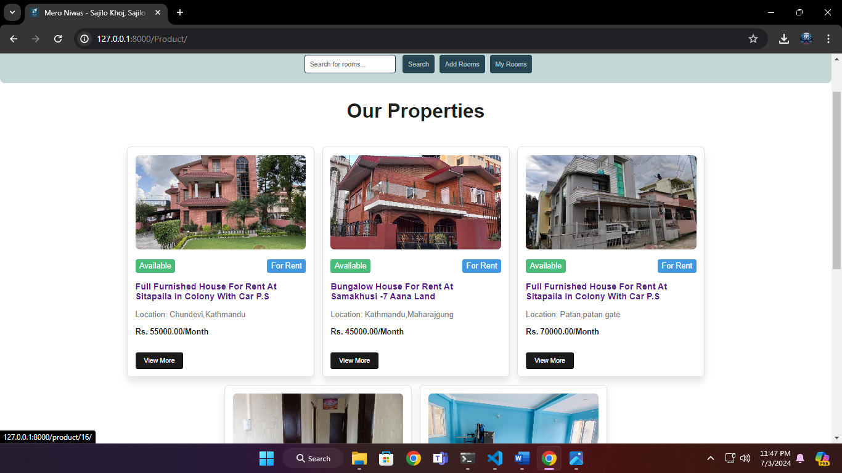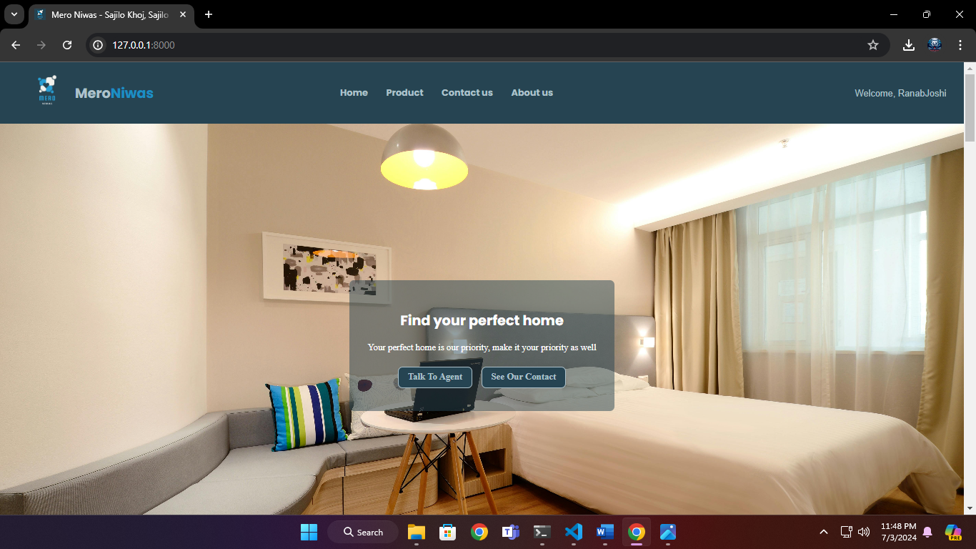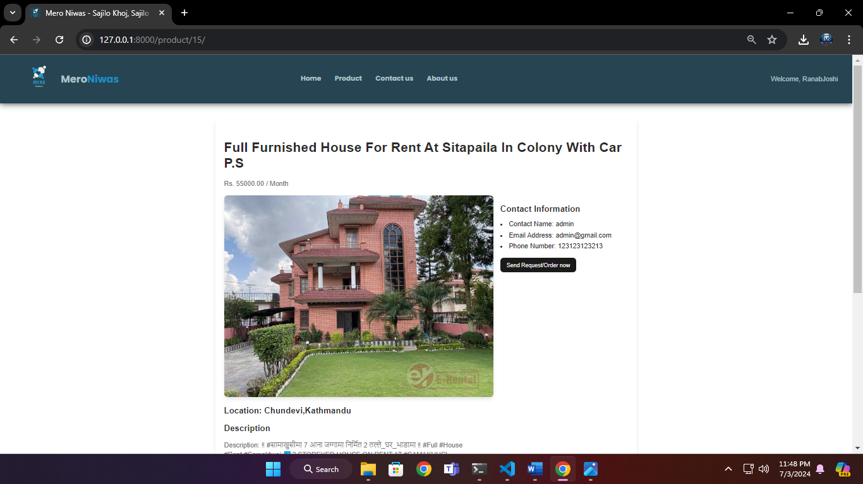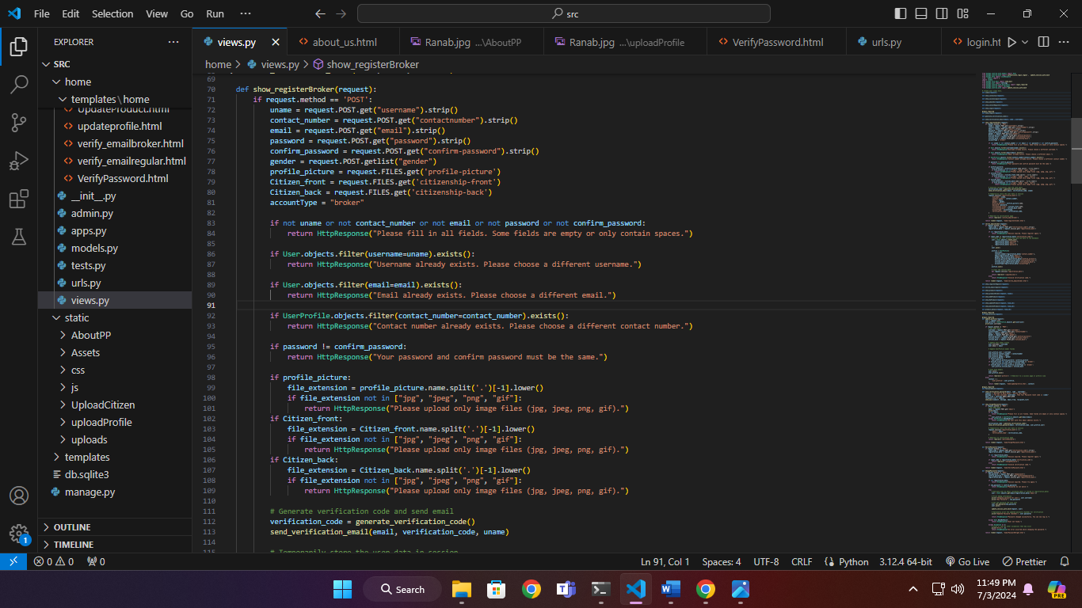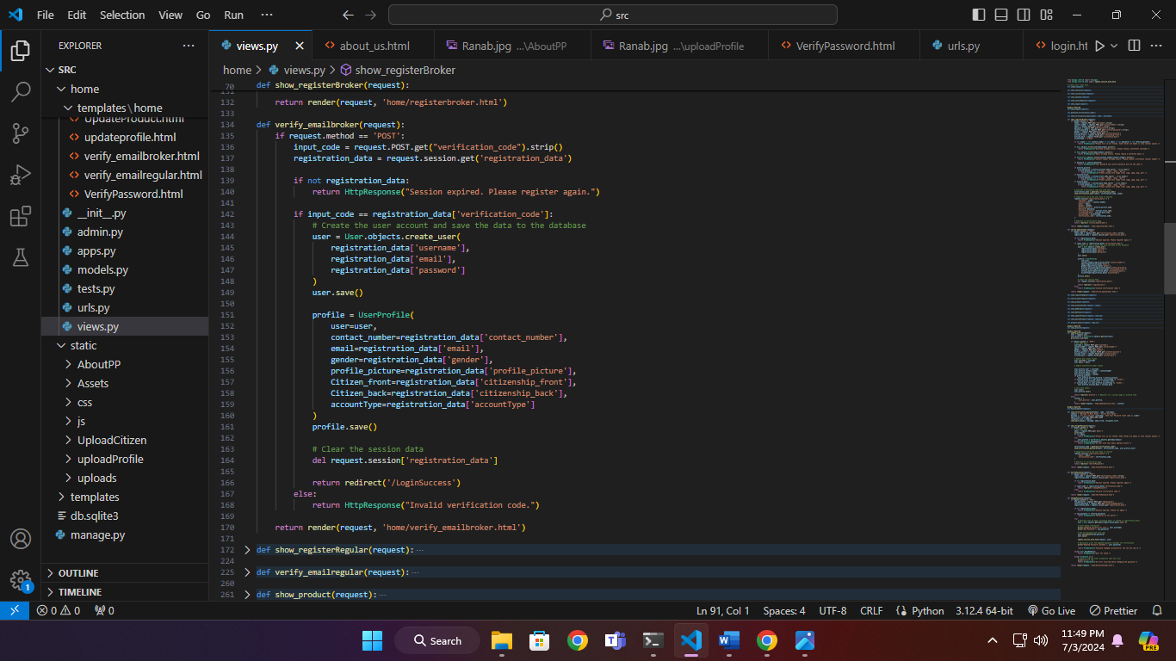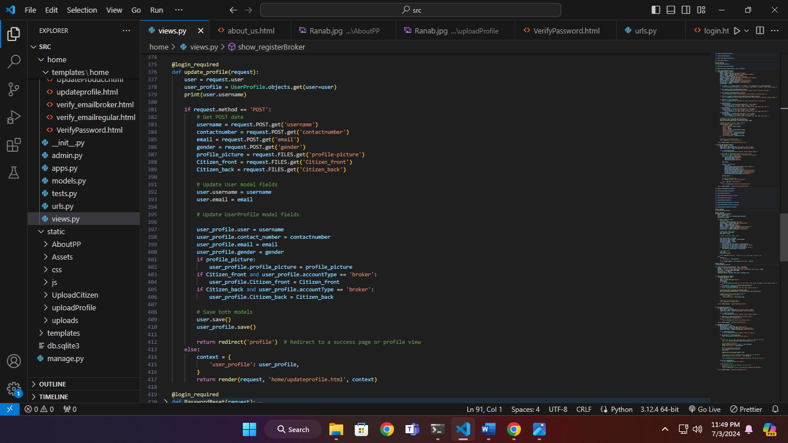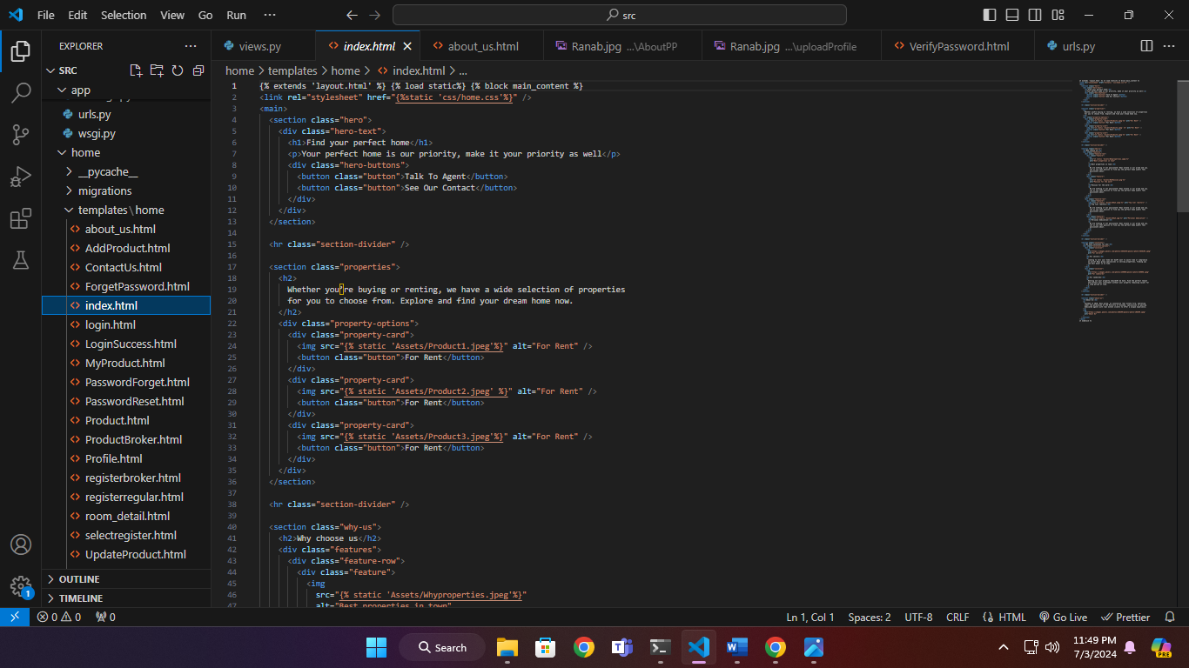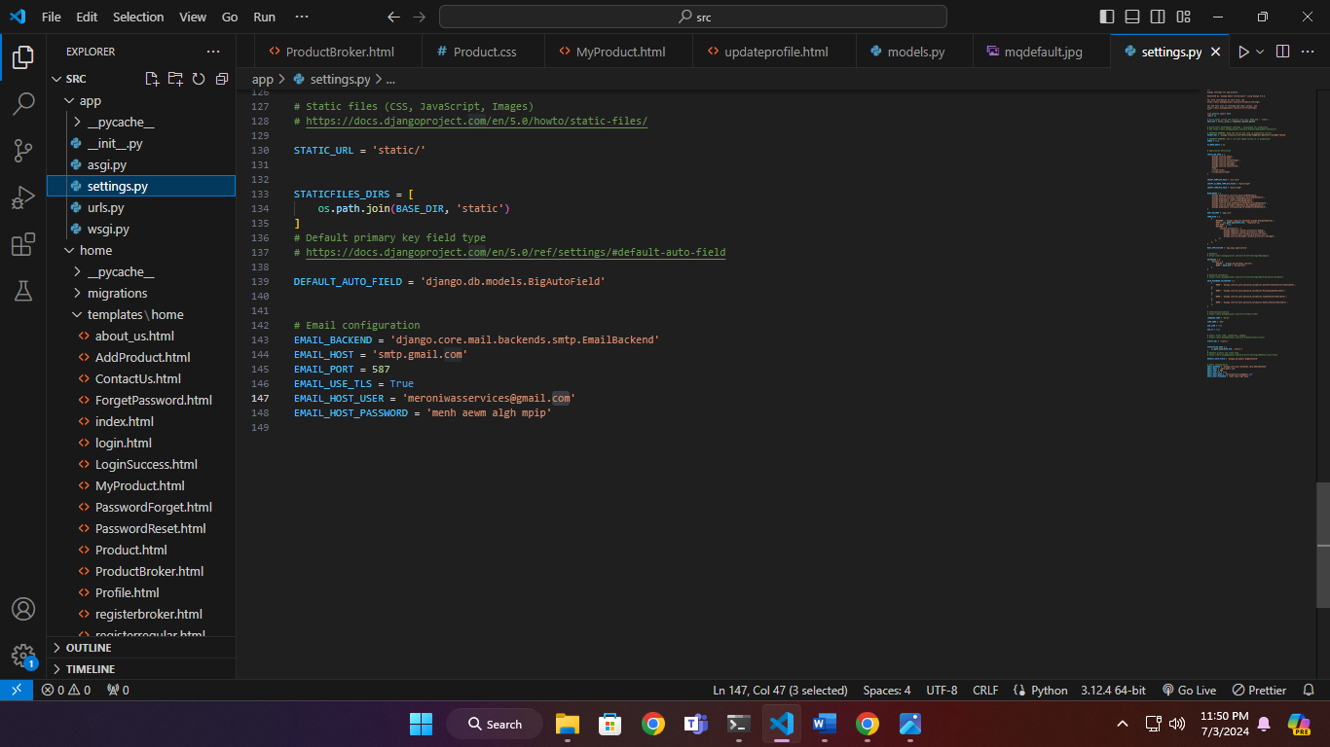

References:

-https://stackoverflow.com/

-https://www.w3schools.com/

-https://www.python.org/doc/

-https://www.tutorialspoint.com/index.htm