ELECTRO CATALOG
DATA FLOW DIAGRAMS (DFD)

Document purpose
This document presents the Level 0 context diagram and Level 1 data-flow diagrams for Electro Catalog, a PHP and MySQL-based electronics catalogue and shopping website. It shows how visitors, registered members and administrators exchange information with the application, and how the application reads or writes product, account, cart and order data.

Scope and assumptions
The website allows visitors to browse and search electronic products, view product details and manage a temporary guest cart. Registered members can log in, keep a saved cart and view purchase history. The Buy action represents a simulated college-project purchase; payment-gateway integration is not included. Product images are stored in the local “item pictures” folder, while MySQL stores the image filenames and other catalogue data.

Diagram notation
Rectangles represent external entities or data stores; ovals represent application processes; arrows represent information flow. D1–D4 are logical data-store labels for the diagrams, not additional database tables.

6. Data Flow and Sequence Modelling
The diagrams follow a request from a visitor or member into the PHP application, then to MySQL or the local product-image folder as required. They describe system-level information flow rather than screen layout or individual code statements.

6.1 DFD Level 0 – system context
At Level 0, Electro Catalog is shown as one system. Visitors and guests browse products and use a temporary cart. Registered members can authenticate, maintain a saved cart, buy items and view their purchase history. An administrator maintains product and category information. MySQL stores structured records, while the “item pictures” folder contains product images.
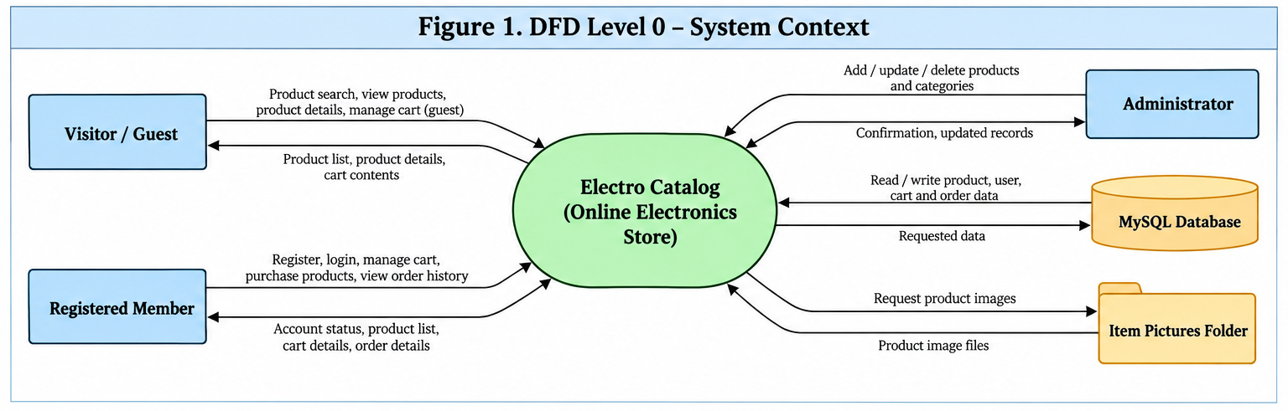
Figure 1. External entities exchange requests and results with the Electro Catalog system.
The context diagram presents the website as a single process and identifies the main data exchanges with people, the database and image files.

6.2 DFD Level 1 – principal processes
Level 1 decomposes the website into six main processes. The logical stores group related records for readability.
Process | Responsibility | Main data used
P1 Browse and Search Products | Show categories, product lists, prices and product details. | D1 Products and Categories; item pictures folder
P2 Account Management | Register members, validate login and create authenticated sessions. | D2 Users
P3 Manage Cart | Add, remove and update quantities; display cart contents and totals. | D3 Carts and Cart Items; product data
P4 Checkout / Buy | Record a simulated purchase and clear the cart after successful order recording. | D3 Carts and Cart Items; D4 Orders and Order Items
P5 Maintain Products and Categories | Allow an administrator to create, update or delete catalogue records. | D1 Products and Categories
P6 View Purchase History | Retrieve a member’s recorded orders and their items. | D4 Orders and Order Items
D1–D4 are diagram labels only. The underlying planned MySQL tables are categories, products, users, carts, cart_items, orders and order_items.

Figure 2. DFD Level 1A – catalogue and accounts
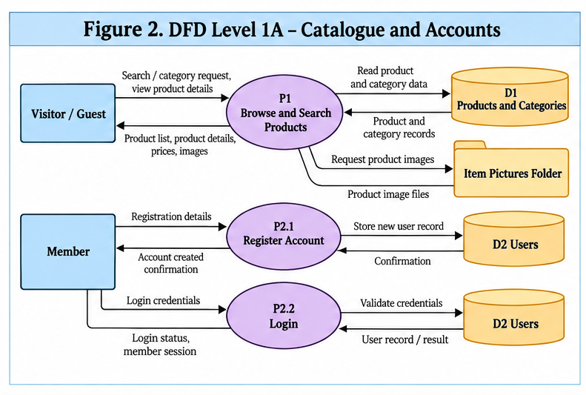
Figure 2. Data flow for product browsing, search, product images and member authentication.
Visitors and guests submit search or category requests. The browse process reads product and category records and retrieves the corresponding image files. Members submit registration or login details; the account process validates the details against stored user records and returns an appropriate result.

Figure 3. DFD Level 1B – cart and purchase
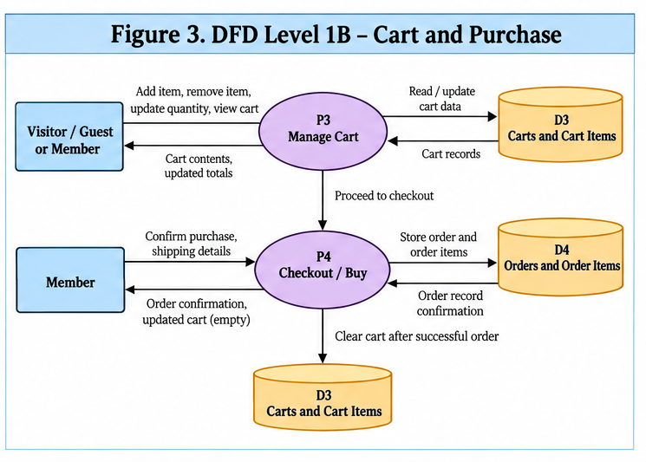
Figure 3. Data flow for guest/member cart actions and purchase recording.
Guests can keep cart contents in a PHP session. For signed-in members, cart data can be saved in the carts and cart_items tables. During Buy, the application records the order and its items first; it should clear the cart only after the order has been stored successfully. This project diagram does not represent a real payment gateway.

Figure 4. DFD Level 1C – catalogue administration and purchase history
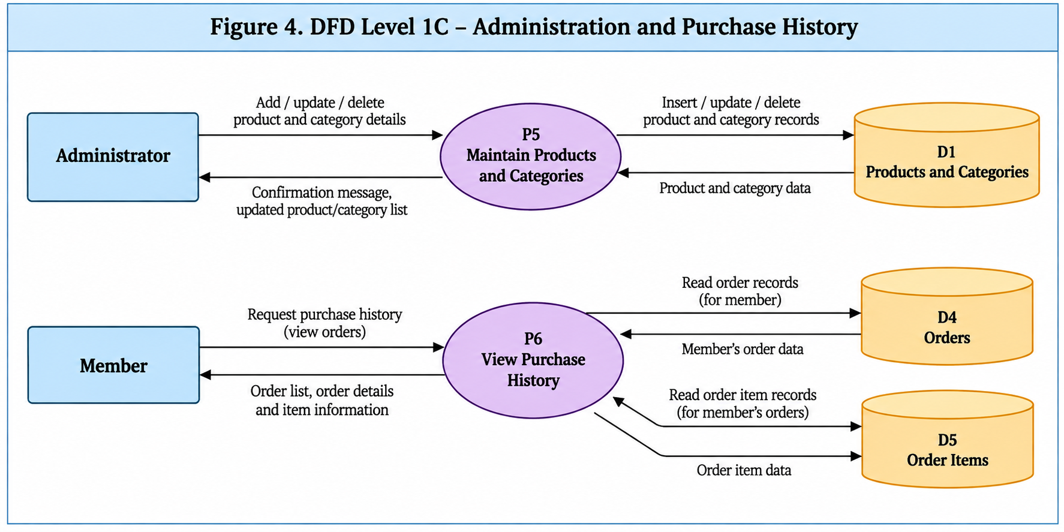
Figure 4. Data flow for administrator catalogue maintenance and member purchase history.
The administrator submits product or category changes, which are saved to the catalogue data store. A registered member requests purchase history; the application reads orders and order_items associated with that member and returns the recorded purchases. No separate purchase_history table is required.

Implementation notes
- Guest cart data may be held in PHP sessions and does not require a permanent user record.
- For a logged-in member, cart ownership should be linked to the user account.
- The Buy operation should create an order and its order items as one logical operation before resetting the cart.
- Store image filenames in MySQL; keep the actual image files in the local “item pictures” directory.

